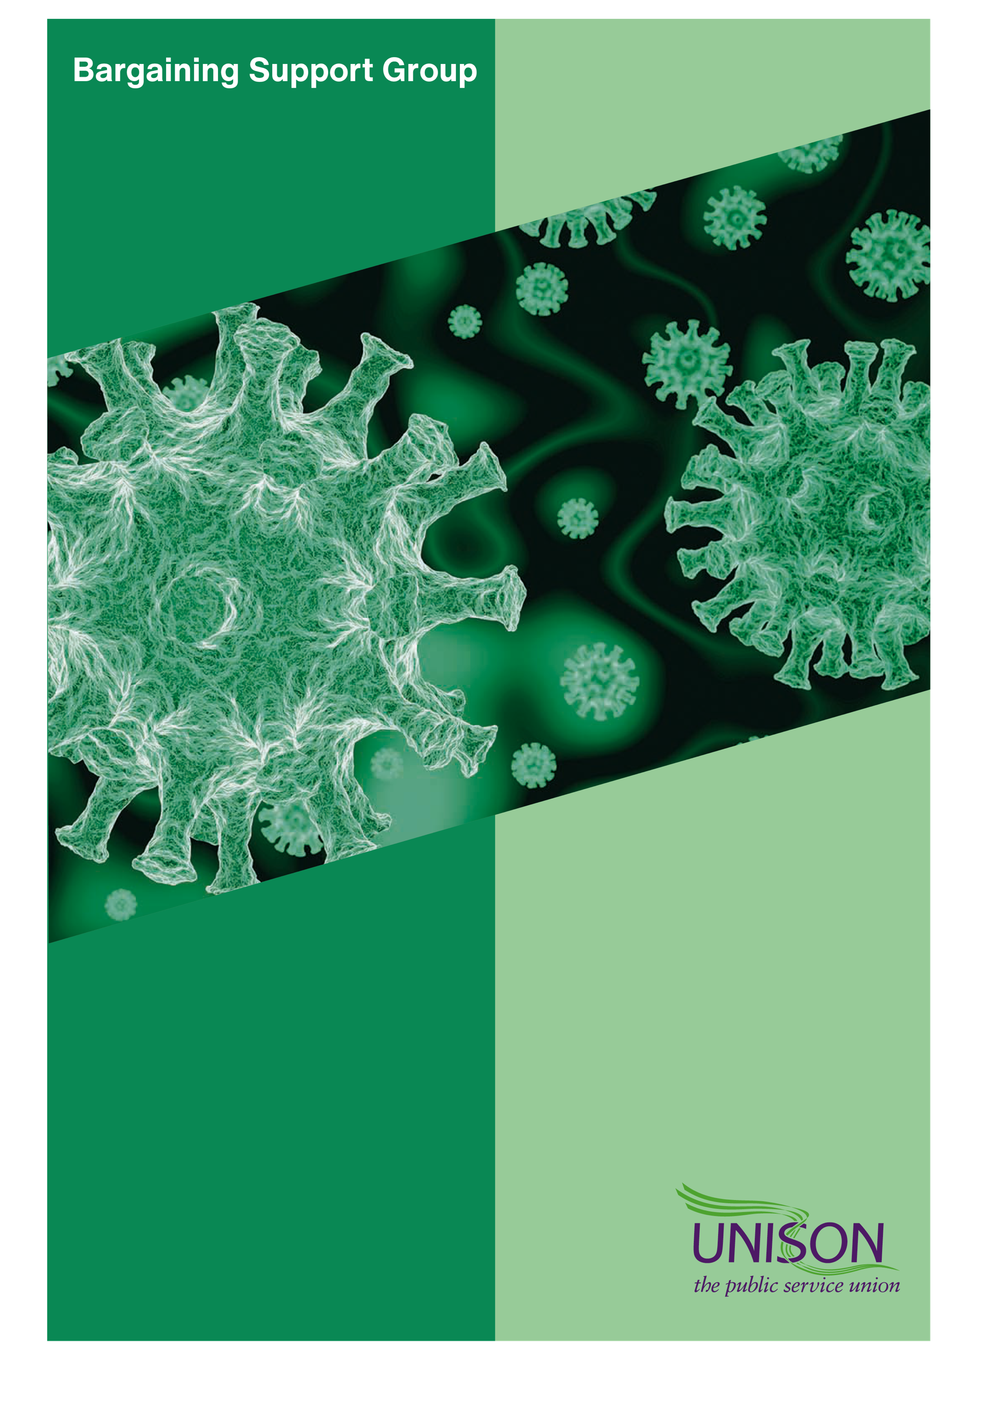
UNISON GUIDANCE FOR MEMBERS ON MANDATORY VACCINATION IN SOCIAL CARE IN ENGLAND
UNISON Guidance for Branches on Mandatory Vaccination in Social Care in England

What is happening?

New legislation means that people who enter the premises of a CQC-registered care home in England for residents requiring nursing or personal care must have completed a course of authorised COVID-19 vaccine doses unless they have an exemption.

The Government’s own guidance for affected staff and employers is https://assets.publishing.service.gov.uk/government/uploads/system/uploads/attachment_data/file/1008446/coronavirus-covid-19-vaccination-of-people-working-or-deployed-in-care-homes-operational-guidance.pdf .

When is it happening?

The regulations introducing this were approved on 22nd July 2021. There is then a 16-week ‘grace’ period.

On 11th November 2021, it will become illegal for the registered care home to permit people into the premises if they are unable to show they are vaccinated or are otherwise exempt.

This means that 16th September 2021 is the latest date that someone could receive their first vaccination dose before the regulations take effect.

UNISON’s policy position on mandatory vaccination.

UNISON has opposed the introduction of mandatory vaccination from the outset (https://www.unison.org.uk/news/2021/03/forced-jabs-counterproductive-says-unison/.

We have repeatedly told the government that persuasion and not coercion is the best way to roll-out the vaccination programme. We believe that these regulations distract from government’s central responsibility to boost trust and confidence in the vaccine, so that vaccination levels reach the same rates seen in the NHS and in Scotland, Wales and Northern Ireland.

In our consultation response to government (http://msgfocus.com/files/amf_unison/workspace_8/UNISON_Consultation_Reponse_-_Mandatory_Vaccination_in_care_homes.pdf) , we said that all the available evidence suggests that mandatory vaccination makes it harder to persuade workers that the vaccine is safe. UNISON’s consultation response included new data from a survey of members working in social care and highlighted new academic evidence that suggested mandatory vaccination created barriers for those hesitant about the vaccine. We have also made clear our concern that this opens up the possibility of discrimination against care workers with protected characteristics under the Equality Act 2010.

We have told government that mandatory vaccination in care homes risks creating dangerous staff shortages in some care homes. During the passage of this legislation through Parliament, UNISON briefed MPs and Lords regarding this counter-productive policy and the risks involved. Unfortunately, the government has not heeded warnings from UNISON.

We provide this guidance to best advise UNISON branches and UNISON members on how to handle the fallout from this counterproductive and misguided policy.

Who does this apply to?
This applies to all CQC-registered care homes providing nursing or personal care in England. Everyone entering the premises of such a care home, including staff, must have received a complete course of authorised COVID-19 vaccination doses unless they are exempt. The requirement does not apply to persons entering ‘any surrounding grounds’ of the care home premises.
Full details relating to exemptions can be found on pages 21, 29 and 37 of the Government’s guidance linked at the top of this document.
In summary, the following people will be legally exempt:
- Service users who reside at the care home
- Friends or relatives of service users who reside at the care home
- Persons under the age of 18
- Persons visiting a service user who is dying
- Persons providing reasonably necessary comfort or support to a service user who has suffered a bereavement of a friend or relative
- Persons providing reasonably necessary emergency assistance in the premises
- Persons providing reasonably necessary urgent maintenance assistance in the premises
- Persons executing their duties as a member of the emergency services

More information about medical exemption for clinical reasons is contained in the section below.

Proof of vaccination

The legislation does not specify how evidence of vaccination is to be provided. It is for the registered care home to satisfy itself for each individual permitted to enter its premises. The registered person will be responsible for ensuring that everyone who enters their care home is either vaccinated or exempt. The registered person will be the person registered with the CQC as a manager or service provider.

Care staff can provide proof of vaccination in different ways. The most common method will be by using the NHS app via smartphones. Staff could, for example, be asked to show their NHS App to the care home manager to demonstrate their vaccination status. A web browser-based version of the app will also be available. More information on the app can be found here: www.nhs.uk/nhs-app/
For those staff who do not have a smartphone or otherwise do not wish to or cannot use the app, there are non-digital ways to provide proof of vaccination. Staff can get an “NHS COVID Pass” letter (https://www.nhs.uk/conditions/coronavirus-covid-19/covid-pass/get-your-covid-pass-letter/) sent to them in the post, which shows they have been vaccinated. Care home workers can ask for a letter 2 weeks after having their 2nd dose of the vaccine, or 2 weeks after a single-dose of the Janssen vaccine. They should receive it within 5 working days.

Medical exemptions

The regulations explicitly accept there are individuals for whom vaccination is inappropriate for clinical reasons but do not specify what this means. Therefore, care home workers with a relevant clinical reason should be allowed to continue to work in care homes, despite being unvaccinated.
Any medical exemption should be based on the recommendation of a clinician. According to the Government’s guidance “There are a range of circumstances in which an exemption may be granted which will reflect the Green Book on Immunisation against infectious disease and clinical advice from The Joint Committee of Vaccination and Immunisation (JCVI). The Government will add further detail to its guidance here as soon as it’s published.”

The guidance also states that “it will not be unlawful discrimination in relation to age, disability, religion, or belief for a care home to ensure that a person over 18 who has not been vaccinated and is not medically exempt does not enter the care home.”
How to confirm a medical exemption
The guidance published on 4/8/21 declares: “There will be a clear process for staff to follow if they think they may have a clinical reason to be exempt. This process will be aligned with certification for domestic events, exemptions from self-isolation for confirmed contacts and travel.”

Guidance for certification is being developed and further detail will be provided to their guidance as soon as it’s published. They will also be producing separate guidance for clinicians, which will align with guidance for vaccine certification in other public settings. This guidance will help clinicians to verify exemptions.

UNISON will update our own guidance to reflect these changes as soon as they are announced.
Where can members find information about the COVID-19 vaccine?
There is comprehensive information about COVID-19 vaccination on the NHS website
https://www.nhs.uk/conditions/coronavirus-covid-19/coronavirus-vaccination/coronavirus-vaccine/
This provides information on the vaccines approved for use in the UK, with safety information including relating to conception, pregnancy and breastfeeding. You can also book an appointment for vaccination by visiting https://www.nhs.uk/conditions/coronavirus-covid-19/coronavirus-vaccination/book-coronavirus-vaccination/.
Agency staff
The new legislation applies to all persons, including agency staff, entering the premises of a registered care home. As such, care homes will be breaking the law if they employ an agency worker who has not completed a course of authorised COVID-19 vaccination doses, except where an exemption applies.
CQC enforcement

The Care Quality Commission (CQC) is the body that regulates health and care services in England, and they will be responsible for enforcing the new legislative requirements. Care home employers in England will be required to provide the CQC with evidence that all persons entering their premises (including their staff) have either proved they have completed a course of authorised COVID-19 vaccination doses or they meet one of the exemption criteria. They will also be required to demonstrate they have systems in place to meet this requirement on an ongoing basis.
Care home employers that do not provide the CQC with this information may be subject to a range of enforcement action, up to and including preventing an employer from operating.
Care workers should expect their employer to ask to see and record evidence of vaccination status of all staff.
Whilst the new law is primarily aimed at care home workers, it also requires anyone else who visits and works in a care home setting (unless it is an emergency situation), such as social workers, occupational therapists, maintenance workers and CQC inspectors. Each care home will be responsible for checking for proof of vaccination or individuals meeting the exemption criteria. The CQC, as part of their inspection regime for care homes, will look for evidence that each individual care home has made these checks.
If you have any concerns that your care home employer is failing to properly introduce and manage this new requirement then you can raise a concern directly with the CQC at https://www.cqc.org.uk/contact-us or alert UNISON at care@unison.co.uk
Scotland, Wales and Northern Ireland
People who live in Scotland or Wales and work in England must still show proof of vaccination/ exemption in English care homes.
However, the devolved administrations in Scotland, Wales and Northern Ireland have all explicitly said they will not introduce mandatory vaccination for care home workers, working in those countries.
Redeployment
If a UNISON member has chosen not to take the vaccine, one possible solution might be to look at redeploying them to another role which does not require them to be vaccinated. Such redeployment opportunities will be very limited but, particularly in larger employers who may operate across numerous sites, and/or have a head office, this may be an option.
It is possible that employers will seek to redeploy clinically exempt staff. Government guidance states that “If you are unable to provide proof of vaccination or exemption, then your manager should explore all options available to you. This could include moving you to an alternative role for which vaccination is not required”
UNISON’s own bargaining guide covering redeployment and COVID-19 is here and provides pointers on key issues to look out for in any redeployment.

Extended grace periods to protect employment

The new legislation contains a 16-week ‘grace period’ from when it was introduced on 22 July 2021, meaning that it does not come into effect until 11 November 2021.
Employers should recognise that some care workers will need more time to individually make a decision on vaccination. Care home workers have often built up years of experience and skills. UNISON’s view is that everything possible should be done to avoid job losses.

Other infection control measures (sick pay for self-isolation, PPE, Testing)
Vaccination reduces your risk of catching COVID-19, but it does not eliminate it. It also reduces the risk of transmitting COVID-19 to another person but does not eliminate the risk. Because care homes residents are often in precarious health and would be affected particularly severely if they were to catch COVID-19, other continued infection control measures remain necessary, especially during a period when the Government’s removal of restrictions has seen an increased level of infection circulating in the community.
For that reason, the full range of protective measures against COVID-19 transmission within care homes which have been developed over the course of the pandemic, including use of PPE and regular testing, need to continue, to protect you and those you are caring for. To ensure staff can self-isolate in accordance with public health guidance.

Information for staff from employers
Care home employers should be providing staff with information about authorised COVID-19 vaccines and how they can be accessed (including ensuring paid time off to get vaccination) for a number of months now. However, we know that some care home employers have failed to provide this support to date. Therefore, it is imperative that all care home employers provide this information during the grace period between the time the law was enacted, and it comes into force. Care home employers also need to make it clear to staff what information they will require from them to demonstrate their vaccination status. Staff should be supported to access the NHS App, particularly those who may struggle with technology. Staff who do not access to smart phones or the internet should provide with support to evidence of their vaccine status via 119.
Care home employers should make it clear to staff what the exemption criteria is and be ready to support anyone who feels they are exempt to evidence it. The CQC will require care home employers to provide evidence that they are supporting staff to demonstrate their vaccination status. If your employer is refusing to provide any assistance to its staff on this matter then please inform the CQC or UNISON at care@unison.co.uk.
Care home employers should also make it clear to staff what the consequences will be for not demonstrating that they have been vaccinated or that they meet the exemption criteria. Care home employers should do this in a supportive manner. Special consideration should be made for staff who have been away from work for long periods (such as long-term sickness or maternity leave) so that they are provided with the necessary information in a timely manner.
In addition to care home employers, a range of other public sector employers such as local councils and NHS trusts will have staff who visit care homes that will also have to be vaccinated or meet the exemption criteria.
These employers need to make it clear that workers who sometimes visit care homes (such as social workers or occupational therapists) must either be in a position to show they have completed a course of authorised COVID-19 vaccination doses or how they otherwise meet the exemption criteria. They also need to make it clear as soon as possible whether these staff have any option to be redeployed or work in alternative settings if they are neither vaccinated nor exempt. We expect these employers to be in discussion with their local UNISON branches about this issue as soon as is practicable.
Will UNISON support care workers who refuse to take the vaccine?

If individual members are refused access to their workplace, or are subjected to disciplinary action, detriment, or dismissal because they refuse to be vaccinated, then they should contact their branch and region for support and representation.

What is the time span for the change in law? i.e. will it apply retrospectively to care workers who have already lost their jobs because of not taking the vaccine.
This legislation does not have retrospective effect; it comes into force 16 weeks from enactment on 11 November 2021. The legislation requires the Secretary of State to review the operation and effect of these new laws and publish the report within one year from the date they come into force and within every year after that.

