GUIDANCE FOR BRANCHES

-

ET PROTOCOL

ISSUED AUGUST 2013
Contents

Guidance for Branch – ET Protocol 3
Guidance for Branch – ET Protocol 3
What’s New 3
What is the effect on UNISON’s legal assistance scheme? 3
UNISON’s Protocol 4
What does the Branch have to do? 4
Step 1 – Carry out initial checks 5
Step 2 - Where a legal claim has been identified on the CASE Form and is in time 7
Documents 8
Declaration 9
Fee Advance Agreement 9
Remission 10
Step 3 - Refer to the Organiser/Case Unit 10
Step 4 What happens after the case is referred to the Organiser/Case Unit? 11
Appendix A - Summary of Fees Payable 12
Appendix B - Template completed Case Form 14
Appendix C - Official court and tribunal service guidance on fee remission
applications including Form T438A (the application form) and sample completed Forms T438A..................................................................................28

Guidance for Branch – ET Protocol

What’s New

This guidance is to assist branches to deal with changes to Employment Tribunals that have been introduced by the Conservative led coalition government. UNISON has argued strenuously against the introduction of fees to lodge claims and proceed to hearings and will continue to campaign for their abolition. UNISON considers fees to be intrinsically unfair and an unjustifiable denial of access to justice for thousands of people. However, in order to ensure our members continue to receive a service from the union and are able to bring claims in the Employment Tribunal we have no choice other than to amend our forms and procedures to comply with the new rules. The changes and processes are explained in this document. Remember, if in doubt consult your region.

From 29 July 2013 new Employment Tribunal rules come into force. The new rules encourage Employment Judges to scrutinise claims so that weak claims will be dismissed at an early stage. Fees will have to be paid where an Employment Tribunal claim is made on or after 29 July 2013. Attached at Appendix A is a summary of the fees payable. There is an issue fee which is paid at the time when a claim is made and a hearing fee which is payable on receipt of a notice to pay. There is provision for those on benefits and low earnings not to have to pay a fee by applying to the Employment Tribunal. This is known as an application for fee remission.

Any legal claim to the Employment Tribunal which does not have either a fee or application for remission attached will be rejected by the Tribunal. There are tight timescales when an Employment Tribunal claim form (known as an ET1) has to be lodged at the Employment Tribunal. Generally the time limit is 3 months less one day from the act the member is complaining about. So, for example, where a member is dismissed on 4 July, a claim will have to be lodged at the Employment Tribunal by 3 October. The exceptions to this are claims for equal pay and redundancy pay which must be lodged within 6 months less one day.

What is the effect on UNISON’s legal assistance scheme?

UNISON is committed to providing access to legal advice and assistance for our members. Even though UNISON’s funds are limited we will not require members to pay a fee upfront.

UNISON believes that most issues are best resolved in the workplace and encourages workplace reps and branch officers to seek a negotiated solution which is in the best interests of the member.

UNISON supports those legal claims which have reasonable prospects of success. Where the member comes to the Branch for advice and assistance less than 28 days before the time limit for lodging an Employment Tribunal claim expires, you must contact the Region immediately. This is because UNISON’s Solicitors will not have enough time to assess the merits of a claim. Therefore you must explain to the member that the Region will decide if any Employment Tribunal application will be lodged by the Union or if the member will be responsible.

UNISON’s Protocol

To ensure UNISON can continue to provide the best employment law service for our members we have reviewed our existing practices and procedures to take into account fees. This includes:

- A new ET Protocol, which sets out the rules for providing members with legal assistance at an Employment Tribunal;
- A revised CASE Form that incorporates a
- Fee Advance Agreement.

If our Solicitors have not received an acceptance form, a copy of a completed fees advance agreement and a completed fees remission application by 4pm 28 days before the time limit for lodging an Employment Tribunal claim expires, the Region will decide whether to lodge an Employment Tribunal claim on the member’s behalf or to advise the member that they will be responsible and that UNISON is not able to accept any responsibility for lodging the claim. It would not be appropriate for UNISON generally to lodge protective claims at the last minute and it is not fair to other members who seek advice in good time.

UNISON has put together a pack of information to assist the Region, workplace reps and branches in light of the new Employment Tribunal Rules and fees. This includes:

1. A revised CASE Form incorporating the fee advance agreement
2. An offer of assistance acceptance form
3. A Remission form, some examples of filled out forms and the official guidance on completing the form
4. An ET1 and guidance on completing the ET1 (the ET1 can be downloaded. Regions have the guidance on completing the form)

This Guidance sets out what branches need to do where the member comes for advice when there are more than 28 days before the time limit for lodging an Employment Tribunal claim and how to complete the new Case Form.

What does the Branch have to do?

Before UNISON can provide legal advice and assistance a CASE form must be completed by the member and the Branch. You should first check in accordance with Rule K, that the member :

- has been in membership of the Union for at least 4 weeks prior to the incident that leads to her/him seeking legal assistance from the Union; and
- is not in arrears of contributions.

Note that a member may also come to you for assistance after she or he has lodged their own Employment Tribunal claim and the matter is coming up to a Hearing for which a fee is payable.

Please remember that only UNISON’s regional and national managers can instruct our Solicitors and that branches cannot advance Employment Tribunal or other legal fees from branch funds.

The CASE form is sent to our Solicitors by the Organiser/Case Unit and forms the basis on which legal advice is sought.

Because of this it is crucial that the CASE form is fully completed. Any which are not will be referred to the nominated Regional Manager who will decide whether legal assistance will be given. Where the Case form is incomplete due to missing information from the member you must inform the member that assistance may not be given until all the information is provided. This is because it is difficult to give proper advice without all the information. If there is a potential Employment Tribunal claim (see below) inform the member the time limit for lodging a claim is within 3 months less one day of the incident they are complaining about, 6 months less one day in the case of equal pay and redundancy pay and that fees are now required for ET claims.

Step 1 – Carry out initial checks

Check the CASE form for the following:

i. Is it fully completed by the member and the workplace representative?.

See template completed CASE Form attached as Appendix B.

Personal Details (Box 4) - This now includes a request for the member to identify if they have a partner and children. This is because, this information will be needed in any application for fee remission.

If there is no workplace representative (Box 15) allocate to a representative and put their details on the form.

ii Has a legal claim been identified? Check box 19 on the CASE form.

Not all members who complete a CASE form will have a legal claim for example: The Case Details on the form has no date completed and in the Box the member has put “I want to put in a request for flexible working but my manager won’t tell me how I can do this”. If no legal claim is identified seek a workplace resolution. In the example given this could mean drafting a letter for the member to send to the employer requesting flexible working

In other cases it may not be clear if a member has a legal claim. For example, where a member put in the Case Details on the CASE form; “I applied for early retirement and was dismissed on 30 June”. In that case you should seek further advice from other colleagues e.g. a senior branch officer, Organiser or member of the Case Unit as to how to proceed.

In some cases you may need to see more documents. A checklist is set out in step 2 below.

iii. Check time limits

If a legal claim has been identified or you think there may be a legal claim after consulting others as per ii above, check if the claim is still in time. In most cases the time limit for lodging a claim to an Employment Tribunal is 3 months less one day from the act which your member is complaining about. The most common exceptions are equal pay claims and redundancy pay claims for which the time limit is 6 months less one day.

Set out below are some examples but if in doubt you should contact your Organiser/Case Unit for further advice on time limits. Do not guess the time limit, if you do not know or are unsure. Always seek advice. The earlier the better

- If the member has put that they were dismissed on 30 April 2013 the time limit for lodging a claim for unfair dismissal to an Employment Tribunal is 29 July 2013.
- If the member says they asked the employer on 5 June for a new chair because they have a disability and the employer has not responded, you should treat the time limit for lodging a claim for disability discrimination as running from the earliest date i.e when the member asked for the chair. The time limit is 4 September 2013.
- There are a number of members who say that they transferred on 1 April and have not received their overnight allowance since then. The time limit for a claim for unlawful deduction of wages is ongoing but it is best to refer the CASE form as soon as possible.

NB: if the time limit for lodging an Employment Tribunal claim is less than 28 days away, you must remind the member of the time limit for lodging an ET1 and contact the Region immediately. You must explain to the member that the Region will advise whether it can put in an ET1 or if the member is responsible for lodging their own ET1.
You should submit the CASE form to the Organiser and confirm you have advised the member of the Employment Tribunal time limit.

Step 2 - Where a legal claim has been identified on the CASE Form and is in time

Ensure the following is completed:

i. Financial information (Box 7) -

Explain to the member that this must be completed because it helps to decide if a fee has to be paid. The member may be reluctant to provide this information either because they do not have it or because they believe the information is confidential. If that is the case ask them to complete the remission form and remind the member that if a claim to an Employment Tribunal is assessed as having reasonable prospects of success that is a condition of legal assistance that they provide financial information and supporting evidence.

In terms of completing the relevant financial information please note the following:

Benefits (Section A) Where a member has been dismissed, they may not yet be in receipt of benefits. If they have applied, but not been accepted for a benefit such as Income Based Job Seekers Allowance (JSA), they will need to complete Section B.

Gross Annual Income (Section B) This is gross income for the year which means pay without deductions for tax and national insurance. The year is the 12 month period back from the date the member completes the form. If the member is completing the form in April/May they can refer to their P60. If the member is dismissed in October they can use their pay slip and use the gross monthly sum on the pay slip x 12. The member must state the amount of other income in addition to pay from employment. The member must state the amount of child benefit and any other benefits such as housing benefit.

Net Monthly Income – the member should also complete the net monthly income. This is the amount they receive per month less any tax and national insurance. The easiest way to find this information is from the most recent pay slips. Pay slips which are more than 4 months old should not be considered when deciding net monthly income. Expenses such as such as mortgage, rent child care, child maintenance or payments under a Court Order can be deducted so it is important that the amounts are completed.
Please note that it is a requirement of the fee remission system that evidence is provided regarding income. Where the member has the supporting documents, take two copies and ask the member to keep the original in a safe place. Explain that the originals will be needed if a claim has to be lodged later. If the time limit is imminent, explain that the member will need to submit originals or copies which have been certified by a solicitor.

If the member does not have all this information to hand she or he must be informed that if any application for fee remission is to be made, copy documents will have to be provided. If they cannot provide them, give the member the fee remission form and guidance and ask them to complete it more than 28 days before the time limit for lodging an Employment Tribunal claim.

If you are referring the form to the Organiser, because the member is within 28 days of the Employment Tribunal deadline, you will need to inform the member that they must complete the application for fee remission and provide all supporting documents.

If an application for fee remission was not made because the member has failed to provide relevant information or has provided misleading information, the Union reserves its right to recover any fees it has paid.

In exceptional matters only, such as where the member is unable to provide information about their partner because they are subject to domestic violence, or in a divorce, then the Union may waive the right to recover the fee from the member.

NB. If you are completing the Case Form and the Employment Tribunal deadline is within 28 days, you must immediately refer the Case Form to the Organiser. Do not delay because financial information is missing. Instead mark on the Case Form where the financial information is missing and set out in Box 20 what you have told the member to do, e.g “the member has been advised to complete the remission form and send to the region by X date”.

Documents

The documents are important in supporting your member’s case. If the matter is to proceed to an Employment Tribunal you will need, as a minimum, the following documents:

Dismissal | Grievance
Contract of Employment | Contract of employment
Letter of dismissal | Letter of grievance
Appeal against dismissal letter | Appeal against grievance letter
Suspension letter | Investigation letter employer
Investigation hearing union notes/minutes | Investigation union notes/minutes
Letter outcome of investigation | Letter outcome of investigation
Disciplinary hearing minutes and union notes | Grievance hearing minutes and union notes
Appeal hearing minutes and union notes | Appeal hearing minutes and note
Appeal letter | Appeal letter
Disciplinary Procedure | Grievance procedure
Redundancy Procedure | Harassment procedure
Redeployment procedure | Bullying procedure
Disability procedure

Note if the relevant documents have not been included make a note of time limits. You should ensure all documents are received more than 28 Days before the time limit for lodging an ET1 expires.

Declaration

You must explain to the member what this means i.e. that the union will only support a legal claim to an Employment Tribunal if:

- it has been assessed as having reasonable prospects of success; and
- the fee advance agreement has been signed and completed ; and
- a remission application has been signed and completed.

You must explain to the member that if they give misleading information including withholding documents that UNISON legal support will be withdrawn.

Fee Advance Agreement

You must explain what this means i.e that where a claim has been assessed as having reasonable prospects of success and UNISON’s Solicitors have ongoing conduct of the case, UNISON will pay any fees due. This is treated as an advance from the Union to the member so that the member does not have to pay the fee upfront.

If the claim settles UNISON or its Solicitors will seek to recover the fee from the other side. If the claim wins at Tribunal the Solicitors will seek to recover the fee from the other side.

Where fees are recovered from the other side in addition to the settlement sum or are Ordered to be paid in addition to compensation awarded by a Tribunal, the fees paid will be reimbursed to the Union. Where the fees are not Ordered by the Tribunal to be paid in addition to any compensation awarded, UNISON may at its discretion waive its right to deduct the fee advance from any compensation the member receives.

If the claim loses at Tribunal UNISON will write off the fee advance and lose the money it advanced to the member provided the member has complied with the Conditions of Legal Assistance.

You must check that the Declaration and Fee Advance on the Case Form has been signed.

You must explain that the union can only provide legal assistance if both the Declaration and Fee Advance Agreement are signed.

Remission

You must explain to the member that completing a fee remission application is a condition of legal assistance for those that qualify and if it is not completed legal assistance may be withdrawn. In most cases you will need to explain that even though UNISON will pay any fees up front for a claim which has reasonable prospects of success, the Union has limited resources and therefore expects members who might qualify for fee remission to apply.

Where the member has already lodged a claim and paid a fee, members who qualify for legal assistance are required to complete a further application for fee remission if the claim has been listed for hearing and/or the member has received a notice to pay.

Explain you can assist in completing the remission form and refer to the remission guidance which is attached at Appendix C, together with two sample filled out remission application forms to assist you in filling out an actual form. The first is a single male in receipt of benefits and with no partner or case number. The second is an employed woman with 2 children, a partner and an existing case so there is a case number.

Step 3 - Refer to the Organiser/Case Unit

You should refer the following to the Organiser/CASE Unit as soon as possible.

- the fully completed CASEForm incorporating the fully completed and signed fee advance agreement;
- the fully completed and signed remission application;
- All the relevant documents, ( refer to check list above)
- If the member has already lodged an Employment Tribunal claim (ET1), a copy of the ET1 and, if there is one, the employers response (known as an ET3), together with any correspondence with the Tribunal;
- Any statements from the member and witnesses where appropriate;
- [Any certificate from ACAS confirming that the case may be issued.]

Step 4 What happens after the case is referred to the Organiser/Case Unit?

The Organiser/Case Unit may do one of the following:

- Refer back to the branch on the basis that the matter does not have reasonable prospects of success. In most cases this will mean that you will receive a summary of the advice which explains why the claim does not have reasonable prospects of success. This can lead to the following responses:

  - The advice includes points you may be able to use to negotiate a settlement in the case. If it appears that the member may be at risk of being dismissed, the employer may contact her or him to attend a pre termination negotiated settlement meeting. You can attend and use the information from the advice letter. Please DO NOT show the advice letter to the employer as it is legally privileged. Showing the letter to the employer may leave you open to claim of negligence if the employer reduces any offer to settle as a result. [Alternatively the case may be suitable for Early Conciliation]

  - The member still wants to pursue the claim. They may ask if you can help. You can give them a copy of an ET1 and guidance, and Remission form and guidance. You should gently remind them that as the claim has been assessed as having no reasonable prospects of success that they remain responsible for lodging the claim and paying the issue fee or attaching an application for fee remission. You can inform them that they can come back to you for further advice later and before a hearing fee becomes payable.

- Request further documents from member – this is likely to come back to the branch - in which case you will be need to ensure that you get the documents from the member and refer them to the Organiser well before the time limit for lodging a claim to the Employment Tribunal to allow time for a merits assessment.

- Request all financial information - if the information which you have requested from the member has not been provided within the time limit which you have set out at Box 20, the Organiser will request these directly from you and you will need to chase the member for copy documents.

- Refer to the Solicitors who assess the claim as having reasonable prospects and go on record as the legal representative. In those cases where the branch has been involved in representing the member the Solicitor may need to contact you for further information or as a witness in the case.

Rarely you may be contacted by the Solicitor or the Organiser/Case Unit for assistance in recovering the fees from the employer. The Organiser/Case Unit will inform you of the outcome.

Appendix A - Summary of Fees Payable

What fees are payable?

Claims are split into two categories: Type A and Type B. There is a list of Type A claims (summarised below). Anything which is not on the list is a Type B claim.

Amount of fee – claim made by a single claimant

Column 1  Fee Type | Column 2  Type A claim | Column 3  Type B claim
Issue fee | £160 | £250
Hearing fee | £230 | £950
Total | £390 | £1,200

The most common Type A claims are :

- Unauthorised deduction from wages
- Claim for a redundancy payment.
- Complaints under the Working Time Regulations in respect of annual leave, compensation, payment and compensatory rest.
- Failure to inform and consult under TUPE.
- A complaint that an employer has failed, wholly or in part, to pay remuneration under a protective award.
- Breach of contract, except where the employer’s contract claim is made by way of application as part of the employer’s response to those employee’s contract claims.
- A complaint that the employer has failed to permit time off for trade union and union learning representatives.
- A complaint that an employer has failed to permit time off for trade union activities.
- A declaration for a Statement of Employment Particulars.
- A declaration for an itemised pay statement.
- Where the employer has refused to allow or failed to pay for time off for ante-natal care.
- Where the employee has been refused time off for dependants.
- Failure to provide a written statement for reasons for dismissal.
- Where prospective employer makes enquiries about disability or health.
- Claims for breach of the sex equality clause, maternity equality clause.
- Claims prohibiting discussions about pay.
- A complaint that a term in a collective agreement is void and unenforceable.
- Where an employer has refused or failed to pay for time off.

The above is a summary of the key cases but reference will need to be made to the final Table with the Order.

All other claims namely unfair dismissal, all forms of discrimination and a claim for a protective award under s.188 TULR(C)A 1992 will attract the Type B fees.

What fees are payable if more than one claim is lodged

If more than one type A claim is lodged, for example, a declaration for a statement of particulars and a claim for unlawful deduction from wages only one fee is payable when issuing the claim plus one hearing fee is payable.

If a combination of type A and B claims are lodged then one type B fee is payable on issuing the claim plus one hearing fee. It is assumed, if more than one Claimant is bringing a claim then multiple fees apply. The fees for multiple claims are set out in the columns below:

Part A – Type A claim

Type of fee | Number of claimants/amount of fee
Issue fee  Hearing fee | 2-10  £320  £460 | 11-200  £640  £920 | Over 200  £960  £1380

Part B – Type B claim

Type of fee | Number of claimants/amount of fee
Issue fee  Hearing fee | 2-10  £500  £1,900 | 11-200  £1,000  £3,800 | Over 200  £1,500  £5,700

Appendix B – Template completed Case Form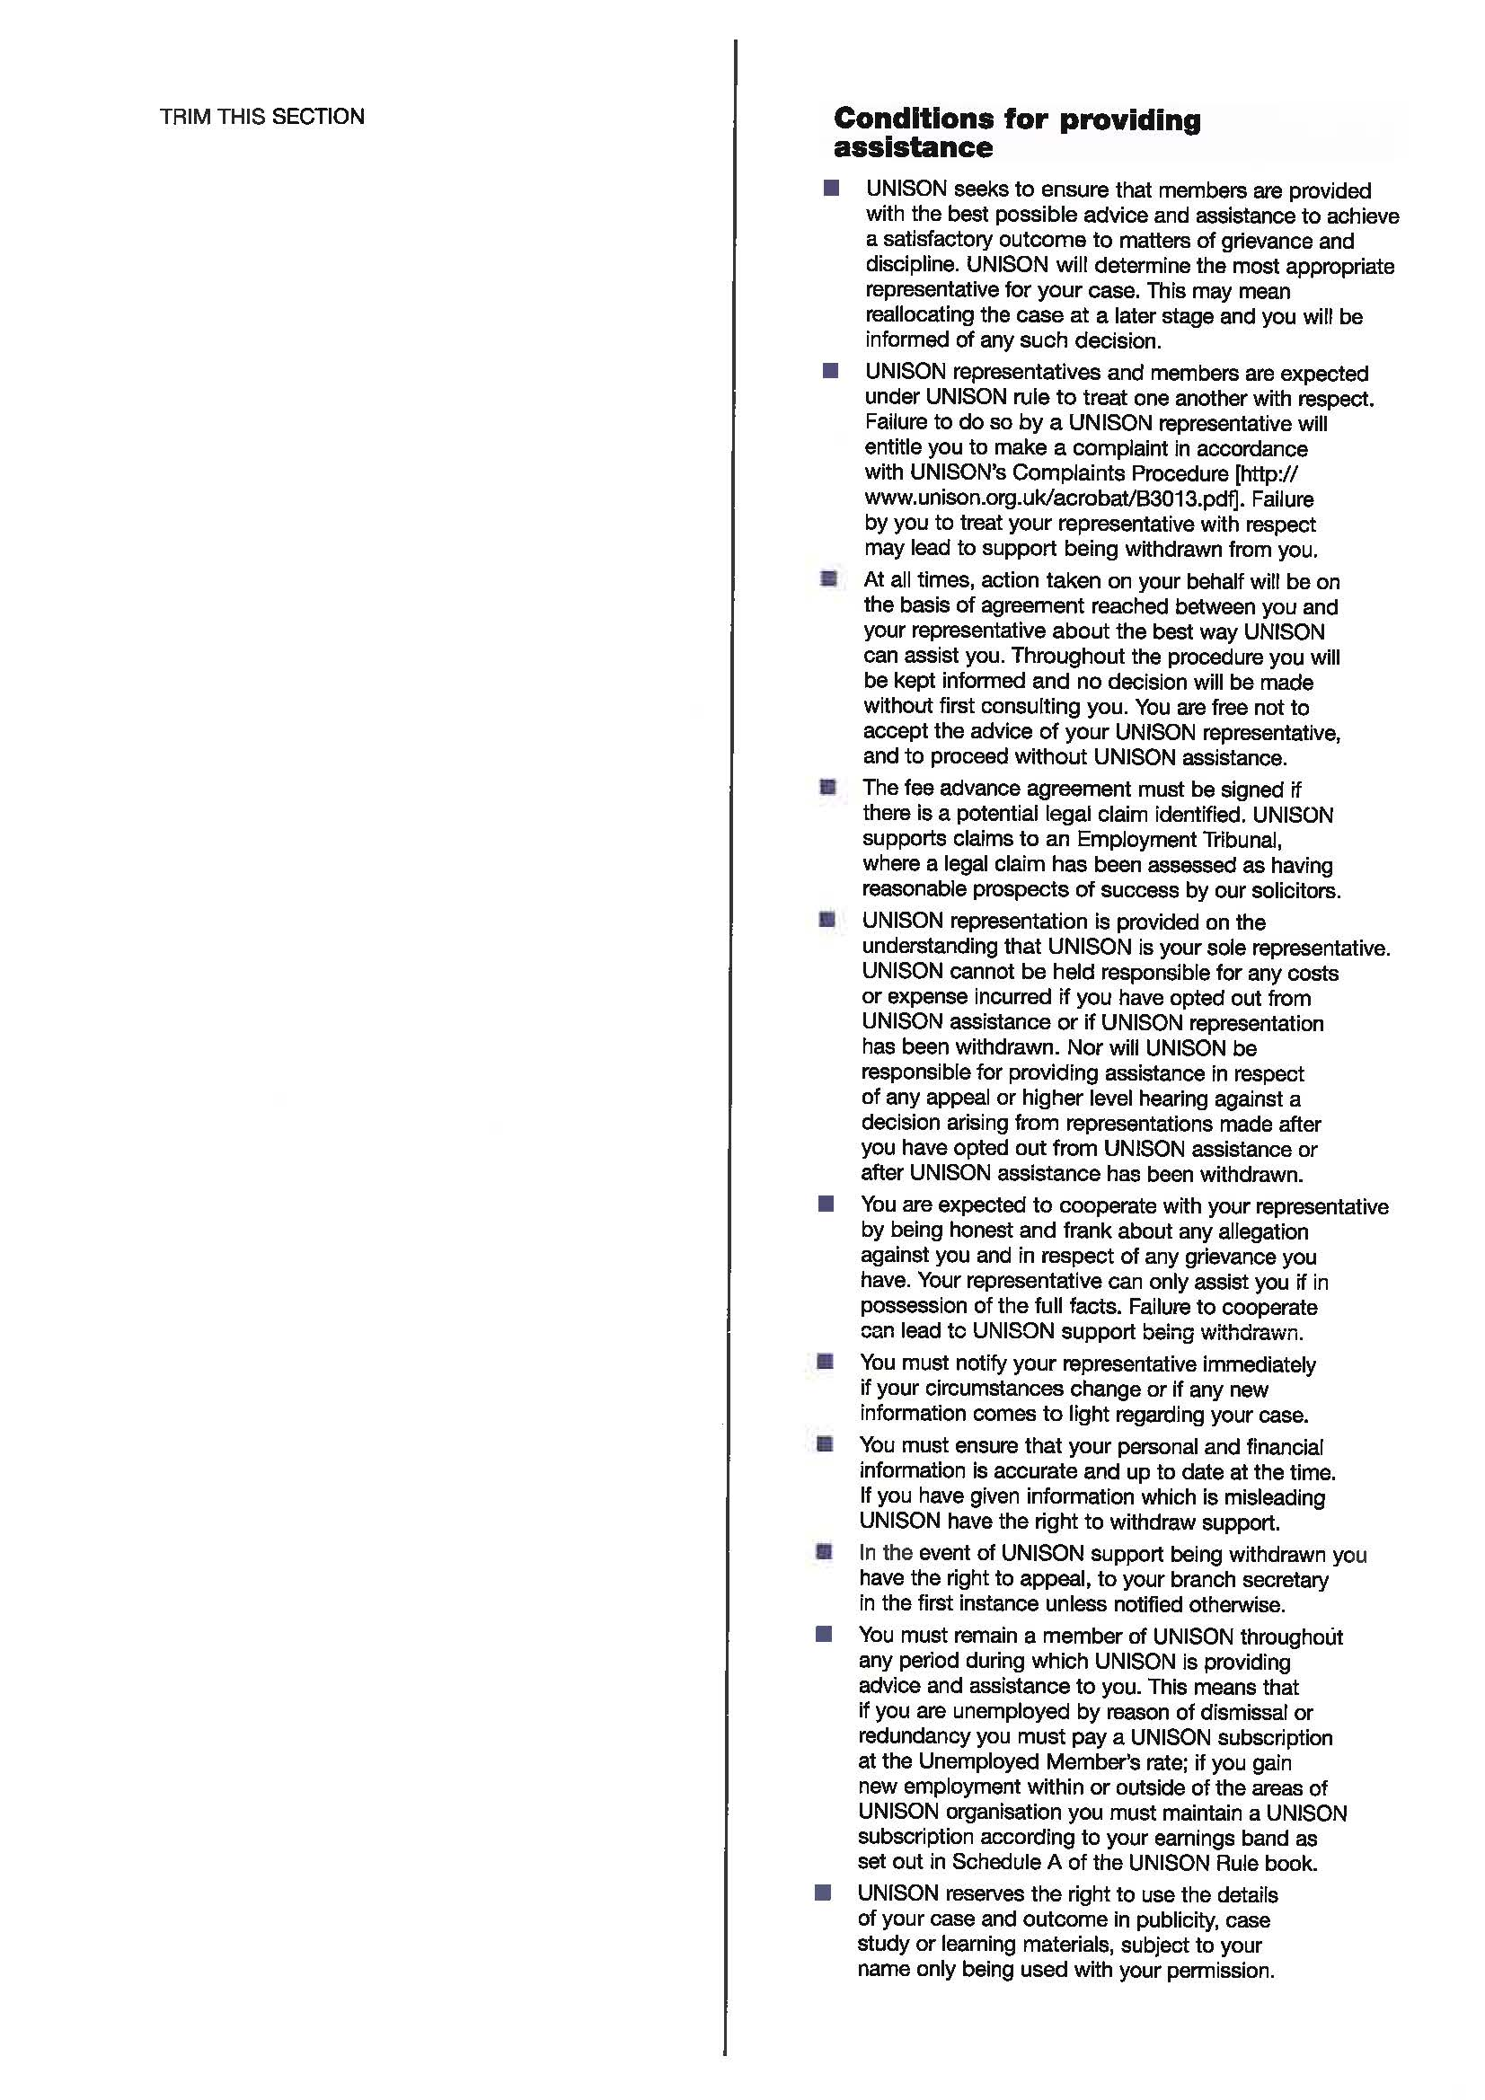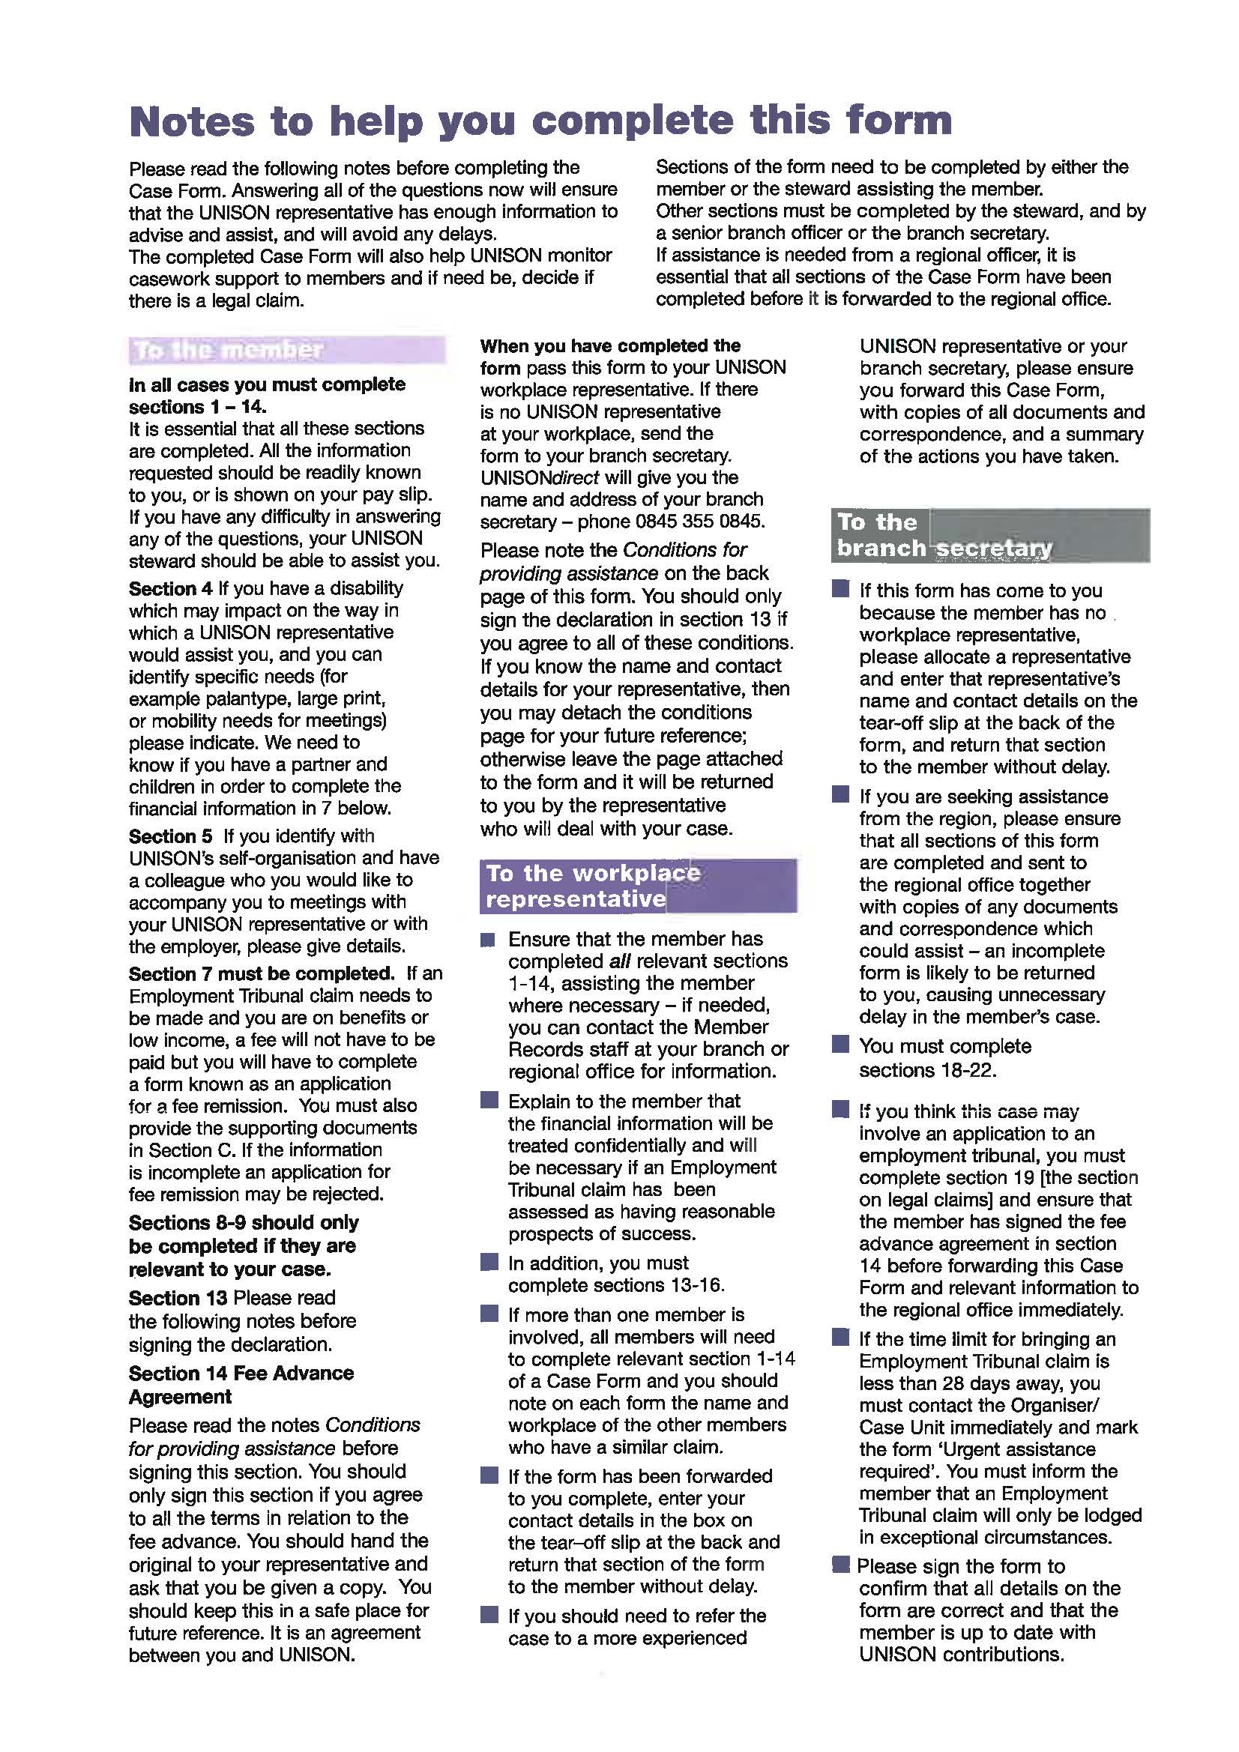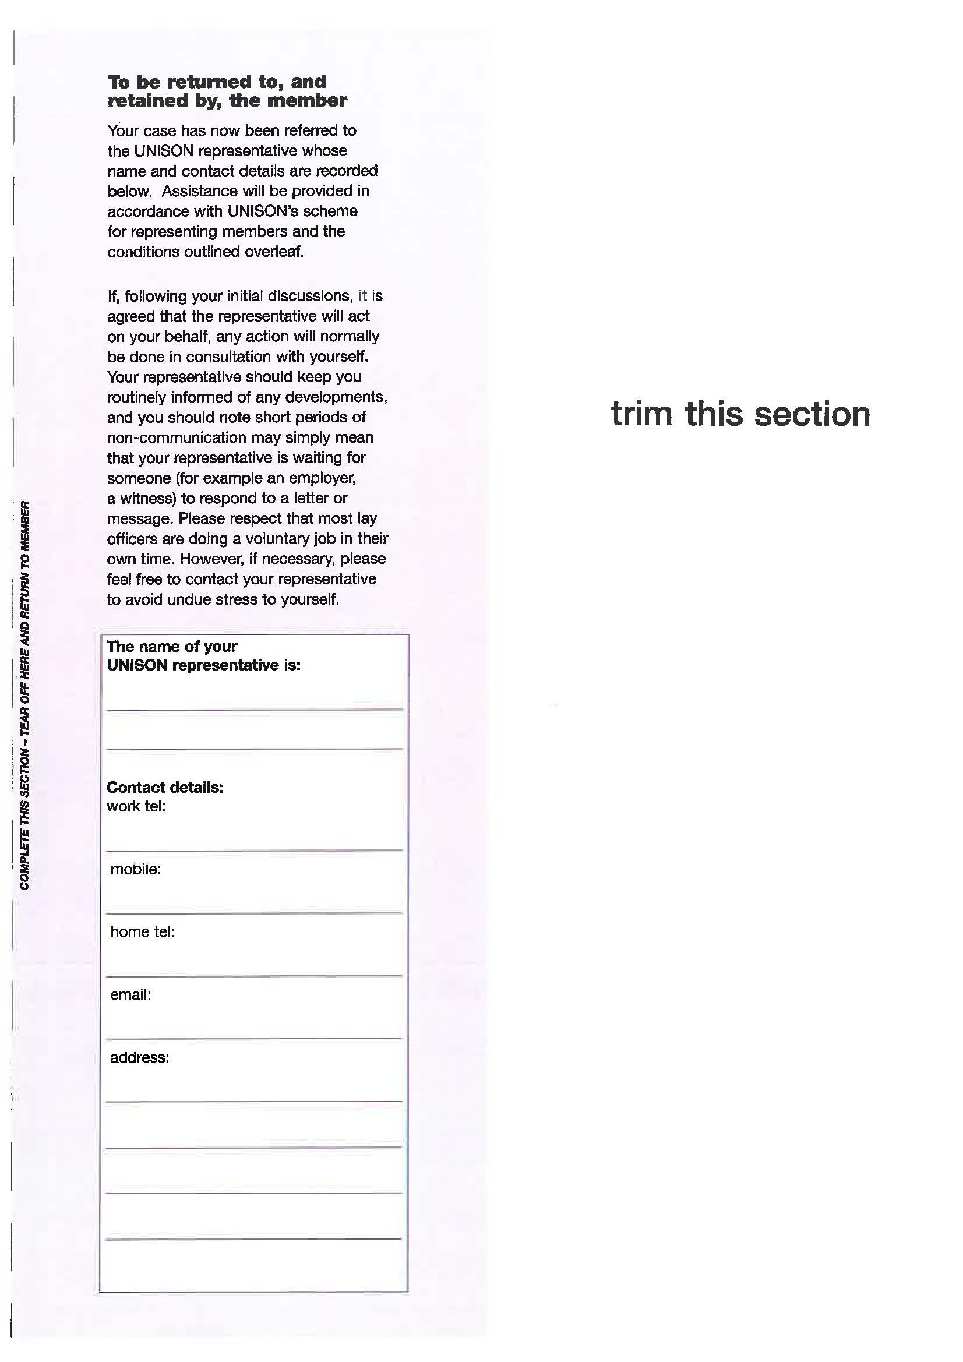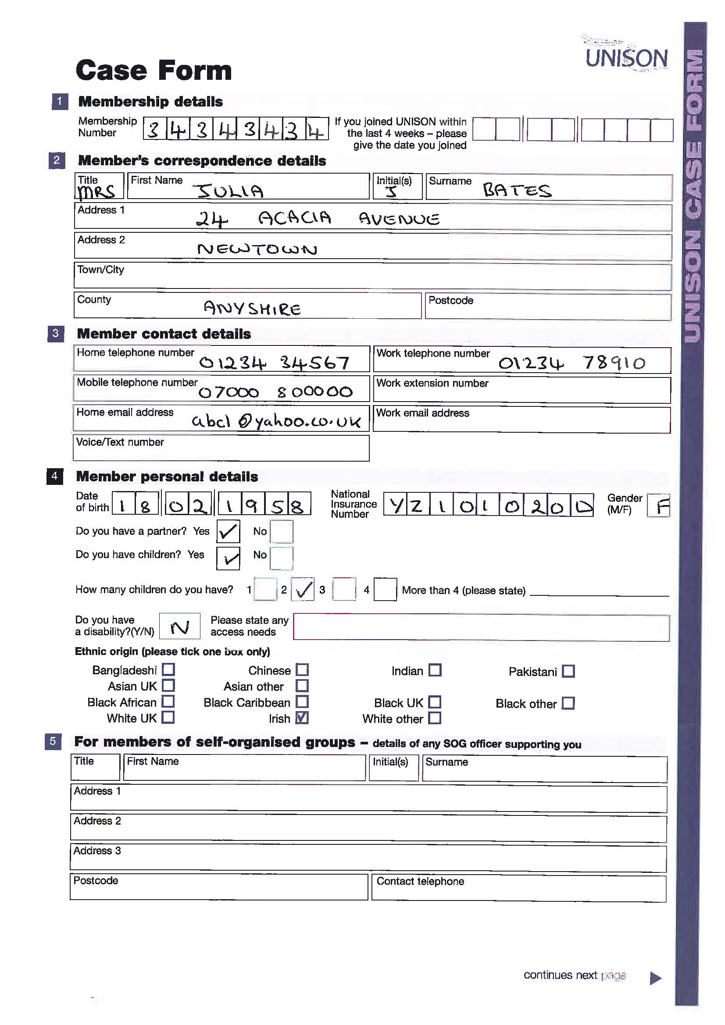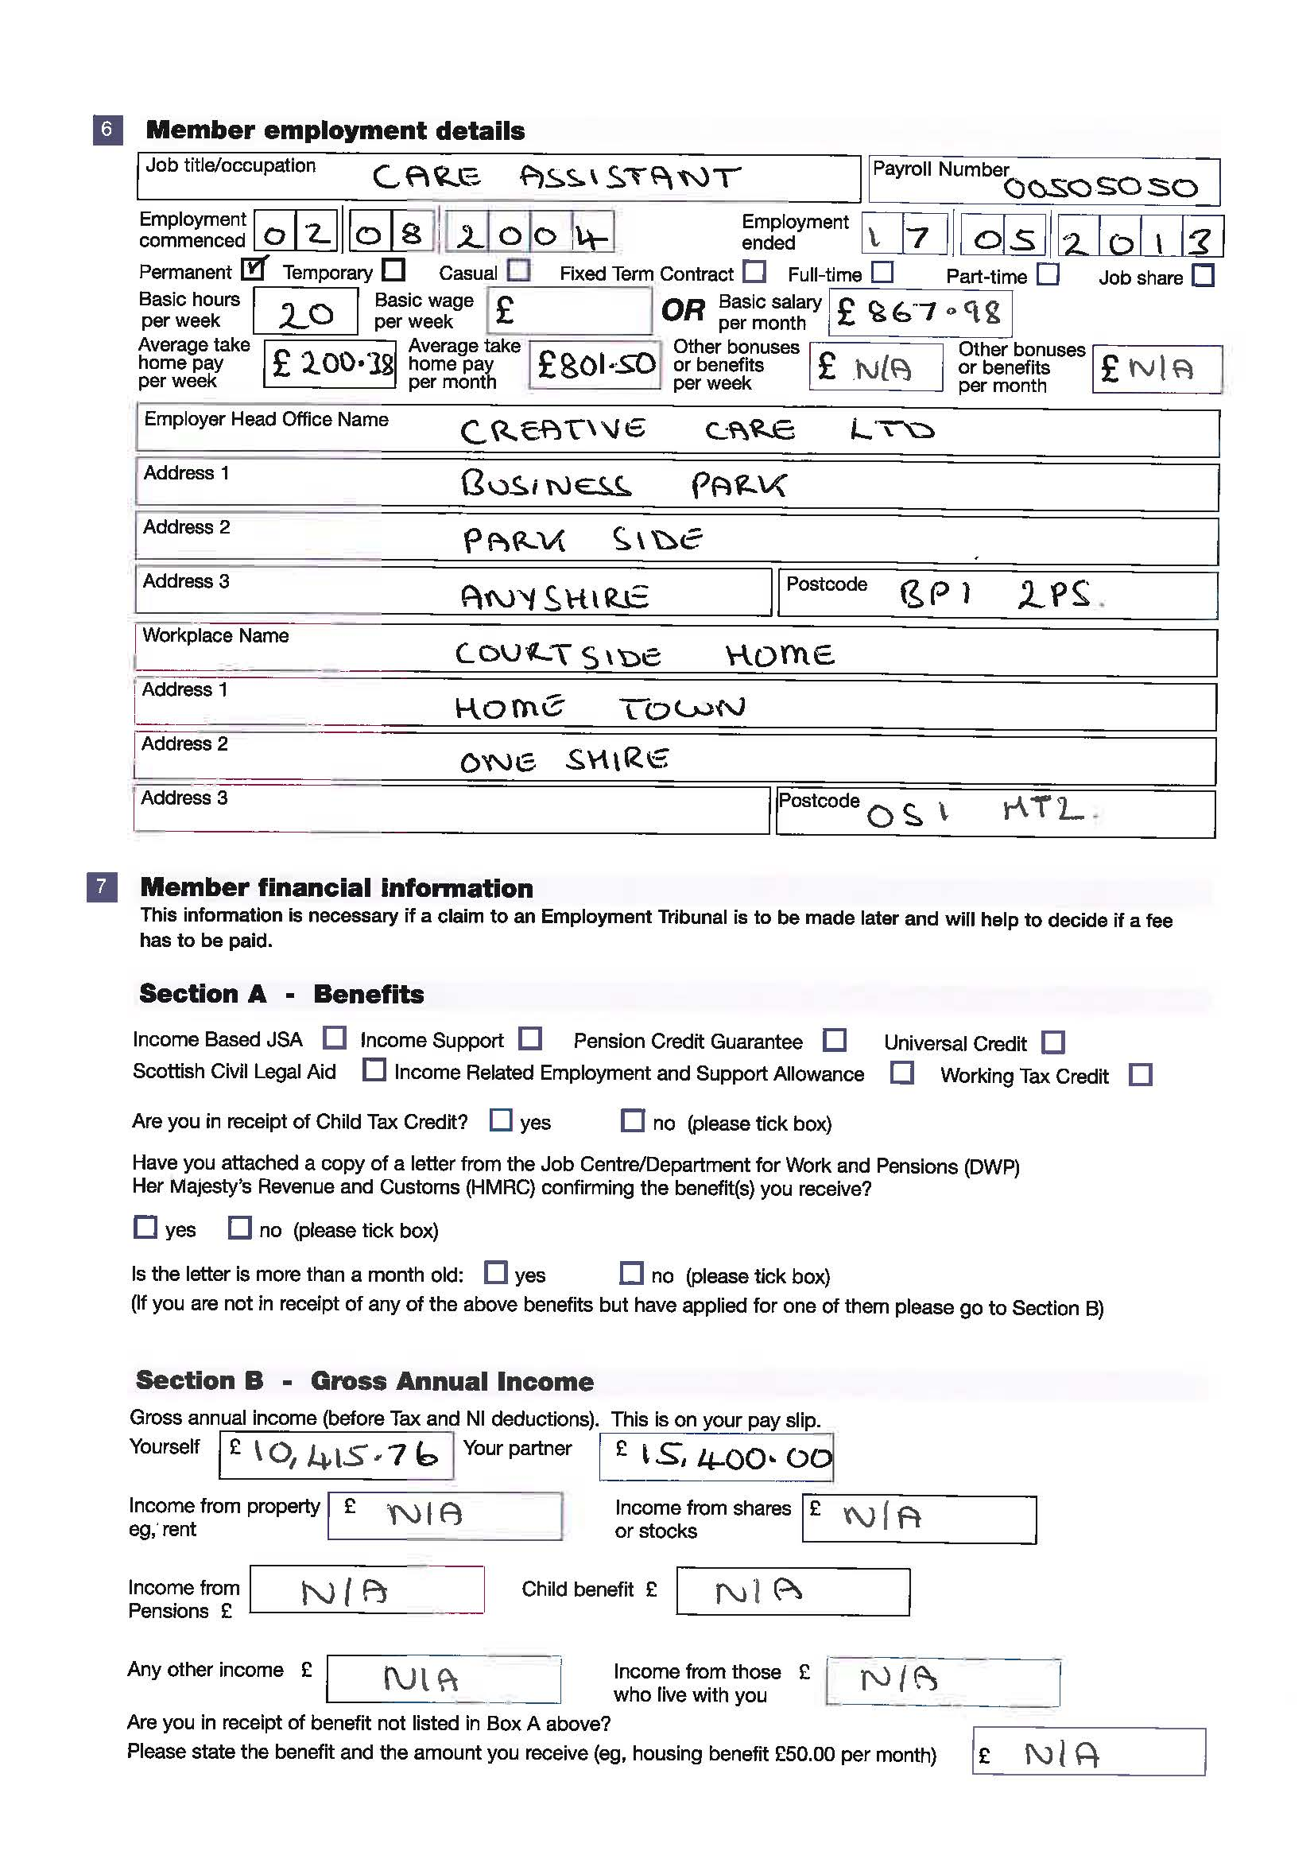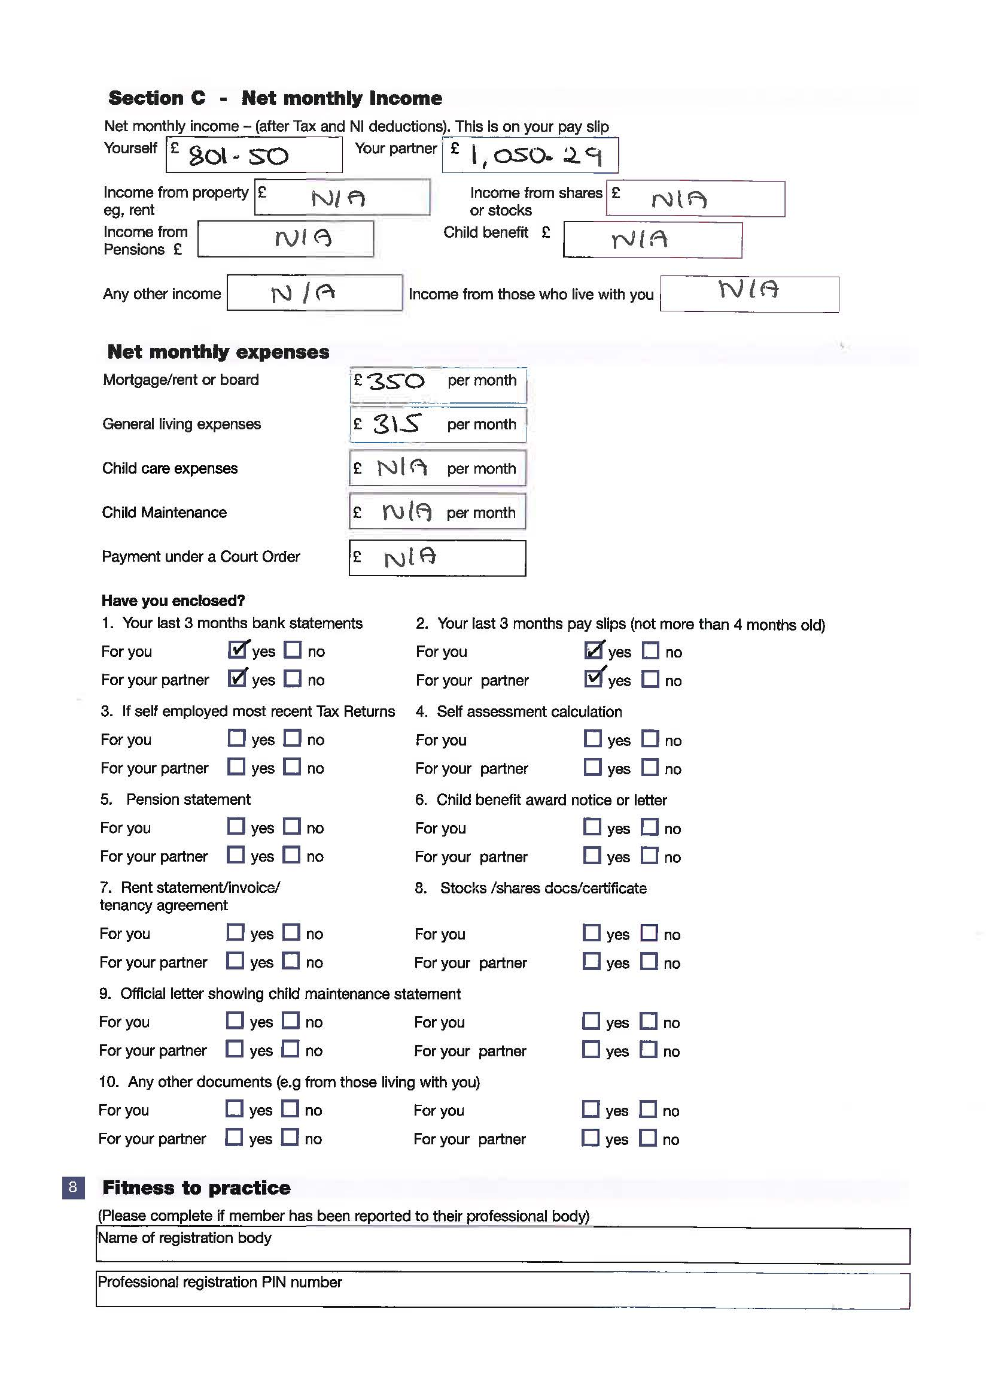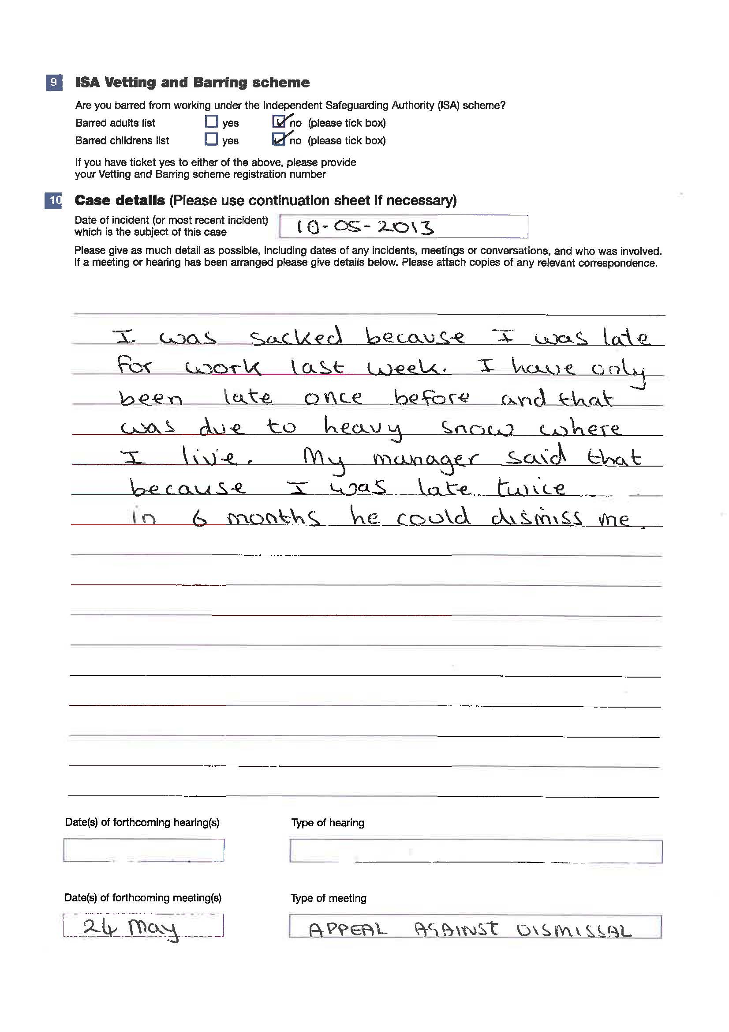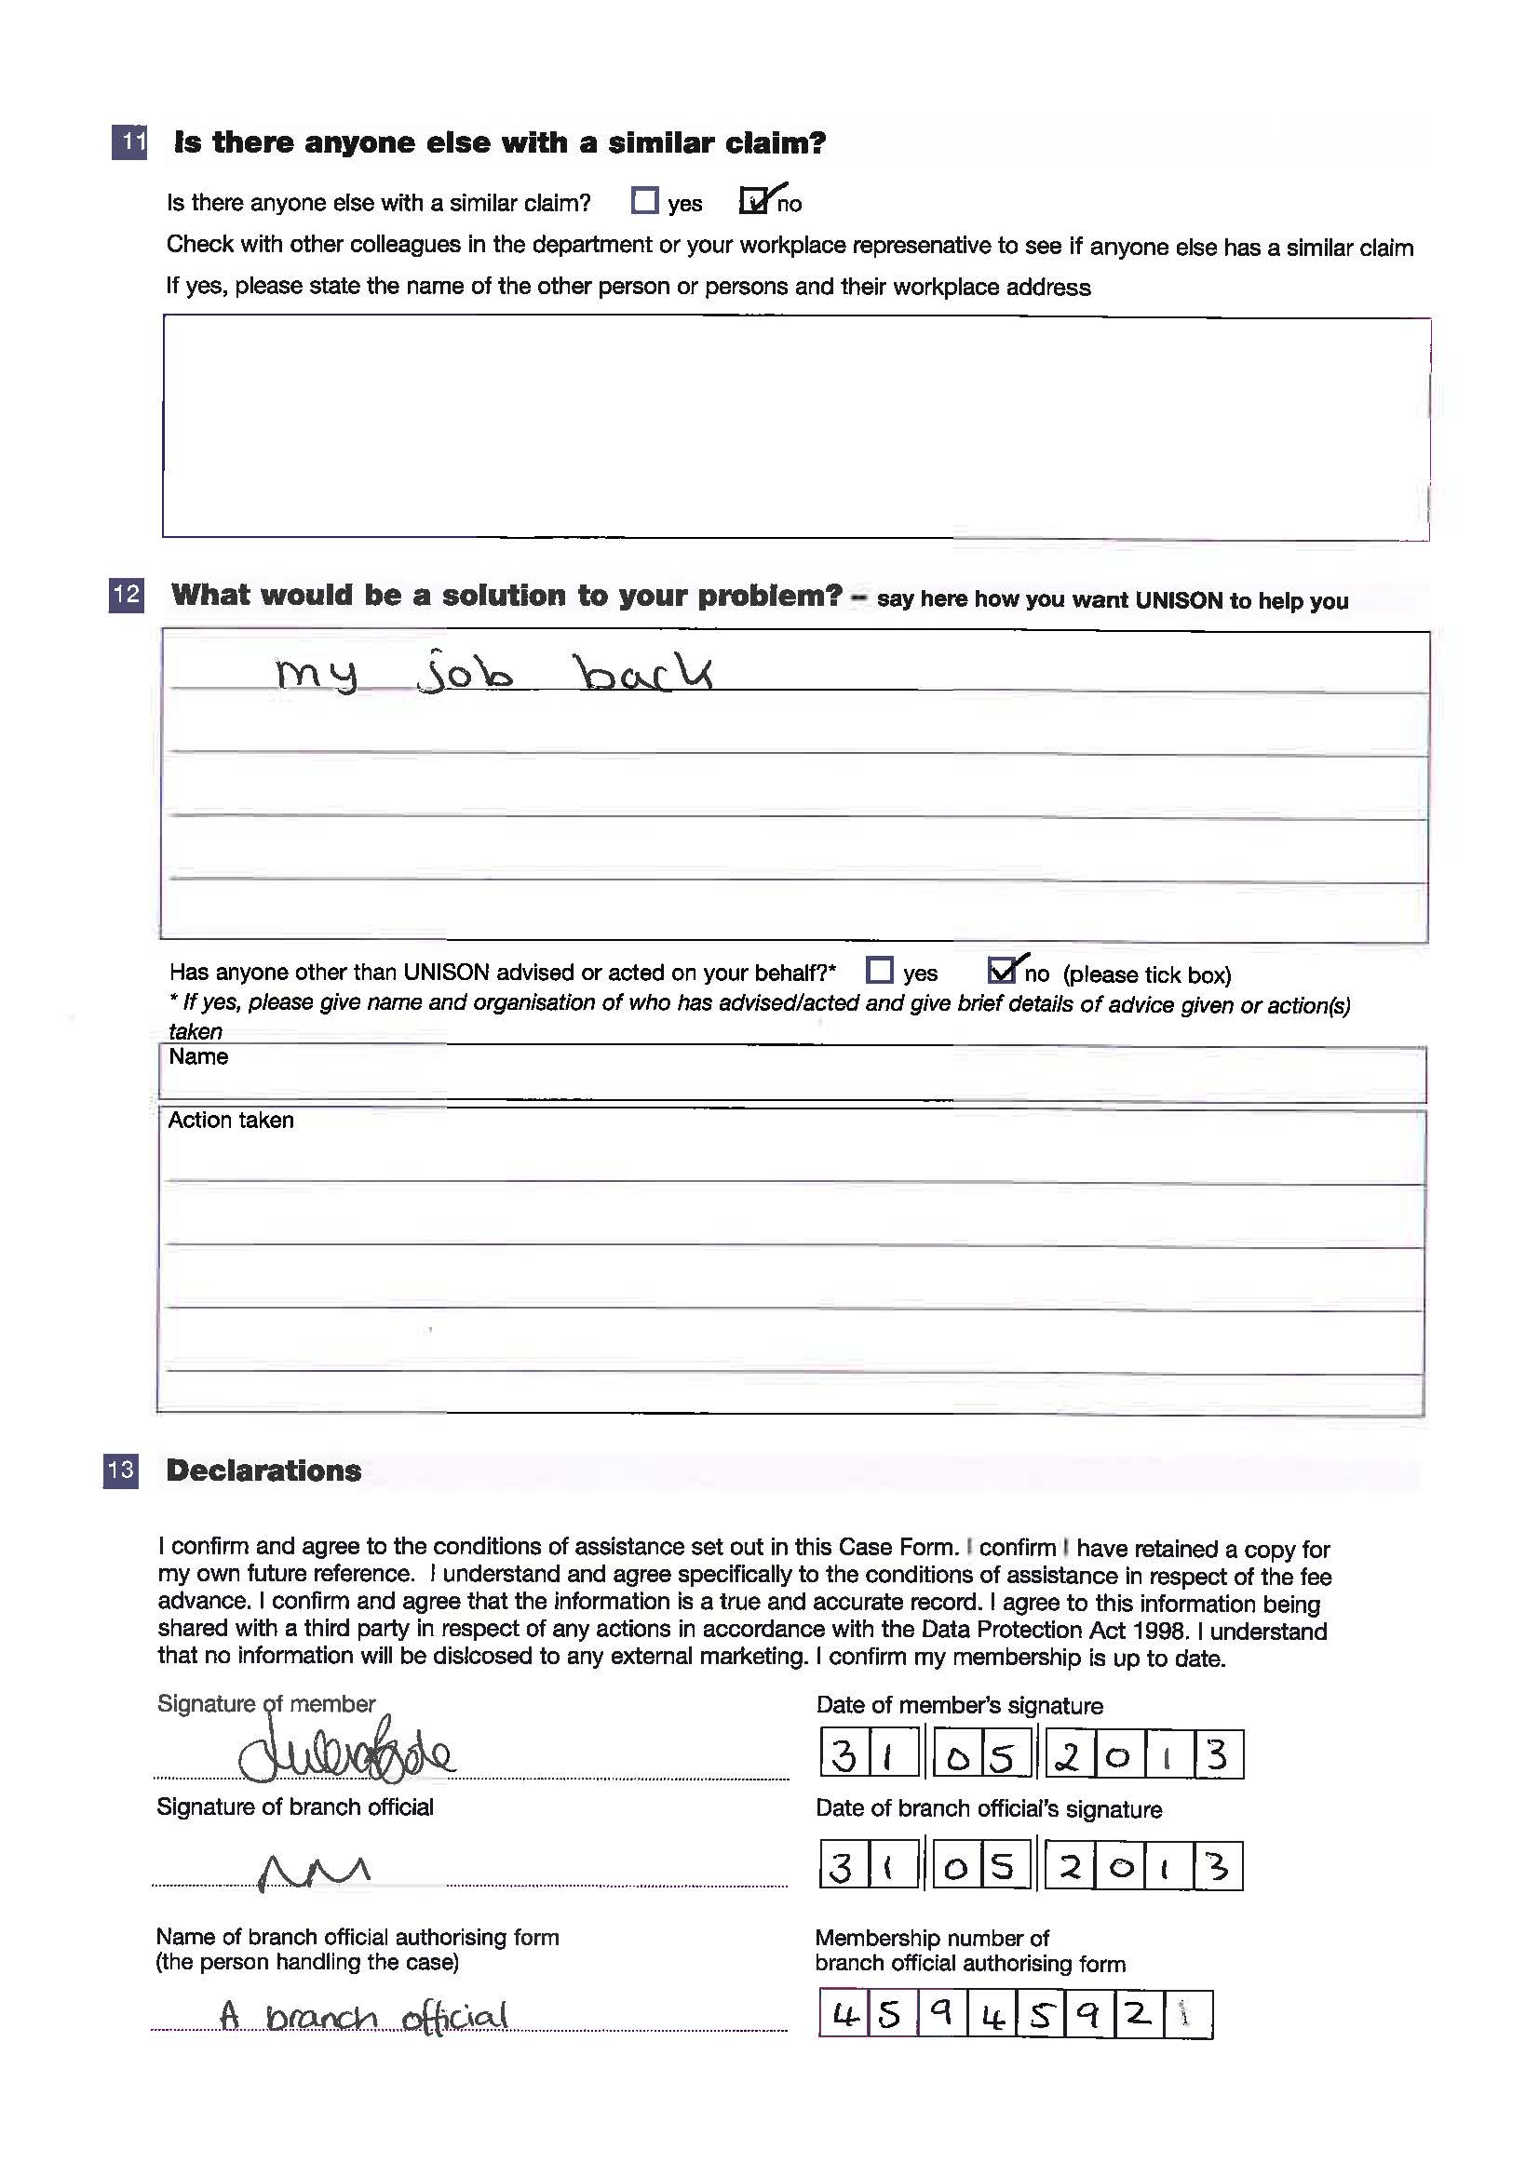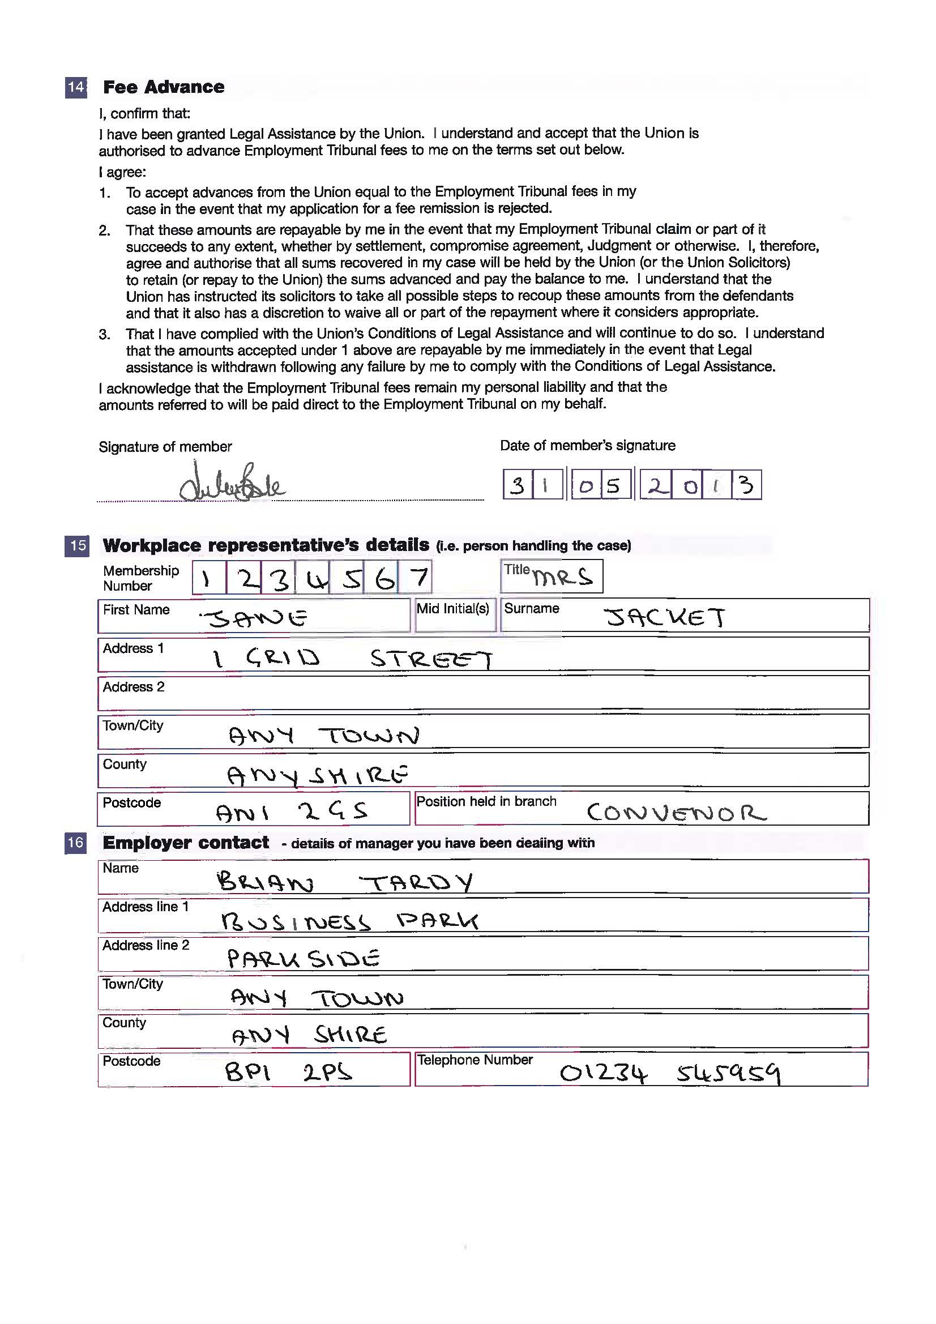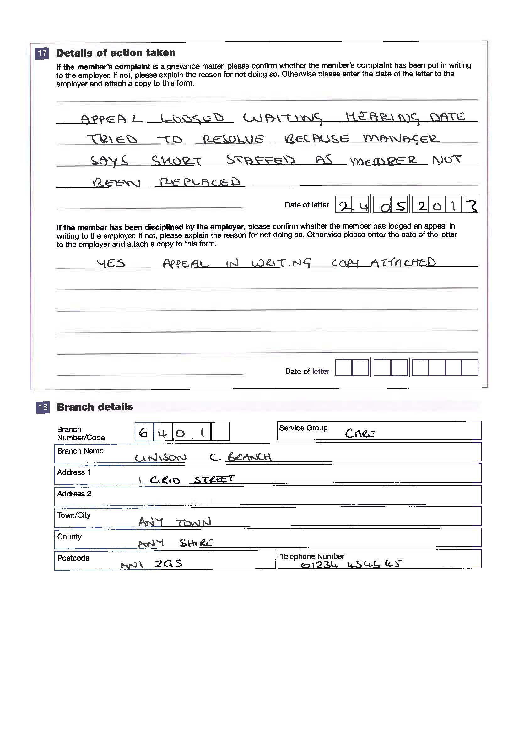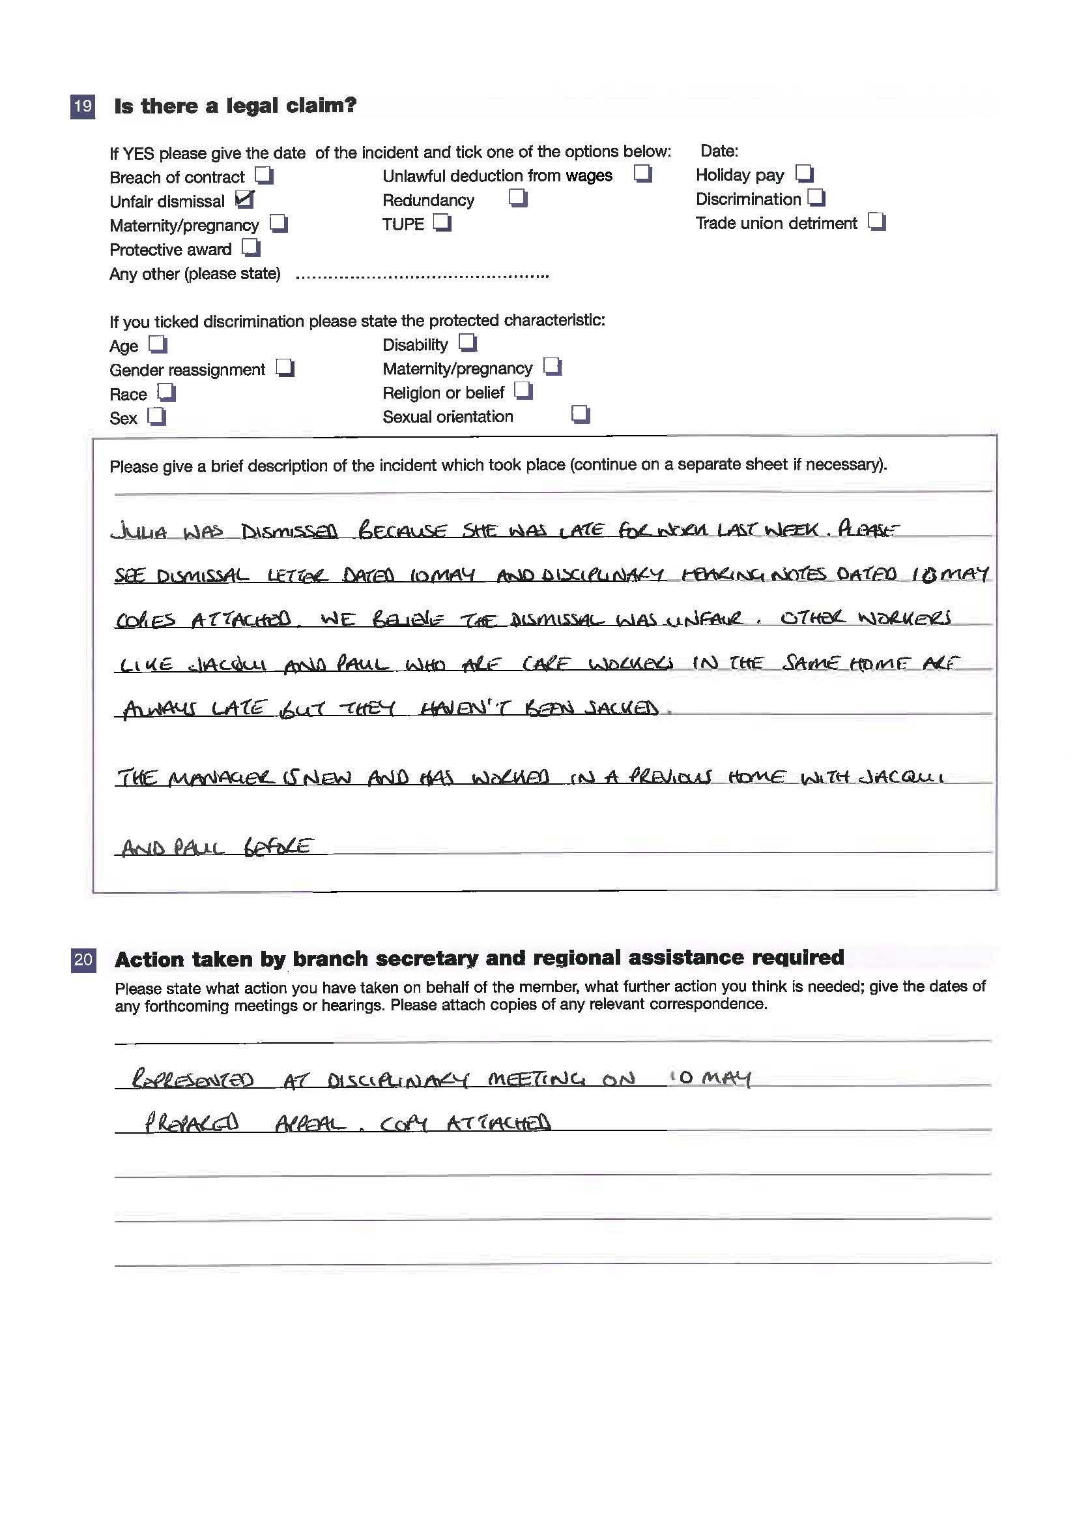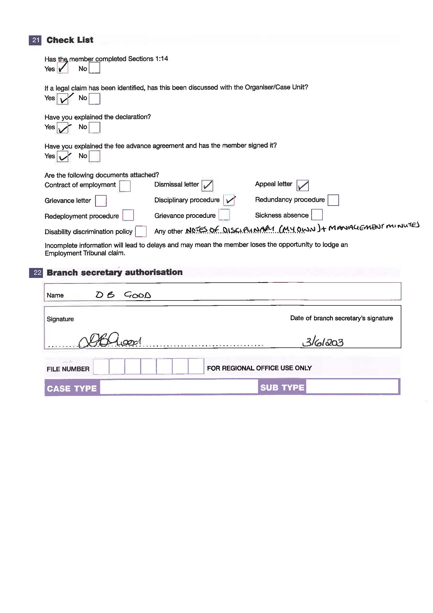

Appendix C - Guidance on fee remission (1) and sample filled out fee remission forms (2)

1. LINK TO HM COURTS & TRIBUNALS SERVICE FORM T438
Employment Tribunal and Employment Appeals Tribunal Fees - Do I have to pay them?

http://hmctsformfinder.justice.gov.uk/courtfinder/forms/t438-eng.pdf

2. see pages 29-30
FIRST OF TWO COMPLETED SPECIMEN REMISSON FORMS
Single, male who is in receipt of benefits and does not have a partner. His is a new claim without a case number.

see pages 31-32
SECOND OF TWO COMPLETED SPECIMEN REMISSON FORMS
Employed middle-aged woman with 2 dependent children and a partner. Hers is an existing claim (so likely a hearing fee) and so does have a case number.

