UNISON National Young Members Forum  NOMINATION FORM  Eric Roberts Award for young campaigners |  |  | 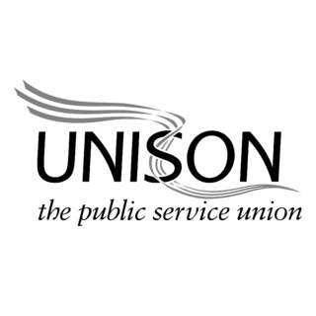
The Eric Roberts award, named after our late President, celebrates innovative and effective campaigning by young members in UNISON. Any young member in UNISON is eligible to be nominated for their campaigning activity – whether on industrial matters or wider political campaigns.

The National Young Members Forum will consider all nominations received, and will announce the winner at National Young Members Conference. An award will be made by the General Secretary at National Delegate Conference 2024.

Nominations may be made by branches and by Regional Young Members Forums. Nomination forms must be received no later than Friday 10 November 2023; please email this form to young.members@unison.co.uk

Name of young member being nominated: Click or tap here to enter text.
Membership number (if known): Click or tap here to enter text.
Branch: Click or tap here to enter text. |  |  |  | Region: Click or tap here to enter text.
Are they: | ☐ A woman | ☐ A man |  |  | ☐ Non-binary/other gender identity
Why would you like to nominate this member for the Eric Roberts award for young campaigners in UNISON? Please write about their activity in UNISON here:

If you would like to, please add more about the young member’s activity outside of UNISON – for example in their community, in politics, or in other campaigns:

Name of person nominating: Click or tap here to enter text.

Telephone number: Click or tap here to enter text. |  |  |  | Email: Click or tap here to enter text.
Are you: | ☐ Branch Secretary | ☐ Regional young members contact |  |  | ☐ Other (please add details)  Click or tap here to enter text.
I am nominating on behalf of (a branch or a Regional Young Members Forum):
Click or tap here to enter text.

Please return by email to Y.Members@unison.co.uk no later than noon on Friday 10 November 2023.

