Her Excellency Mrs Tzipi Hotovely

Ambassador of Israel

Embassy of Israel

2 Palace Green

Kensington

London

W8 4QB

By email to: [consular10@london.mfa.gov.il](mailto:consular10@london.mfa.gov.il)

13 March 2023

Your Excellency,

**Demolition of Jubbet ad Dib School**

As trade unions representing teachers and other education staff in the UK, we are shocked and dismayed to hear of the imminent demolition of yet another school in the West Bank.

We understand that on 6 March, the Israeli Central Court rejected a petition filed by Palestinians against the demolition of the school Jubbet ad Dib. The Court gave the Civil Administration a period of 60 days to demolish the school.

These demolitions are happening despite the signing by Israel of the Optional Protocol to the Rights of the Child in Armed Conflict on 14 November 2001 and ratified on 18 July 2005.

Israel is also a signatory to the Universal Declaration of Human Rights, including Articles 25, 26 & 27; and a signatory to the UN Convention on the Rights of the Child, including Articles 28, 29, 30 and 31. These articles of international law are being violated as schools are being demolished.

As education trade unions who are committed to the realisation of rights under the Universal Declaration and the UN convention on the Rights of the Child, and whose members dedicate their professional lives to children and young people’s education, this is a situation that we are profoundly concerned about, that we understand to be completely beyond the law, and that we call upon the Israeli authorities to bring to an immediate end.

We urge the Israeli Government immediately to call a halt to demolition of Jubbet ad Dib, along with other planned demolitions of schools in the West Bank.

Yours faithfully,

**Andrea Bradley Patrick Roache**

**General Secretary, EIS General Secretary, NASUWT**

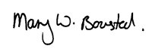 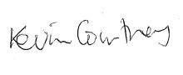

**Mary Bousted Kevin Courtney**

**Joint General Secretary, NEU Joint General Secretary, NEU**

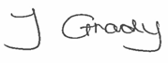 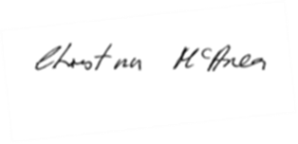

**Dr Jo Grady  Christina McAnea**

**General Secretary, Unison General Secretary UCU**