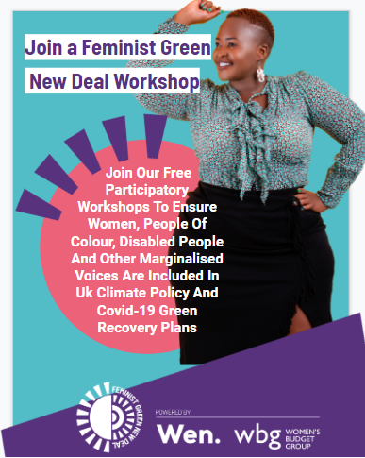 | 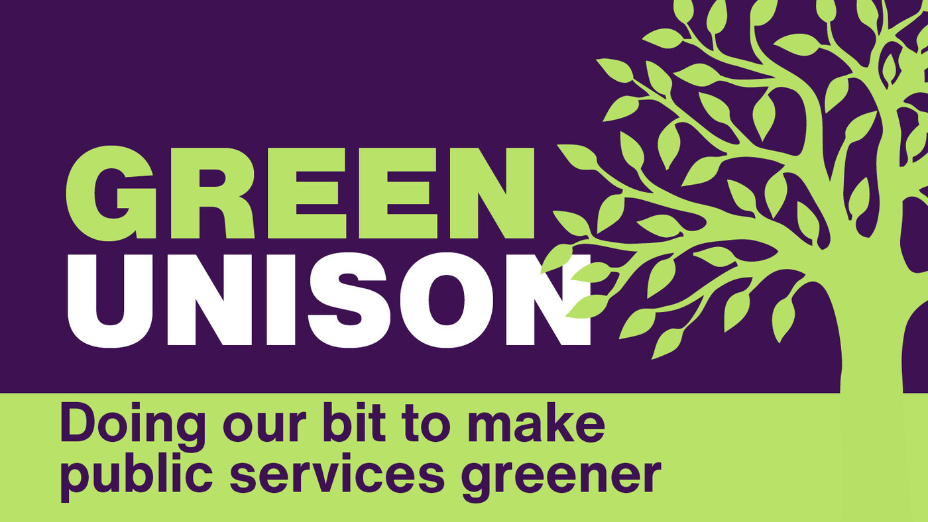
- come and share your thoughts, ideas and concerns

- learn about the feminist Green New Deal

- help ensure women, people of colour and marginalised voices are included in UK climate policy and Covid-19 green recovery plans.

Women, People of Colour and Disabled people are often the most affected by climate change but are the last to be consulted. We want to hear your ideas and concerns to help develop a vision for a green caring economy.

As part of our UNISON Green Week offer, the Women’s Environmental Network (WEN) has kindly agreed to adapt their national workshops to offer to run a specially adapted 1 hour workshop for our members. There will be three chances to attend – 2 to take place during lunchtimes and with one evening session for those with non-standard, or non-flexible lunchbreaks

Click on a link below to book your slot
Tuesday 27th September - 1-2pm | Thursday 6th October - 1-2pm
Tuesday 11th October - 6-7pm

