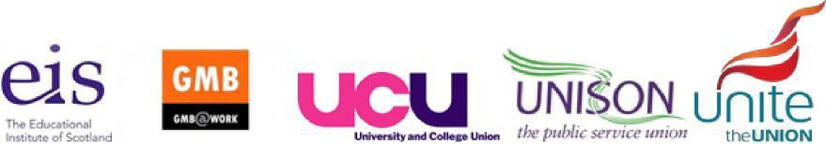

New JNCHES dispute update

The Joint HE Unions (GMB, EIS, Unison, Unite and UCU) met with UCEA yesterday, (6 July) in the first dispute meeting over the 2022-23 pay round and pushed the employers to improve their final offer that all five HE unions have rejected.
The two dispute meetings, 6 and 14 July, take place in the context of an unprecedented cost of living crisis and cumulative sub inflation pay outcomes in recent years. As a result, the meeting focussed on the derisory pay offer of 3% for the majority of our members.
UCEA did not make any improved offer at the dispute meeting. This will be very disappointing news for members struggling to pay their bills, dealing with excessive workloads, working weeks in excess of 35 hours, contract insecurity, pay inequality, no incremental head room, nor a Scottish JNCHES committee.

The joint union negotiators pressed the employers hard. As a result, UCEA have committed to formally consult their members on an improved offer for negotiating at the next dispute meeting on the 14 July. UCEA will take the outcome of the employer’s consultation to a meeting of their board, which will take place before the final dispute meeting.

The joint union negotiators are encouraging branches to use the short window between now and the meeting on 14 July to lobby their Vice Chancellor or Principal to feedback to UCEA that they should make an improved offer and avoid a damaging dispute this autumn.

Send on behalf of the Joint HE Trade Unions.

