McCloud Judgement FAQ’s – what does it mean for me?

We all understand that pensions is far from simple and causes confusion even at the best of times! So, what exactly does the recent Government response to its consultation on correcting the age discrimination determined in the Court of Appeal’s McCloud’s judgement mean?

Read UNISON’s Pensions Unit’s handy frequently asked question document here which will hopefully make this clearer for you!

- What exactly is “McCloud” and what does it all mean?
In 2015 the Government introduced new reformed schemes where existing members had to switch to unless “protected”. In the case of the NHS Pension Scheme the new scheme is called the 2015 Scheme.

There was no choice about this matter. You simply switched to the 2015 Scheme if you did not satisfy the protection requirements.

This protection has been found to be age discriminatory and accordingly public service schemes have been ordered to address this discrimination and offer members a choice over which scheme they wish to be in for the duration of the remedy period.

- What is the remedy period?
The remedy period is all service between the 1 April 2015 and 31 March 2022. This means that if you were a member of either the 1995 or 2008 Sections and were required to move to the 2015 Scheme because you did not have protection then you will be able to choose to have all of your service before the 1 April 2022 in the 1995 Section or 2008 Section as appropriate.

- How do I know if I’m a protected member or not?
There are two types of protection. Full Protection and Tapered Protection.

Full Protection applies if you were within 10 years of your Normal Pension Age as at the 1 April 2012 and enables you to remain in your current scheme (i.e. 1995 Section or 2008 Section) indefinitely.

Tapered Protection applies if you were within 10 years and 13 ½ years of your Normal Pension Age as at the 1 April 2012 and allows you to remain in the 1995 or 2008 Section until your Tapering Protection ends (i.e. at any point between the 1 April 2015 and 1 April 2022).

- Do I need to submit a legal claim or do anything?
No, you will be offered a choice automatically and you do not need to submit any claim.

- When will I be given a choice?
You will be given a choice on your retirement although this might not be before October 2023. The Government needs to introduce some regulatory changes to enable these changes and choices to happen.

- What about if I’m retiring or have retired? Will I still get a choice?
Yes, as long as you were in the NHS Pension Scheme on the 31 March 2012 and the 1 April 2015 (or were in the scheme on the 31 March 2012 and returned within 5 years), you will be offered a choice as soon as possible.

If you are in receipt of a pension your award will retrospectively be amended and backdated to your retirement date should you make a choice which increases your entitlement.

This also applies to retirement on ill-health grounds, spouses pensions, children’s pensions, survivor lump sum payments, transfer values, pension on divorce cases etc. In short, all awards paid over the duration of the remedy period will need to be re-assessed and a choice offered where the member satisfies the choice eligibility conditions.

- What happens if I don’t make a choice?
The default position is to assume you are in your “legacy scheme” for the period 1 April 2015 to the 31 March 2022 unless you specifically choose otherwise. This means that if you don’t make a choice you will be regarded as being in the 1995 Section or 2008 Section for all service up the 1 April 2022.

- What exactly happens from the 1 April 2022?
All members will earn benefits in the 2015 Scheme from the 1 April 2022. Even protected members. It will no longer be possible to build up any more service in the 1995 or 2008 Sections.

- What about my benefits in the 1995 and/or 2008 Sections?
All terms and conditions are fully protected. This means that if you have 1995 Section benefits, for example, that you can still retire and draw these at 60 without any reduction for early payment applying. Similarly, if you have Mental Health Officer or Special Class Status in the 1995 Section you can still retire at 55 if you continue to satisfy the qualifying conditions.

- What are the key differences between the 1995 Section, 2008 Section and 2015 Schemes?
Please see below for a brief summary of the schemes:

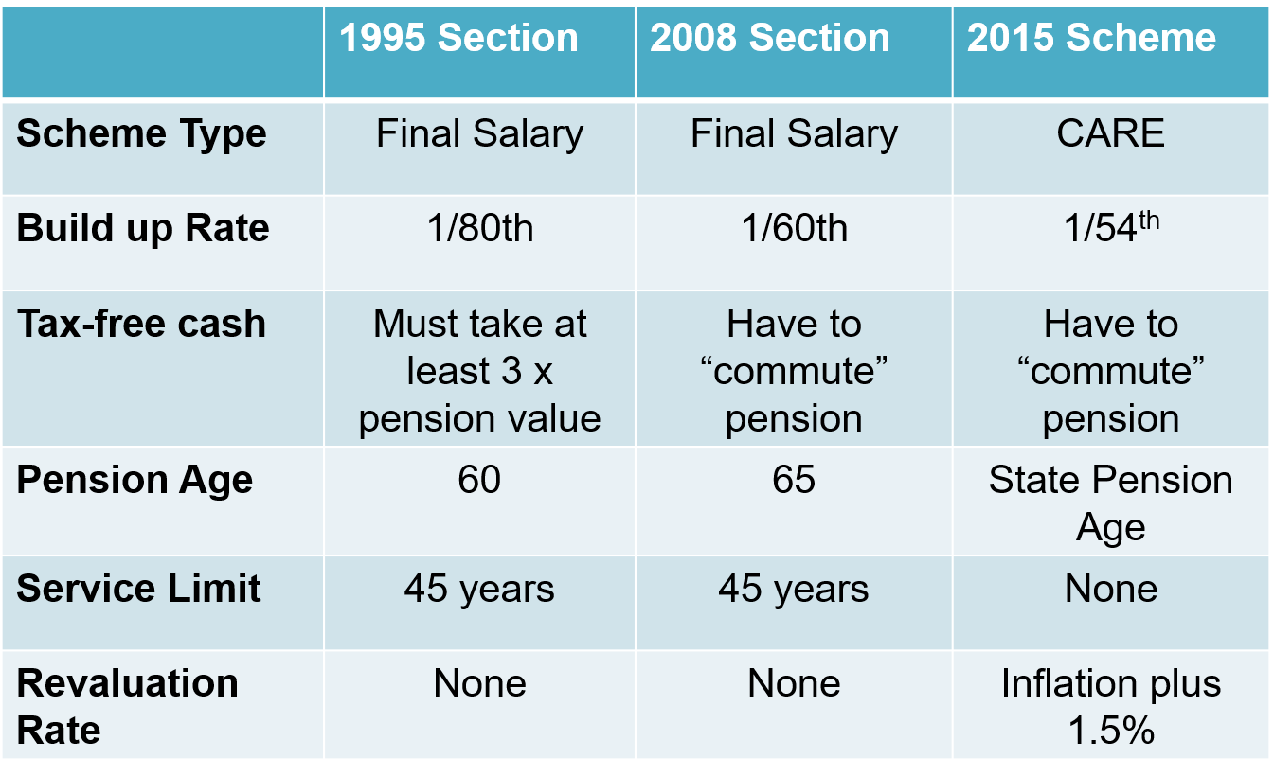

- Is there any benefit in moving to the 2015 Scheme if I’m planning on retiring shortly after April 2022?
You should bear in mind that although the Normal Pension Age in the 2015 Scheme is your State Pension Age that you can still draw your pension benefits from age 55. It’s just that these will be reduced for being paid early with the earlier you draw these the bigger the reduction.

You should also note that you do not have to draw your 2015 Scheme benefits at the same time as your 1995 and 2008 Section benefits and can draw these closer to, or at, your 2015 Scheme Normal Pension Age.

England and Wales members
If you are a member of the England and Wales scheme you can get an idea of the typical reductions for drawing your pension benefits early at

https://www.nhsbsa.nhs.uk/sites/default/files/201908/Early%20Retirement%20factsheet%20%2805.2017%29%20V3.pdf.

You can also use NHS Pensions Early Retirement Calculator to get an estimate of your likely entitlement on retiring early at https://www.nhsbsa.nhs.uk/member-hub/getting-estimate-your-pension.

Scottish members
If you are paying into the NHS Pension Scheme Scotland, you can use the NHS Pension Calculator to get an estimate of your likely pension at
retirement. You can access this at https://pensions.gov.scot/nhs/your-membership/calculators/nhs-pension-calculator.

Members in Northern Ireland
HSC administer the NHS Pension Scheme in Northern Ireland and provide a range of calculators that you can use to estimate your pension at retirement. Please go to:
http://www.hscpensions.hscni.net/quick-links/calculators/.

- Am I going to in effect have two NHS Pensions then?
In short yes. You will have pension benefits in the 1995 (or 2008 Section) and potentially benefits in the 2015 Scheme (at least in respect of all service from the 1 April 2022).

You will still retain a Normal Pension Age of 60 for 1995 Section pension benefits (or 55 if you have Mental Health Officer or Special Class Status) or 65 if you have 2008 Section benefits.

It’s simply that for all pension benefits you build up in the 2015 Scheme your pension age will be your State Pension Age.

You can draw both pensions independently or at the same time. It’s up to you.

- I don’t believe the Government’s remedy is sufficient and feel I have lost out because of this discrimination. Is there anything I can do?
If you feel you have made a decision that you would not otherwise have done because of the Government’s 2015 scheme reforms which has caused you financial detriment, you can potentially pursue this.

One such example could be you opted-out of the 2015 Scheme whereas you wouldn’t have done had you known that in fact you could accrue further 1995 Section benefits up to the 31 March 2022.

We are awaiting further Government guidance on the potential scope of such cases, how to handle and potential settlements so please watch this space if you think this is relevant for you.

What we do know is that you will need to raise such a complaint, if relevant, for yourself (i.e. there will be no automatic revisiting of cases) and you will need to provide evidence to substantiate your complaint.

