**The UK government must support the UN Binding Treaty on Business and Human Rights process to ensure primacy of rights over corporate profits**

Briefing Paper of the UK Working Group on the Binding UN Treaty on TNCs, Oct 2020

*Support our call for the UK Government to support the UN Binding Treaty*

**Why do we need a binding instrument on business and human rights?**

Businesses shape many aspects of our lives. The private sector can create quality jobs, provide products and services and generate tax revenues.  But some business practices cause harm, directly or indirectly, to people and the planet for which it can be difficult to hold them to account.

Such difficulty can arise from various factors, including lack of political will and/or resources, imbalances in power, and complex corporate structures[1]. It is particularly evident in cases involving transnational impacts, for instance exploitation in global supply chains, environmental pollution impacting climate change, misuse of personal data, tax avoidance, corruption, and preventing the renationalisation of failed privatised public services.

Transnational companies (TNCs) wield significant economic and political power. Just 100 giant global companies are responsible for 71% of all carbon emissions - contributing to the collapse of ecosystems on which lives and livelihoods depend.  Such power is enabled by the current global trade, investment and financial regimes which are based on legal rules[2] [3] and norms that protect and prioritise corporate interests. Combined, this enables violations of human rights and are continuing to prevent countries, especially in the Global South, from realising their development aspirations and meeting human rights obligations.

Further, in 2020 the COVID-19 pandemic has exposed structural injustices in our economy and the burden of risk carried by workers, indigenous people and local communities in supply chains – whether workers in the Global South producing for UK companies hit by big brand cancellations, or the exponential demand in rubber gloves and ventilators that leads to increased forced labour. It is no surprise there is a growing consensus on the need for national[4] and international regulation to address supply chain and other injustices.

**Background: The UN Treaty process to date**

After decades of discussions within the United Nations, recognition is growing that we need more effective measures to regulate global companies and their influence. The Human Rights Council adopted the ***Resolution 26/9 on the elaboration of an International legally binding instrument on transnational corporations (TNCs) and other business enterprises with respect to human rights[5]*** in June 2014. This established an open-ended intergovernmental working group (OEIGWG), with the mandate to elaborate such instrument.

This was a historic achievement. Such a legally (as opposed to voluntary) binding instrument is essential to end corporate impunity and make TNCs accountable. Social movements, trade unions, women’s rights organisations and NGOs are hoping it will address the systemic and disproportionate power of TNCs. The future Treaty has the potential to address the asymmetries of power meaningfully and effectively between States and TNCs on the one hand, and between affected communities, individuals and corporates on the other. Crafting an effective treaty requires the participation and support of governments across the board, including the UK government.

It was envisioned by the advocating states and civil society that the future Treaty will provide for extraterritorial mechanisms, direct obligations for corporations and build on previously existing instruments to regulate TNCs and guarantee the protection of human rights.

The Treaty must also integrate a strong, intersectional gendered approach, explicitly analysing how activities may have different, disproportionate, or unanticipated impacts on women whatever their identity, status or role compared to me. Being intersectional means recognising and addressing specific impacts and issues that may be experienced by groups of rights-holders based on their gender, as well as other ​multiple aspects of ​their identity.

After two annual Sessions (2015 and 2016), wherein parties discussed the elements that must be included in the treaty, the Chairperson-Rapporteur (Ecuador) of the OEIGWG presented the ***Elements for the Draft Legally Binding Instrument[6]*** for substantive negotiations at the start of the Third Session in 2017. Fast-forward to July 2020, the Presidency of the OEIGWG published the ***Second Draft of the UN Binding Treaty[7]***, to be discussed in the **sixth Session in the week of 26th October 2020.**

**Our Appeal to Members of the UK Parliament**

The Office of the High Commission on Human Rights and the European Union (EU) Parliament have given strong backing to the treaty process. Additionally, recognising the urgency of corporate regulation, the EU will introduce a new mandatory Human Rights Due Diligence Directive in 2021. Many hundreds of civil society organisations, including environmental and development NGOs, faith groups, women’s right organisations, trade unions and people’s movements, as well as parliamentarians participated in the 5th Intergovernmental Working Group in Geneva and discussed the 1st draft in 2019.  Across Europe, more than half a million citizens called for the Treaty and an end to corporate courts. Yet the UK government has failed to support either.

The future Treaty needs to guarantee specific protection of individual and collective human rights, especially for those in the Global South. Therefore we, the supporters of the treaty process, appeal to all governments to ensure that the negotiations continue and successfully produce a final document that fulfils the above-mentioned aspirations.

**Towards this end we urge UK MPs to:**

1. Encourage the UK government to engage positively, attend the 6th Session and work to ensure the process continues until a final instrument is passed;
2. Become members of the Global Interparliamentary Network that supports the UN binding treaty process by signing the declaration on [www.bindingtreaty.org;](http://www.bindingtreaty.org/)
3. Work to ensure legislation at the UK level for a Failure to Prevent regulation requiring businesses to address the risks that their operations and supply chains pose to people and the environment globally.







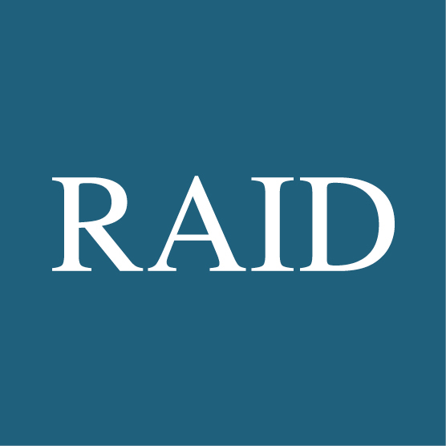

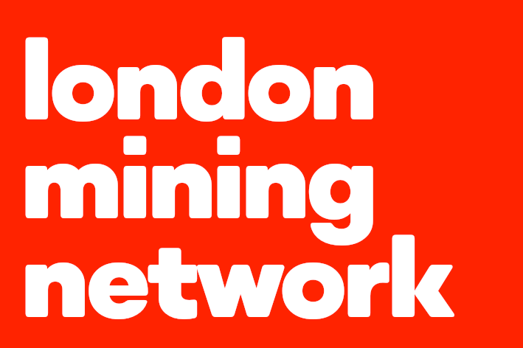







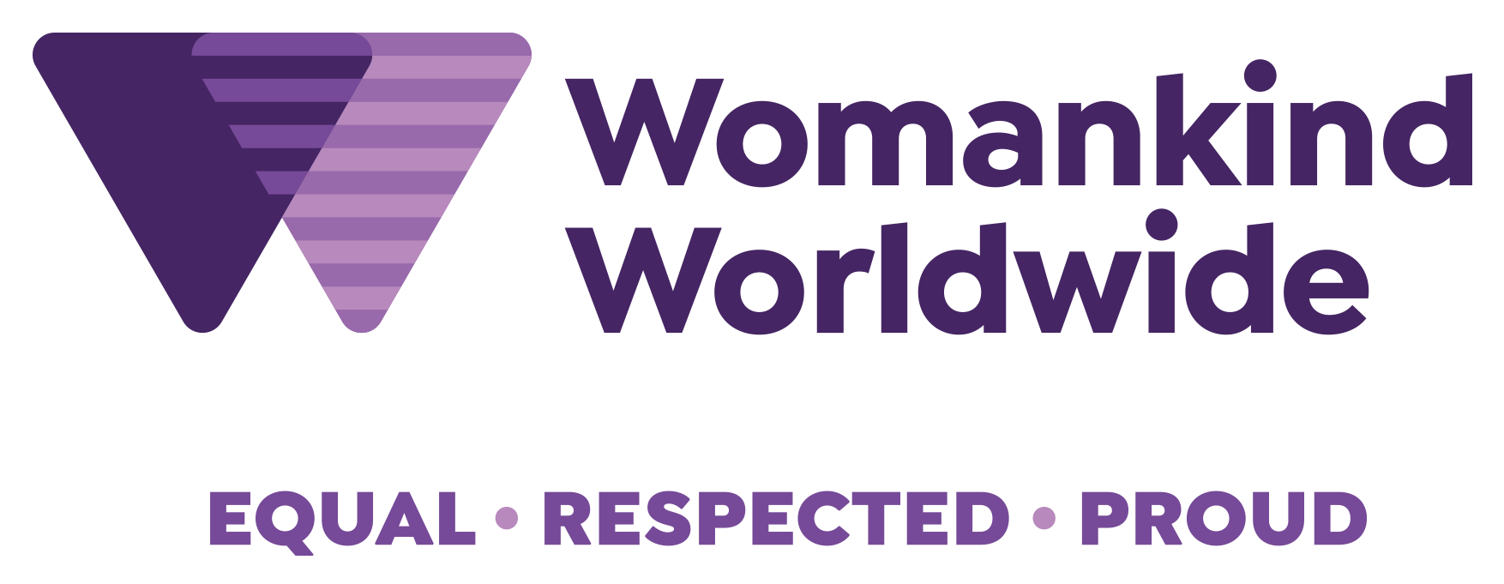

1. Marx, Bright, Wouters, Pineau, Lein, Schiebe, Wagner and Wauters, ‘Access to legal remedies for victims of corporate human rights abuses in third countries’, Policy Department for External Relations, European Parliament, Feb 2019
2. UNCTAD, 20
3. These secret private arbitration centres on which trade lawyers sit, implement the Investor-State-Disputes-Settlement agreements for each trade agreement
4. In Europe there is a growing movement for mandatory human rights due diligence – see Core Coalition.
5. <https://documents-dds-ny.un.org/doc/UNDOC/GEN/G14/082/52/PDF/G1408252.pdf?OpenElement>
6. https://www.ohchr.org/Documents/HRBodies/HRCouncil/WGTransCorp/Session3/LegallyBindingInstrumentTNCs_OBEs.pdf
7. https://www.ohchr.org/Documents/HRBodies/HRCouncil/WGTransCorp/Session6/OEIGWG_Chair-Rapporteur_second_revised_draft_LBI_on_TNCs_and_OBEs_with_respect_to_Human_Rights.pdf