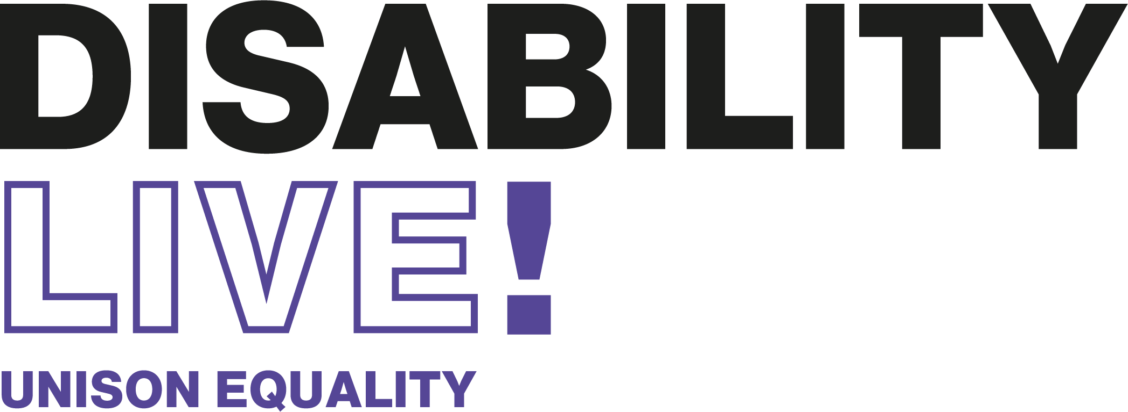

**Interim report of the work of UNISON’s National Disabled Members’ Committee**

**2020**

**Table of Contents**

Chairs’ introduction 3

Disabled Workers and COVID-19 5

National Disabled Members Committee Work Programme 12

Conference Reports 17

TUC Disabled Workers Conference 17

Service Group Conferences 18

Community 18

Higher Education 20

Police & Justice 21

Self Organised Group Conferences 23

Black Members Conference 23

Women’s Conference 25

LGBT+ Conference 28

# Chairs’ introduction

When we met in Brighton in November last year for UNISON’s 2019 National Disabled Members Conference we had no idea what was to come in 2020.

In January we watched with increasing worry as the coronavirus spread in China. For disabled workers like us, the threat of COVID-19 was especially concerning. By March our worst fears were realised when we faced a global pandemic and a UK-wide lockdown was enforced.

Disabled people are twice as likely to die from COVID-19 and UNISON’s first concern has been for our members. Many of our disabled members have continued to go to work during the pandemic – whether in the NHS or local councils, as care workers or teaching assistants, or in the private sector.

Our reps have worked tirelessly to keep disabled members safe, including negotiating home working, fighting for individual risk assessments for disabled staff and raising concerns about lack of PPE and reasonable adjustments.

There was a brief lull over the summer as we hoped we might have seen the worst of the virus, but it now looks increasingly like we are facing a second wave. UNISON will continue to fight disabled workers’ corner, workplace by workplace. We will also continue to hold government to account for the many mistakes they have made in handling the crisis – from lack of PPE and testing for key workers to ignoring disabled and Deaf people’s rights.

We have to believe that there will eventually be a vaccine. But UNISON is clear that there can be no “back to normal”.

The pandemic has highlighted how inequality means that disabled people – and Black people - are more at risk from disasters like this. So we will step up our fight for fairer workplaces and a fairer society.

The key workers – our members – who have kept us all safe during the pandemic – need to be paid a decent wage. And the inequality that is endemic in our workplaces needs to finally be addressed so that disabled, Black and other workers are never again disproportionately affected in the way we have been by COVID-19.

We hope to see you all again in happier times at a future National Disabled Members’ Conference. Stay safe.

**Graeme Ellis and Tansaim Hussain-Gul**

**Co-Chairs National Disabled Members Committee**

**Kathleen Kennedy and Iain Scott-Burdon**

**Co-Vice Chairs, National Disabled Members Committee**

# Disabled Workers and COVID-19

It’s a frightening statistic but disabled people are twice as likely to die from COVID-19 as non-disabled people. The risk is even higher for Black disabled people, disabled people who are pregnant and disabled workers in front line jobs.

UNISON has worked to ensure that the concerns of our disabled members are at the heart of our responses to the coronavirus crisis and that equality is central to our bargaining, lobbying and campaigns agenda.

**Communicating with members**

UNISON has used its dedicated COVID-19 webpages as the main means of communication with members about COVID-19 and work. There is a constantly updated section for disabled workers which has been well used by members.

The COVID-19 web pages are the first on the UNISON site to have accessibility settings. In addition, we produced advice on rights at work during the epidemic in British Sign Language (BSL) on UNISON’s BSL microsite. These changes to the accessibility settings are now being reviewed by interviewing disabled members and will be rolled out to other sections of the website.

The National Disabled Members Committee (NDMC) also produced a COVID-19 Guidance for Disabled Members leaflet giving members advice on individual risk assessments and safe workplaces.

Members of the NDMC produced a number of blogs for the UNISON website raising issues such as homeworking and disabled members, problems with the government’s definition of vulnerable people, the concerns faced by Deaf workers, and Black disabled members’ experience during the pandemic.

**Supporting our reps**

Our local reps have had a huge job on their hands to negotiate safe workplaces with employers and to reduce the risk to disabled workers. UNISON produced a number of training webinars for activists focusing on risk assessments and making workplaces COVID secure where we ensured there was a strong focus on the needs of disabled members.

We also produced a number of bargaining guides for reps with advice on how to negotiate home working, special paid leave, risk assessments and reasonable adjustments for disabled workers. See <https://www.unison.org.uk/get-involved/in-your-workplace/key-documents-tools-activists/bargaining-guides/>

We have raised concerns about employers not understanding that a risk assessment is insufficient on its own. Although they may have a “COVID-safe” workplace, they may need to take additional steps when it comes to disabled and other particularly vulnerable workers. We have ensured this approach is central to all our bargaining advice.

**Campaigning on the unequal impact of COVID-19**

UNISON lobbied government about concerns on the introduction of the Coronavirus Act, including highlighting the impact of the suspension of the Care Act on disabled people.

From the outset of the crisis, government failed to recognise disabled people as a group with protected characteristics and rights under the Equality Act 2010. Instead they established two new groups, “clinically vulnerable” and “extremely clinically vulnerable”, neither of which had any basis in equality legislation.

Workers and employers were unsure of the difference between the two new categories. In particular, disabled workers in the “clinically vulnerable” category who had significant health problems were often forced to go to work because they did not belong to the “extremely clinically vulnerable” group.

UNISON raised this in our detailed response to the Women and Equalities Committee inquiry into the impact of Covid-19 on disabled people.

Amongst other matters, UNISON’s evidence to the disability inquiry highlighted the gaps in government guidance which leaves many disabled workers at risk, having to go to work to pay their bills. By contrast, we evidenced the very positive experiences of many disabled members working from home during lockdown. Able to better manage pain and other health related issues, they have been more productive – making a strong argument for greater availability of home working in the future, for those who want this. This is despite difficulties with home working including lack of reasonable adjustments and lack of capacity in Access to Work.

Our evidence called for:

* Increase in Statutory Sick Pay (SSP) and extension to more low paid workers to encourage those who have symptoms or live with someone with symptoms to stay off work
* New right to home working for disabled workers who choose it
* A significant investment in Access to Work to support a revolution in home working for disabled people who want it
* Clear and unambiguous advice from Government that those who have been shielding should work from home if it is possible to do so
* Extension of the furlough scheme for disabled people (whether in the “extremely vulnerable” group or not) where it has not been reasonably possible to facilitate home working or redeployment to a suitably COVID-safe role.

In our own bargaining advice, we ensured disabled workers’ additional rights under the Equality Act were made clear. We consistently advised both shielded members and those in the vulnerable group to work from home - and if this was not possible to contact their UNISON rep.

UNISON has repeatedly raised the inadequacy of public health guidance with government officials. The initial guidance for shielding people did not include any reference to them as workers - it was assumed they would not have a job. UNISON successfully got this guidance updated on 29 May to include a new section on shielded workers. This referred to Equality Act duties on employers for the first time.

UNISON raised further concerns about the shielding guidance which came into force on 1 August. It was phrased in a way that may make it easier for employers to argue these workers should return to the workplace. The guidance was again changed due to UNISON pressure.

UNISON has also raised concerns about lack of a safety net for shielded workers who cannot work from home; UNISON has called for an extension of the furlough scheme for this group.

We also raised concerns about workers with shielding family members. Our General Secretary Dave Prentis wrote to Matt Hancock, the Secretary of State for Health, setting out how many of these members are not being allowed paid leave, and have to make the agonising decision to go to work, putting their loved ones in danger.

We have raised concerns with the NHS in relation to the government decision to require all NHS workers to wear masks as this has a particular impact on safe working for Deaf members. Regions have assisted in resolving specific issues through local representation.

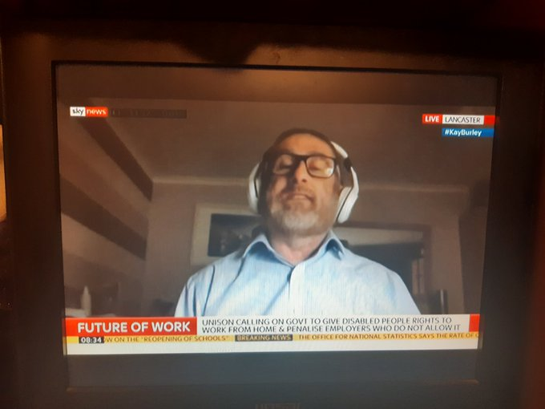

NDMC co-chair Graeme Ellis on SKY News explaining our homeworking campaign

**Our homeworking campaign**

In June, we received about 5,000 responses to a survey of disabled workers. Findings included:

* 50% of disabled workers worked from home all of the time during the Covid-19 pandemic
* 73% of disabled workers were more or as productive working from home
* Reasons for increased productivity included reduced impact on pain and fatigue due to less commuting and ability to work more flexibly with additional breaks or later start times
* A number of disabled workers reported taking less sickness absence as they were able to manage their condition better when working from home.
* For those who were less productive, reasons included lack of reasonable adjustments, IT equipment and the mental health impact of homeworking
* 53% had not been given any reasonable adjustments to support them to work from home
* Only 5% had help from Access to Work, the government’s flagship agency that funds adjustments for disabled workers
* 41% did not know about Access to Work and 23% did not think Access to Work could help with working from home
* 54% felt that they would benefit from working from home in the future
* However, 37% believe their employer is unlikely to allow them to work from home in the future

The full report is here: <https://www.unison.org.uk/content/uploads/2020/07/C19-disability-and-homeworking-report-FINAL.docx>

As a result of this survey, Assistant General Secretary Christina McAnea wrote to the Chancellor, Rishi Sunak, in early July, calling for a significant new investment in Access to Work as part of his mini-budget, including additional help for those working from home. This was followed up by face-to-face meetings with Treasury officials. In a significant victory for UNISON, we were delighted in August when the government announced that they would be making this investment. See https://www.unison.org.uk/news/article/2020/08/unison-wins-access-work-victory/

We are continuing to work with DWP as part of their Access to Work stakeholder group to achieve a more accessible online application portal.

Based on our report, UNISON is now calling for a new right to work from home for those disabled workers who want it. We received significant coverage in late August, including on Sky News, the BBC and regional news outlets.

This campaign will continue to be a priority and will be included in UNISON’s new “No Back to Normal” campaign.

**Democracy in UNISON**

The pandemic has clearly created a challenge to our *Democracy in UNISON* guidelines but we have found ways to uphold our member-led approach and to ensure we continued to be fully accountable to the lay leadership of our disabled members self organised group.

Although we have been unable to hold in-person formal committee meetings, we have held regular virtual briefing sessions for NDMC on issues relating to Covid-19 and other urgent areas for discussion.

The Labour Shadow Minister for Disabled People, Vicky Foxcroft, attended our NDMC briefing in July and heard from members about the issues for disabled workers during the pandemic and beyond.

There have also been regular chairs group meetings so that any urgent decisions can be made via chairs’ action and then reported to the full committee by email.

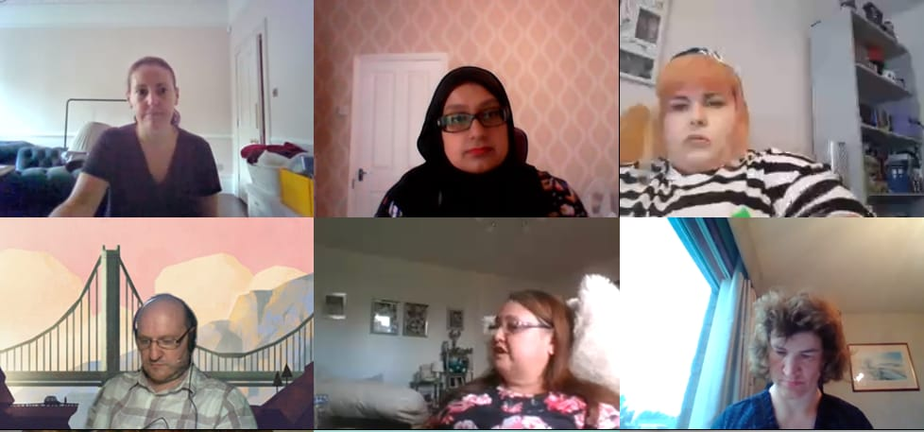

Vicky Foxcroft MP, Shadow Minister for Disabled People (top left) with NDMC members at our virtual briefing in July

Although current government guidance has meant that our annual National Disabled Members conference had to be cancelled, we organised Disability Live! as a replacement virtual event so that members still have a chance to get involved in our work.

# National Disabled Members Committee Work Programme

The motions agreed at UNISON’s National Disabled Members Conference form the basis of the NDMC’s annual work programme. As in previous years, the NDMC met in January and agreed the final work programme for the year. However, in early March the pandemic hit. Work on the 2019/20 work programme was immediately paused as the NDMC re-focussed its efforts on dealing with the impact of the pandemic on our members.

At the time of writing we look set to be coming into a second wave of the virus. It is expected that the 2019/20 work programme can be deferred to 2020/21 but this will depend on the course of the pandemic. The immediate needs of UNISON’s disabled members in their workplaces will always be of paramount concern to us as a trade union.

Despite all of this, some progress has taken place on the work plan and this is outlined below. A full progress report will be presented in 2021 if the impact of Covid-19 allows.



**Campaigning to end the Disability Pay Gap**

On 3 November we marked the first TUC Disability Pay Gap Day with special UNISON “Smash the Disability Pay Gap” placards. We were delighted that many of our UNISON disabled members were featured on Channel 5 News explaining how the pay gap affected them.

On 19 November we held an event to launch the results of our survey into disabled workers’ experience of asking for reasonable adjustments. Speakers at the event included Lord Low and Michael Paul from Disability Rights UK. The event outlined our findings that 67% of UNISON members had been turned down for reasonable adjustments. Even where employers agreed to provide adjustments, 23% of our members waited more than a year to get them



Our event in November, with Lord Low and Michael Paul from Disability Rights UK

Our report highlighted that lack of reasonable adjustments leads to increased sickness absence and lack of career progression, which in turn feeds the disability pay gap with disabled workers stuck on the lowest rungs of the pay ladder. We called on government to increase enforcement of reasonable adjustments as a key way to tackle the pay gap. The report was shared with government ministers, MPs, peers and civil servants.

At the NDMC policy meeting in January the NDMC agreed to set up a new disability pay gap project to include campaigning for a change in the law to require mandatory reporting along the lines of the gender pay gap. The project was also to include developing bargaining resources to support local branches in addressing disability pay gap issues with their employer. This work was put on hold due to COVID-19 but we will return to it when we have the capacity.

We have included mandatory disability pay gap monitoring in our work to influence the government’s disability strategy. We have planned an event on Influencing the Disability Strategy for 3 November 2020. Increased enforcement of the right to reasonable adjustments is also a key aim of this

ongoing work.

.

**Access to Work**

As outlined above, based on feedback from our survey of disabled members, Assistant General Secretary Christina McAnea wrote to the Chancellor, Rishi Sunak, in July to demand an increase in funding for Access to Work. She also called for the scheme to be extended to help people with homeworking. We followed this up with a meeting with Treasury civil servants. We were delighted when in August the government gave in to our demands and announced an increase in funding for Access to Work and its extension to homeworking. This was a big win for our disabled members. UNISON has also been asked to sit on the Department of Work and Pensions Access to Work stakeholder group where we will continue to push issues such as the need for online options and greater publicity.

**PIP – Personal Independence Payments**

As requested by a motion from the Black disabled caucus, we wrote to the Department of Work and Pensions asking for data on the number of Black applicants for PIP and the percentage that were turned down for help, compared to the white population. The DWP told us that they do not collect data on the ethnicity of PIP claimants as it wasn’t necessary to deciding the claim. They said they only collected age and gender. We pointed out that gender is not necessary for deciding a claim either, and in any case they ought to collect ethnicity data to ensure they are fulfilling the public sector equality duty. We are continuing to follow this up with civil servants. We welcomed the government’s decision to improve the provision of trained British Sign Language (BSL)interpreters or Deaf PIP applicants.

**Recruitment**

A small sub-group was set up to look at our recruitment materials and Disability History Month. As a result, a new range of branded merchandise for disabled members has been produced. This includes pens, key rings, t-shirts and tote bags. All branches are encouraged to order merchandise in advance of Disability History Month (18 November-18 December). Order here - https://shop.unison.site/product-category/disability-equality/

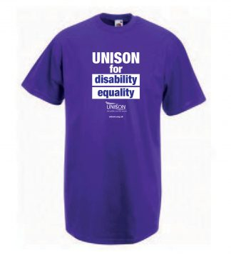

**Accessible public toilets**

This motion called on the NDMC to campaign for Changing Places toilets to be a mandatory requirement under building regulations for large public places. We were pleased to welcome the government’s announcement that changing places toilets would be required in all new and refurbished larger public buildings in England from 2021 and a similar announcement in Northern Ireland.

The motion also called on the NDMC to raise the issue of accessible toilets in local government buildings with the local government service group. We agreed and submitted a motion on the subject to the 2020 Local Government conference. However this conference was cancelled due to COVID-19. We have followed up with the service group and are hopeful that they will still be able to progress this work.

**Domestic Abuse**

COVID-19 saw an increase in domestic abuse and UNISON gave evidence to the parliamentary Women and Equalities Select Committee on the impact of domestic abuse on our members during lockdown. UNISON also worked closely with Jess Phillips MP to try to get improvements to the government’s new Domestic Abuse Act. UNISON supports the new Act but believes it needs to be stronger and to recognise the impact of domestic abuse on workers. We want a right to paid time off for victims of domestic abuse and for protection orders to extend to the victim’s workplace. At the time of writing however, it seems that government is not willing to support this – but the fight will continue.

# Conference Reports

## **TUC Disabled Workers Conference**

The 2020 TUC Disabled Workers Conference did not take place in its usual format due to COVID 19. Instead there was a virtual meeting of the members of the TUC Disabled Workers Commiittee to agree the motions that had been submitted before the virus struck.

UNISON had submitted a motion entitled ‘Make 2021 the Year of Disabled Workers’. Although the TUC Committee supported the motion, they felt that it might need to be delayed due to COVID-19 as there would be no time to prepare and there was no guarantee life would return to “normal” in 2021. They therefore agreed to remit the motion, which means that at a future meeting they will consider how it can be implemented.

UNISON also submitted an emergency motion on the impact of COVID-19 on disabled people. This motion was agreed by the TUC Committee. It was also chosen in the ballot as the motion to go to TUC Congress 2020.

UNISON also put forward two amendments to motions from other unions and these were accepted.

Our representative on the TUC Disabled Workers Committee, Sian Stockham, was re-elected for another term.

## **Service Group Conferences**

### **Community**

The conference started with different community seminars. We had a welcome address from Malcom Gray who stressed the importance of active participation at the conference and encouraged delegates & visitors to attend caucus meeting as it’s an avenue to learn and network. His speech was followed by Christina McAnea speech assistant general secretary for bargaining, negotiating & equalities, she emphasised the impact of cuts to social care & how low wages for care workers affect disabled people.

I moved motion 6 ‘Community employers, accessibility passports and access to work’, Peter moved motion11 ‘National standards for social care- protecting disabled workers.’ Both motions passed and were supported by other delegates.

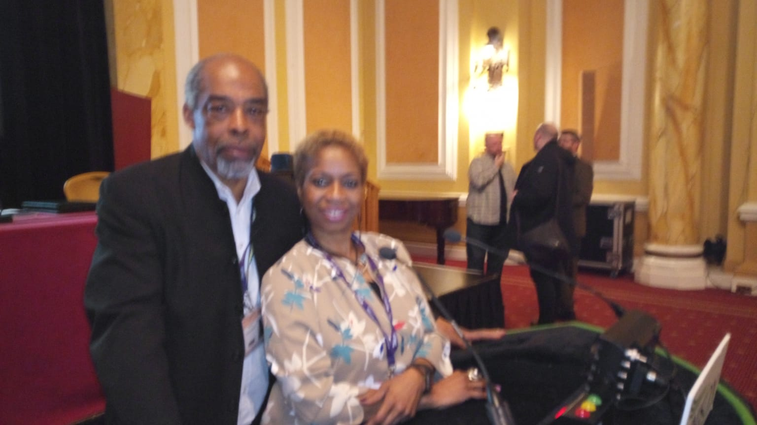

Lola Oyewusi with Peter Daley at Community Conference

Other notable debates that were linked to disabled members are as follows:

* Health & Safety Representation Motion 3
* Racism in Community Workplaces Motion 4
* Making it Fair For Social Care Motion 8
* Supporting People Motion 10

Twelve delegates attended the disabled members caucus meeting. The highlights of the conference for me were the speech made by RT Hon Mark Drakeford AM (First Minister) who passionately spoke about what the Welsh government is doing to improve lives of the local people. I was so impressed about the all the everyday necessities that are provided for free in Wales including prescriptions, education, free school meals, building more affordable homes which equates to affordable rent. I might move to Wales!

In conclusion it was a very successful conference.

Graeme Ellis was very helpful throughout the conference supporting & encouraging us all the way. Thank you Graeme.

**Peter Daley**

### **Higher Education**

I was delighted to move motion 6 ‘Negotiating Reasonable Adjustments for Disabled Workers in HE’, this motion was unopposed and passed unanimously by conference. The motion raised how universities pride themselves on the support available for disabled students but often fall short in the support provided for disabled staff. The motion called for circulation of UNISON’S existing resources on reasonable adjustments e.g. the Reasonable Adjustment Bargaining Guide, and to seek and publicise examples of best practice and the inclusion of the issues mentioned within national bargaining.

Other motions of interest included motion 4 ‘Supporting peri and post-menopausal women in the workplace’ as well as motion 5 ‘Positively promoting mental wellbeing in the workplace.’ Motion 5 presented some interesting ideas and we welcomed that the motion placed the emphasis on employers providing mental health first aid training, not UNISON. The motion also discussed mental health days which is an interesting proposal and something I felt may be worth further discussion within National Disabled Members as this is not something we had previously discussed to my knowledge but certainly may have many benefits.

There was a very engaging and insightful talk from Jim Dickinson from WonkHE on what is going on in HE policy and why it matters.

**Alice Smith**

### **Police & Justice**

As a short notice delegate on behalf of the committee it was a bit of a battle first to arrange for me to drive to the conference, there being a not very suitable train service on the last leg to take my mobility scooter on. Secondly it proved nigh on impossible to locate a hotel with parking, which was within scooter distance of the conference and had a disabled friendly room. In the end we found The Prince of Wales Hotel that had at least two of the criteria namely a car park and half a mile away from the conference. However the room was not disabled friendly having no walking shower being at the end of a long corridor and having to negotiate two set of steps thus not allowing me to take my scooter to my room. The room and the hotel was in a bad state of repair, food was just about bearable with very limited choice and the staff although helpful, not very knowledgeable and unable to address my concerns.

The conference venue was at least disabled friendly. The staff were very helpful and aware of the needs of disabled customers. Although as typical with all venues expensive for food and drinks.

I very quickly made contact with Paul O’Dyer (Pod) as until the conference we had only communicated via email, we decided between us how we best could carry out or duties.

Pod and I both took one motion each and prepared speeches for moving them. I took the Disability Passport Motion as I was able to speak on some authority as I have a Disability passport agreed with my employer.

Both motions were carried unopposed and if my memory serves, without amendments.

Pod an I did miss one of the guest speakers as we needed to plan for the Disabled Members Meeting which I pleased to say went very well although not attended by many members but enough to make it worthwhile.

I really enjoyed the conference as have never attended my Service Group Conference before. It was an honour to represent the National disabled members and I believe that Pod and myself made a great team and accounted ourselves well for disabled members.

I have since been elected from Eastern Region to sit on the National disabled members committee, so I am looking forward to meeting you all at the next meeting.

Thanks you for giving me the opportunity to attend and represent you.

**Michelle Edwards**

## **Self Organised Group Conferences**

### **Black Members Conference**

The following motions were passed at conference

1. Mind the Gap Addressing Racial Disparities in the public sector

Composite A Motion 2, 3 the effects of Austerity on Black members

4 Challenging Racism and Disability Discrimination in the workplace

4.1 carried

4.2 carried

5 Black workers in NHS and Disciplinary Procedure

6 Gender pay gap Valuing Black Women

7 The Ethnicity Pay Gap

8 Recruitment and Retention a Targeted Plan for Black Workers

9 Access to immigration Advice and Representation

11 Black Women in leadership

12 united we stand divided we fall

13 Kashmir crisis

14 stop Xenophobic Attacks in South Africa

15 Jamaica Mining in Cockpit Country

16 Cry children Missing campaign

27 Palestine

Composite B- Motion 17, 18 the treatment of Black women in maternity care

Composite c motion 19, 20 unite against state Racism

Motion 21, 22, 22, 1 composite D the Trade union response to rise of the far right and fascism no Pasaran

23 Brexit and Black Workers

24 Black Disabled people and wind rush scandal

25 Widen Wind rush Descendants and families belong too

26 Minority ethnic Employment gap in Scotland

The annual report was accepted

The Guest speakers were:

* Dave Prentis General Secretary
* Fundi Ayana young Black Members Award winner
* Josie Bird UNISON President
* Katrina French CEO Stopwatch
* Yvonne Green Mandela Award winner
* Kye Gbangbola truth about Zane

I attended a workshop on non-apparent disabilities it was good – if you have a non- apparent disability tell your employer and your line manager. And I attended show racism the red card workshop. I also attended the social it was very good. I did not get to attend the Disabled caucus because there was problem with the trains to Conference.

I moved motion 24 and Veronica Davies moved motion 4

**Lincoln Paul Davis**

### **Women’s Conference**

* Conference was commenced with housekeeping, Standing Orders Report and a warm welcome
* Angela Raynor, Labour MP and campaigner for Deputy Labour Leader, gave a heartfelt and inspirational speech surrounding women in the union, health service free at point of need, free education up to and including degree level education. “Vocational education has to be a corner stone of our economy and educational system”. Higher education means higher salaries equating to higher taxes being contributed back into the economy. Human understanding becomes more valuable in a society where computers are taking over. Further and Adult Education has suffered the most in the last ten years of Tory rule. A vote for Labour is a vote for practical change for people within our communities. “Knowledge belongs to the many and not the few” in todays society knowledge is quite literally “power” and to have no education is to have no power. Labour aims for an education for all to ensure power for all. Angela also took questions from the floor in relation to the UN Convention for Elimination of All forms of Discrimination Against Women (CEDAW), the next five years under Tory rule and the National crisis surrounding HRT.
* Emma Proctor moved the National Women’s Annual Report
* Katrina started the ball rolling by moving motion 1.
* The first conference session was a very emotive series of governmental let-downs that see the very poorest and under-valued members of our communities facing lives of extreme pressure and austerity. Performing jobs that offer lack of training and unsafe staffing levels. It also covered topics that are unique to women or transgender males who were born identifying as a female such as the menopause. Smear campaign, early miscarriage, shared parental leave, black women and the menopause and menopause-a workplace issue.
* Motion 12 commenced with the speaker telling us she has been treated to racist abuse on the way into the conference centre and thanking the women in the room who stood up in support of her.
* Motion 12 was followed by a presentation from Dave Prentis who gave an uplifting speech on the importance of women within the union. He gave praise to Northern Ireland and the victory they have fought hard for in pay parity and forcing restoration of the NI Government. He also mentioned St Helens, Bradford, Blackpool hospital staff. Birmingham, Sirona members, Scotland marching in Glasgow striking for equal pay, to name a few. Each picket being run by women showing solidarity and support for each other. He paid tribute to all women and mentioned a few by name to acknowledge the amazing work undertaken by these women. He continued, giving examples of how the Tory government are still using the same tactics behind cheeky grins and ensuring that we do not forget behind the charm is the same lack of respect for our NHS, Education and low-paid workers. Unison attracted 160,000 new members last year and the majority were women. He thanked the women in the room for all their support of himself during the 20 years he has been our General Secretary. He offered the assurance that he will never let the women of Unison down.
* Motion 13 followed Dave and the afternoon session recommenced.
* Some of the topics covered in Session 2 were Heart Attacks and the misdiagnosis which is more common for women, Hostility in the Workplace for Pregnant women and Breastfeeding mothers, Health and Safety in the workplace being performed with men in mind rather than women and their specific needs which can be extremely different than their male counterparts. The lack of women in Health and Safety positions was highlighted and the suggestion given that women should put themselves forward to be Health and Safety representatives so that these anomalies within Risk Assessments can be challenged and changed. Our NHS and the problems facing it due to Brexit ended Session 2.
* After house-keeping Conference kicked off with a hustings for all the nominated candidates for National Womens Delegate to NDC.
* Christina McAnea gave a heartfelt speech on equality related abuse, the effects of Brexit on the UK, the NHS and the poorest in our community and all the issues that bring us together as a union.
* The afternoon commenced with Motion 16. The motions debated during this session were issues surrounding the crisis on the NHS, Stalking, Sexual Harassment, women supporting women, the Gender Pay Gap, Domestic Abuse and supporting our representatives while assisting members through this traumatic and harrowing process.
* Tansaim Gul-Hussain and Eve White were elected to represent National Women at NDC. Liz Cameron was nominated as the substitute. The chair advised due to time constraints and the amount of motions still to be heard, debates would be limited to 3 speakers. Women supporting women was the motion that drew the most attention during this session. Female leadership is vital to help all women learn and achieve. The Gender Pay Gap, the effect of this on Women, Equal Pay, Brexit and the effect of this on Women in Northern Ireland, Re-inspiring Women and Women in Leadership were the motions up for debate. A fabulous display of strong Women who are proud to help those around them and speak up for the rights of those around them.
* 35 people attended the disabled members caucus meeting. Kuldeep, Katrina and Amanda led the meeting. The caucus raised various issues and questions relating to reasonable adjustments at conference. These have all been sent to the conference team.
* The meeting was closed with details of upcoming meetings and conferences and leaflets given out to attendees for knowledge and learning.

**Kuldeep Bajwa and Amanda Sweetlove**

### **LGBT+ Conference**

I was very proud to have been nominated to attend UNISON’s LGBT+ Conference on behalf of the National Disabled Members’ Committee LGBT+ Caucus this year. This was the first conference which included the ‘+’ in LGBT following the unanimously carried rule change at National Delegates Conference back in June 2019, so the event felt particularly momentous!

On Friday afternoon, I attended the Disabled Members Caucus meeting. At the meeting we reviewed the annual report and the chairs sought nominations for a female representative to sit on SOC. We were also informed of motions which the Disabled Members Caucus had submitted and the chairs requested volunteers to speak on these.

A discussion also took place about access issues at conference for disabled people, namely the lack of breaks during conference sessions, which are often long in duration. A suggestion was made of a ‘break out room’ which disabled delegates could use, where their votes could also be counted as if they were on the conference hall floor. The meeting chairs took note of this suggestion for referral back to National LGBT+ Committee.

I also attended the Young Members meeting where a discussion took place on motions submitted by the Young Members Forum and other motions which were relevant to us as young people. I was very pleased to see my branch’s motion recommended for support by my fellow young members: ‘Motion 7 – Ensuring LGBT+ Representation in Apprenticeships’.

Following this I attended the Labour Link meeting where we received a verbal report on the work completed over the previous year. Another delegate also provided a report on her attendance at the Labour Party National Women’s Conference.

The final meeting of the day was the Local Government Service Group meeting. We heard a speech from Matthew Egan who is the National Officer for Local Government. Matthew’s speech highlighted the importance of nationalising the adult social care sector and putting people before profits, and a Q&A took place so that delegates could put questions to Matthew.

Saturday morning saw the start of conference, and motions 5, 2 and 1 were all carried unanimously. We then heard a speech from UNISON’s Assistant General Secretary, Christina McAnea. Christina’s speech highlighted the importance of standing up to injustice and the importance of promoting equality and inclusivity for all.

On Saturday afternoon we resumed conference business and also watched a video message from Angela Rayner MP, who was unable to attend conference due to the imminent general election. Angela spoke about LGBT+ inclusive education at schools and how we must ensure we keep pushing so that our young people receive an education that is reflective of the society we live in.

Following Saturday afternoon’s session, I attended a workshop:

‘Engaging branches in LGBT+ Recruitment and Organising’

The workshop was very helpful for me as a new Equalities Officer. As a group we looked at all of the equalities based events, awareness and visibility days which take place over the course of a year. This highlighted the many opportunities I have within my branch to engage with members on very important events such as LGBT History Month in February 2020 and the International Day of Persons with Disabilities on 3rd December.

I attended the North West social event on Saturday evening at ASK Italian. It was a great opportunity to network with colleagues from across the region and find out the important work we are all part of on local, regional and national levels.

Conference resumed on Sunday morning and delegates and motions to National Delegate Conference 2020 were announced. We heard an impassioned speech from UNISON President Josie Bird and Josie also presented the LGBT+ organising awards. I was very pleased to see the North West win an award for their photo at Crewe pride which featured a placard stating that Pride is a Protest.

In conclusion, I felt LGBT+ Conference 2019 was very successful, with lots of passionate and inspiring debate from delegates. I believe the National LGBT+ Committee will have a packed agenda for the coming year with so many important motions passed!

**Leigh Fredson**