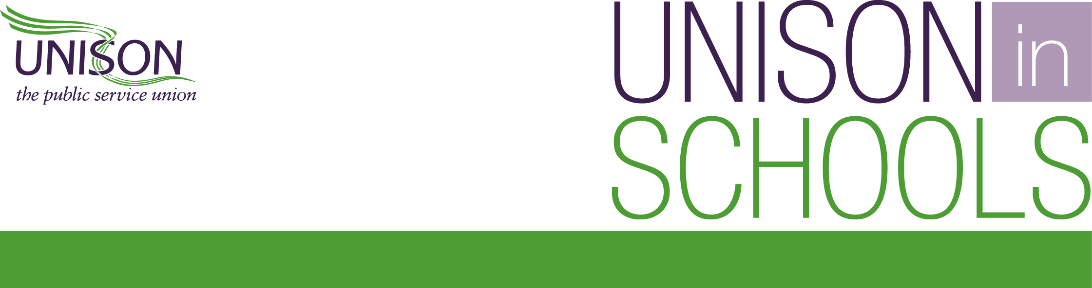
Survey of support staff in schools which opened more widely from 1 June (England)

The government in England confirmed on 28 May that nurseries, primary schools and special schools were able to open more widely from 1 June. UNISON carried out a survey of members whose schools chose to do this to see how school staff have been affected and how school plans were operating. The survey was emailed to members on 4 June and closed on 7 June with 8,791 responses. A summary of the results is given below.

Type of setting
- 87% primary
- 9% special and pupil referral unit (PRU)
- 4% nursery
Main role of respondents to the survey
- 62% teaching assistants / learning support assistants
- 9% higher level teaching assistants
- 5% administrative staff
- 4% nursery nurses
- 2% learning mentors
- 2% midday supervisors
- 2% site/facilities staff
- 2% catering staff
- 2% school business professionals
- 1% technicians
- 1% cover supervisors
- 1% behaviour management officers
- 1% cleaners
- 1% family support advisors
- 1% receptionists
- 1% attendance officers
- 3% other
Current working pattern
- 82% of respondents had been in school during the lockdown supporting keyworker and vulnerable children.
Number of schools increasing pupil numbers from 1 June
- 51% of respondents said their schools had opened to reception from 1 June, and less than half said they had been open to year 1 and year 6 pupils.
- 96% were open to key worker and vulnerable children.
Number of schools expected to increase pupil numbers from 8 June
- 63% said reception would be open from 8 June, 60% said year 1 would be open and 62% said year 6 would be open.
- 16% of respondents said they school plans were still uncertain.
Percentage of eligible pupils that attended in first week of wider opening
We asked roughly what proportion of eligible children had attended their school/nursery where they had opened more widely:
- 41% said that less than a quarter of eligible pupils had attended school.
- 37% said between a quarter and half of eligible children attended.
- Only 22% said over half of eligible children attended.
Social distancing in schools/nurseries between pupils – worrying early signs

- Only 13% of respondents said social distancing between pupils was being followed a large extent. A total of 40% said it was being followed to some extent and 17% said it wasn’t being adhered to at all.

Almost half not reassured after first week of wider opening
- Almost half (48%) of all the respondents said that – after the first week of opening for reception, year one and year six pupils – they weren’t reassured by their experience of working with increased pupil numbers.
Catching and spreading Covid-19 biggest concern after first week of wider opening

- 56% said their biggest concern was contracting COVID-19 and passing it to others.

Maximum class sizes breached

- Over 1 in 5 respondents (22%) said their schools were operating class sizes bigger than 15 pupils per group. This breaches government guidance which recommends no more than 15 pupils in a group in a bid to try and maintain social distancing. This is extremely worrying as 84% of respondents stated they believed that limiting class sizes was effective in reducing larger groups of pupils and staff mixing.

Nursery school ‘bubbles’ have more children than the government’s preferred maximum

- 48% of respondents reported their nursery was operating bubbles where the number of children exceeded the government’s preferred maximum of 8 children. Nearly a third (31%) reported their nursery was operating with up to 16 children in their bubbles - the absolute maximum allowed by government. This suggests that nurseries are under severe strain and without enough resources.

Risk assessments and health and safety training – serious breaches

- 19% of respondents said they hadn’t been consulted on their school/nursery risk assessment in good time before wider opening, and 10% hadn’t even seen a copy of the risk assessment.
- 39% of respondents said training hadn’t been provided for staff in their school/nursery on the health and safety measures in place prior to opening more widely.
- This suggests a significant number of schools/nurseries aren’t complying with health and safety regulations around Covid-19.

Staff with childcare problems being asked to come into work

- 31% of respondents reported that their school was asking employees with childcare problems to come into work.

Some schools asking vulnerable employees at increased risk to come into school

- 16% of respondents said their school was asking employees who were clinically vulnerable to work on the school site and 20% stated that their school was requiring staff who live with someone who is clinically vulnerable to attend.
- 10% reported their school was asking Black staff (BAME) concerned about returning (due to this group being disproportionately affected by the virus) to work on the school site.

Test, trace and isolate – school and nursery staff not being told how it will work locally

- 80% of respondents said their school/nursery had not given them any detail on how the government’s test, trace and isolate infrastructure will work locally.

PPE – staff not allowed to wear kit

- 33% said their school/nursery was not allowing staff to wear PPE if they wish to do so.
- 23% said their school was not even providing PPE to staff who needed it following a risk assessment.

Conclusion
The survey raises several urgent issues. Despite what the government has said about the test, trace and isolate system, the survey results are clear it’s not yet operational at a local level.

This is particularly relevant in light of the rising ‘R’ rate in the North West and the South West. The proportion of support staff reporting that they had not been consulted in good time on risk assessments, or not even seen a risk assessment before the school opened more widely, shows the pressure schools have been under from government.

This is further highlighted by the fact that 39% of respondents had not been trained on the new health and safety measures prior to the school opening more widely. This suggests corners are being cut in health and safety and legal requirements.

A third of school staff had been told by their heads that they were not allowed to wear PPE. In light of the government’s recent policy change on facemasks in the NHS, the Department for Education needs to review its guidance.

Pupils, staff and wider communities are being put at increased risk by the government’s drive to get schools open before risks have been minimised as far as possible.

Now that the government has ruled out a further expansion of schools before September, the focus should be on supporting pupils already in school, those still at home and the most vulnerable children.

