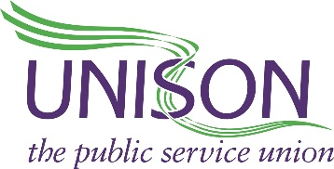

UNISON Centre
130 Euston Road
London NW1 2AY

Rt. Hon. Boris Johnson MP
Prime Minister
10 Downing Street
London SW1A 2AA

19th June 2020

Dear Prime Minister,
Public Health England report recommendations
I am writing to urge you to act immediately on all the Public Health England (PHE) recommendations into disparities in the risk and outcomes of Covid-19 published on June 16th.
A further commission is not necessary in the circumstances – answers are needed now.
Many public service workers – including many UNISON members – have tragically lost their lives from Covid-19. This is while continuing to deliver services to their community and we need to prevent further deaths.
We believe safety of the public and workers is paramount and demand the government and the Health and Safety Executive implement robust measures. These must include spot checks and sanctions to ensure employers meet their statutory obligations to carry out risk assessments so workplaces are Covid-19 safe and secure.
The PHE report highlights that factors such as racism and inequality may have contributed to increased risks of Black communities dying from Covid-19. The report suggests that Covid-19 has exacerbated existing inequalities, and the unequal impact of coronavirus on Black communities may be explained by factors ranging from social and economic inequalities, racism, discrimination and stigma, occupational risk and issues related to health inequalities.
We therefore further call on your government to:
1. implement the recommendations from the Windrush Lessons Learned Review by Wendy Williams in March 2020. Two years on and the victims are still waiting for the promised compensation;
2. implement the 2017 Lammy Review of the criminal justice system;
3. bring into force Section 1 of the Equality Act 2010 – the public sector socio-economic duty in England – which already exists in Scotland and Wales;
4. take action to close the ethnicity and disability pay gaps. The government has consulted, but no decisions have been taken;
5. act on Theresa May's 2017 Race Disparity Audit.
Coronavirus is inextricably linked to inequality. Office for National Statistics data relating to ‘Deaths involving Covid-19 by local area and deprivation’ highlight that people living in more deprived areas are twice as likely to die from COVID-19 than those in more affluent areas. Urgent action is needed to close the gaps in health inequalities and poverty that accelerate susceptibility to coronavirus and life expectancy.
We believe that poverty is a political choice. Ending deprivation and rising inequality must be a government priority as the UK deals with the economic, health and social challenges of the pandemic. Specific Black groups are two, three and four times more likely to die from Covid-19.
Black workers and communities deserve to have the PHE report acted upon and their lives valued and protected as all others.
Yours sincerely,

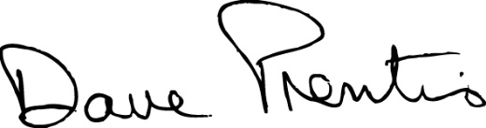

Dave Prentis
General Secretary
UNISON

