**  **  

23 May 2019

**Further Education England Joint Trade Unions 2019/20 Claim**

Dear Gerry,

On 29 April 2019, the joint trade unions submitted their heads of claim for 2019/20 to the Association of Colleges (AoC) at a National Joint Forum (NJF) officer level meeting. That claim focuses on two elements:

* **£1 extra per hour for all staff with Foundation Living wage being the minimum wage in FE.**
* **An additional 5 days of annual leave per year.**

As an update - those working in Further Education (FE) find themselves suffering real cuts to pay every year since 2009, those who have received all the AoC recommended increases in those years, have now suffered an untenable and sector damaging real terms cut in pay of over 27% since 2009. The highest pay cuts in all the public sector.

In cash terms that means a cut of:

* **£2,481 for those on the bottom recommended point on the scale.**
* **£9,550 for experienced lecturers and even more for those higher up the scale.**

Many have suffered worse cuts in colleges where few or none of the AoC recommendations have been awarded in the decade. The joint trade unions maintain their demand for meaningful and therefore binding national bargaining and negotiations.

The joint trade unions acknowledge that the AoC has declared that it believes that teachers in FE are paid on average at least £7,000 less than secondary school teachers, often teaching the same courses, and at the very least that this is a serious problem for recruitment and retention for colleges. We also believe that the AoC accept that staff in FE are worth more than they are currently paid for the work they do.

It would seem pointless to mount an elaborate argument in support of principles that are already agreed between employer representatives and the joint trade unions. We can provide the underlying statistics that support our claim and assertions; however we see that there is little argument between us on this ground and indeed that the AoC is already aware of these.

Staff in Further Education colleges receive a range of different annual leave entitlements. A pattern is emerging, from recent local pay settlements, of colleges awarding extra annual leave to staff as part of their pay offer. In Scotland, national bargaining has resulted in all staff being entitled to at least 45 days of annual leave. Whilst addressing low pay in the sector must be an absolute priority, at a time when there are funding difficulties, additional leave in the form of an additional 5 days can be a welcome gesture towards the value of all college staff. Such offers on annual leave improvements, as part of a package, have resolved entrenched pay disputes in the sector over this last year.

This year we do not just look for a different approach from the AoC. We seek an approach that actually makes a difference, improving the real pay of all the members we represent in line with our joint claim. Again we look to an approach that makes a declaration of the true worth of staff in FE, an approach that accepts the problem and proposes a solution that is required and one that delivers.

We all know that no staff working in FE are happy with their pay or believe that their pay is fair when compared with the rest of the education and public sectors. As the joint trade unions said before:

“Ultimately the responsibility for delivering better pay and better jobs in FE rests with the sector’s leadership. With a skills shortage, BREXIT looming and acceptance that FE pay is a problem, there has never been a better time for the sector’s leadership to stand up and demand the sector’s worth.”

We have seen a significant increase in trade disputes and industrial action over pay, along with other issues, in FE over the last two years. The resolutions of these disputes have shown that where colleges make an active decision to prioritise staff pay, then above inflation increases can be delivered. The National Joint Forum is at risk of becoming irrelevant if it fails to deliver a comparable outcome for all college staff.

We, the joint trade unions, commit to continue to work together with the AoC to campaign for the funding that FE needs and deserves and expect the same commitment from the AoC. We also call upon the AoC and colleges to acknowledge that staff pay is now an existential threat to the future viability of college operations and therefore accept that an above inflation pay award is required.

Yours sincerely

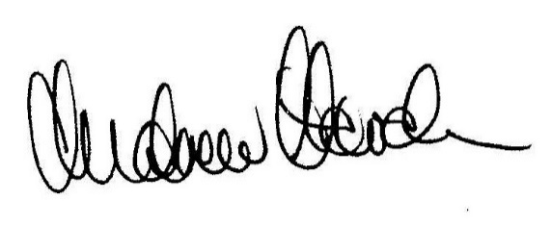

**Andrew Harden Leigh Powell**

Joint Secretary NJF Trade Union Side Joint Secretary NJF Trade Union Side

Head of Further Education National Official

University and College Union UNISON

CC: Mary Vine-Morris, Evan Williams