CONTENTS

NBMC chair’s welcome and report 2

UNISON national executive council members’ reports 4

Committee organisation 8

Organisation, development and services to members/ Policy, campaigns and international 9

Caucus reports 22

Conference reports 24

Round the regions 32

National Black Members’ Committee attendance 43

NBMC CHAIR’S WELCOME AND REPORT

Welcome to the National Black Members Conference 2018, my name is Ash Dhobi and I was elected as the Chair of the National Black Members Committee back in March 2017.

I am very pleased to welcome you all to the National Black Members Conference 2018, here in the historic city of Liverpool and a special welcome to those who are attending conference for the first time.

In June this year we were given a glimmer of hope after the results of the General Elections. Even though Labour did not get the required majority of seats to kick the Tories out, the Labour Party came close. This has sent out a clear message to the Tory Government that people have had enough of their austerity, propaganda and the racist rhetoric they have been branding about; blaming immigration on their failures. We now have an opportunity better than ever to build an opposition that truly reflects the community. We aim to serve and encourage Black members to register to vote for the future.

It has also been an excellent year for our great union. In July the union’s 4 year fight came to a successful end with the Supreme Court ruling that the Tribunal Fees introduced in 2013 by the Tory Government was unlawful. This has been seen as a monument win, not only for UNISON but for the injustice faced by many poorly paid Black workers who had been victimised by the race discrimination and who were never in a position to afford the cost of going through industrial tribunal.

With Brexit in full swing now, we are still faced with challenging times for the union and I have no doubt that Black members/workers will feel the brunt of yet more far-reaching cuts to Public Services, attacks on our human and employment rights with a disproportionate impact on our families and friends.

With the lifting of the pay cap and UNISON’s continued fight to get a fair and proper pay rise, I believe we are entering a new phase in the trade union movement where the trade unions are going to claw back some of the powers that they used to have. Black workers who have for decades the lowest paid in the public sector will now have the chance to rise with the rest of the unions around the country and say enough is enough and we deserve a proper and decent pay rise which should have been afforded to us many years ago.

This also goes in line with Black workers/members who over the many years have worked so hard to build and support the NHS. The same Black workers have campaigned for a living wage and changed the course and representation of race cases in UNISON and as the chair of the national Black members committee, I am very proud to be bringing experience, leadership, inspiration, confidence and giving my unwavering commitment to keep equality and race on top of the agenda in and outside of UNISON.

The NBMC throughout the year have continued to put race at the heart of our work, by challenging racism in the workplace and ensuring the principle of equality involves growing our membership, organising, campaigning, challenging reorganisation, redundancies, negotiating and bargaining for our members.

This year the NBMC’s work on Defining Black has been around to different Regional Council meetings. The presentation is to send a clear message to the wider membership in UNISON why we define ourselves as Black and not by other abbreviations whether in literature or in speech.

There has never been a greater time in our union than now for us to come together and to recruit more Black Members.

Also within our great union we must all pull together behind a strategy to protect the future of our Public Services, the Voluntary Sector and Private Sector. To provide protection against the onslaught of attacks and realise that in the next few days here in Liverpool, all delegates and visitors are representatives of thousands of Black members across the UK, within these Sectors and community.

The NBMC has continued to work in partnership with other self-organised groups increasing participation of Black women in UNISON, young Black members, supporting Black LGBT campaigns, countering the anti-immigration rhetoric, highlighting the positive impact of immigration, promoting anti-austerity campaigns, Black mental health and highlighting the importance of organising our strategic campaigns to protect our future young members and fight against discrimination in all its forms.

As your Chair, my role along with colleagues on the NBMC this year has been to focus and ensure Black self-organisation is respected and embedded across all UNISON structures:

- Enhance our capability to meet the recruiting, organisational and representational challenges posed by austerity measures including cuts, workforce reductions, reorganisations, attacks on facility time and privatisation. Ensuring the union is relevant to all members who provide public services – including those who work in the private sector – regardless of the economic sector in which they work.

- Protect and secure fair and equal pay, good conditions, high quality employment, and pensions for UNISON members, building confidence for industrial action when required. Fighting for and promoting equality and challenging all forms of discrimination, including racism and hate crime, supporting migrant workers, and promoting UNISON’s alternative to austerity.

- Develop our public service campaigns in support of quality public services, in defence of the NHS, and all public services, building our political influence, forging alliances with unions, appropriate campaigning and community groups to challenge the austerity programme, including challenging the attacks on the welfare state. To campaign for the election of governments in Westminster, and the devolved nations, which value public services and working people, rejecting the arguments of UKIP and other far-right parties.

- Ensure that the union’s structures including organisational, lay member, ICT infrastructure and internal management systems are efficient and effective to meet the changing needs of all sections of the union and its members.

This has been my first year as the Chair of the NBMC and the journey has been somewhat an eye opener. However, I would not have been able to achieve all that I have achieved for the Black membership without the support of the NBMC and therefore I would like to take this opportunity to thank all the members of the committee in their support and the hard work they all have put in throughout the year.

Also, a very special thank you to Margaret Greer, our National Race Equality Officer, and Bukky Akinwale, Assistant National Officer for their support and commitment throughout the year.

Ash Dhobi

UNISON NATIONAL EXECUTIVE COUNCIL MEMBERS’ REPORTS

Abiola Kusoro

Hello brothers and sisters,

First and foremost, I would like to take this opportunity to thank you for your continued support and the opportunity to be a member of the National Executive Council (NEC). I have been allocated/elected to the following committees and continue to serve on them with enthusiasm and a desire to do more for members:

- Services to Members
- Industrial Action Committee (IAC)
- Standing Order Committee (SOC)
- General Political Fund (GPF)

One of the parts of my role that I take great joy in, is marching in solidarity with other members to further causes that I know will make a positive difference to our lives. This year I have taken part in the Stand up to racism march in March and the Public Services march in July.

A key focus this year has been on PAY UP Now. For too long, public sector workers have been working to make a difference in their own way, rewarded only with salaries that don’t match the cost of living. How can it be that the cost to get from A to B is increasing, it’s costing more to stock your cupboards – even the cost to put a roof over your head is going up and yet the amount we’re paid to do the things that take up so much of our valuable time, the very jobs we take up to pay for travel and food and housing are not paying a relative wage.

If pay freezes are necessary to support the economy then it should be a national phenomenon – not something that affects only workers in the public sector. I’m a big believer in working to live, not living to work but it’s become increasingly difficult to do one without the other. Having to take on extra hours, at the expense of quality time with family and friends, should not become the norm. I was at Parliament on October 17th 2017 saying just that. I hope you were all there too to lobby your MPs!

Some of our other successes from the year include:

- The landmark victory regarding Employment tribunal fees. UNISON's legal victory sees employment tribunal fees scrapped which means tax on justice has been lifted and is a victory for all workers
- The Public Service Champions campaign was established by UNISON in response to growing concerns about the impact of spending cuts on public services in the UK
- The result of the General Election, which, although we didn’t win, was definitely a step in the right direction.

I would however, like to express my sadness about the loss of the lives of those who fell victim to the hatred and racism that fuelled the Westminster Bridge attack, the London Bridge attack, the Manchester attack and the Finsbury Park attack. My hope is that the work we do as activists will go some small way to shaping a better future for the generation to come.

I would also like to express my deep sympathy and support for the families of the victims of the Grenfell Tower disaster – I hope and pray that lessons will truly be learnt and actions will be taken to allow families to begin to heal.

Lastly, I’d like to congratulate the following on their new roles; Margaret Greer as National Race Equality Officer, Liz Cameron as the chair of the General Political Fund, Eleanor Smith as the MP for Wolverhampton South West and also say thank you to our Assistant National Officer, Bukky Akinwale for her hard work and support to the National Black Members Committee.

Thank you again for your support and here’s to a successful 2018.

April Ashley

What a difference a year makes!

A year ago Black members were fearful of the rise in racist attacks immediately following the vote to leave the European Union. UKIP and Tory rhetoric whipped up racism and scapegoated migrant workers for Tory austerity.

But working people have had enough of austerity- 760,000 job cuts in local government, pay cuts of nearly 20%, public services destroyed, and priviatising the NHS led to fantastic support for Jeremy Corbyn’s anti-austerity general election campaign.

Young people were particularly enthused with an estimated two thirds of young people voting for Corbyn’s Labour and a record turnout of young people of 64%.

The mood of workers has completely changed with trade unionists celebrating a Labour Party leader who actually supports trade union struggles and our agenda after the barren Blair and Brown years. Many workers are hopeful for a future Jeremy Corbyn led Labour government to reverse the years of Tory misrule.

Corbyn’s anti-austerity manifesto which included £10 an hour minimum wage, banning zero hours contracts, ending student tuition fees, mass council house building and renationalisation of the NHS, energy providers and the railways is massively popular with young Black workers who have been worst hit under the Tories austerity programme with Black youth unemployment of 25% compared to white youth unemployment of 12%.

Black Workers make up 14% of the working age population but only 10% of the workforce. Employment for white workers stands at 75.6% whilst for Black workers it is 62.8%. A study by the Joseph Rowntree Foundation showed that Black Workers were disproportionately over-represented in lower paid jobs and twice as likely to be on temporary contracts as white workers.

UNISON’s own surveys through Freedom of Information requests show a consistent pattern of under-representation of Black Workers in the workforce, over-representation in lower paid jobs, and over-selected for redundancy in Local Government. Black workers also suffer disproportionately when services are cut for example Black youth have been particularly hit when youth services and community support programmes are cut. This has led to Black youth involvement in community and anti-cuts protests.

However, Black Workers are playing a significant role in fighting the austerity agenda that effectively has taken money from the poor to give huge hand-outs to the rich. Black care workers in UNISON are taking a legal claim over the minimum wage against a Haringey Council care contractor who paid live-in care workers as little as £3.27 per hour! In addition there have been inspirational strikes in of low paid privatised workers such as SOAS Cleaners, LSE cleaners, Barts Health Workers and numerous others. Black workers show that collective action can fundamentally undermine division and discrimination.

My work on the Policy Development and Campaigns Committee (PDCC -sub-committee of the NEC) continues to ensure that UNISON is at the forefront of the campaign against racism and attacks on migrant workers including campaigning against the Tory Prevent Strategy which is clearly an attack on the Muslim community. PDCC ensured that UNISON played a full role in the March Against Racism - National Demo for UN Anti-Racism Day in March and the UNISON National Black Members banner was proudly at the head of that demonstration.

For the coming year the PDCC will be developing UNISONs ‘Pay Up Now!’ campaign to end the public sector cap for a rise in public sector pay. As Black Workers are amongst the lowest paid section of the workforce the NBMC will be greatly involved in the national mobilisation for the campaign and fully supporting the TUC’s national demonstration in support of public sector pay with other public sector trade unions.

Elizabeth Cameron

NEC Committee membership 2017-18: Services to Members, Development & Organising, Chair, General political fund, Industrial action committee, Equality liaison committee.

Activism: North West rallies, National rallies cross union, TUC rally, Anti racism rally, Black Lives Matter campaign Manchester, Show Racism the Red Card – speaker at various events, Stand up to Racism, TUC Equalities Northwest, Reclaim the night, NW Skills for strength, Caribbean Carnival, Manchester University and Ahmed Iqbal Ullah Race relations, Black member development North West.

Conferences: National Black members conferences, National Women’s conference, TUC Black members, TUC Women’s conference, Local Government conference, Health and Safety seminar (joint workshop lead), National delegates conference, In addition, I have played an active part in National Black members, and National Women’s committee (now retired).

As a member of the policy committee:

I played an active part in key debates around equality and immigration and influenced by contributing the strong stance the union has taken with regard to racist media reporting around immigration.

I raised awareness of the experience of Black members at a grass root level and how the rise of racism in our communities has affected their lives. PDCC committee has created strong policy documents and made many governmental level interventions with the experience of Black people an integral part of campaigns around health, housing policy and all aspects of our lives. I have done cross union work and regional work in this area taking part in workshops debates and speaking at conferences.

In my role on the National Health and Safety Committee, I participated in the Guardians of safety seminar and co facilitated a Bullying and Harassment workshop, I shared a platform with the TUC Race equality officer raising awareness of the historical and current experience of Black people in society and in the wider trade union movement at a recent Black history month event, commenting on progress over the last thirty years.

I have championed the cause of all equality strands with my contributions to the GPF committee and was proud to be elected by my peers to chair that committee over the next two years period.

As a member of the finance committee and women’s committee (now retired), I contributed to the proposal for considerable change in support of members who have caring responsibilities. I have been involved in regional work that tackled national issues such as Black lives matter, the Grenfell tragedy and horrific hate crimes that have followed the heinous terrorist attacks which have shaken our cities, not least in Manchester where I am a resident. I was also actively involved with the Jo Cox memorial event in Manchester.

The situation for Black members as experienced by increased racism in our society is a bleak one, especially following terrorist attacks but also with regard to the media portrayal of immigrants and refugees. Our work as representatives of those having these experiences; (and sometimes also being amongst them) must find its platform in work in the community and in our union and be heard in order to change the situations for the better.

The horrific tragedy at Grenfell, caused in no small part to a cuts agenda that has allowed for dangerous short cuts and decision making which caused the tragic deaths of so many. The Manchester bombing, the destruction of the Mosque, the murders outside the mosques, the acid in the faces of two young women, all events we wished did not occur and we can only pray for them and the families of all those affected and do all we can in our own ways to prevent a reoccurrence of such events and offer support where we can.

With Hurricane Irma devastating the Caribbean, Barbuda in particular and other Jamaican islands and Cuba, I have sought the support for a motion to go to regional committee and council which can offer the maximum of financial support to the people affected by these tragedies.

As a strong supporter of the student union movement I continue to champion the cause for young people in employment and education as well as mature students like myself, who it is reported have a negative experience in relation to our white counterparts. Also, being part of the student voice wanting to preserve the institution of Ruskin as a base for trade union education and good socialist values with its shrinking funding streams and staff adjustments which have necessitated change.

Cuts in health services and a rapidly expanding privatisation agenda continue to be a cause of concern but I have been applying additional emphasis around mental health cuts, highlighting through a regional conference the need to fight against service closures and to increase funding right across the service from CAMHS to adults.

The role of Black member reps as a voice for Black people under attack in our workplaces and communities has never been more vital. We must continue to ensure we have meaningful Black representation throughout the union and at all levels. I will be fighting to build strength in our union as we take the fight for better pay to our members and the community. We deserve a pay rise and Black members will be part of the fight for it. I will stand against bullying, racism and fascism in society seeking fairness and equality in our workplaces and in our branches always.

It has been my pleasure to serve you and hope with my input into new areas of the NEC committees, that I can help to educate and influence as to the needs requirements and necessary provision for Black members of UNISON.

COMMITTEE ORGANISATION

The National Black Members’ Committee met in Stevenage in March 2017 for a policy weekend to consider the motions that were passed at the National Black Members’ Conference in January 2017 and other UNISON campaigns and issues that needed to be addressed.

This year, the Committee again split into working groups 1 and 2 to take forward the work in the manner agreed by members of the Committee as a whole.

This report will feedback on the work the Committee has done; motions with similar themes are grouped together.

The membership of the working groups is outlined below:

Group 1 Members
Ash Dhobi, Tianna Wright/Nicola Francis (JS), Annette Heslop, Mitsy Harmon-Russell, Iqbal Syed, Azara Azam, Madhu Sharma, Rosita Ellis, Nathan Aljoe, Kebba Manneh, Manjula Kumari, Sharon Dixon, John Campbell, Jacqueline Jones, Davis Mac-Iyalla, Abiola Kusoro, Elizabeth Cameron.

Group 2 Members
Kim Johnson, Rodney Williams/Sandra Okwara (JS), Sudeep Bone, Elizabeth Baptiste, Lilian Adani, Rakiya Suleiman, Tania McGee, Kitty Smith, Pam Singh, Aniqa Hashmi, Kuldeep Bajwa, Bev Miller, Pam Sian, Chelsea Skervin, Hugo Pierre, April Ashley.

ORGANISATION, DEVELOPMENT AND SERVICES TO MEMBERS/ POLICY, CAMPAIGNS AND INTERNATIONAL

RECRUITING AND ORGANISING BLACK MEMBERS

Motions 1: Improving our work to reach young Black members, 2. Organising and training, 3. Recruiting and organising Black members, 4. Recruiting and organising Black members in the fragmented workplace, 5. Standing together for equality, 6. Securing Black LGBT perspectives and participation, 7. Access to Immigration and representation

UNISON is only as strong as its membership, recruiting, and organising members has continued to be a priority for the union this year.

Recruiting Black workers is key to ensuring that Black members remain visible and vocal within union structures. An organised Black membership means we can continue to support members and lead on achieving race equality and challenging racism in the workplace.

Achieving race equality is an important stream of UNISON’s work and part of the union’s equality objective. In achieving this, all Black members, especially young Black members must continue to be key in driving the anti-discrimination messages and represented and engaged in all levels of UNISON’s structures.

Improving our work to reach young Black member in UNISON

The level of young Black member’s attendance at Black member’s conference continues to be very low; this year saw a slight dip. However, it is a vital piece of work that is being undertaken to ensure young Black members can contribute to and benefit from Black members conference.

The National Race Equality Officer and Young members Officer have to continued to pursue and action the uptake of activities on behalf of young Black members. This included using the Black members meeting at the national young member’s weekend to explore why the proposed course on Black confidence skills had such a low take-up including whether there are better ways of promoting the course and the relevance of it.

Seeking agreement from those attending that meeting to have their contact details passed to the National Officer Race Equality, those that gave permission details have been uploaded on Black members update for future contact.

In the autumn a survey will be run to help identify barriers to participation and promote the take up of attending the next national Black member’s conference via young member’s social media.

Organising and training

In 2017 UNISON provided many recruitment and organising opportunities for Black members. The campaign materials produced by the National Committee to promote the visibility of Black members in UNISON and to support members to recruit, engage and organise continue to be a valuable resource. The national Black member’s conference supported the initiative to develop a Black member’s officer training course and work with regions and branches to deliver this. Review of training materials and exploring with the learning and organising unit to create a handbook for newly elected committee representatives and a re-emphasis to ensure the race discrimination claims protocol and defining Black is incorporated in the re-accreditation ERA training of officers and stewards across all regions.

UNISON also explored the use of on-line courses and potential sessions for Union Learning Representatives (URL) and will be developing this further in 2018.

The use of video VPOX cases studies at future conferences is being developed to target young members and promote the role of young members in the union and new delegates and visitors.

Recruitment and organising Black members in the fragmented workplace

It is important that UNISON is equipped for the challenges within the changing and evolving landscape of the UK today. UNISON recognises that a high proportion of Black workers eligible to join the union work in the fragmented workforce. The motion was submitted to all service group conferences to support the campaign initiative to recruit and ensure Black members become and remain active. It is heartening to see that Black activist levels appear to be proportionate to the number of members.

Black members are not only more likely to join a union, but Black members are joining the union and becoming active too. Within the fragmented workplace we need to organise and ensure UNISON continues to be visible to Black workers.

Recruitment without organising is like a house built on sand. New members will slip away unless they see UNISON being active which is why alongside UNISON equality survey that was completed in 2017, joint work with all service groups and self-organised groups will look at developing initiatives and strategies for recruiting and organising Black workers and continue the drive to deliver effective recruitment campaigns.

Standing together for equality and Black LGBT perspective and participation

UNISON was founded on the principles of solidarity and equality. These principles are vital for our union and also vital for a strong society where all can thrive.

UNISON have developed its work and material on tackling prejudice and hate, including tackling the LGBT and disability hate crime and hate incidents. A guide has been produced across the self organised groups ‘Tackling hate crime and hate incidents, a workplace issue’ which looks at our roles in identifying and encouraging reporting of all forms of hate crime and incidents at work and outside the workplace.

https://www.unison.org.uk/contents/uploads/

Several workshops took place across regions to initiate this activity and feedback has been very positive.

The National Race Equality Officer and National LGBT Officer have discussed various joint work initiatives. The LGBT Black network day was promoted in Black Action, and part of the meeting was used to discuss the NBMC work programme and share ideas on increasing participation.

An article in Black Action featuring active participation from an LGBT perspective will also feature in ‘Out Now’ at the November LGBT Conference.

The committee actively participated in events such as Black Pride UK 2017 and supported various other events across the UK.

Immigration advice and representation

For Black members who are not fully settled in the UK or do not have British Citizenship, immigration is a major issue. UNISON recognises that immigration rules come and go and can be changed overnight. We have been working tirelessly to address this issue and welcome the advice line through Joint Council for the Welfare of Immigrants (JCWI) and the Migrant Rights Network (MRN)

Current immigration processes lead to unfavourable treatment against Black workers who do not have full legal rights to reside in the UK. They face deportation before appeals, no right to housing, and no financial support from public funds and detention; which divides families.

An article was featured in Black Action on the details of the advice line and support from UNISON. ‘Challenging Prejudice’ and ‘Stand Together’ can be downloaded from the UNISON website at www.unison.org.uk. They can also be ordered from the UNISON online catalogue; stock numbers 3686 and 3687

We will continue to pursue the request for increased access the advice line to be available at a local, regional level with the NEC Services to Members Committee and will report back throughout the year.

CHALLENGING RACE DISCRIMINATION IN THE WORKPLACE: Negotiating and bargaining around race equality

Motion 11. Workplace bullying of young Black workers, 22. Stop and Search of Black people, 24. Career progression of Black workers, 25. Challenging hate crime and supporting victims, 27. The format of Black member’s standing orders committee, 28. Bullying of Black workers in the workplace

Workplace bullying of young Black people and workplace bullying of workers in the workplace:

Challenging racism in the workplace (CRW) toolkit guidance and its associated training courses offer a range of resources, ideas and checklists for the incorporation of anti-racist work, which includes the Race Discrimination Claims Protocol formulated in 2010 by UNISON.

Challenging racism in the workplace is vital to UNISON’s work whether it involves growing membership, organising members around campaigns, challenging pay freezes, reorganisation and redundancies or bargaining and negotiating for members.

UNISON has an important role to play in offering support to individuals. However it also has to consider bullying and harassment as a collective issue, and that bullying of young members, in particular, is a reflection of the racism and ageism in wider society.

Working with the local government service group and the police and justice service group, data, via a questionnaire, is being gathered on the extent of racial discrimination and harassment that is linked to bullying in the workplace of Black people and their experiences.

It is planned that by using this data we will raise awareness of racial discrimination, harassment and bullying as a workplace issue and reaching out the Black workers, particularly to young Black workers, by validating their experiences of racism in the workplace. With the recent government data on the disparity of inequalities, putting race and bullying of Black workers back on the political and public policy agenda is vital.

The marginalisation and discrimination faced by Black workers, with entrenched barriers, structural and institutional racism, coupled with bullying and harassment continues. The work of UNISON is a long-term strategy of activity to ensure confidence and support are being provided to Black workers.

Equality legislation provides trade unions with the means to hold employers to account and fight austerity, but the principles of equality can only become a reality in workplaces if we organise around them and place them on the bargaining table.

Stop and search

The issue of stop and search continues to be a challenge. With some deaths in police custody, the debate has turned to making police forces accountable for their actions and established plans to change their culture and behaviour.

Work with the police and justice service group and other community organisations is being progressed. Guidance is being explored to produce as part of ‘knowing your rights’ alongside the articles that are being produced in Black Action and E-Quality bulletin.

Career progression of Black workers

The level of career progression of Black workers is very low in most workplaces and is imperative that this is addressed.

The recent survey by the Runnymede Trust ‘Reframing Racism’ explains ethnic inequalities in the UK labour market.

While strides have been made for Black pupils in schools. Whilst attainment gaps are shrinking, there is still work to be done.

However, this progress has not been matched regarding labour market outcomes. UNISON submitted a motion to the TUC Black workers conference this year ‘A better deal for Black workers in the labour market’ this motion was submitted to the Trade Union Congress (TUC) in September 2017.

UNISON will continue to work with the TUC Race Committee to address some of the fundamental issues raised around several of these reports by demanding that this government bring about a step change in culture, policy and practice to close the racial inequality gaps in the United Kingdom (UK).

Challenging hate crime and supporting victims

UNISON has a long history of opposition to racism and xenophobia and has consistently highlighted and campaigned against discrimination against Black communities.

The flames of xenophobia and racism fanned by some during the EU referendum campaign must not be allowed to sow division in our communities.

The national Black members have hosted several fringes, meetings and workshops on the issue of hate crime and will again be holding a fringe at this year’s conference 2018 on ‘hate crime and hate incidents’. An article was also produced for the October Black Action, and further information will be provided in future editions.

The format of Black member’s standing orders committee

The important and crucial role of the national Black member’s standing orders committee will be reviewed, and an update will be forthcoming at the 2019 conference.

It is recognised that the National Black Members Conference has increased in size over several years and the over-view of workload, facility time and format are constantly under review to ensure we adhere to proportionality and fair representation on the committee.

Regional Constitutions 2018:

The National Race Equality Officer is reviewing all current regional constitutions from all 12 regions to ensure they are complying with the Rule Book, Aims and Objectives and proportionality and fair representation of the union.

A report will be circulated to each Region for consideration once completed in 2018.

COMMUNITY CAMPAIGNS

Composite A. Challenging the rise of Islamophobia, 12. #BlackLivesMatter – solidarity to oppose police brutality and murder, Composite B. Domestic Violence and Black Communities, 15. Discrimination in the NHS, 16 Immigration and austerity, 19. Immigration and the effects of the EU Referendum and the Brexit vote

Challenging the rise of Islamophobia

Race Hate Crime has been on the rise again in the UK particularly since the UK voted to leave the EU. UNISON reaffirms our commitment to all Black Muslims and those perceived to be Muslim, Hindu, Sikh and other religious beliefs to unify as one post Brexit.

As evidence continues to illustrate that Black communities are one of those being hardest hit by a range of issues of racism, that include the rise of Islamophobia, police brutality and murder, immigration and Brexit. The Committee continues to campaign on issues that unfairly disadvantage Black communities alongside the TUC Race Committee, Stand up to Racism, Hope not Hate and other like-minded and affiliated groups.

UNISON and the committee continue to address this through work with other UNISON committees and regions, highlighting the success of Islamic awareness training through Black Action and ensuring challenging racism in the workplace is being used as best practice as part of the collective approach in organising around equality and diversity as a trade union priority.

A fringe meeting will be taking place at the 2018 conference incorporating the hate crime and hate incidents guidance and materials to support victims and help support activist in branches and regions.

#BlackLivesMatter – solidarity to oppose police brutality and murder

Conference extended solidarity to #BlackLivesMatter movement both in the UK, US and internationally and congratulates #BlackLivesMatter for reinvigorating a new, younger generation into a new civil rights movement.

The committee supported the anti-racism march on 18th March and 1st July, where thousands of people marched with Black pride. The issue has been raised with the International committee, and further initiatives are being explored.

Domestic Violence and Black communities

Domestic violence cuts across every age, class, ethnicity, religion, sexuality or gender. It is predominately violence against women and is sometimes seen as a family secret in some of our Black communities. However, there is also an under-reporting from LGBT victims and male victims.

Work continues with the national women’s committee in reviewing the ‘Guide to workplace policy’ on Domestic Violence’, with signposting for an activist to raise awareness of the information and how to access this on the website.

Domestic Violence and Abuse: A Trade Union issue was updated February 2017 and is available to order stock number 3477.

Work will continue with the community and voluntary organisations that seek to stimulate debate and education on domestic violence.

Discrimination in the NHS

The conference will be holding a workshop on the Workforce Race Equality Standards (WRES) report that was published in June 2016 and discuss the issue of discrimination faced by Black people in the NHS.

Joint work with the Health Service Group and Executive is being explored on how best to support and raise the issue of Black discrimination in the NHS, producing guidance for branches and regions on how to use WRES in their negotiations with employers to achieve tangible improvements in race equality.

Immigration and austerity and immigration and the effects of the EU referendum and the Brexit vote

UNISON understands that international solidarity includes the fight for the right to asylum for those fleeing war, families to be reunited and calling for an end to asylum seekers being treated like criminals and locked up in detention centres which are not different to prisons.

However, the struggles that Black members face began long before any mention of an EU Referendum.

UNISON recognise that the issue of immigration and free movement of people will continue to be high profile. The immigration debate is one of the most complex issues in the UK and has been toxic and divisive.

We will continue to share best practice and ideas on how to support members impacted by this and highlight the positive influence of immigration both to our public service and wider society.

Our approach, whether regarding policy or bargaining, negotiating and organising starts from the position of our migrant worker members and their right to decent pay, conditions of service and trade union solidarity as any other member. The benefits of immigration are vast and we must continue to ensure the facts and real stories are told on the UK’s immigration legacy.

We must be the ones informing the public debate and not the fear and hate fuelled fiction that divides communities for political gain. Our work has been supplemented by supporting positive contributions to the immigration debate, none more so than the saving of our NHS.

The general election saw a swing to challenging hostile measures from the government and working during the elections to drive out the vote against anti-immigrant politicians. Over the past year, this has been delivered through local and regional campaigns.

The union will continue to support a wide range of anti-racist organisations at local and national level including Stand up to Racism which UNISON affiliated to in early January 2017.UNISON continues to work with Hope not Hate and the Joint Council for the Welfare of Immigration (JCWI) and the Migrant Rights Network (MRN).

BLACK MENTAL HEALTH AND WELLBEING: motion 18 Mental Health issues affecting young Black people, 23. Why Sickle Cell Matters

Black people living in the UK are more likely to suffer from particular health conditions which can manifest itself in many forms, including mental health and have particular health issues regarding cultural background

Long-term health conditions have serious implications for Black workers – particularly those who require time off from work to have treatment and who may have long periods of sickness absence. There is an important role for trade unions to play in protecting vulnerable workers as management seek to introduce more stringent absence policies in the face of increasing pressure on public services to reduce costs and improve efficiency.

Research has shown that Black people in the UK with Mental Health problems are more likely to experience poor outcomes from mental health services, leading to social exclusion and deterioration in their mental health at a rapid speed.

UNISON has supported the private member's bill which had its second reading on 3rd November Mental Health Unit (Use of Force) ‘Seni’s Law’.

The Seni Lewis case is what the Black community have been complaining about for many years. There needs to be more transparency, accountability, training and justice which could firstly take the form of an independent public inquiry, with immediate access to free legal advice for the victim’s family (or advocate).The Bill is welcomed by UNISON, and we will follow its progress in the Houses of Parliament.

Research from Young minds has shown that three children in every classroom have diagnosable mental health disorder. UNISON research on spending cuts found that mental health services are being increasingly restricted, that the quality of service is deteriorating and that there is also evidence of mental health services closing. This is happening at a time of mass youth unemployment with a consequent detrimental effect on mental health.

At present young people in England can find themselves with no help and support when they reach 16 and 17 because access to child and adolescent mental health services ceases. They may be deemed too young or not ill enough to access adult mental health service, which starts at the age of 18. UNISONs mental health matters campaign making the case for fairer funding for mental health services and the committee have inputted into the campaign.
Youth offending, drug and alcohol advice, sexual health and relationship counselling are key local services for young people and should be protected, but austerity cuts have seen an impact on all of these services over the years

UNISON is continuing to fight these spending cuts across our service groups and, the Committee have been working jointly across service groups and self-organised groups to address these fundamental issues and will continue to raise the importance of these services for young Black people.

Sickle Cell disease is the most prevalent blood disease that affects the Black community. The committee has produce information in Black Action and is working on reviewing the guidance when negotiating with employers on sickness absence procedures on this specific health condition.

‘Proving Disability and Reasonable Adjustments’ guide is being updated and sickle cell will be included in the revised guidance.

https://www.unison.org.uk/content/uploads/2016/10/Disability20-20Proving20disability20and20reasonable20adjustments.pdf

A number of the issues highlighted in the motion have already been covered in the following guides: Flexible working, Contract types (including agency, fixed term, zero hours), Medical screening leave

Health awareness and UNISON guidance on negotiating sickness absence has been promoted across UNISON

HUMAN RIGHTS AND INTERNATIONAL:

UNISON policy on international and human rights issues continue to be an important part of the committee's work. Civil and human rights have always been and continue to be entwined. Black members have connections across the world and recognise that the events across the globe affect us all including the economy, environment and workers’ rights.

POLITICAL ENGAGEMENT AND BLACK REPRESENTATION IN PUBLIC LIFE

Motion 17 building on the success of the London Mayoral election, 20. Black representation in public life, 21. All Black woman shortlist

Building on the success of the London Mayoral election

UNISON was proud to have supported Sadiq Khan and his campaign to become the first Black Muslim Mayor of London. Winning the biggest personal mandate in the history of British politics, Sadiq Khan has become a role model for young Black members to follow as Barak Obama did in the United States.

Aregional training initiative was set up supporting members in how to ‘Become a Labour Councillor’, following the tester sessions held at the 2016 conference, this has proved beneficial for some UNISON Black members being nominated as candidates for the 2018 Local Government Council elections.

Black representation in public life

The committee and the wider union continues to consider ways to develop political awareness and engagement amongst Black members, particularly highlighting the influence they have and encourage them to take an active part in the politics of today.

We continue to campaign to increase Black representation on Public Boards and urge the government and devolved governments throughout the UK to address this under-representation and prioritise it as a matter of urgency, using as a model, the approaches and impact of the award-winning NHS programme ‘Leading Better Care – Leading Across Differences’.

UNISON will continue to monitor this progress over the coming year.

All Black woman shortlist

Work and discussion have taken place with the national women’s officer and Labour Link to explore the feasibility of lobbying for all Black women shortlist to redress the balance. In 1993, the Labour Party introduced a policy of all woman shortlists to address the under-representation of women in elected positions. However, they failed to recruit Black women into politics in significant numbers, and do not reflect all ethnicities.

The motion was submitted to the Labour Link Forum supported by the national Black member's committee and national women’s committee in September 2017.

The committee will update on the progress of this throughout the year and the Labour Link Forum.

Black History Month

This year marked the 30th anniversary of National Black History Month in the UK.

The committee organised a networking and community event to celebrate Black History Month at the UNISON Centre on Friday 20th October with the theme “The History of Black Trade Unionism across the Diaspora – The Journey”. The event focussed on the journey and link with trade unionism that brought many Black people to the shores of the Great Britain.

There were various presentations on educational aspects of Black History, which also included music poetry, food from different continents of the world and lots of drinks and nibbles.

There was a wide selection of speakers from across the Diaspora, with over 150 registered to attend.

Regions and branches across UNISON continue to promote and organise around Black History Month. A time to acknowledge Black achievements and discuss wider issues affecting the Black community. This year, guidance for branches was issued with suggestions for branches to plan one-off activities or develop a programme of events celebrating Black History for the coming year to specifically target Black members. The guidance is available as a members’ resource online http://www.unison.org.uk/black-members/black-history-month . To mark these events across the UK, Black members organised branch and community events which were promoted through Black Action.

Headlines

Race Discrimination Law Awareness

Throughout the year articles by Thompson solicitors on discrimination law published in Black Action have covered; the definition of harassment, the tests that Employment Tribunals apply to harassment, defining victimisation and defining direct discrimination. The introduction of fees to bring cases to ET denied access to justice to so many of our members who were mistreated at work.

No More Employment Tribunal Fee’s – UNISON’s Victory for the workers:

Shantha David, part of UNISON legal team, said “Bringing an end to the four-year legal battle; UNISON legal services have been successful in its challenge to Employment Tribunal Fees in the Supreme Court. The UK’s highest court ruled that the Government acted unlawfully when it introduced fees to bring claims in the Employment Tribunals in England, Scotland and Wales”.

Further work will continue, UNISON has updated its CASE form to remove the loan agreement that members had to sign. The Regional and Branch Guidance has also been updated.

UNISON and Thompson will seek to get a reimbursement for all the fees they have paid on behalf of members as soon as possible. They will then seek to pay back any members that have reimbursed UNISON for their fees.

UNISON v The Lord Chancellor & the EHRC.
Link to decision: https://www.supremecourt.uk/cases/doc.uksc-2015-0233-judgement.pdf

A provision in the Equality Act 2010 to prevent third-party harassment, which makes employers liable for repeat discriminatory harassment of staff by third parties if they have not tried to prevent it, has been repealed. Further details can be found via ACAS.

Race Discrimination Claims Protocol

The Race Discrimination Claims Protocol was developed as part of the effort to improve the support UNISON provides for members suffering racism. The Protocol aims to provide a more transparent, effective and accountable way of dealing with racist discrimination by standardising the approach to legal referrals, fully investigating the details of race cases in every incident and setting out the process and basis by which a race case is assessed for legal representation.

The Protocol is reviewed annually to ensure the effectiveness of the Protocol across UNISON through:

- Mapping activity at every stage of the Protocol
- Collating the experiences of representatives and members of the level of service provided
- And reviewing case outcomes

Regions are currently preparing their reports to review the statistics and referral of race cases to Thompsons and will be updated to the Committee in 2018.

Regions must also invite Thompsons on an annual basis to discuss work being done on race discrimination cases with regional Black members committees and must also monitor particular problematic employer and report back to branches.

African Memorial Statue:

UNISON is supporting the campaign project to create a permanent memorial to remember and honour the millions of unnamed enslaved Africans and their descendants in an Enslaved Africans Memorial Garden to be sited in Hyde Park.

The Memorial Sculpture will form the centrepiece of the garden. This will be the first memorial to remember enslaved Africans and their descendants in Britain.

The General Secretary Dave Prentis was invited to be a Patron of the campaign project and accepted the honour on behalf of UNISON.

For more information, please visit: www.memorial2007.org.uk

Show Racism the Red Card

UNISON is proud to be supporting organisations like Show Racism the Red Card and the amazing work that they do with young people

Support and activity took place across the country in branches ‘Wear Red Day’ and the Black History Month event held on Friday 20th October, also participated.

UNISON held the 2018 annual School Launch Competition on Wednesday 8th November at the UNISON Headquarters in London. The Show Racism the Red Card School Competition sees young people from schools throughout England create their anti-racism messages in a variety of formats and is the largest equalities-themed competition for young people in the country.

For more information go to www.theredcard.org/news/2017/11/1/school-competition-2018-launch

UNISON Equality Survey

UNISON held its second annual survey in June 2017 to find out about members workplace and financial situations, and some of the results reveal some uncomfortable truths.

The results have been analysed and produced both by specific characteristics but also across all equality groups when the data was filtered to those who identified as Black; the results are even more disheartening.

In 2016, 38 out of every 100 members, who identify as Black, said that their living standards were worse. This year half of all Black members have experienced their living standards drop.

The Committee has produced a motion ‘Black members losing out’ to the 2018 conference seeking that the shocking figures and information should be used to support the union's campaigns to win a better pay deal for members.

All service groups are being asked to use this information in bargaining and to draft a campaign proposal for future activity across regions.

Government Disparity Audit

In 2017 the Government published the first release of data compiled from the ‘Race Disparity Audit’. The overview aims to assess differences between ethnic groups, to identify public services where disparities are diminishing and those where work is needed.

The Government also launched an ‘Ethnicity Fact and Figures’ website as a ‘permanent resources’ which compiles data on the experiences of people from different ethnic backgrounds.

The data is divided by the following topics:

- Crime, justice and the law
- Culture and community
- Education, skills and training
- Health
- Housing
- Work, pay and benefits

A full report will be submitted to the National Black Members Committee for consideration of potential and future campaigns and bargaining activity in UNISON over the coming months in 2018.

TUC Race Committee

UNISON has continued to work alongside colleagues at the TUC and TUC Race Committee. The strategy for discussion and action has been around the TUC Race Survey launched in September 2017 ‘Let’s Talk About Racism’.

The University of Manchester is analysing the results of the survey and has been commissioned to produce a report that will analyse the responses to the open questions in the survey and examine how trade unions have responded to issues of workplace racism.

The UNISON motion submitted to the TUC Black Workers Conference ‘A better deal for Black workers in the Labour Market’ which was prioritised to go to the TUC Congress in September 2017 – the direction of travel is set out for addressing some of the issues raised and working with UNISON are as follows:

Reach out to Black workers, in particular to young Black workers by validating their experiences of racism in the workplace.

Highlight the experiences and impact that race discrimination has on Black workers as a means putting race back on the political and public policy agenda

Build and strengthen alliances with organisations campaigning on racial discrimination and harassment at work such as the Runnymede Trust, Stand Up to Racism, Voice4Change, Race on the Agenda, Business in the Community and the Migrant Rights Network.

Public Services centre stage at Notting Hill Carnival

UNISON’s message at the Notting Hill Carnival 2017 was in tune with our Public Services Champions campaign. UNISON continues to support carnival, particularly poignant as a minutes silence was observed to remember the victims of the Grenfell Tower fire, which was on the route of the carnival procession.

Notting Hill Carnival is not just an important event, but a significant part of British History and tradition. It has changed over many years, with a more cultural diverse of communities taking part each year. UNISON is committed that we must ensure we promote inclusion and develop initiatives to enhance the participation of our members across community activities in the Black community.

Other activities:

Work continues to progress the research report on ‘The Employment of Black workers in Local Government and Community Schools in Wales and England August 2016 with Connect and the Local Government Service Group Executive.

UNISON’s response to the Governments consultation on ‘Caste in Great Britain and Equality Law’: A Public Consultation – the consultation will seek views on whether case law should be used to implement a legal ban on caste discrimination or whether the provisions of the Equality Act 2010 should be implemented.

UNISON and the TUC believe this should be part of the Equality Act 2010, by putting caste discrimination provisions into the legislation will enable all sections of society to be aware that caste-based discrimination exists and is wrong.

Training:

UNISON and the National Black Members Committee continue to look at the best ways of supporting activists, including flexible and creative training opportunities to enable the strengthening of the union.

Activists are at the heart of the union, and we cannot underestimate the commitment and work that they do every day.

CAUCUS REPORTS

Disabled Caucus

‘Celebrating 50 years of Black History Month’

“Success is to be measured not so much by the position that one has reached in life as by the obstacles which he has overcome while trying to succeed”. (Booker T. Washington).

The disabled members’ caucus remains an important opportunity for our Black disabled members to meet and not only get information pertaining to Black people with disabilities but also have the safe space to discuss their struggles at work. It is in this area that we discuss possible motions for conference.

This year we have submitted a motion on ‘Hidden and Non-apparent disabilities’. As members felt that due to their disabilities not being visible they had a hard struggle getting people especially employers to understand what they have to endure on a daily basis.

This was one of three major topics of concern that were highlighted. The Next area of concern was reasonable adjustments. Getting some adjustments in place is still an uphill struggle for our Black disabled members, as many employers continue to be either reluctant or often cite the complexity of the bureaucratic ordering systems. Whatever the reason the impact is that our members are left feeling undervalued, frustrated and isolated which exacerbates our illnesses. This area of work continues.

This year has not been a great one for our Black disabled members in relation to government cuts. Many find themselves having their motability vehicles taken away or being turned down for PIP (Personal Independence Payment) which leaves people struggling. All this is compounded with high levels of stress coupled with high workloads and working longer hours.

The Black Members Disability Caucus continues to highlight issues and work with other groups towards redressing the imbalances Black people with disabilities are facing.

Although the implementation of the Universal Credit seems daunting, we remain optimistic, and we will continue to fight the good fight on behalf of all Black disabled members.

“Hold fast to dreams, for if dreams die, life is a broken winged bird that cannot fly”. (Langston Hughes).

LGBT Caucus

Bev Miller and Davis were elected to the NBMC from the National LGBT Committee and as such have engaged in sharing information regarding the issues faced by Black LGBT people and contributed to the work programmes on the NBMC.

There remains an acute lack of Black LGBT members on the NBMC which has led to the LGBT caucus meetings either not taking place or only having two members present. Work needs to be done on encouraging Black LGBT participation in branch and regional Black members group to increase the likelihood of Black LGBT members being elected at regional level to the NBMC.

Davis has contributed to Black Action. This article was so successful that it was reprinted in Out magazine.

Bev was elected to attend local government conference and she moved the motion on “Bullying of Black workers in the workplace.” This was well received and successfully carried.

Davis and Bev promoted UK Black Pride in June and the Black LGBT network day in September both of which were supported by the NBMC. Furthermore, Margaret Greer, the national race equality officer attended UK Black Pride as did other committee members in solidarity which was appreciated by those of us who were there.

The NBMC has been very supportive whenever Black LGBT issues were raised and discussed during committee meetings.

Women’s Caucus

The Women’s caucus is a forum open to all women members of the National Black Members Committee, which meets prior to the National Black Members meeting to discuss issues affecting Black Women. The caucus’s representatives work closely with the National Women’s Committee (NWC) to action motions where Black women’s views can be input for positive outcome and take the necessary actions required. The caucus work closely with the two co-opted members from the NWC and other Black women members on the NWC. This ensures that Black women’s issues were highlighted and addressed within the wider union forums.

The caucus is very proud to note that Eleanor Smith has become the first Black MP to be elected in the West Midlands, in Enoch Powell’s old seat. Jenny Forbes-Reid another Black woman was elected as Chair of the NWC. This gave the caucus more determination to push our agenda and work with purpose with the NWC to keep Black Women’s issues on the agenda of the NWC.

The caucus submitted two motions to the National Women’s conference both of which were carried. They are as follows:-

- Equal Pay and Black Women – this motion called upon the national women’s committee to work with NBMC and the NEC to raise awareness of the disproportionate impact of low paid work on Black women, also to encourage regional reps to work with their RWC to raise awareness and also promote the Ethical Care Charter.

- Lack of Black women participation in UNISON - this motion called upon the national women‘s committee to work with Regions and Branches to empower all Black women (Lesbian, Gay, Bisexual, transgender, disabled and young members) from all backgrounds to become activists, stewards and get involved with SOGs and to work with branches to actively be inclusive of Black women where appropriate across the country.

In addition to the above there was joint work with the NWC on general issues affecting women and Black women. Work on women’s health and information on conditions affecting Black women e.g. lupus, sickle cell etc. were also added to the health pack.

The NBMC sent two representatives to the National Women’s conference to move the NBMC motions and to speak on other debates which have an impact on Black Women.

Overall we had a successful 2017.
CONFERENCE REPORTS

UNISON national delegate conference

Brighton, 20 – 23 June 2017

Black members’ delegates: Kim Johnson and Tania McGee

NDC was chaired by current acting vice presidents; Carol Sewell, Margaret McKee and past presidents, Maureen Le Marinel and Wendy Nichols, due to the very sad loss of Eric Roberts. The conference recognised and held a silent vigil for all those UNISON members who had died in the previous year. The bucket collection was to be shared between Eric’s Blue light charity and Grenfell Towers Charity.

Key Speakers
Dave Prentis, UNISON’s General Secretary addressed the conference. He started his speech by paying respect to Eric Roberts, and spoke about the great result of the general election, with the popularity of a left-wing manifesto. He spoke of how young people were inspired by Jeremy Corbyn to get out to campaign and vote. Dave stated now was the time to unite and use the experience of fighting the Tories in the general election to unseat them whenever the next election is called. A special mention of Eleanor Smith who was voted in at the election in Wolverhampton South West and now sits in the seat that was previously filled by Enoch Powell.

On Thursday morning the Guest speaker, Stephen Lewis, co-founder and co-director of the international advocacy organisation AIDS free world, spoke on their campaign to get the International Labour organisation to recognise child marriage, as the worst form of child labour and to be identified as a crime. Also on Thursday was a Colombian video message from Huber Ballesteros and the Scottish young members won this year’s UNISON young members award, they also won the TUC campaign award. Their work focused on bullying and harassment of young workers and this has been taken up at National level.

The Labour Leader Jeremy Corbyn delivered his speech on Friday Morning, with rapturous applause and standing ovation from conference. He congratulated UNISON for the work it has done in representing people every day at a time when this government attack the poor and vulnerable members of all our communities. Jeremy also attacked the austerity imposed on us and said that austerity is a political choice and not an economic necessity. Labour will continue to work closely with UNISON to elect the Government we all need.

Key motions of interest debated at the conference

Both Kim and Tania were kept very busy throughout the week and spoke on many motions, supporting the other SOGs;

Kim spoke on M18, stepping up the campaign against Harassment and Bullying, M30.1 The crisis in health and social care, M86 Race inequality in the workplace.

Tania spoke on M87, Challenging Racism and Xenophobia, M36, Why we need to build a new housing consensus for affordable and decent homes for all, Composite A - Activist Support.

NBMC had two motions on the conference agenda, Motion 5 Recruiting and organising Black members in the fragmented workforce, moved by Tania was quite way down on snake but was prioritised for Friday afternoon session. Motion 75, Immigration and the effects of the EU referendum and the Brexit vote, moved by Kim.

There were over 40 motions and composites debated at this year’s conference and a number of rule changes, Rule amendment 2 from National Young members, to increase the number of young member’s seats on the NEC from one to two. NEC in support of rule amendments 1 and 3.

Fringe meetings and workshops.

Both Kim and Tania attended events and fringe meetings throughout the week

- International reception and Rally
- UIA Presidents Reception
- Black Caucus meetings on Tuesday 20th 5.15 and Wednesday 21 @ 12.45, both well attended and well debated.
- Tania represented the NBMC on the panel – Equality in our Time, from the NMBC prospective. The UNISON equality survey and what it told us
- Kim represented the NBMC on the panel – Challenging Racism in the Workplace and beyond
- Show Racism the Red Card - Racism on the rise, education is the answer
- Fighting Schools Cuts – A Strategy to win

We held two well attended Black members’ caucus meetings, on Tuesday evening, chaired by Kim and Wednesday afternoon, Chaired by Tania. The agenda covered; introduction from NEC Black members, discussed prioritised motions, provided details about the two fringe events, Challenging Racism in the Workplace and beyond and Equality in our time. Members were also given information about the Nelson Mandela award, Black History Month event and the NBMC conference 2018. There were lively debates on both occasions.

Special thanks to everyone who attended and helped support Black members at NDC. The whole week was a great success from moving both NBMC motions at NDC to staffing the NBMC stall, attendance at the caucus meetings, first time and seasoned speakers. A big thanks to all who helped to staff the Black Members stall during the conference and to Jacqueline Jones and Margaret Greer our National Officer for their excellent work in contributing to the Equality today newssheet.

UNISON water, environment and transport conference

Brighton, 18 June 2017

Black members’ delegate: Aniqa Hashmi

Brief description of the conference
Water, Environment and Transport annual Conference, represented by delegates from throughout the country.

Key Speakers

Roger McKenzie - Assistant General Secretary.

Summary of the points made by key note speaker:

- Recent incidents which had happened, Manchester, Grenfell Towers, Borough Market. Politicians praised the public sector workers involved in these incidents but they still have the 1% cap on pay rise.
- Pensions –The Government are rolling back on their promises but we need to be organised to fight them. We need to stand up for our colleagues in the public service sector as no one else will. They should be treated with respect in both the workplace and the community.
- Organising – The Government are trying to make things difficult in different ways, two of which are by splitting the unions up and by slashing facility time.
- We are the only growing union in the private sector. This presents a different organising challenge but the basic principle won’t change. Visibility is key and if you believe in what you’re doing then pass it on.

Key motions of interest debated at the conference
All the motions were passed with no issues.

NBMC Delegate contribution:
I moved the motion submitted by the NBMC, motion 8, Race Inequality in the Workplace. This was supported by all delegates. All in all, Conference was as always enjoyable to attend and a success.

UNISON local government conference

Brighton Centre, 18 – 19 June 2017

Black members’ delegates: Bev Miller and Tania McGee

Conference was chaired by current acting vice presidents; Carol Sewell and Margaret McKee, due to the very sad loss of Eric Roberts. The conference recognised and held a silent vigil for all those UNISON members who had died in the previous year. A bucket collection was raised for Grenfell Towers Charity. Grenfell Tower Bucket collection: £1365.13.

Key Speakers
Becky Everett and Julia Redfern from Derby and Megan Charlton from Durham spoke about the school support staff disputes in Derby and Durham. Both disputes have been supported by UNISON and had taken strike action – Derby has had to strike more than 13 times so far with an overnight vigil which was supported by parents. Durham County Council planned to sack 2,700 Teaching Assistants (TAs) and reemploy them on term time only contracts which would result in them losing up to 23% of their already low salary. This resulted in strike action and after months of negotiation and several strikes last year, a revised offer is being proposed – not results as yet. All speakers gave their personal account of how this has affected them.

Mo Baines, Head of Communications and Coordination, Association for Public Service Excellence (APSE) spoke on Austerity effects and that she spent a number of years on the floor of conference and is proud to be a member of UNISON and her involvement at conference gave her grounding.

Dulce Maria Iglesias Suarez, General Secretary of the Cuban Public Services Union spoke about the Cuban public services union, describing how the economic failure and social disaster of the global financial meltdown has been “devastating for the poorest of the world,” she said that neoliberal governments have created threats to the world itself and to people across the planet.

Service Group Executive Report, Section 2.1
Monday morning Statement about Grenfell Tower that from day one, UNISON members were deployed, A 24-hour response centre was operational, The Council had offered counselling services to staff and those affected, death toll increasing was an issue, Alleged instructions to tenants to remain in their flats will be investigated and that Grenfell Tower is now a crime scene.

UNISON had offered fast-track welfare support and the potential for respite breaks.

Conference thanked Sonya Howard, Branch Secretary of Kensington and Chelsea, and members of the branch.

Key motions of interest debated at the conference

Both Bev and Tania spoke on other motions, supporting the other SOGs;

Bev spoke on motion 6 Inclusive equality policies in local government
Tania spoke on motion 8 Closing the gender pay gap in local government

There were two NBMC motions on the Local Government conference agenda, Motion 21 Recruiting and organising Black members in the fragmented workforce, moved by Tania and motion 18 Bullying of Black workers in the workplace, moved by Bev.

Thanks to everyone for their support during Conference.

Health Care Conference

Liverpool, 24 - 26 April 2017

Black Members’ Delegates: Rakiya Suleiman and Ishrt Raouf

National Health conference provide a forum for bringing activist together from various regions to debate on issues that are of concerns to our members. The conference was also a reminder of the reason why we must continue to fight, as every worker matters whatever their rank or position at work.

Key Speakers
Carol Sewell, UNISON Senior Vice President gave the welcome address.

Roz Norma, chair of the Health Service Group Executive Committee also addressed the conference on the key areas with great contribution from our members who deliver these services.

The key note address was delivered by Dave Prentis, UNISON General Secretary. His speech was very moving and thought provoking as usual.

Steve Rotherham, Labour’s mayoral candidate in the Liverpool city region also addressed conference.

Motions debated at the conference
The motions debated at conference were grouped into the following:
- Recruitment and organising
- Health and wellbeing
- Professional and occupational issues
- Defending the NHS and campaigning against privatisation

The NBMC motion, Discrimination in the NHS was moved by Ishrt Raouf. This motion was carried; it was supported by other branches and many delegates spoke on the motion.

There were good speakers on motions and the debate kept the conference vibrant throughout.

NBMC Delegate contribution
Rakiya and Ishrt met with 25 Black members who were delegates/visitors to the conference. They had requested for the meeting and asked the NBMC to find ways in which Black members caucus can be incorporated into the timetable at future health conferences. Rakiya also supported 3 first time speakers and encouraged them to be more active at their respective branches and regions.

TUC Black workers conference

London, 7 – 9 April 2017

Black members’ delegate: Kim Johnson

I attended the TUC Black workers conference from Friday 7th April to Sunday 9th April 2017, as a delegate. I spoke on Motion 18 Mental health outcomes in BME communities.

This was the 21st TUC Black Workers conference, there were 20 motions debated over the 3 days. There were a number of inspirational speakers, including; Faiza Shaheen, director of the Centre for Labour and Social Studies (Class), Sandra Kerr, race equality director at Business in the Community, and Malia Bouattia, president of National Union of Students.

There were lots of debate around the consequences of Brexit, the continued under-representation of Black workers in senior positions and the continued and heightened racism and harassment experienced by Black staff in the workplace, the TUC aims to shine a light on the everyday racism that still goes on in too many workplaces. The conference debated access to employment, with the unemployment rate for Black workers standing at 10.2 % compared to 5.6% for white counterparts.

The conference identified how young Black workers are mainly concentrated in health, public services, business administration, social care, retail and commercial enterprise instead of higher-paid sectors such as engineering, science and construction.

Black women have been identified as suffering twice as much, a report by the Women’s Budget Group and the Runnymede Trust showed that low-income Black women are suffering the most from public spending cuts.

What I found interesting about the event was the previous year delegate from another union insisted on referring to BME, however this year he came back and supported unison in our definition of Black and only using ‘Black’.

The theme of the conference was mobilising Black workers and communities, and encouraging all members to stand together to challenge racism in all its forms, not only in the workplace but in our own communities too.

Labour party conference

Brighton, 24 - 27 September 2017

Black members’ delegates: Kim Johnson

I was elected as a delegate to attend the National Labour Link Forum and the Labour Party Conference.

The Labour Party conference commenced on the Saturday 23rd September with the National Women’s Conference, I was not able to arrive in time for the delegation meeting or the opening, but I did attend a Fringe meeting on the Saturday afternoon on Domestic violence, it was very powerful with a survivor talking about her personal experience and the actions she had to take to become free from her abusive partner.

I attended the National Women’s conference Reception on the Saturday evening, networked with lots of women and MP Dawn Butler, who facilitated the evening. The event was attended by lots of new and established Women MPs. Regional meetings took place during the Saturday evening, I attended the North West event.

On the Sunday morning the 24th September, UNISON delegation meeting took place to brief delegates and seek volunteers to speak on motions. Motions linked to specific sections of the National Policy forum, I agreed to speak on the Work, Pensions and Equality section, Challenging Racism in the Work place. The process for selecting speakers was an eye opener!! Unlike the UNISON conference were you give your name and wait for your turn, here the chair would randomly pick delegates from the floor. My name and description was given to the chair and told where I would be sitting, unfortunately I was not selected. The process was not equitable; the number of Black speakers was very low.

I attended a number of fringe meetings and raised questions at each including; Next steps for Policing, there was no Black representation on the top table, I raised concerns about the over representation of Black people in the criminal justice system and quoted details from the recent David Lammy report, the response I received from the Police and crime commissioner from Northumbria was waffle!

Monday afternoon I attended the Rise of Racism, Islamophobia and Anti-Semitism, and challenged why in recent publications ‘institutional racism’ is being replaced with ‘negative bias’ unconscious bias etc, is this a way of making racism more palatable!

On Tuesday afternoon I attended the BAME fringe, it was a well-attended meeting, I raised issue about the under-representation of Black people at conference and the fact that there had been no representation of Black delegates speaking on motions, I mentioned that I wanted to speak on challenging racism in the workplace but was not called to speak.

There were a number of card votes; composition of the NEC for 430,805, against 9485; Nomination of leader and deputy leader for 352 759, against 86, 343; conduct prejudicial to the party for 405 552, against 30 657, Contemporary motions for 278, 931 against 155,357 CAC report 3 134,353 against 224,941.

It wasn’t all hard work, I attend a couple of social events with colleagues, including a very lively Jamaica night party organised by Dawn Butler and attend by Jamaican High Commissioner, the Diversity event organised by BAME was very well attended and some great dad dancing from Shadow Health Secretary Jonathon Ashworth. UNISON held an event attended by Jeremy Corbyn who gave a great speech.

Trade Union Congress (TUC)

Brighton, 10 – 13 September 2017

Black members’ delegate: Ash Dhobi

I attended the 149th TUC conference in Brighton on behalf of the NBMC.

On the 10th September, prior to the delegation meeting, I attended a photo shoot on Brighton beach for Unison’s launch of the ‘Pay Up Now’ campaign, which is challenging the government to give a real pay raise to all Public Service Workers and to fight against the pay cap they imposed onto workers in 2010.

The conference began on Sunday at 4.00pm and was opened by the TUC President, Mary Bousted. Mary is the General Secretary of the ATL Union. Mary in her address told conference that the government should be ashamed that in a country that is the fifth richest in the world, so many citizens are insecure. So many do not know what their wage packet will be from week-to-week and so many work all the hours God sends, but cannot make enough to make ends meet. She wanted this conference to be well-informed with passionate debates and in her closing statement she stated that she was confident we can achieve this by organising, by mobilising, by reaching out to those workers most in need of our solidarity. We can fight for great jobs and wages with equality and justice at work and for all our citizens.

On Monday, Frances O’Grady, TUC General Secretary, addressed conference and talked about the single market membership being the best option for working people. She told the government that five million hardworking public servants need a pay rise and they need it now. She also challenged all political parties to keep an open mind when it comes to Brexit and not to rule anything out and to put jobs, rights and livelihoods first for all our communities.

Conference also paid tribute to the brave emergency service workers who worked tiredly during the terrorist attacks in London and during and after the Grenfell Tower fire.

Other guest speakers at conference were Glenis Wilmott- Sororal delegate from the Labour Party, Rt.Hon. Jeremy Corbyn MP leader of the Labour Party and Huber Ballesteros- Colombian trade union leader who was imprisoned for his involvement with trade unions in Colombia.

Our General Secretary, Dave Prentis, moved Composite 9 on Public Sector Pay and UNISON’s motion ‘Ending Austerity and the Pay Cap' which had 10 speakers from various trade unions supporting the composite. Carol Sewell moved the TUC Black Workers Conference motion, which was the UNISON motion, submitted to the TUC Black Workers Conference, Organising a Better Deal for Black Workers. Asha Wolfe Robinson from UNISON spoke in support of the TUC LGBT Conference, Same Sex Marriage. I spoke in favour and seconded the Motion moved by USDAW, Organising against racism in the Work Place.

There were in total 79 motions, which were all debated and apart from the motion submitted by ASLEF on De-criminalisation of Sex Work, were carried. There were also three Emergency Motions submitted by Royal Mail, Unite and National Education Union.

This year UNISON held a fringe meeting on Tuesday lunchtime, ‘A UK Progressive Migration Policy Protecting Worker’s Rights’. Hugh Lanning from Alliance for Freedom of Movement chaired the meeting. Diane Abbott MP was due to address the meeting, however due to another urgent matter she was unable to attend. The other workshops I attended were: Let’s Talk About Race and Class, Chaired by Gloria Mills and Confronting the Rise in Racism, Roger McKenzie was a guest speaker.

This was my first TUC conference and I found the whole experience very enjoyable. The Conference was very well planned and ran well. All our delegates played a significant part in the whole conference with some excellent speeches and the motions on the TUC agenda were debated.

The Conference was closed with the optimism of all the unions coming together to defeat the Tory Government once and for all and to join the fight to secure better living standards and better living pay for all.

ROUND THE REGIONS

Cymru/Wales region

Campaigns and activities

Race equality and cuts/Million Voices
- Developed commemoration of the abolition of slavery branch events to include incorporating modern day slavery and Welsh Government code of practice – ethical employment in supply chains. To support a more equal and globally responsible Wales. Six events were held across branches in Wales.

- Continued work in Challenging Racism in the workplace with Branch briefings from The SOG and recommendations / actions for branches to take in challenging employers equal opportunities information / Accuracy and career progression for Black petiole within public services.

- Developed Challenging racism in the workplace training availability for schools support staff with show Racism the red card.

- Developed work with other SOGs e.g. women’s group on common issues.

- Regional secretary attended a SOG meeting to help support the SOG in ensuring Black members challenges are heard at every level within Cymru / Wales region & Nationally. A plan will be developed further to achieve this.

Recruiting and organising Black members
- Anti slavery events held in branches with recruitment focus

- Sponsorship of Black history month events right across Wales with excellent publicity and sponsorship of awards for black members.

- Black members SOG Facebook page boosted and regularly updated with significantly widened coverage and engagement with branches and black members.

- New induction pack developed for branches for new embers and activists

- Recruitment materials supplied to branches for black members recruitment

- Promoted events to Black members and had interactive recruitment stalls at all Wales’s events and branch events.

Other activities linked to UNISON objectives and priorities for 2017
- More focus on strengthening Black members activity in branches with the objective of ensuring branches are inclusive in their approach to UNISON objectives.

- Work with the region to ensure black members voices are heard in political consultations / initiatives with Welsh government

Planned future activities
- Black member SOG constitution review

- Work to improve Communication with Black members in the region

- Anti slavery events to be held in August 2018

- Continue work with SRTRC

- Continue work with Black history month

- Challenging racism in the work place training to continue in the region with increased emphasis for activists to undertake this training

Eastern region

Campaigns and activities

Recruiting and organising Black members
The regional Black Members SOG staffed a recruitment stall at the Luton Carnival in May 2017. 11 Members supported the stall under the UNISON Eastern gazebo. We used recruitment materials purchased from a bid to the regional pool – along with other materials donated by local branches. During the day we spoke to over 250 people, from all over the country and from all age groups, and gave out a large number of application forms. 8 people returned their completed application forms on the day. We spoke to non-members about the role of trade unions and the benefit of UNISON membership.

We also spoke to a number of existing members about the different ways they could get involved in their union. We got many new contacts of people who wanted to go onto the regional Black members’ mailing list.

Planned future activities
We hope to attend the bi –annual Bedford River Festival in July 2018.This is the second biggest free community event in the UK after the Notting hill Carnival.

Greater London Region

Campaigns and activities

Race equality and cuts/Million Voices
The impact of the cuts and austerity on Black members and Communities is regularly discussed by the Committee and is an ongoing feature of the workplan.

The RBMC continue to receive updates from senior Labour politicians about the cuts and the Tory Government’s austerity programme at the AGM and other meetings.

Thompsons Legal Services regularly attend policy meetings to give an update on the Race Discrimination Claims Protocol and conference review.

The Regional Equality Strategy has six objectives which will follow through on the work plan points in the region. “Equality issue are not an ‘add on’ or a ‘bolt on’ to everyday trade union work, they are the core of what we are trade unionists do. Dealing with equality issues is not more work, it is the work of the union”. The RBMC continue to work with the region to ensure the equality strategy will encourage the mainstreatming of equality issues throughout the region and branches.

Recruiting and organising Black members
Engaging and Encouraging Black Members: A working party continues to focus on recruitment & organising, in particular how Branches engage with and encourage Black members to join and become active.

This year the working party organised a seminar which took place on Friday 14 July, the theme of which was ‘The Future of Young Black Members’. Guest speakers included, Margaret Greer, National Officer, Race Equality, Malia Bouatia former President of the National Union of Students, Johnesia Francis who works in the Medical profession, and Unison Greater London Region Organiser, Kairon Gordon.

The day was interactive and very informative, all participants gave very positive feedback. We had a really good turnout, it was quite hard getting the young people to engage but we must encourage them because they are our future. The plan is to engage those in attendance to attend the National Black Members Conference in January 2018 to continue to develop this.

Supporting Self Organised Groups:- The group continues to look at ways to assist with setting up or re-launching a Branch Black Members group. Members of the working party have attended branch meetings to advise on aspects of self organisation and offer advice and support. The Working Party will continue to encourage SOGs to share best practice and support regional SOGs with their work plan.

Attendance at Black Members and other National Conferences: 199 delegates and visitors registered from the Greater London Region for the 2017 National Black Members Conference – the biggest region in attendance. The Committee continues to work to maximise the number of members attending the 2018 Black Members and also other Self Organised National Conferences.

The Greater London region has historically had a policy that one in three branch delegates attending National Delegate Conference should be Black to accurately reflect the population of London. The Regional Committee reaffirmed their position on this in October 2014. As the Online Conference System (OCS) does not apply such a rigid formula for NDC 2015 the region implemented a manual checking system to ensure that all delegations from London meet this criteria. Branches adhered to this policy

Other activities linked to UNISON objectives and priorities for 2017
Black History Month: The Regional Black History Month event took place on Friday 27 October. The theme was ‘Pursuing Your Dream’ with a focus on celebrating Black History Month by sharing inspirational stories that may help others to fulfil their dreams for themselves and their communities. As always this event was well attended with positive feedback.

Political Campaigning: The focus of the political engagement working group is to campaign amongst Black members and communities, to raise the profile of London Mayoral and GLA Election and why it’s important that members engage with the election and vote. Also to support the campaign to oppose the Trade Union Bill and other key issues for UNISON Black members.

In the run up to the General Election on 8 June, this group held a very successful event on 22 May 2017 on ‘Mobilising Black Members which was hosted by Chuka Umunna MP. Other guest speakers were Margaret Greer, UNISON’s National Race Equality Officer, James Beccles, Regional Labour Link and Newham Councillor, Liz Snape, Assistant General Secretary, Stephanie Thomas, Acting Regional Secretary, Steve Terry, UNISON Labour Link, John Gray, Chair, Regional Labour Link Committee. Gloria Mills, member of UNISON’s Senior Management Group and is responsible for managing strategic equality work, was invited but was unable to attend. The working party will be looking at future events to coincide with the upcoming London Boroughs Local elections in May next year.

Motions: The RBMC have submitted 4 motions to the National Black Members Conference 2018:-

- Building on the success of the General Election
- Zero Hours and Black Workers
- Blood Donation
- Education not Profit / Bridge International Academies

A motion will also be submitted to the Regional Council AGM on ‘improving the quality of RMS data of UNISON Black Members’.

Planned future activities
The Committee will meet for our annual policy day on Friday 17 November to agree the work programme and working parties for 2017/18 but activities are likely to continue to focus on ongoing work on recruitment & organising, supporting self organised groups, Black History Month annual event and motions.

Northern region

Campaigns and activities

Race equality and cuts/Million Voices
- Promotion of Black members group within Region. The Chair has initiated meetings with Branch Secretaries with branches through the region.
- More Branches have active Black members than previously. Supporting Black members facing cuts and redundancy in the workplace, its effects on job security
- Region and Branches monitoring equality issues in relation to cuts in services and jobs
- Development of links between the Black members SOG and Public Service Alliance.

Recruiting and organising Black members
- Activity linked to branches. Now have several branches with Black members taking prominent and leading roles – e.g. Woman’s Office and Communication Officer in NHS Trust Branch.
- This has lead to branches having specific recruitment events around Black members (Black History Month, Equalities Week). Resulting in more Black members being active in these branches.
- Participation and Newcastle and Teesside Mela, including stall, and Vice Chair making a speech on behalf of UNISON.
- Working with Community Groups, e.g. North East England African Community Association, including joint event celebrating Black History Month.

Other activities linked to UNISON objectives and priorities for 2017
- Development of Regional Equalities working group to co-ordinate activities and arrange joint events with other Self Organised Groups (SOG)
- Working with ‘Show Racism The Red Card’ to develop their Anti-Racism Ambassadors programme, this has lead to development of activists.

Planned future activities
Sub group set up to co-ordinate events and activities. For example, planning the policy weekend and co-ordinating activities around Black History Month. The aim is to continue the sub-group.

Northern Ireland Region

Campaigns and activities

Race equality and cuts/Million Voices
Members of our group attended various conferences and rallies again this year.

There were many protests / pickets and meetings over proposed health cuts in recent months; members attended regular events such as May Day, International women’s day march, etc. One of our delegates attended the Irish Congress of Trade Union (ICTU) conference in the Republic of Ireland in July.

A member of our committee also received an award as “outstanding new steward” during our regional organising awards ceremony.

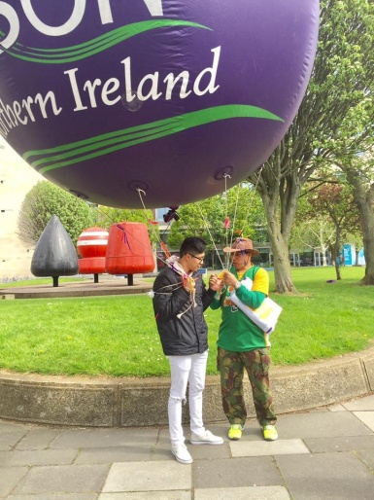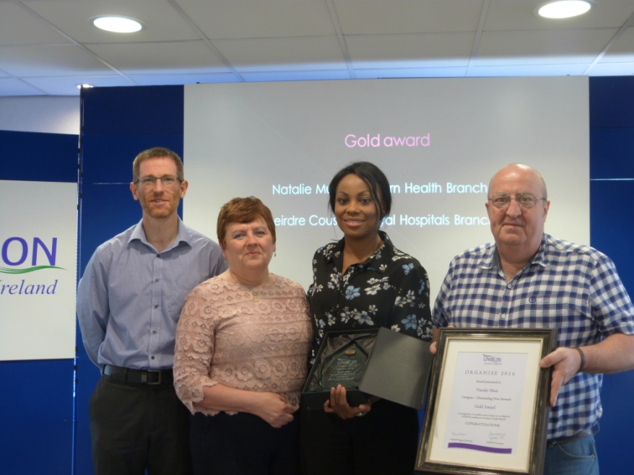

Recruiting and organising Black members
The Black and Migrant Workers group (B&MW) had an exciting and busy year with new members joining the group, and some completing their steward training.

The activities organised by the group are based on needs identified through our meetings and reflect the makeup of the Black Members’ membership in our region: Over 99% of Black members in Northern Ireland are migrant workers. This gives the group a slightly different focus than most Black members’ SOG in England or Wales.

- Communication and visibility
The group continued to meet bi-monthly and send e-bulletins to all Black and Migrant Workers and to branches in the region after each meeting. The group also put together a report after attending Black Members Conference in January.

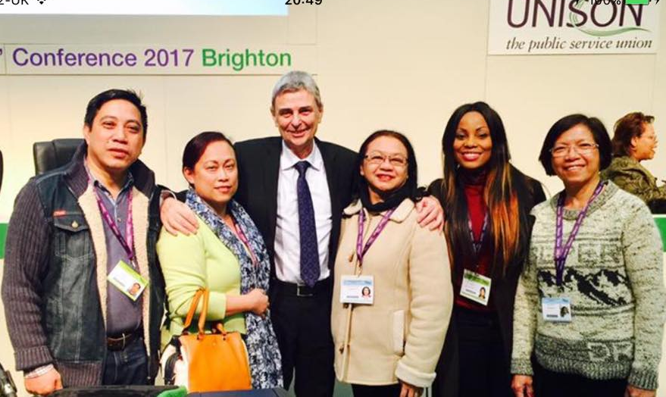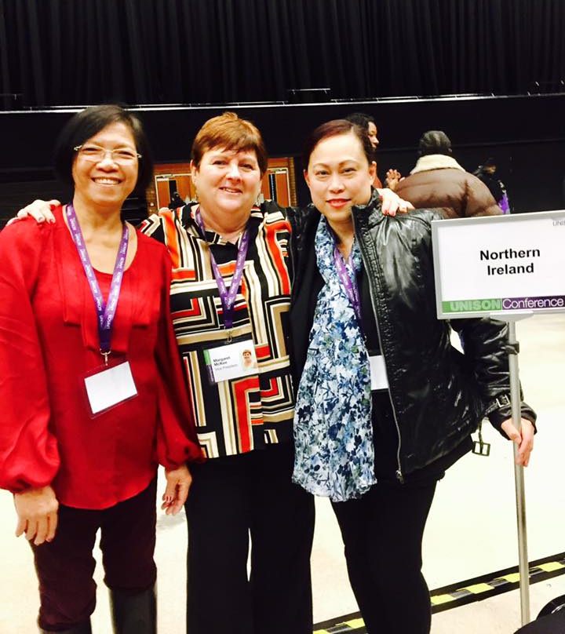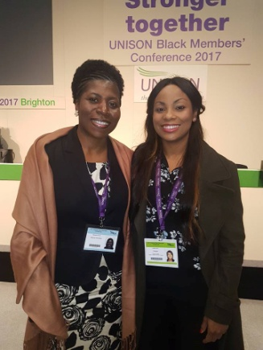

The group was represented at a number of events within Black / Migrant communities throughout the year (e.g. stalls at Onam festival celebrations in September, Horn of Africa Eid Celebration; etc.). Members of the committee have also been very active in organising reception parties to welcome (and sign up!) newly arrived Filipino nurses.

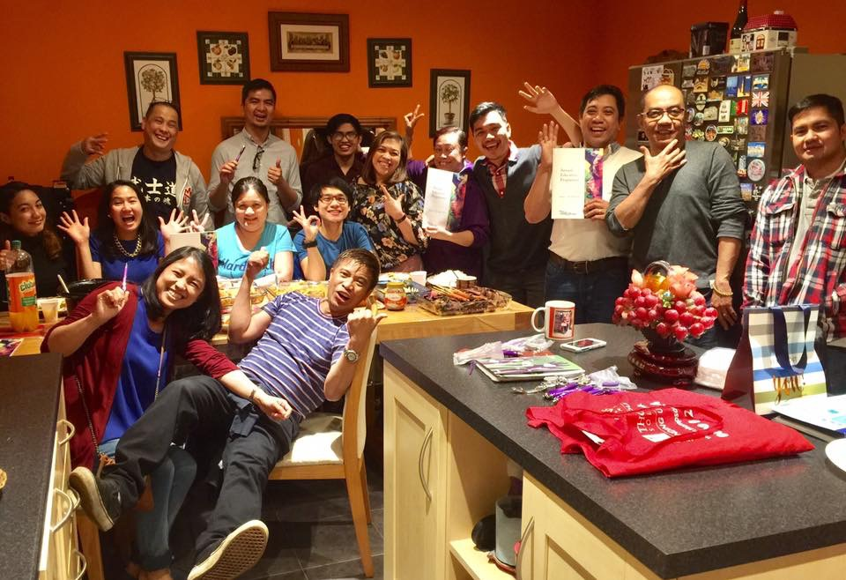

- One Day Without Us
On Monday 20th February UNISON members joined the “1 Day Without Us” celebration.
1 Day Without Us was a UK wide initiative that emerged following the EU referendum to celebrate the contribution of migrants. It coincided with UN World Day of Social Justice and was also marked by a mass lobby in Westminster to ensure EU migrants’ rights were not used as bargaining chips in the Brexit negotiations.

Locally we had lively stalls in hospitals throughout the region. A delegation also went to a demonstration outside Belfast City Hall under the ICTU banner “Migrants make us richer”.

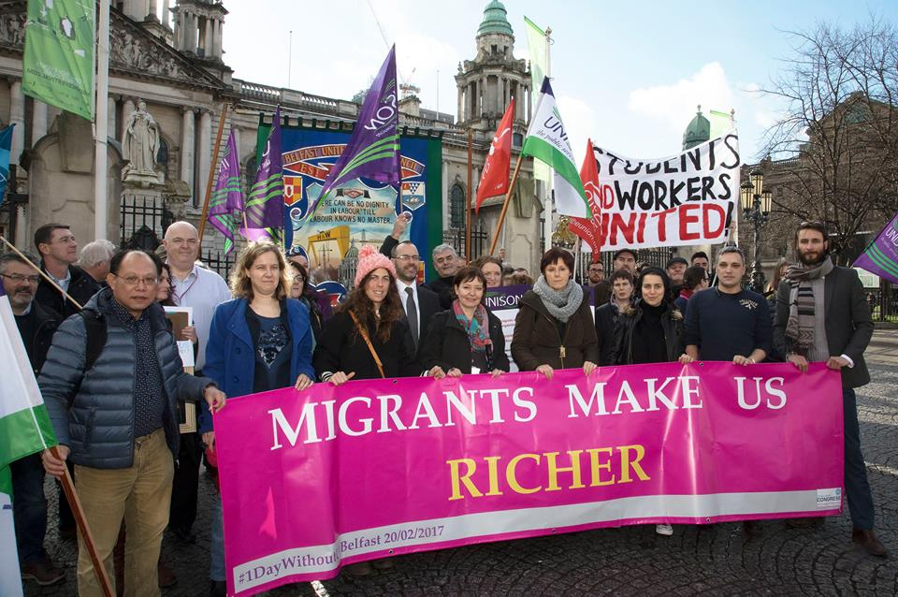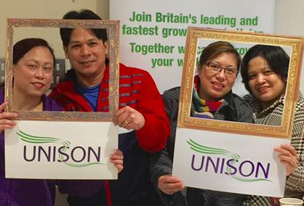

- Anti-racism
A delegate from our group represented us at an Anti Racism rally organised in March in London.
Locally we continued to speak out against racism and contact members who have been intimidated / attacked in their homes to try and offer support.

We also continue to have a regular input into the steward training courses to discuss racism, discrimination and raise awareness about issues faced by Black and Migrant Worker members.

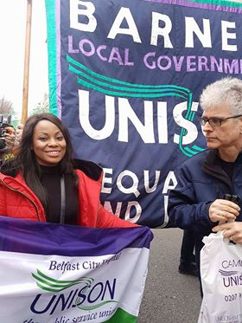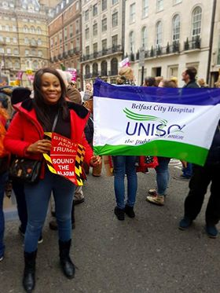

- Brexit follow up
The group was involved in a coalition looking at the effect of Brexit on migrant workers living here. This led to a petition asking the Irish Government to allow access to Irish citizenship for people with permanent right reside & Indefinite Leave in NI.

Currently while local people can opt for Irish or British citizenship, this option is not open to migrants who need to go down the citizenship route.

“We firmly believe in the principle of equality before the Law and non-discrimination under the Good Friday Agreement and applicable international human rights law; and accordingly demand that anyone who acquired permanent residency or Indefinite Leave to Remain in NI has an equal right to Irish citizenship, as Irish or British nationals born in NI.”

- International English Language Test System (IELTS)
Our group had been campaigning for years -submitting motions to UNISON conferences and sending petitions / letters to the NMC- for a change in the criteria used to measure the level of English of overseas applicants. The IELTS English exam (where nurses need to score 7 out of 9 in all sections of the test) seemed a colossal hurdle. We campaigned to lower / average out the score needed and / or to allow access to a different, more tailored test such as the Occupational English Test (OET).

The announcement by the NMC that it would accept OET as well as IELTS from November 1st was therefore a very welcome news for the group!

- Immigration advice clinic
Our region continues to give members (and refugees / asylum seekers) access to monthly immigration advice clinics with an immigration solicitor. This is a vital service for our members; it also contributes a great deal to making us very visible in the community voluntary sector and with organisations dealing with migrants.

- English classes
Similarly, our English classes remain very successful and contribute towards making us stand out as a union providing support for Black and Migrant Workers. The IELTS preparation class is hugely popular and has now reached full capacity.

Other activities linked to UNISON objectives and priorities for 2017
- Supporting Refugees
Our region continued to support refugees and asylum seekers through a number of initiatives.

Firstly our English IELTS classes and our immigration advice clinics are open to referrals from refugee support organisations. This has allowed us to develop closer contacts with a number of asylum seekers who came from a medical background and will hopefully be able to work in the health sector eventually (and join UNISON). Some of the students are nurses but others are also doctors, pharmacists, physiotherapists, etc; all are trying to find their way through the many loops and hurdles that will face them before being allowed to practice their profession in Northern Ireland.

In July, this lead to a scoping exercise that was organised with the Department of Health and HR from the Belfast Trust inviting those with qualifications in medicine, nursing and allied health to an information session in one of the Belfast hospitals. New opportunities for placement, local training, volunteering and adaptation courses are currently being explored by UNISON and Trust HR.

The B&MW group was also involved in an event organised with the education team about Refugees at home and abroad. The event gave an opportunity for the refugees attending the English class to join the workshop and establish contact with branch activists who were at the event.

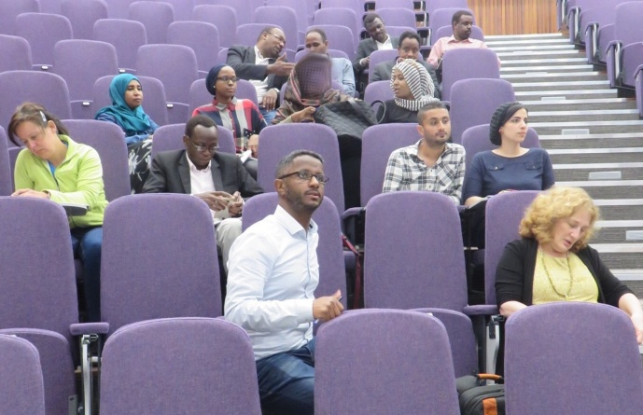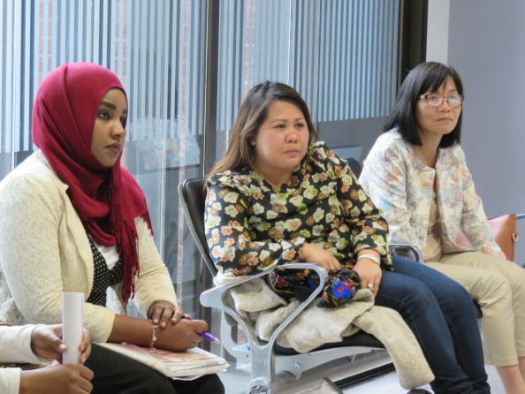

- End DP
Last winter our group was involved in supporting organisations and asylum seekers asking the Irish government to scrap the Direct Provision system in place in the South of Ireland which puts asylum seekers in quasi detention conditions.

UNISON’s B&MW committee was key in getting the Irish Trade Unions to condemn that practice at one of the ICTU’s annual conference, and the group remains involved in campaigning against this appalling situation in the South.
. 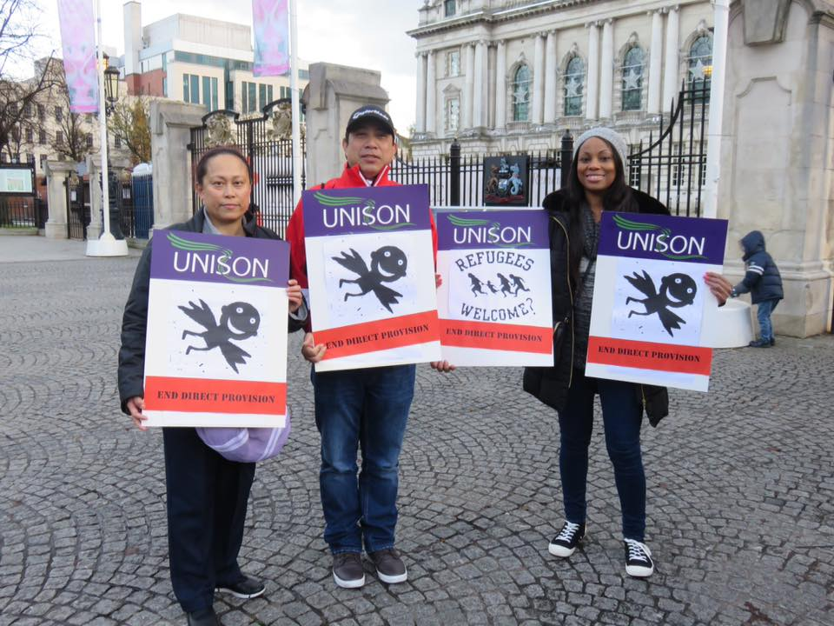 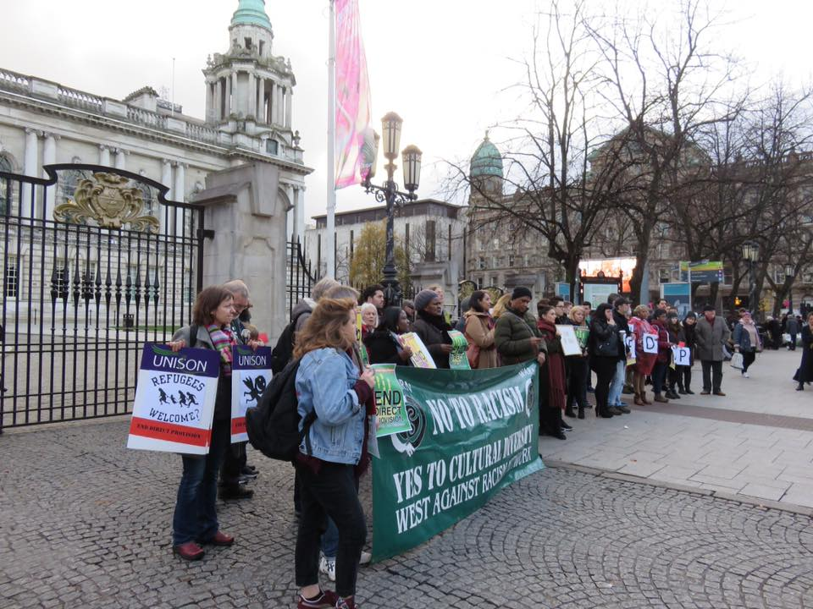

Planned future activities
The group is planning an event around Easter next year with members and their families. Our group has not organised any celebration event for all B&MW members in the region for some time and the group feels that it would help bring people together and identify new activists.

Members of the committee are busy organising further reception parties for newly recruited overseas nurses in the different Health Trusts. This will be a feature of group activities for next year and will hopefully be a source of new people for our committee as well.

The English classes will need to be revisited next year to reflect the changes announced by the NMC.

The group is also sad to lose one of our active members who had brought fantastic new energy to our group. Natalie is moving to the Republic of Ireland and although we are delighted for her and wish her all the best, we are all sad to see her go.

The group will continue its anti racism work within the union, especially through its input into the steward training courses.

South East Region

Recruiting and organising Black members

- Members of the South East region attended various Carnivals including Oxford, Portsmouth
- Look at data leaver/joiners in the region, new stewards training data and how we can use this for more participation of members to regional meetings
- SERBM 2nd Newsletter to be produced for Conference in Liverpool
- At the Training Forum we highlighted to members from the region that attending National Black Members conference is very helpful in understanding how the Union works and getting more involved. We hope this means that more will attend as our numbers were pretty low in 2017.
- Mapping of Black SOG’s in the region
- Black members leadership training and forum was a success with 15 attendees for the weekend in Eastbourne. 3 motions were written in the workshop and 2 will be submitted to NBMC. 2 motions that were not heard in 2017 will be submitted again. 3 motions were submitted by the Vice Chair Judy Richards and these will also be submitted making 7 motions from the SE Region.
- The SE Region are not holding a Black History Event this year so it has been decided to award small monetary amounts to SE Groups who apply. This went on the website and to members.
- Equality Action Group meeting held in Guildford, new terms of reference to be completed
- First Race Advisory Group (RAP) meeting terms of reference updated and action plan agreed (formally SLWG)
- Sent out leaflet ‘Setting up a SOG in your branch’ to all SERBMG
- Oxfordshire Unison Black Members launch event planned for recruiting Black members in and around Oxfordshire

- The production of a Black health pack is ongoing – information is being collated

Planned future activities
- South East Region Black members forum and networking 2018
- South East Region Black History Month Event 2018

South West Region

Campaigns and activities

Race equality and cuts/Million Voices
- Tolpuddle
- Bristol Pride
- Plymouth Pride
- Patchway Community Event
- Bristol Souls of Nation History Exhibition and Black History walk
- Network and recruiting - 2017

Recruiting and organising Black members
- Race equality and cuts/Million Voices
- Tolpuddle
- Bristol Pride
- Plymouth Pride
- Patchway Community event
- Bristol Souls of Nation History Exhibition and Black History walk
- Network and recruiting - 2017

Other activities linked to UNISON objectives and priorities for 2017
The year started with Conference training for the new delegates to Conference and UNISON structures for both new delegates and committee members.
Training was given by Sharon Foster and Paulette Blake. However the take up for Conference training is very low.

Reason: Apathy and information not being sent out from the facilitator of the committees section.

Various other events took place during the year within the South West. The committee took every opportunity to inform the public about Unison work and to recruit.

Building on last years successful Black History tour and walk in Liverpool. The committee decided as part of it’s contribution to Black History Month to go to London.
We took 49 Unison members and their familes plus non-members from Bristol to London to see the exhibition, Souls of a Nation. This was followed by a successful
Black History walk around the St Pauls area of London.
Feed back was brilliant and we have a waiting list for next year’s event.

Planned future activities
- Helping to reforming the Bristol Branch retired members committee
- Food Banks
- Migration
- Memory lost awareness
- The dangers of the rise of the far right in Europe
- Recruiting more members

Yorkshire and Humberside Region

Campaigns and activities

Recruiting and organising Black members
- The group has an effective group webpage for members to access

- SOG stall at the Region’s Doncaster Race Event in August 2017

- The group has written to branches and equality officers introducing the Chair and the group’s plan for the year.

- Encouraged branches/members to participate in Show Racism the Red Card – Wear Red Day on 20 October 2017

- Regional BM survey devised on the effective support given to BM at branch/regional level. Closing date 31 October 2017

- Encouraged BM voter registration and sign up to Labour link/Party

Other activities linked to UNISON objectives and priorities for 2017
- Chair/Deputy Chair attended Race Discrimination case conferences with Thompsons

- Chair attended Regional Leadership meetings

- Leeds Teaching Hospital planned visit to Liverpool Slavery Musuem 21 October members of group invited, subject to seat availability

Planned future activities
- Develop a 6 monthly newsletter

- Continue working on UNISON key objectives

- Training to take place in December – Pathways into UNISON.

National Black members’ committee attendance

There were four meetings of the National Black Members’ Committee over the last year which took place in March, June, September and November 2017.

The appearance of a (JS) after two names together indicates job-sharers.

Name | Region / Self Organised Group | Potential Attendance | Actual Attendance
Rodney Williams/Sandra Okwara (JS) | Eastern | 4 | 4
Tianna Wright/Nicola Francis (JS) | Eastern | 4 | 4
Sudeep Bone | East Midlands | 4 | 3
Ash Dhobi | East Midlands | 4 | 4
Elizabeth Baptiste | Greater London | 4 | 3
Annette Heslop | Greater London | 4 | 4
Mitsy Harmon-Russell | Greater London | 3 | 3
Iqbal Syed | Northern | 4 | 4
Lilian Adani | Northern | 4 | 4
Vacant | Northern Ireland | 0 | 0
Vacant | Northern Ireland | 0 | 0
Kim Johnson | North West | 4 | 3
Azara Azam | North West | 4 | 3
Mirza Hamie/Calvin Smeda | North West | 4 | 1
Rakiya Suleiman | Scotland | 4 | 3
Madhu Sharma | Scotland | 4 | 1
Tania McGee | South East | 4 | 4
Rosita Ellis | South East | 4 | 2
Nathan Aljoe | South West | 4 | 4
Kitty Smith | South West | 4 | 4
Pam Singh | Cymru / Wales | 4 | 3
Kebba Manneh | Cymru / Wales | 4 | 3
Manjula Kumari | West Midlands | 4 | 3
Sharon Dixon | West Midlands | 4 | 2
Sharon Carby-McLean | West Midlands | 4 | 3
Kuldeep Bajwa | Yorkshire & Humberside | 4 | 4
Aniqa Hashmi | Yorkshire & Humberside | 4 | 4
John Campbell | Yorkshire & Humberside | 4 | 2
Chelsea Skervin | National Disabled Members’ Committee | 4 | 3
Jacqueline Jones | National Disabled Members’ Committee | 4 | 4
Bev Miller | National Lesbian, Gay, Bisexual & Transgender Committee | 4 | 4

Davis Mac-Iyalla | National Lesbian, Gay, Bisexual & Transgender Committee | 3 | 3
Paulette Whyte | National Women’s Committee | 3 | 3
Pam Sian | National Women’s Committee | 4 | 3
Elizabeth Cameron | NEC Black Members’ Representative | 4 | 2
April Ashley | NEC Black Members’ Representative | 4 | 3
Abiola Kusoro | NEC Black Members’ Representative | 4 | 4
Hugo Pierre | NEC Black Members’ Representative | 4 | 4

