Parks and open spaces Freedom of Information request
Background
Britain’s parks and green spaces, run by local authorities, are a vital local service, contributing to the health and well-being of the UK in many ways.
They give children and young people a chance to meet friends in a safe place, take part in sports and recreational activities, and get involved in a variety of educational events.
For adults, parks provide space to exercise, socialise, and enjoy natural environments.
Research by the Heritage Lottery Fund (2014) made clear how important parks are to people. It found that 68% of park users consider spending time in their local park important or essential to their quality of life (State of UK public parks 2014 – Renaissance to risk?).
But years of austerity have left many of our parks run-down, under-staffed, and in need of urgent attention.
In February UNISON sent Freedom of Information requests to council’s responsible for parks in Britain. Of the 270 council’s contacted, 207 responded in full or part. We asked them about their parks budgets, and what has happened to staffing levels in recent years.
Results
- Six in ten (59%) of responding local authorities – more than 100 – had cut their parks budgets between 2016/17 and 2018/19, resulting in spending cuts of more than £15m.
Total number of councils who responded fully to this question: | 172
Number of councils reducing their budget: | 101
Number of councils increasing their budget: | 67
Number of councils staying the same: | 4
Difference between overall budgets 2016/17 and 2018/19: | -£15,412,667
Average decrease of those who decreased their budget: | -£275,765
Average increase of those who increased their budget: | £185,666
Percentage of councils decreasing their budget: | 59%

- Sixty local authorities had reduced parks staffing levels, with an overall loss of around 275 workers since 2016. That’s 275 fewer people to do basic, but vital jobs like open parks on time, close them, keep them clean and safe, check everything is working properly, and maintain park services.

Total number of councils that responded fully to this question: | 166
Number of councils reducing their staff: | 60
Number of councils increasing their staff: | 44
Number of councils staying the same: | 62
Difference in staff: | -274
Of the councils who lost staff, the average loss of staff is: | -9
Of the councils who increased staff, the average increase is: | 6

Local authorities with the biggest reduction
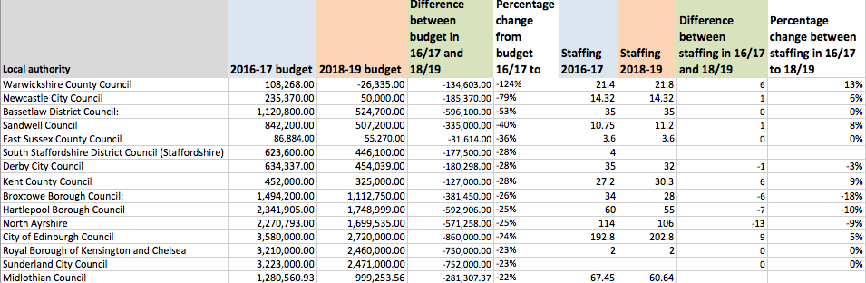
Overview

Not surprisingly, the cuts haven’t been spread evenly. Each local authority has set varying priorities and made different decisions about how to spend their money. In Warwickshire County Council, for example, the parks and green spaces budget was slashed by 87% in just one year, reducing spending from £108,268 in 2016/17 to £14,184 in 2017/18. But this council’s parks and green spaces budget for 2018/19 is even more worrying. It reports a negative budget of minus £26,335.
The real fault for council spending cuts lies not with local authorities, but with the Westminster government. Councils may make their own decisions on how to spend their money, some more successfully than others, but all local authorities are battling with incredibly scarce resources.
Since 2010, UNISON estimates that £16bn has been cut from central government funding for local authorities.
As councils struggle to fulfil their statutory responsibilities, like coping with the social care funding gap amid rising demand, it is no surprise that parks aren’t getting the resources or attention they deserve.
Parks and other services like youth centres can play a vital role in the longer term health and well-being of the population. Investment in these services can reduce the reliance on health services, the criminal justice system, and social services in future years. But with millions of pounds in savings needed, councils have little scope to engage in long-term strategic planning.
Indeed, by 2020, the revenue support grant – the main source of Westminster funding for councils – will have disappeared. This will leave councils completely reliant on council tax and business rates for their survival. There is enormous uncertainty about what comes next for local authority funding, so it is hard to see how councils can develop effective long-term strategies to save vital services like parks.
Clearly something needs to change. This year, UNISON is campaigning for a new and fair funding settlement for local government. We are calling on the Chancellor to use the November Budget to address the massive and disastrous funding shortfall that the UK’s councils are facing.
We are also supporting the Charter for Parks, backing a legal duty to maintain parks to a minimum standard and committing to ensuring they have the funding, resources and protection they need. We want Members of Parliament, whatever their political party, to talk publicly about how important their parks services are, and to put maximum pressure on the Chancellor to recognise this in all future local government funding settlements.
The health and well-being of our communities depend on it.

