Stronger together

UNISON national lesbian,
gay, bisexual and
transgender committee

Annual Report 2017

#ULGBT17

Contents
Introduction from the co-chairs 4
Recruiting and organising 5
Bargaining 7
Campaigning 10
International 12
From the caucuses 14
In the regions 19

This report of UNISON’s national lesbian, gay, bisexual and transgender members committee covers our work from November 2016, following the last annual conference, to the end of September 2017.
Actions on last year’s conference decisions and monitoring information are included in a separate document. Please email out@unison.co.uk for a copy, or write to Carola Towle, UNISON LGBT equality, 130 Euston Road, London NW1 2AY.
UNISON is the UK’s largest public service trade union. We have a proud history of working for equality for all. For more information on our work for LGBT equality, visit unison.org.uk/out.

Introduction from the co-chairs
What an extraordinary year it’s been. Who would have thought that in just 12 short months the whole world would have changed in the way it has? From political instability, to the rise of the right and increases in intolerance and hate crimes, it seems that every month we have been battered with more bad news, challenging situations, and the deaths of so many.
We galvanised ourselves in our droves to knock on doors and leaflet drop ahead of the snap general election, we campaigned for Labour candidates all over Britain and were rewarded with new Labour MPs.
With the Tory party rapidly losing credibility over Brexit negotiations, its majority partnership with the dubious DUP causing disquiet, and the constant infighting, we need to step up our engagement with LGBT Labour and Labour Link to keep LGBT equality on the agenda. We need to remain in a constant state of readiness for the next elections. Despite the constant negative messages, we hope that the events of the past 12 months enthuse and encourage a new generation of people to become active within the union to make sure that we continue to win rights for LGBT members.
Who knows what lies ahead on the campaign trail – what we do know is that together we will challenge the erosion of equality, we will fight for our rights and we will tackle discrimination in all its forms.
We hope you have an enjoyable conference. There promises to be a lot of interesting debate.
Darienne Flemington and Dave Merchant

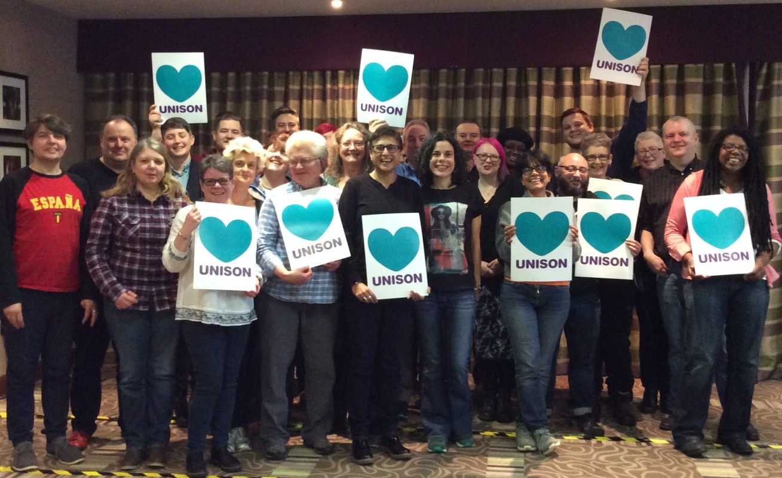

Recruiting and organising
Organising is the beginning, middle and end of our work as UNISON LGBT group. Without it, we are just another set of good ideas and aspirations. Fortunately, it’s something we do well. The second annual UNISON equality survey showed that LGBT members have particularly high levels of activism, a great appetite for more union involvement and a lower age profile (meaning more years of union activism ahead of them!) than members in general.
Our regional groups and national networks of bi, trans, Black and disabled LGBT members are the backbone of this. Of course, groups have their ups and downs, but what they achieve together over the course of the year is very impressive. You can read about what they’ve been up to in their reports below.
Nationally, we support all this organising activity by providing regular information and up to date resources, via our webpages, Out in UNISON, the monthly LGBT e-bulletin, social media, the LGBT forum on the UNISON organising space and advice on hand by email, on the phone or in person. We also bring activists together in twice yearly regional convenors meetings, network meetings, caucus meetings at other UNISON conferences and a host of other initiatives.
New for this year’s LGBT conference is our LGBT recruitment toolkit, which brings together our resources and top tips in an easy to reference format.
Numbers of branch LGBT officers are growing steadily. We now have a hundred and thirty nationally trained, with the next training scheduled for Spring 2018 and an e-note (online training module) in development. We are pleased to see the growing involvement of branches at local pride events, that has reaped rewards already. Special mentions are always tricky but we would like to wave the rainbow flag for Hull, which hosted the first UK national pride event and the first ever Isle of Wight pride, which the UNISON branch was central to organising. Details are in the Yorkshire and Humberside and South East regional reports, respectively.
We also want to record our immense gratitude to Bromsgrove samba band Someone at the Door, who played through a marathon London pride march. It may not have been 26 miles, but it certainly felt like it. They kept our spirits high and gave UNISON a great profile on the march. Thanks too to the general political fund for supporting our attendance at key national events. In 2017, this was UK national pride, Black pride, London pride, UK trans pride, Sparkle and BiCon.
We also organise via calendar events, as well as geographical ones. There are a host of opportunities throughout the year to promote our values, resources and the benefits of union membership and activism. For LGBT history month in February this year, we promoted a presentation of our proud history. This has detailed notes pages so it can be – and indeed was – delivered by anyone. We had overwhelmingly positive feedback on this, one of our favourites being that it was used in one workplace for their ‘Feel good Friday’ session. It is being tweaked for 2018 and will be available in plenty of time for February, which marks the 30th anniversary of the infamous Section 28. If you don’t know about Section 28, you will find out in February!
We have marked Trans Day of Visibility, IDAHoBiT, Bi Visibility Day, world mental health day and national hate crime awareness week. We are preparing to mark Intersex Awareness Day, Trans Day of Remembrance and World AIDS Day. We have publicised flag flying initiatives, such as the bi flag over Oxford Town Hall. Recounting how she had achieved this, branch activist Stephanie said her only regret was that she hadn’t got a bigger flag! Following a suggestion at this year’s bi network meeting, we produced a downloadable UNISON Bi Visibility Poster and urged branches and activists to display it in workplaces on 23 September.
UNISON is noted in the trade union movement for our LGBT organising. We were glad to support the first TUC LGBT leadership school this spring. UNISON’s Anu Prashar and Katrina Gilman participated in the school and our national officer, Carola Towle, led a session on organising.
Tackling under-representation is always high on our organising programme. We are determined that our LGBT group and activities reflect the full diversity of LGBT members. Particular initiatives this year include promoting greater attendance of young and low paid members at LGBT conference. As most branches only send one or two delegates, this involves encouraging experienced activists to step back in favour of first time delegates. We have promoted the value of attending conference as a visitor, through Out in UNISON and via regional LGBT groups.
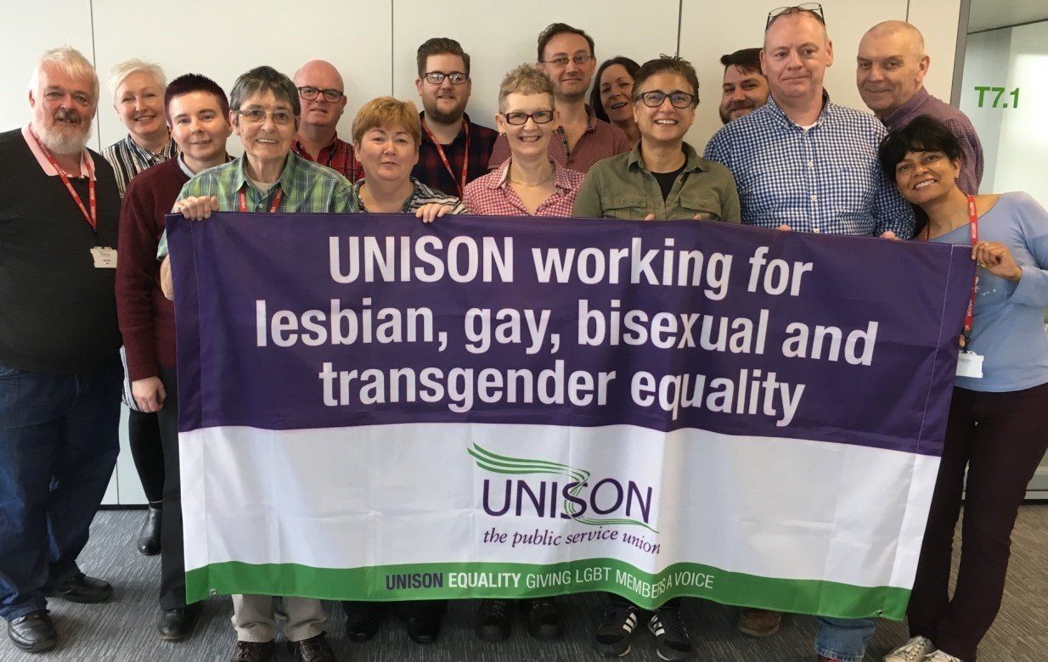
We continue to publicise the importance of retaining LGBT members in activism when they retire. They are an invaluable organising resource. This is working well in some pockets: the challenge is to spread the good practice. We have supported retired LGBT activists in building their network, via LGBT and retired members organisation. We had a very useful session at the first regional LGBT convenors meeting of the year, where two retired members led a session on how to make it work. They have been collating information on what happens around our regions. We will continue working with them to pursue best practice. We are considering a similar initiative with the young members forum in 2018.
Our major piece of organising work this year has been building non-binary inclusion. This is a vital and timely initiative. The number of motions on our 2017 conference agenda on this show the interest from around our union. Work this year has included publishing and promoting a factsheet ‘Gender identity: non-binary inclusion’; speaking at numerous events and training sessions; continuing to check UNISON’s myriad systems and procedures and correct them where necessary; a series of articles in Out in UNISON and links to further information in our monthly e-bulletin. This work is by no means complete. Our first survey of non-binary members is out now. We hope to have preliminary findings at conference in November. One of the conference workshops is on non-binary inclusion.
We have packed out the programme for this year’s conference, with a host of side events and drop-in sessions. These include branch LGBT organising surgeries, advice on digital organising and on strategic organising, and a skills share session for regional LGBT convenors.

Bargaining
It’s been a busy year on the bargaining front. Our main role is supporting and informing the negotiation of decent workplace policy and practice. We do this by providing advice and guides for reps, which we update at least annually. Our core advice includes bargaining guides on LGB, trans and bi equality. The next challenge is getting this into the hands, hearts and brains of negotiators. This is by working with our service groups, training, awareness raising and publicity. The more reps we have that are LGBT, the easier this task. The 2017 UNISON equality survey shows that LGBT members are particularly active across our union and we are determined to build on this.
This year, we have seen a big increase in the number of draft trans equality policies sent to us for comment. These range from very good (a small minority) to truly terrible. It is clear that many employers struggle with language and terminology, and also with the law on trans equality. But random searching online does not result in progressive and inclusive framing of good practice. Most employers have been very grateful for our input and the vast majority of our proposed changes have been accepted. One sticking point can be paid time off for absence relating to gender reassignment. But there are more and more examples of good practice, such as three months special leave, recorded separately to sickness absence.
We were proud to be featured in Transgender Europe’s new best practice catalogue, published at the beginning of the year, which you can read on their website tgeu.org .
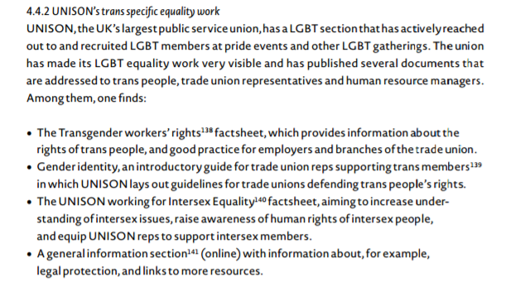
The trans caucus has been developing a much needed model policy, which was discussed at the trans network meeting in July. We hope to launch it at LGBT conference this year.

Other overarching themes have included LGBT workers and mental health, pointing out the impact of discrimination on mental well-being. There is growing recognition of mental health as a workplace issue. It has been debated at most UNISON conferences this year. We have consistently highlighted the need to differentiate between long term mental health conditions and stress related mental ill health. And when it comes to stress related mental health, pointed out that workplaces are the primary cause of this. While individual workers need support, it’s the workplaces that need to change to solve the problem, not the people affected.
Another major area this year has been our work on non-binary inclusion. We are working with all parts of the union calling for national and local agreements to be reviewed for unnecessary gendering, seeking inclusive language that raises awareness of non-binary identities, and negotiating inclusive policies, practices and procedures.
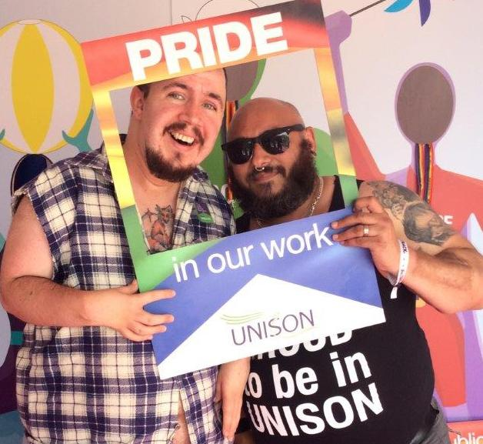
The LGBT group continues to promote UNISON’s work on intersex equality, publicising the bargaining factsheet which had its first outing at LGBT conference last year. There is a determination that LGBT members will be good intersex equality allies. There was an excellent session on this at the September regional convenors meeting.
As ever, our group was ably represented by all the delegates elected to service group conferences. Our thanks to them.
Terry kicked off the year, calling for action on trans equality at higher education conference. Darryl moved our motions on organising LGBT members and on fighting the cuts in the community sector. Frances and Jonai spoke at health conference on the impact of cuts on trans health workers and on taking forward the work of the NHS Equality and Diversity Council LGBT group, noting the challenges ahead. There is more about this work below.
Maz and Andrew at energy conference and Carl at water, environment and transport conference took forward our motions on UNISON’s Call Centre Charter. This charter aims to set a decency agenda for call centre workers, following a 2012 report showing appalling working conditions and high levels of stress. The original charter didn’t specifically refer to equality. Our motions called on the service group executives to find out where the charter had been adopted and check if there are specific initiatives to tackle anti LGBT abuse. We know from our members this is a real problem. Where there are no initiatives, we urge training for managers and staff and for this to be integrated into work on the charter going forwards.
Jennie and Jennifer moved our motions at local government conference on the impact of cuts on LGBT services and LGBT workers, highlighted by the NatCen survey, and on inclusive equality policies and terminology, focusing on non-binary inclusion. They also moved LGBT amendments on the equality dimension of UNISON’s work on apprentices, and on workforce mental health.
Shortly before LGBT conference, Lucy and Karl will have represented us at police and justice conference. Our motions there are beyond the binary in police and justice, noting good practice already established by some employers and the need to do more; and on promoting hope and saying no to hate. This second motion emphasises UNISON’s key role in identifying and tackling hate and promoting an inclusive workplace culture. We have submitted amendments on the loss of LGBT liaison officers and specialist hate crime officers and on the effects of austerity on our members and the services they provide, highlighting the findings of our NatCen research.
Lots happens between conferences of course. The annual joint energy and WET equality seminar this July included a session on supporting parents with trans children, led by one of our trans convenors, Emma.

We have assisted the National Association of Head Teachers (NAHT) develop advice for school leaders in supporting their LGBT staff. NAHT covers England, Wales and Northern Ireland. This is their first LGBT initiative. Their guidance is due out later this year.

We have worked with Scottish Trans Alliance (STA) and the Equality Challenge Unit on improvements to how the Higher Education Statistics Agency collects data on staff. This included removing a problematic question asking the legal sex of staff. This is unnecessary for virtually all employment purposes and risks breaching confidentiality. A compromise was agreed for 2017/18 and work continues of the framing of gender and gender identity questions in future.

Meanwhile, the NHS collects LGBT workforce monitoring information, including in the annual staff survey, but it is not routinely reported in findings. Trusts have to pay extra for that slice of their staff survey results. We have raised this with the NHS as a barrier to pushing forward LGBT equality work.
We sit on the group overseeing the implementation of a sexual orientation monitoring information standard for service users across health and social care in England. The delayed launch of the standard took place early in October and it is being rolled out in pilot trusts. The LGBT Foundation has published guidance to support the roll out, which we contributed to, and Health Education England is developing e-training for staff on collecting this information from service users.

We are also on the advisory board for research investigating the effectiveness of staff LGBT networks in the NHS in England, Scotland and Wales. The aim is to generate interest and ideas during the research, beyond the particular Trust networks in the study. You can join the conversation at lgbtnetworks.org.uk .

We have made contact with the national LGBT ambulance network. A number of UNISON members are involved through their ambulance services. We had a stall at their second annual conference and have invited two representatives as guests at our conference in November. We look forward to developing this relationship.

All this work takes place in the context of the devastating and multilayered impact of cuts on LGBT workers and our fight against austerity and to smash the public sector pay cap. LGBT members are at the heart of that fight.

Campaigning
We have always known that while clear campaign objectives are vital, it’s also important to be light on your feet. We need to be ready to seize opportunities as they present themselves.
This year has certainly had a few surprises up its sleeve.
Our LGBT priorities sit comfortably within UNISON’s priority campaigns – to smash the pay cap, promote our public service champions, build political influence and challenge the austerity programme, including attacks on the welfare state. We campaign for the election of governments in Westminster and the devolved nations which value public services and working people, rejecting the arguments of UKIP and other far-right parties. We say no to hate and are determined to defend workers rights and trade union rights during the Brexit process and beyond.
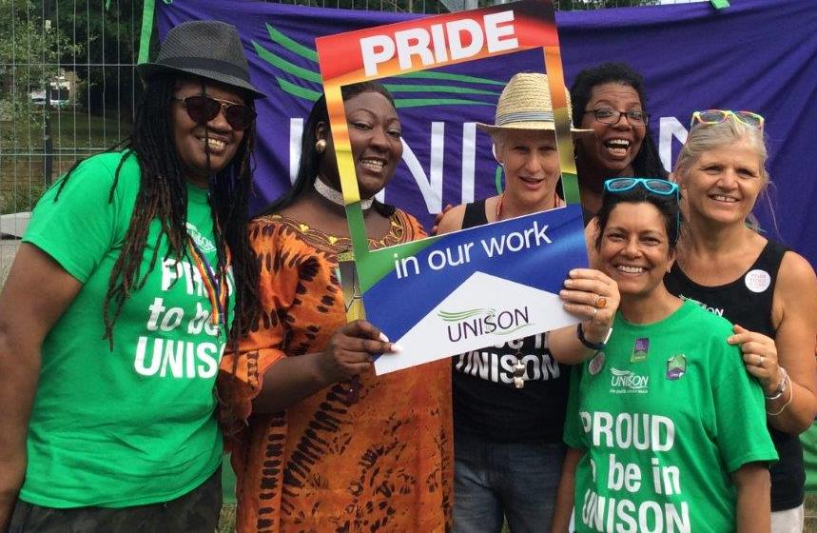
GPF-funded research by NatCen on the implications of austerity for LGBT people and services, launched at our last LGBT conference, has given us the stories and the robust evidence to feed our campaigns. We prepared a presentation with detailed notes pages for use by regional and branch LGBT groups, linking directly into UNISON’s public service champions campaign. This has been well used and customised for specific purposes such as our session at BiCon this year – see bi caucus report for details.
Early in the year, the Children and Social Work Bill presented an opportunity to push our long-term demand for compulsory sex and relationship education that is LGBT inclusive. We won half of this – the compulsory part. And we were pleased that Labour included the other part, the LGBT inclusive part, in its 2017 manifesto.
We submitted two motions to the 2017 LGBT Labour AGM in February – ‘LGBT Inclusive Sex and Relationship Education’ and ‘Protecting Our Rights, Asserting Our Values in a Post Brexit UK’. We were pleased to support UNISON members Chris Wills and James Anthony who were both elected to the new LGBT Labour national committee. Mark Kelly stood down at the AGM – we thank him for his work over a number of years.
We have always said that political education work has to take place all the time, every year, not only in the lead up to elections. Just as well – we were only a few months into the year when Theresa May called the snap general election.
We were well-placed to influence Labour’s LGBT manifesto. Along with commitments on sex and relationship education, the majority of our other suggestions on LGBT equality were written into the manifesto, including strengthening laws on trans equality and anti-LGBT hate crime, tackling bullying, ensuring health and social care workers have the necessary training to understand the needs of LGBT service users, and the roll-out of PrEP to high risk groups. Our main demand that was not included was full equality in surviving partner pensions. We carry on pushing this point.
As ever, LGBT members were out canvassing with LGBT Labour and in their own constituencies. Nationally, we pushed voter registration, the importance of using your vote and campaign resources to LGBT people and communities. We worked to place inclusive public services at the heart of this election. This time, the message gained real traction. The Tories came out of it much the weaker. The sting in the tail was their post-election deal with the DUP – the Democratic Unionist Party. The DUP have consistently blocked everything to do with LGBT equality in Northern Ireland. This deal shows the Tories’ true values, if these were ever in doubt.
The dodgy deal was struck in the lead-up to TUC LGBT+ conference and that conference selected a motion condemning it and calling for renewed action on LGBT+ equality for debate at Congress. UNISON’s motion was on solidarity for LGBT+ equality. This took key points from the two motions selected by our 2016 LGBT conference for debate at UNISON national delegate conference. It was carried unanimously. We submitted an amendment to a PCS motion on mental health, strengthening the action points. Both our nominees, Dettie Gould and Asha Wolfe-Robinson, were re-elected to the TUC LGBT+ committee. We thank them for all their work, promoting UNISON’s values and priorities.
Other wins this year include John Walker’s victory in the Supreme Court, in a case which has run for many years, seeking pensions equality for his same sex spouse. The court found that the get-out clause in the 2010 Equality Act, which permits the discrimination, is incompatible with the EU Framework Directive. This is an important ruling, but we still await a reply from the Treasury on whether the letter and spirit of this ruling will be applied to all public sector pension schemes, and if so, when and how. Other campaigns that have come to fruition are for ‘pardons’ for men convicted of homosexuality, the Isle of Man Equality Act, providing protection in goods and services, progress on the provision of PrEP on the NHS and of course UNISON’s stunning victory on having employment tribunal fees declared unlawful.
We are updating our LGBT campaign guide for branch and regional groups and incorporating our anti-far right guide into it. Having the two documents separate risked one or other being overlooked.
We are putting this report together during national hate crime awareness week, so our work on tackling hate crime is a fitting place to end this section. The national LGBT committee made it one of their priorities for the year and spent a session on it at their policy weekend this spring. We have worked with the other self-organised groups to develop a guide for reps on identifying and challenging hate at work, supporting those experiencing it, encouraging reporting and negotiating good workplace policies. This is supported by a one day course for activists which is being piloted in the East Midlands as part of their hate crime awareness week activities. There is also now a module on hate crime awareness on UNISON’s ERA (Employment Relations Act) stewards refresher course. It’s a one hour session to cover what is hate crime and why it's a union issue.
We have sought all opportunities to raise awareness across the union, including submitting an amendment to an NEC motion on tackling hate at national delegate conference and a motion on the subject to police and justice conference. We’ve raised awareness of the damage caused by hate spread online and via social media and what to do about it. This is a growing threat that we must be ready to respond to.

International
When we started our LGBT international work, many years ago, there were very few organisations of any kind with this focus. There is now much greater awareness of global LGBT equality issues and a proliferation of UK-based organisations with an international remit. They work on a range of issues, from decriminalisation and human rights abuses through community development to workplace policy.
Our objectives remain the same. We work to ensure an LGBT equality dimension in UNISON’s international work and to encourage an internationalist perspective among LGBT members, linked to UNISON’s international priorities. But there has been a shift in how we achieve these objectives. We need to maximise our particular advantage, as members of a global trade union family.
2016 LGBT conference set us a busy agenda for the year. We were asked to work with UK parliamentarians, including via the All Party Parliamentary Group on global LGBT rights. The APPG’s work to date has referenced the need for greater understanding of the role of trade unions in global LGBT equality. We are delighted that one of the leading officers of the APPG – Lord Ray Collins - has agreed to address our conference this November. The APPG works closely with the newly formed UK Alliance for Global Equality. This alliance of UK-based organisations is currently made up from the International HIV/AIDS Alliance, All Out, Commonwealth HIV/AIDS action group, Human Dignity Trust, Kaleidoscope Trust, UK Lesbian and Gay Immigration Group, Stop AIDS and Stonewall. We (unsurprisingly!) believe this group could benefit from trade union input and are having preliminary discussions about this with some of the partner organisations.
Conference also instructed us to continue our active involvement in ILGA, the international LGBTI association. ILGA is a democratic organisation with over 1200 global member organisations from 132 countries. There are 500 member organisations in 45 of the 49 countries in the European region alone. It is a brilliant organisation, unlike any other working on global LGBT equality. It gives voice to local LGBT groups and harnesses our collective expertise and ambition. The Europe region has co-ordinated the response to the terrible persecution of men in Chechnya and more recently in Azerbaijan. They have supported people working on the ground and raised donations via a dedicated fund. UNISON’s NEC agreed a donation to this fund at our request and we have promoted ILGA’s calls to action. We submitted an emergency motion on Chechnya to TUC LGBT+ conference in the summer.
Our thanks to the NEC international committee for their support on Chechnya and for supporting all our international work.
We have promoted many other ILGA campaigns, including their global maps and rainbow indexes and the #ComeOutForMentalHealth campaign this October. UNISON activist Darienne Flemington is co-secretary of the ILGA-Europe Board and heavily involved in steering their work. Other activists also contribute to ILGA’s work in Europe and globally. The one thing ILGA has struggled to get right is its system for paying affiliation fees and we know regional groups have had difficulties with this in the past. So this year, we led the collection of fees and submitted them all to ILGA in one go. This has been a resounding success and we now have nearly a full set of paid up regional LGBT affiliations, as well as the national LGBT affiliation.
Another priority is solidarity with Palestine – specifically stepping up LGBT awareness of the reality of the Israeli occupation and the importance of supporting the boycott, sanctions and divestment campaign. We were helped in this by an excellent exhibition and booklet - A dangerous occupation: the impact of 50 years of occupation on Palestinian workers. You can read this on the international pages of UNISON’s website. We used it to expand our own knowledge at our policy weekend and a number of regional LGBT groups have also used it. The exhibition will be on display at our conference in November. We have used our e-bulletin and Out in UNISON to promote the campaign, including an article on why Israel should be a no fly zone for tourists.
One of the motions selected by last year’s LGBT conference for debate at 2017 national delegate conference was on working globally for LGBT rights. This picked up the work towards the APPG and also work on the Commonwealth, noting that the UK is hosting the 2018 Commonwealth Heads of Government Meeting, or CHOGM as it is known (if you wonder how to pronounce that, the nearest rhyme we can think of is toboggan). We have offered to host ILGA in its meetings for the 2018 CHOGM and will be discussing this further with them over the coming weeks.
Our global union bodies Public Services International and Education International have long co-operated on their LGBT programmes. There have been a series of joint forums and publications, which UNISON has been involved with from the start. The next of these takes place in Vienna at the beginning of November. UNISON has offered a session setting out our history of LGBT organising.
Finally, there is growing recognition from a range of organisations that international LGBT equality is a workplace issue. That may sound obvious to us, but it has taken some others a while to reach that point. Clearly we have a great deal to contribute on this, but union recognition is not always on the agenda. Some initiatives have an almost exclusively employer/management focus. We will continue to network with activists in other unions and make sure that LGBT workers rights are not seen in isolation from wider issues of workplace justice.
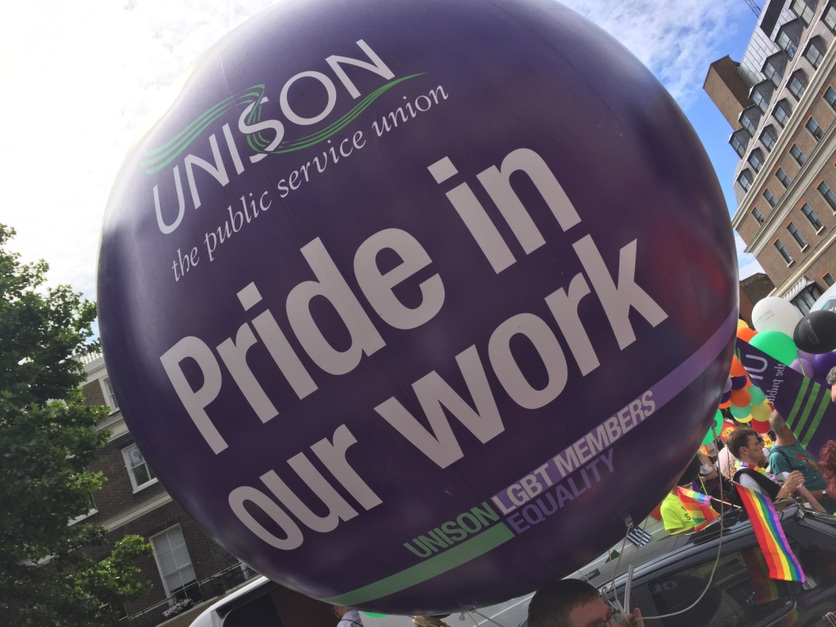

From the caucuses

Bisexual members
We have had a continued presence in Out in UNISON magazine over the year, from photos and articles about the bi network day to photos taken of us at various events.
We had our network day on Friday 14 July, which more people attended than in previous years and was a mix of regular faces and some new ones. This is positive as the bi caucus has grown considerably over the past year.
Our network day kicked off with us running the workshop for BiCon, the annual weekend for bi people, family and friends, which UNISON has sponsored for a number of years. We felt it was important for the caucus as a whole to get involved and give constructive criticism. Our theme for BiCon was about promoting the public service champions campaign with a bi focus.
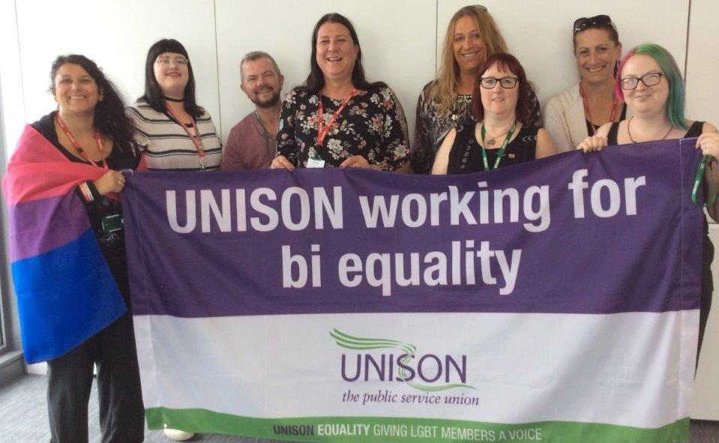
We spent a good deal of time discussing motions for conference at network day and the overall consensus was that we need to continue to have something on the agenda around tackling biphobia. We had a discussion around how this is always on the agenda and why it 11 years after the B was included, we still need to address it. This year we have 3 motions included on conference agenda.
We successfully delivered the public service champions campaign at BiCon in Leeds this year, including showing UNISON’s 15 minute care make over film. This was a good event with many attendees, and lots of audience participation. We had some lovely feedback. It was good to have done such prep work on the workshop and actually have a presentation, which was nice to hear.
This year has also seen the creation of a bi caucus facebook group, which members can be added too. We have a public facing page and a secret closed group so it’s confidential.
We are planning for Bi Visibility Day as many of us are isolated. Plans include a twitter thunderclap called the big bi tweet. If you missed it this year – look out for the next one!

Black members
Throughout the year, Black LGBT caucus members have worked collaboratively with the national LGBT committee, convened by Anu Prashar and Bev Miller. We suggested Aderonke address our national conference to share the news about her long fight for leave to remain in the UK.
Our representatives on the National Black Members Committee (NBMC) were Bev Miller and Davis Mac-Iyalla. They have contributed to the work of the NBMC and ensured a Black LGBT perspective in motions and during discussions.
With NBMC, caucus meetings take place on the evening before the committee meeting. Unfortunately, due to lack of membership and attendance none have taken place. We need to discuss ways of increasing Black LGBT participation on the Black members’ committee, particularly from regions.
Bev was elected to attend national women’s conferences, on behalf of the NBMC.
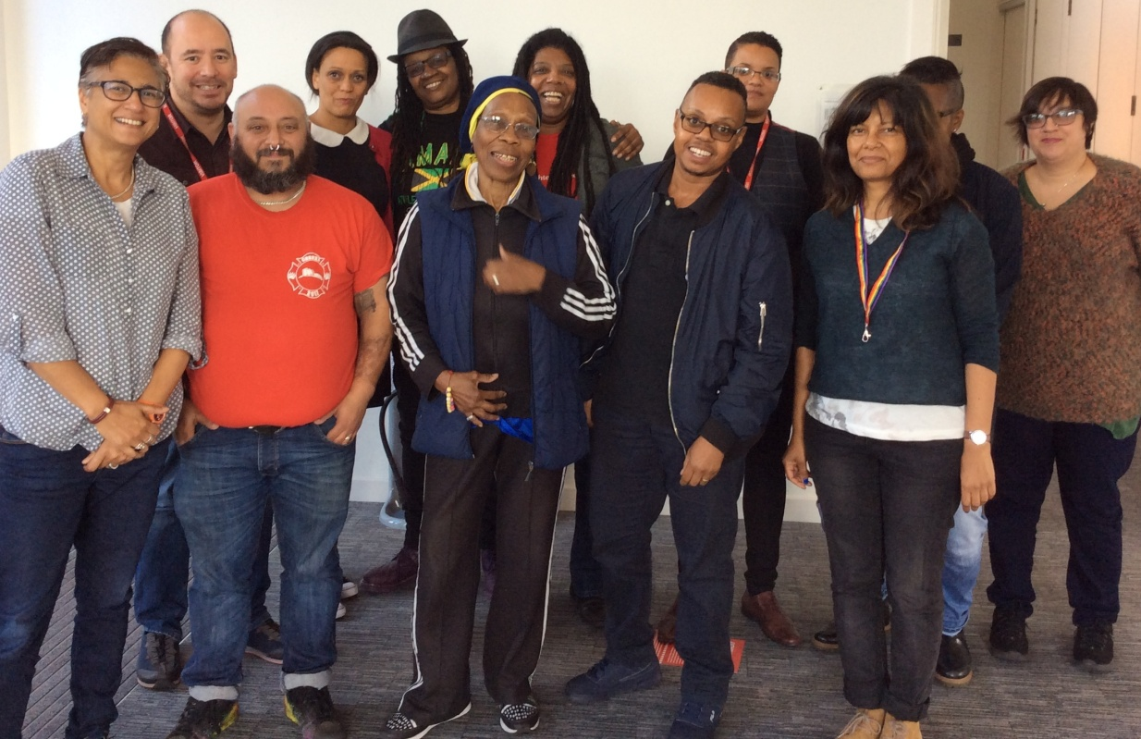
Dettie Gould and Asha Wolfe-Robinson were successfully re-elected as UNISON nominees to the TUC LGBT+ committee in July. They have shared UNISON’s views and promoted pertinent policies as exemplary. Other caucus members were also on the UNISON delegation at the conference.
Members of the caucus, plus other Black LGBT members, UNISON LGBT staff and the national race equality officer, actively participated in UK Black Pride. The event was held as part of the London Pride events after the TUC LGBT+ conference. Our focus Pride was recruitment and raising awareness of our work within UNISON and the trade union movement. UNISON’s stall had materials promoting our public service champions campaign, equality factsheets and publicity for our Black LGBT network day. It created opportunities for us to network with other LGBT unions, community based groups and LGBT organisations.
Our Black LGBT network day, held in September, was well attended. It was promoted by the LGBT group and the NBMC throughout the year.
Anu Prashar reported on Black members’ conference 2017. This included guest speakers, meetings, motions presented and activity of the Black LGBT caucus in terms of motions that we spoke on. Bev gave feedback on the work with the national Black members’ committee.
Caucus attendees discussed motions and amendments. We also made nominations to next year’s standing orders committee, and for delegates to national delegate conference, TUC LGBT+ conference and service group meetings.
The discussion touched on Brexit and how in the wake of the result, the rise in racist attacks have particularly affected Black LGBT people. We also discussed racism within the LGBT community. We agreed motions and amendments to LGBT conference and motions to Black members conference.
We had a wonderful speaker from the strategic organising unit who spoke on organising migrant workers. She answered questions and suggested ways we could get involved in the work. Some of this information was incorporated into our Brexit motion.
Bev Miller will represent UNISON in October at a Black history month event on mental health and Black LGBT people.
We are looking forward to LGBT conference this November. Caucus members will be moving motions and amendments and chairing conference and the Black caucus meeting.

Disabled members
Throughout 2017, disabled LGBT caucus members have worked with the national LGBT committee in many areas, including those from last year’s LGBT conference decisions and other work which arose during the year.
Bev Miller and Louise Ashworth represented the national LGBT committee on the national disabled members committee (NDMC), providing the disabled LGBT members point of view on many issues.
They have raised awareness around intersex equality. This has led to a motion from the disabled LGBT members caucus to 2017 national disabled members conference. We have distributed the UNISON factsheet on intersex equality, raised awareness around non-binary inclusion, proposed amendments to election procedures and language used in meetings.
Our reps have actively contributed to the NDMC work programme in respect of PIP, Access to Work, sickness absence, disability rights post-Brexit, general election, reasonable adjustments and other areas. At NDMC network days, Louise facilitated a session on ‘How we got here and where we still have to go’. This focused on the 50th anniversary of partial decriminalisation and the history that got us here. We also took photos to promote Wear Red Day for Show Racism the Red Card.
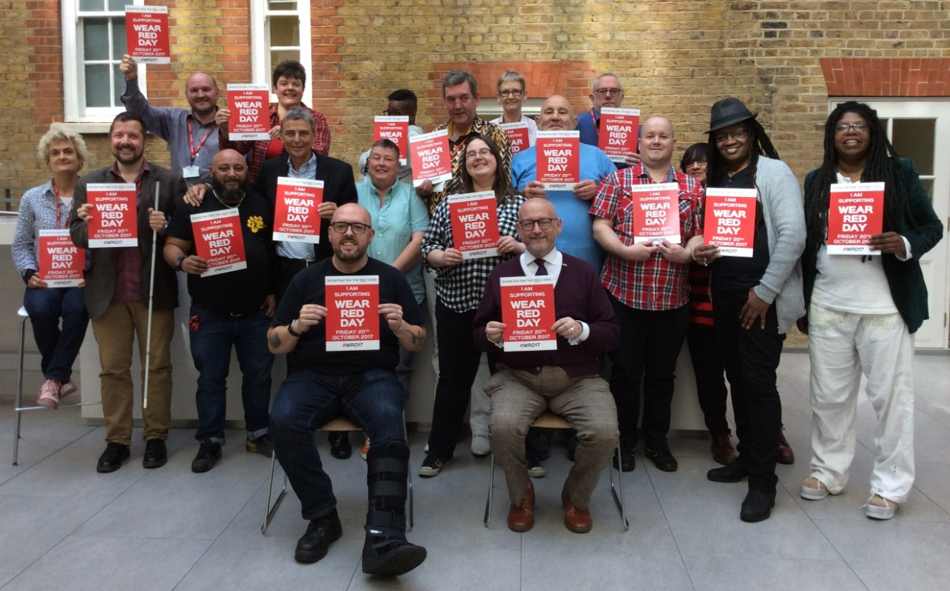
Disabled LGBT members play an active role in the work of the sub-committees. We’re pleased to report that two of our reps to sub-committee, EJ Kingsley-Grace and Tom Johnson-Kirkland, are young members.
EJ was on the organising and development sub-committee. Our focus here was resolution 13, “Discrimination in the LGBT Community”, and Resolution 15, “An inclusive movement, an inclusive union”. Tom was on the campaigns and policy development sub-committee. Work here with a disability focus included Composite C, “We stand together to say no place for hate crime”; Composite D, “After Brexit”; Composite G, “Dementia care for LGBT Community”; Composite E, “PrEP for the future - UK awareness and access”; Motion 4, “End of Life Care LGBT People”, and Resolution 45, “Equality since 2010 Equality Act - regression instead of progression”. Disabled members are also active on the LGBT committee’s international sub-committee.
Members of our caucus also represent the national LGBT committee on other bodies, ensuring we have an influence. For example, Asha Wolfe-Robinson and Dettie Gould sat on the TUC LGBT+ committee. Many of our members were active at various community events and prides throughout the UK this year and helping during the snap election.
At our network day, our co-convenors, Katrina Gilman and Neil Adams, provided reports on the work of the caucus throughout the year. Katrina led on dementia awareness activities and discussions, expertly written by Louise Ashworth. Feedback indicated how pleased people were to receive this, with many stating how informative and useful they found it. There were also discussions and debate on motions and amendments for this year’s conference.

Transgender members
The trans caucus has had another busy year. Last year’s conference was very successful, with many motions focussing on trans issues. Phillippa and Dave moved the trans caucus motions, and it was great to see the number of trans activists who spoke on many different motions.
Although we are sad to say goodbye to Phillippa as one of the co-convenors of the caucus, we are very pleased to welcome Emma, working alongside Dave who is continuing in the role of caucus co-convenor.
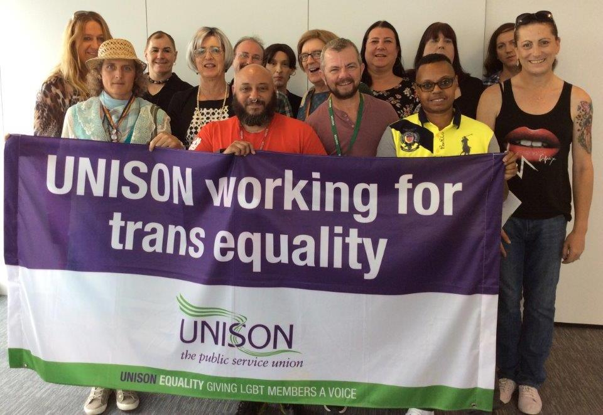
This year, we seem to have had an unprecedented number of trans employment policies submitted to us by both employers and activists for our comments and critiques. It seems that this is a hot topic in many workplaces, with employers realising that it is important to have something in place, rather than panicking when an employee informs them of their plan to transition. We have also been working hard on a model policy. We urge everyone to check whether their workplace has a policy in place, and if not, to take steps to implement one.
During the year, both Emma and Dave have been busy representing UNISON on both trans-specific and LGBT issues. Dave attended the branch officers’ training day, where he led the session on trans awareness. The session went well, and good feedback was received from attendees following the event. He also chaired the national launch of MIND’s LGBTQ good practice guide in Manchester.
Emma has delivered trans awareness courses to children’s service workers on a number of occasions during the year, and also addressed the WET equality seminar on “supporting parents with trans children”. Along with other members of the trans caucus, she also assisted on the stall at Sparkle, and ran a well-attended workshop on “transitioning at work” as part of the weekend’s #TransMCR programme at the LGBT Foundation, as well as running a very successful stall at TransPride.
Dave also co-presented a well-received workshop at a trans retreat on “getting politically active”, along with two Labour Party activists who are also UNISON members. In his role as co-chair of the national LGBT committee has ensured that trans issues are kept at the forefront of the agenda.
The network day this year was very successful, with around 15 attendees. We discussed conference motions, reported back on our activity during the year and worked collaboratively on the model trans policy, as well as discussing other pressing matters raised by the attendees.

In the regions

Eastern
Last year’s LGBT conference was very successful for Eastern region. New LGBT activists are gaining confidence and increasing their involvement as they learn more and more about LGBT campaigning in UNISON.
We had a successful presence at all of the local prides in the region following a General Political Fund bid.
Essex Pride is a well established event, as is Hertfordshire Pride. Both were ticketed and quite well attended. Our UNISON stand was in prominent position which attracted a very diverse audience, from students to retired members, and from UNISON members to people seeking support from a trade union in their current or future workplace.
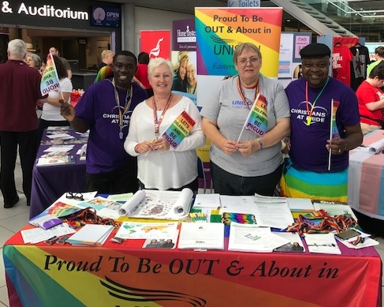
We were proud to be a part of the very first Colchester Pride which was a busy vibrant event, with plans already afoot to expand the event next year. Norwich Pride was again a very busy and vibrant event complemented by a rapidly expanding, colourful parade. Both of these events were extremely successful. Engagement with visitors throughout the day gave us a great opportunity to promote our work, recruit and provide a great service to an increasing number of enthusiastic students interested in what a trade union is. We have been encouraged by the number of young people taking an interest in politics and the trade union movement. Pride events have proven to be a great platform to engage with them.
At all these pride events, our LGBT members have taken the lead in working on the stalls, gaining confidence and experience in delivering UNISON’s message.
Sadly, a number of proposed pride events have not taken place this year due to organisers struggling to gain funding. Cambridge Pink and Suffolk Pride are two that have been lost in 2017. Plans were afoot for a Luton Pride but this did not happen. The good news is that there is a new Huntingdon Pride planned for 2018.
Our involvement in pride events has enabled us to have many conversations with members and potential members. These include lots of students, many of whom have no experience of workplaces or what a trade union does, making for very interesting conversations.
We again had a stall at our regional council AGM in April. This has been very helpful in raising awareness of our work, where we can discuss the importance and value of self organisation with senior lay members and staff. This year we launched our Transgender Equality Guidance and Model Employer Policy document which was very well received.
We were also pleased to receive approval from our Finance Development and Organising Committee for ILGA membership – (International lesbian gay bisexual trans and intersex association) this is a first for Eastern region!
In previous years, open meetings have been held in different parts of the region in an attempt to mitigate geographical barriers. However, our meetings will now all be held at one of the UNISON offices (Bury St Edmunds or Chelmsford), primarily to ensure we do not exceed our budget.

East Midlands
2017 has been a really exciting and active year for our group and has involved a lot of change. This will continue into our new year. It has been marked by an influx of new and committed members, fresh and innovative ideas and collaborative working practices. Life in the East Midlands is never dull or stagnant. Donna and Richard have been our co-convenors and we are building our group. We are now being looked after by Cathy Symes at a regional level. Donna also has joined Sean on the national LGBT committee
Attendance and support of LGBT events has improved with more members taking on responsibilities based on their geographical locations. Social media such as Facebook has been used to great effect to ensure members at grass roots level are aware of forthcoming events. LGBT members have worked hard to promote events within their branches and the response was tremendous! We have had a much more visible presence at prides throughout the region this year. Our banner has been on show with at least one of the group in each of the seven counties we cover.
We promoted lunch and learn sessions, offering a space for people to learn more about equality issues. We’ve had lunchtime lectures on LGBT issues, published articles in branch newsletters and held wide scale recruitment drives, promotional stalls and even held a pub quiz to raise funds for an LGBT charity.
We have found that district councils often lack a clear sense of direction in developing LGBT agendas and themes. To assist in redressing this balance, we have recently set up an LGBT forum, drawn from members of the community and supported by both UNISON and the council. The group held its first AGM in September and is already helping to shape and inform that council’s LGBT agenda as well as to provide support for LGBT people locally.
Our campaigning focus has been around facility time for equality work as well as working with our regional champions to disseminate information to our region. We continue to work closely with our LGBT colleagues in our branches to form a network that is effective. We are now much more visible in our communities and are promoting our work in a much wider arena, meeting members and promoting our work with members of the public.
We have worked hard since last year’s conference to reach out to and engage with new group members. This has been through various activities and a better use of social media.

Cymru/Wales
The group has been busy this past year with good participation from across the region with representation from many branches of all the service groups. Meetings have been well attended and a number of new faces have been seen. The group is represented on many regional committees such as equalities, education and training, regional committee, local government service group, energy service group and regional council to whom the group reports and is always available for support and guidance.
Pride events were fully supported this year including Pride Cymru. All events were popular and attracted many visitors to the stands which led to recruitment of new members, education and increased visibility to existing members and to members of the public. We face challenges in the more rural areas of Wales and we still need to work in these areas to empower our members and encourage them to be themselves in safety.
The group continue to share information and communicate through a Facebook group sharing good practice and LGBT policies across Wales as we can.
The group met in Cardiff for the annual development weekend earlier in the year and a large part of this was spent working on writing and speaking on motions led by one of the group who is a lay tutor. It was very productive and a number of ideas for motions were created and drafts put together to build upon. Everyone had positive feedback on the work done and hopefully you will hear some of the motions debated at conference this year. We also looked at UNISON’s international exhibition on Palestine - A Dangerous Occupation. As a guest speaker we had Jenny-Anne Bishop from Unique Transgender Network who spoke to the group about transgender issues and the work she does to support and educate. Feedback for the weekend was excellent and thanks go to everyone that attended and particularly to the facilitators.
The action plan of the group details the targets and plan regionally to recruit and organise and encourage activism through campaigning at pride events throughout the year and continuing affiliations and seeking new community organisations to potentially campaign with. The region’s leaflet and handbook have been updated.

Greater London
We’ve had another eventful year in London with plenty of recruitment, campaigning and organising to get our teeth into. We had some changes of personnel - we said goodbye to staff member Carol Lewis as our secretary, welcoming welcomed Mel Russell in her new role and Cally Thompson as our admin officer. The committee was ably chaired by Anu Prashar and Darryl Strawson.
At our policy day in February we agreed our workplan for the year and held detailed planning sessions on gender and non binary issues.
We continue to be involved in the work of the region, and send representatives to regional committees.
The snap general election in June was a challenge but we managed to get the message out to members and to encourage them to knock on doors for Labour in constituencies across the capital. We hope to build on this in the council elections next year and we will be planning how we can best contribute to this work.
At the AGM we agreed to work more closely with the Greater London Authority and the Mayor’s Office now that we have a Labour administration in London. We attended a meeting with the new Deputy Mayor for Social Inclusion, Matthew Ryder QC, to focus on what we wanted to see delivered for LGBT Londoners. UNISON was the only trade union present. We focused on the need to deliver on the Mayor’s promise to make the Greater London Authority an exemplary employer, including in terms of union recognition and LGBT/equalities policies, and to roll this out across London. The Deputy Mayor has now released his draft strategy which we will be responding to.
Our Organising Day was on 24 February at the UNISON Centre, to coincide with LGBT History Month. The key note speaker was Seb Dance MEP, Labour’s only out LGBT member of the European parliament. Seb spoke about Brexit and how this might affect workers rights and LGBT rights. There was also a presentation on supporting intersex members and workshops on practical skills for supporting LGBT members in the workplace (with Thompson’s solicitors), UNISON’s work internationally for LGBT equality, trans awareness and setting up a branch LGBT group. There was a presentation on the history of UNISON’s LGBT group. The event was well attended and there was some very positive feedback from delegates.
We had a recruitment stall at the WOW “Women of the World” event held annually at the Southbank to celebrate International Women’s Day. This was very worthwhile, with lots of comments about how great it was to see UNISON there - we were the only trade union.
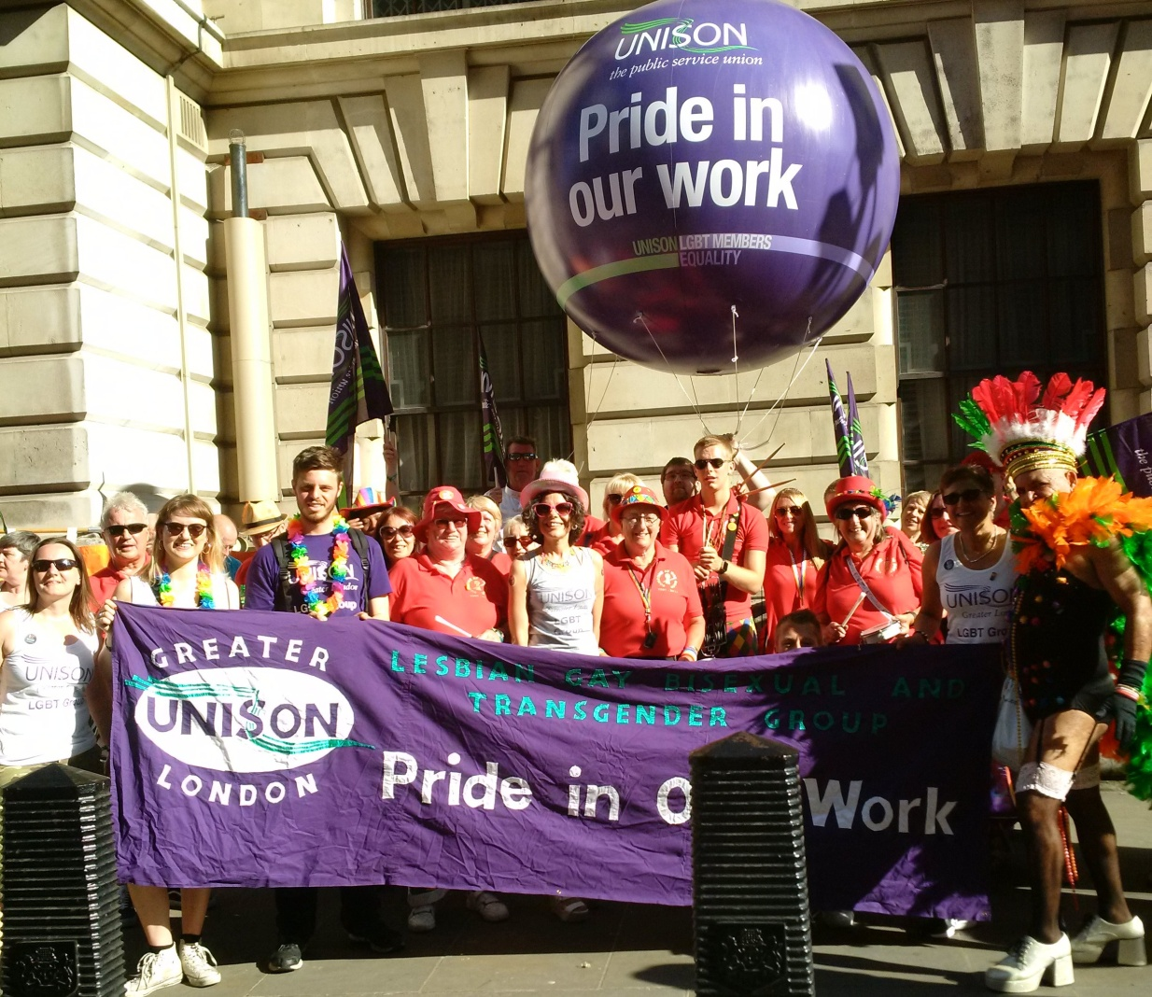
As last year, we were delighted to welcome Bromsgrove samba band in the Pride London march, giving us high visibility (and audibility!!). Some of us helped staff the national stall in Trafalgar Square. With significant delays last year, we made our annual pride breakfast a brunch but we didn’t succeed in getting the word out. The increased security this year, with a more rigid wrist band system, put some members off attending. Despite our decision to arrive later, the wait was still more than three hours. We will further review logistics in light of what looks like being a continued issue.
A number of group members attended UK Black Pride and helped on the UNISON recruitment stall. As ever this was an excellent event with a strong community feel and a very visible UNISON presence.
We’re sending a delegate to ILGA Europe conference in November and have continued our active support for the No to Pinkwashing group.

Northern
This last year has been a busy and eventful time for the Northern region LGBT group. The group continues to meet regularly and it is exciting to see an increasing amount of young members are becoming active within the group and that all the service groups are fully represented too.
February was LGBT history month where a number of branches organised events in the form of stalls, talks and fun filled activities in their individual workplaces. One branch screened the outcast to raise awareness of homelessness LGBT youth and over 120 colleagues attended to watch. A number of branches also had the rainbow flag flying from work place buildings.
The group decided to try something new for their policy weekend this year and rather than have a weekend away, the group held two separate training and development days which were very well attended.
IDAHOBIT saw many branches around the region hold events. The regional group also attended Penshaw Monument which was lit up in the rainbow colours of the LGBT flag which allowed the day to be visible on a monumental scale.
The group attended an event organised by Newcastle upon Tyne Hospitals entitled Trans Lives Matters which looked specifically at the experiences of the trans community when accessing public services. This was a multi agency event with many public sector bodies represented. Workshops were put on in order to give maximum participation and allow delegates to look at ways of improving services to be truly inclusive.
The regional group supported the Curious Festival which was an opportunity to celebrate and explore LGBTQ culture through the arts and provided an opportunity for visibility, dialogue and increased understanding. The 2017 programme which ran over five days from 5 - 9 of July included young people’s events, participatory workshops and professional performances.
The group attended a number of prides over the summer months. Durham pride was on 29 May. The day was a phenomenal success. The parade from Durham Cathedral to the Sands saw the regional group fly our flags and banner with UNISON being the only trade union to do so. At the main event we had a very busy stall. The importance of being in a trade union was the key message of the day, many young people, those in college and university asked about the role of trade unions and the group was proud to point out UNISON’s self organising structure, which went down well.
July was Northern Pride and many of our activists were on the parade which helped made this a very successful and high profile event. September was Sunderland Pride, which was highly successful. The group also attended Durham miners which was a huge success as usual and we had high visibility.
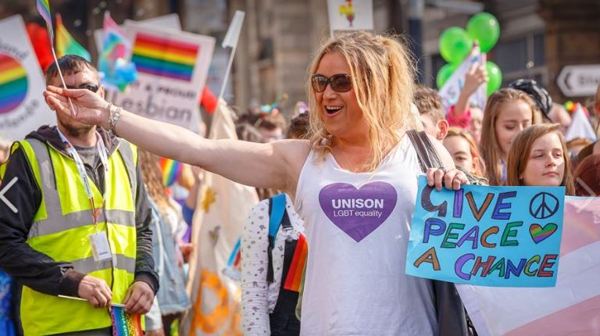
We hope that the year ahead will provide even more opportunities for LGBT members to be active and our membership to keep growing.

Northern Ireland
The focus this year has been to promote visibility and inclusive workplaces, engage branches and campaign on marriage equality. The committee secured funding from the GPF to run additional events and have resources for campaigns. Our LGBT committee members Martin McConnellogue and Gillian Foley have featured in Out in UNISON public service champions profiles. We sent out eleven editions of our LGBT e-bulletin as well as Out in UNISON and Pride programmes.
We have been very involved in the campaign for marriage equality. Love Equality, which comprises of ICTU, Amnesty NI, Student Movement and LGBT organisations hosted a rally on 1st July in Belfast City Centre. The purpose was to profile the refusal of the Assembly to legislate for marriage equality, garner wide public support and send a clear message to politicians within the political vacuum which exists. Over 20,000 people attended with a huge contingent from UNISON and we were well featured in media coverage.
Our photoframes supporting marriage equality proved popular at pride, in workplaces and trade union events. We have over 500 photos on our LGBT facebook and encouraged people to tag themselves which facilitated increased exposure. This is an ongoing campaign.
Our main Belfast pride event was a Stand Up for Marriage Equality Comedy Night. We organised three comedy workshops and then volunteers did their first ever stand up set on our night. This attracted over 150 people and raised £600 for Belfast Pride and Love Equality.
We organised four events for LGBT awareness week in May, including a health and wellbeing day in UNISON Derry office in partnership with the Rainbow Project. Over 100 people came through the doors and 12 organisations had stalls. Also in Derry, UNISON Community Branch supported a fundraising disco and cabaret, raising over £300 for Foyle Pride. In Belfast we ran two open workshops on advanced care planning for lgbt people and supporting young trans people in school and youth settings

Information on UNISON was circulated widely in the LGBT community and we used facebook and twitter to promote each event.
UNISON had a great presence at Belfast Pride which was very well supported by members. For the first time we had a float in the parade. The theme was being out at work which featured members in work uniforms, their children and our marriage equality couple – Gillian and Sam. There was fantastic engagement from branches and staff to plan and decorate the float and feedback was very positive.
As part of the Foyle Pride Festival, the Community Voluntary branch sponsored the Football v Homophobia event. Members were well represented at both the Foyle and Newry Pride Parades.
Our GPF bid supported an art competition on the theme of pride and visibility. This attracted over 40 works of art from throughout the UK and Ireland. 16 pieces were selected for the exhibition which coincided with Pride festivals in Belfast, Derry and Newry.
In July and August we organised LGBT stalls in Linenhall St and nine hospitals. Many branches helped out and the Ulster Hospital branch ran a whole week of visibility. We gave away over 900 rainbow lanyards and 200 LGBT posters to promote inclusive workplaces and encourage support for local Prides.
An online gallery of staff who are out at work in the health and social care service was launched over the summer. UNISON encouraged staff who are out to participate and the majority of those featured are members - see lgbtstaff.hscni.net/gallery.
In September over 30 LGBT+ people attended the first meeting of a new Queer Activist group hosted by UNISON. It aims to re-engage with grassroots activism on issues such as visibility, the experience of young people in schools, mental health and the homophobic/transphobic political narrative which exists in Northern Ireland. We will continue to support this group through promotion and hosting its meetings.
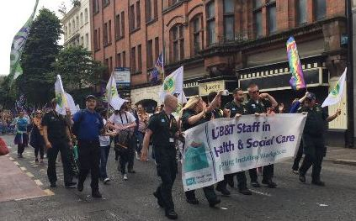
UNISON LGBT Chair Martin McConnellogue was one of ten activists from across Ireland selected for a programme organised by Boston College to see LGBT community work in the area. It included a visit to an 8 bed unit for homeless LGBT people up to 25 years of age. Martin works with young homeless people in Derry and was very impressed with this safe space, where staff where all trained in appropriate language and work closely with LGBT services around the Boston area. He saw the potential for replicating the project in Derry. He met with the Council for the Homeless, senior managers in First Housing Aid and Support Services and local LGBT organisations to develop a local model. The FHASS LGBT Safe Housing Scheme was launched in September. This included protocols for staff and a visible window sticker indicating that this is a safe space for LGBT people. Staff training assures that they are skilled to deal with LGBT issues.
We’ve responded to the Health Service Gender Identity and Expression Employment Policy consultation, welcoming the introduction of this new policy, commenting on some aspects and advocating for an inclusive approach to transgender people in the workplace.

North West
This has been a busy year for the North West as always.
In May we held our annual training and development day which was well attended. Workshops were organised around UNISON’s core objectives, motions from our last conference and issues cascading from the national committee policy weekend. Workshops were followed by debate and agreement on the relevant section of the work plan.
We delivered a presentation on ILGA’s work to our regional international committee and were delighted that they agreed to become associate members of ILGA. They also choose ILGA as one of their main work actions for the year.
We have held recruitment and organising stalls at 17 prides across the region. Highlights include:
Bury Pride – Bury’s first ever pride and our first pride of the year.
Blackpool Pride – we pitched our stall in the winter gardens for the weekend, speaking to members about the recent election and its impact on LGBT members and society.
Trafford Pride - another first ever pride and although it was tagged onto another community event it was a success.
Liverpool Pride – We had a great turnout, with local branches joining us alongside Cabasa Arts and Juba Do Leão. Our stall was so popular that we ran out of materials before the march had finished! We pioneered our ‘Beat the Pay Cap Wheel’ which was useful for engagement, particularly on the quieter Sunday.
Oldham Pride - one of our favourite events and again very successful, with one group asking about membership for over 70 people.
Stockport Pride – yet another first ever pride held at the market place on a glorious Sunday afternoon. The recent UNISON victory over tribunal fees had lots of people coming over and congratulating the union.
Wigan Pride – Wigan’s second pride and a bigger success than the first. There was a march with our banner and plenty of activity on the stall, even a visit by Gandalf (Sir Ian McKellen).
Levenshulme Pride - a first pride called in response to a homophobic attack earlier in the year. After a slow start, this proved a great success. A fantastic local community pride.
Wythenshawe Pride – we spoke to people about the cuts to local services and handed out recruitment materials. There was great interest in the ILGA maps with our volunteers offering insight into penalties facing some of our community abroad.
Manchester Pride – we joined forces on the parade with local branches and again by Cabasa Carnival Arts and Juba Do Leão. The footfall in the Expo and recruitment was good, our wheel of fortune again proved popular and definitely encouraged people to come over to the stall.
Sparkle – a UNISON workshop on transitioning in the workplace and a recruitment stall throughout the weekend
Family Fun Day – a day with a community fundraising group to raise funds to place defibrillators in the local community.
Pride at the Pictures is an important piece of work we’ve been involved with for a number of years. They have screened a number of LGBT films throughout the year and ran an enhanced programme across Liverpool Pride. We put extra effort into supporting Out of Iraq, a very moving documentary highlighting the challenges faced by a gay couple who fell in love. We worked with Many Hands, One Heart, the Liverpool LGBT asylum seeker support group. The regional president spoke at the event and we screened a number of UNISON adverts including the 15 minute care makeover film. We have produced shared materials with Pride at the Pictures, giving both them and us a better profile.
We are building our relationship with Homotopia and following a regional pool bid, we will be a key sponsor of this year’s festival, supporting the ‘Tales From the City’ exhibition at the Museum of Liverpool which will run for five months.
Last year we reported on our first international training day, where Aderonke Apata spoke passionately about the struggles of LGBT asylum seekers in Britain. Aderonke and her group African Rainbow Families work tirelessly for LGBT asylum seekers. We are extremely proud to be associated with Aderonke. We are beyond pleased that Aderonke has been granted refugee status in Britain and we are of course delighted that she will be a guest at our conference in Brighton.

Scotland
In early December last year, members of the committee attended the Equality Network’s BiTastic event. We did a workshop on why bisexuality is a trade union issue and chatted to people on our stall and even signed up some new members. We are pleased this year’s event is moving to the Highlands and there will again be a presence from our members.
We held a very successful policy weekend on weekend of 4th February in Glasgow which was the first meeting of the new committee. This was the first meeting where we had managed to fill our 3 reserved seats for bi, trans and Black workers which was excellent.
This year we have attended a lot of demos - anti-cuts demos, Stand up to Racism, anti-Trump demos etc. We also attended prides in Edinburgh and Glasgow where we took part in the parade and held stalls. We have used these events to recruit new members as well as speaking to existing members on our objectives and priorities.
We attended the STUC LGBT conference again this year where our motions relating to support for young unaccompanied LGBT+ asylum seekers in Scotland and defending LGBT+ rights in the new world of Brexit and Trump were overwhelmingly carried.
We continue to have good diversity on the committee with an equal gender split and representation from all service groups.
At the time of writing, we are finalising arrangements and speakers for our AGM which is being held in November with a theme of hate crime. We are hoping to improve on last year’s large turnout.
Four delegates from the committee will be attending the ILGA Europe conference in Warsaw in November.
We encourage all delegates to get involved in your branch and regional LGBT committees and if you need any support or information, do not hesitate to get in touch.

South East
We were proud to be the main sponsor for the Isle of Wight Pride – the first ever!
We would like to thank Yve White for her organisation and hard work in organising the IoW Pride for which she received an organising award from South East region at their recent strategy weekend.
It was an extremely successful event, with planning already starting for next year. On the day a host of acts played the main stage including DJ Russell Small, from Freemasons, singer songwriter Horse McDonald, Reigns and Nicki French, as well as speakers including human rights campaigner Peter Tatchell. It is thought that as many as 3500 turned out on the day. It has been suggested that IoW Pride may have been shortlisted for a community award.
UNISON SE also sponsored Oxford Pride and Reading Pride as well as having a regional presence at Hampshire Pride held in Winchester, Folkestone Pride (also held for the first time) and Canterbury Pride where Rosie Duffield, UNISON member and newly elected Labour MP was warmly received. Local branches also supported prides in Southampton, Margate, Brighton and Eastbourne.
Oxford and Reading were well supported by members, and very well received by participants, with new members approaching the UNISON stand to ask about joining. In Oxford many nurses were approaching UNISON due to our visibility in supporting the NHS. It helped that at Oxford UNISON were sharing a stand with South Central Ambulance Service. It just goes to show that cooperation can benefit everyone.
What has been evident is how local prides are now becoming much more popular, both in terms of attendance, acceptance, and support from local councils and residents. While there will always be negative groups of people, the response has, in general, been amazing. UNISON LGBT SE is already planning our funding bids to support local prides next year.
South East region has now affiliated to ILGA and at our last regional meeting we invited Jasna Magic from ILGA-Europe to give us a talk. This was very informative and useful.
The regional group is planning for LGBT conference, which is being held in Brighton again. Invitations have gone out to local groups who might like to have stalls at the conference.
The South East region has focused on two areas for their motions. One is the rights of trans prisoners, and where and how they are housed, and any medical support that they might need being provided. This was as a result of yet another trans woman taking her own life in prison, something which happens too often.
The second motion focuses on the vulnerability of young LGBT people and housing. This is an area that returns year after year, and it’s time for things to change.
Our group meets 3 times a year in London and is an open forum for all LGBT members across the region. Our next meeting will be addressed by a speaker from the Albert Kennedy Trust on housing Issues for young LGBT people.

South West
Our planning activities are guided by resolutions from our annual conference with recruitment as a priority.
Members of the committee successfully delivered a workshop on the history of LGBT activism in UNISON in Exeter as part of the 3rd National Festival of LGBT History. This event is organised by Schools Out nationally and provides us with an eclectic audience to showcase our activism in the trade union movement.
Listening to members, we designed a system to support volunteers on the various stalls that included instructions on how to set up the stall, explanations of what some of the materials actually mean and how to use them. We also included guidelines for engaging with prospective members which has resulted in new members joining the SW LGBT network.
With the regional committee’s capacity to organise and participate in the various events seriously depleted due to unforeseen personal circumstances, we only organised at Exeter and Cornwall Prides, and collaboratively with the regional Black members group at the 2 day Exeter Respect festival.
Although we had some regional LGBT support, we needed more people. Reaching out to branch secretaries for help, we were delighted in the positive response that resulted in branches staffing and organising at 8 pride events around the region. We supplied the stall and material resources. This was a wonderful affirmation on just how far we have come in mainstreaming support for LGBT equality.
To all who helped make each of these events the joyous success that they were, our heartfelt thank you!
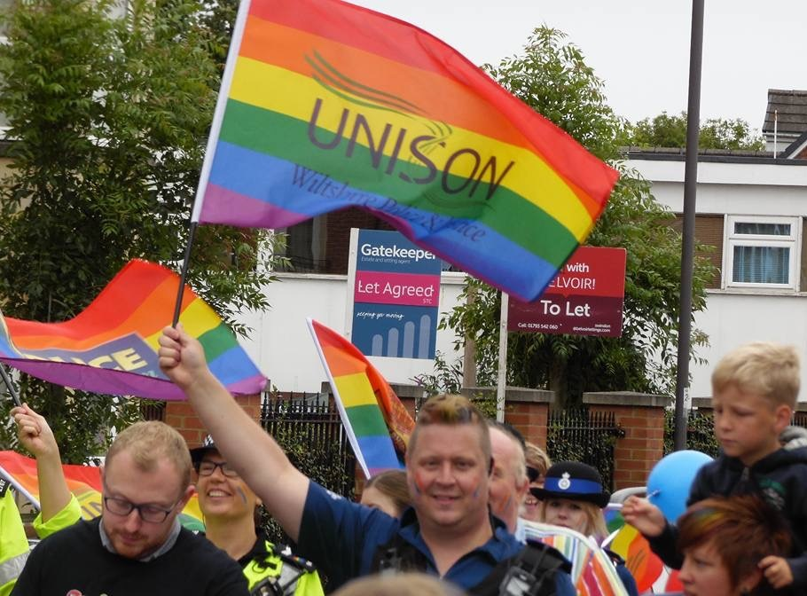
Prides covered by our allies were Gloucester, Bristol, Swindon and Wilts, Plymouth, Dorchester Love parade, Exmouth, and Salisbury.
These events are a platform to highlight UNISON campaigns, to recruit from underrepresented groups, and to raise awareness around LGBT inequality globally, including ‘No Pride in Israeli Apartheid’.
This year the very popular rainbow photo frame encouraged an array of colourful happy people to pose for LGBT equality. The photos were uploaded onto various social media sites.
A regular component of our stalls is donations for lanyards, chats and ILGA maps. This is a vital part of our work around solidarity with other LGBT groups and gives financial support for ILGA Europe’s scholarship programme and diversity fund. To date we have collected over £1000 in donations.
We send information to branches in the South West using existing publicity materials, including reminders for our members, who identify in the LGBT caucus groups, of the national network days. The bi and trans leaflets have been visible and well received at all our events. We engage with SOG groups, UNISON young members, LGBT Labour and where possible local CLPs.
SW LGBT activists participate on all regional committees, hold branch officer posts and are represented from all service groups except WET.
An essential part of the SW committee’s work is being Out and Proud in all six counties of our region, and this year has been no exception.

West Midlands
LGBT members are active in all parts of UNISON West Midlands, with a number of us holding branch and regional positions and participating in regional activities.
We started the year with a film screening in Birmingham for LGBT history month.
We have been involved in regional discussions looking at Labour’s performance in the EU Referendum and the general election. These have identified marginal wards and constituencies where canvassing and campaigning is urgently needed. We will use this to inform the focus of our SOG activities across the region.
We have held open meetings to make plans and arrangements for prides in the region. We are investigating the use of skype to increase participation in regional meetings where members want this.
Our first pride event was Birmingham Pride where people marched with the Unison LGBT banner with comrades from other unions and Stand up to Racism and we welcomed a member from the South West who joined us.
We also planned for Hereford – 29th July (event cancelled by organisers), Warwickshire – 19th August (in Leamington), Walsall – 26th August, Worcestershire – 23rd September, and Wolverhampton – 30th September.
It was the first time we had attended Warwickshire Pride. We had a stall next to LGBT Labour at a well-attended day. It was really useful having a Labour Party/ trade union section. All the local Labour councillors - including Jojo Norris, voted in at a by-election 2 days previously - and Matt Western MP, spent a lot of time at both stalls. Warwickshire and Leamington is a marginal Labour seat for councillors and MP. They are very keen to build and sustain the relationship with LGBT UNISON. All spoke of the need to campaign hard locally and of the positive response in the general and local elections. We agreed this is a pride the SOG should attend again.
During the day we gave a lot of information out about trade unions, membership and particularly – retired members. Bob had frequent conversations about the arrangements for Retired Members to remain active in Unison. We borrowed the Unison National LGBT selfie frames and are circulating the results on website and Twitter.
Andy found an article excavated from the Leamington Art Gallery archives stall about the 1984 Rugby Council ‘Stop the Gay Ban’ campaign, which he was personally involved in. We are considering a SOG social trip to visit the gallery’s LGBT& exhibition.
For Walsall Pride, we had a stall inside the arts centre and made good use of the national LGBT selfie frames again.
Worcestershire Pride the first time the area staged a pride. This historic day coincided with Bi Visibility Day. The regional group supported local branches who put on a stall. It was great to see a large number of young people there. Contact was made with a housing organisation of 700+ workers who want to establish a UNISON presence in their workplace. A local diversity network is putting on a conference in March 2018 and invited us to participate.
Last year, we marched through the city for Wolverhampton Pride with the national LGBT banner. We’d like to have done the same again this year – but as UKIP were invited to participate by the organisers, we boycotted the event.
We are in touch with regional Black members SOG so we can work together on projects for Black History month and other future events.
Birmingham LGBT SOG and our regional group are jointly organise a refugee event – Rap workshop and performance - for Black History month. We are also planning a film showing at Midland Arts Centre – either Moonlight or Hidden Figures.
We are participating in trade union and activist planning for the anti-austerity demonstration at the Conservative Party conference on October 1st in Manchester.

Yorkshire and Humberside
Last year’s conference marked a fantastic start to this year. Our group received the recruitment and organising award for best region and we saw our highest number of delegates in many years, with a very well attended regional meal on the Saturday night. Another exciting year has followed as we continue to increase engagement and activity.
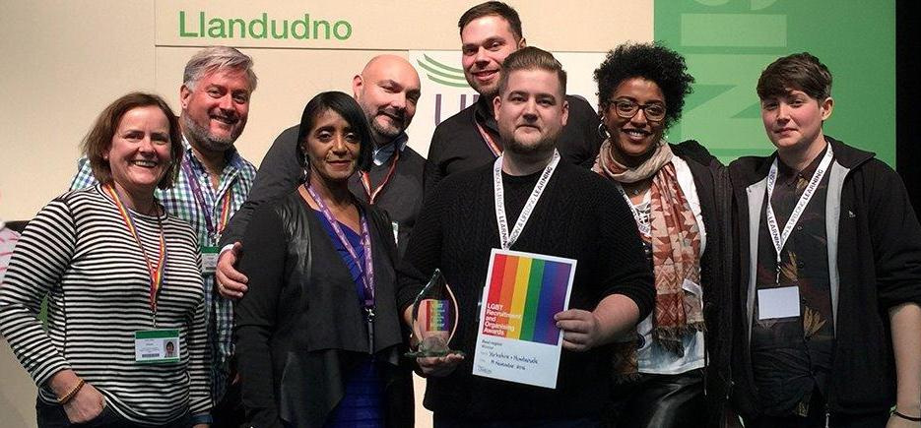
Our regional priorities have remained in line with the national priorities of responding to the threats to public services and a continued focus on recruiting, to the union and to the SOG.
We have increased our visibility, including holding a stall and workshop / discussion at Leeds Beckett Students’ Union’s “Educate, Agitate, Organise” event, presenting the findings of the NatCen research into LGBT people and austerity.
We increased our motions to national LGBT conference by 100% to two: on encouraging non-binary visibility and tackling transphobic feminism. Sadly, the latter was not admitted to the agenda.
We have increased the number of members engaged with the SOG starting with an informal social in December and communicating directly with branches at multiple points throughout the year. Our Facebook page (www.facebook.com/unisonYHLGBT) has been an invaluable tool for engagement, seeing a number of new members make contact and almost doubling in “likes” over the course of the year.
Our attendance at prides has been a key focus. Recognising that we are limited in resources and availability of members, we have developed partnerships with branches for their local pride events. Branches led our attendance at Rotherham and Doncaster prides, resourced by the region through GPF funding. We hope to have a presence at all Yorkshire & Humberside prides in 2018.
The region itself committed to three pride events this year, Happy Valley Pride, Leeds Pride and UK National Pride in Hull.
The first UK National Pride took place at Pride in Hull in July. UNISON sponsored the viewing platform and accessible toilets and hosted the Pride committee operations base in the Hull UNISON office. It was a huge success. Around 20 mostly new volunteers joined us in the parade or helped on the stall. We lost count of the number of conversations we had. But it really stood out the numbers who came over just to tell us that they were already members and were pleased to see their union supporting Hull Pride.
UNISON attended the Leeds pride parade with our regional van and held a stall in the centre of the activities. Again, we saw a high number of volunteers and all had a great day. There were a number of cheers throughout the parade as we passed.
Happy Valley Pride is a grassroots event, in its second year, that took place in the beautiful town of Hebden Bridge. We were really pleased to sponsor it this year. Despite initially feeling that the stalls were a bit hidden away (in a neighbouring school), the room was soon bustling and it allowed for more in depth conversations. It resulted in a number of membership applications being completed, and an organisation encouraged to unionise in UNISON. We also met members new to the region.
Our attendance at each pride was really successful. New members joined us on the marches in Leeds and Hull and we spoke to hundreds of existing and potential members from the stalls at all three.
We continue to participate on all regional committees and reports are received back from the delegates at each meeting of the SOG.
We remain affiliated to ILGA.

