**UNISON empowering disabled workers**

**Disabled Members Annual Report 2017**

**Table of Contents**

1. **Chairs introduction**
2. **Summary of Work Programme**
3. **Reports:**

* National Delegate Conference (NDC)
* NDC Newssheet
* TUC Disabled Workers Conference
* Labour Link
* Report from Disabled Members elected to the NEC

**Self Organised Group Conferences**

* LGBT Conference
* Women’s Conference

**Service Group conferences**

* Community
* Health
* Higher Education
* Local Government
* Police & Justice
* Water, Environment Transport
* Energy

**Caucus reports**

* Black caucus
* Deaf (BSL)
* LGBT caucus
* Women’s caucus

1. **List of Committee members**

**Chairs introduction**

This year has been difficult to manage with the government calling a general election for the beginning of June. Many things stopped as election campaigning started. Politicians told us what they thought we wanted to hear. Of cause disabled people would be at the heart of their concerns! Of cause they would tackle causes close to our hearts!

Our union worked hard to put disabled members issues and questions to parliamentary candidates both locally and nationally, to gain recognition that disabled members’ conditions and opportunities at work and in life generally have not been sufficiently understood by previous governments.

Disabled people have always had to fight for their rights. The Conservative government continued its agenda of austerity and, as in previous years, disabled people are still seen as an easy target.

As we know the general election results made for a huge shake up of government, with new ministers in positions. Politicians and the media alike predict life after Brexit with doom and gloom. The expectancy of losing the blue badge scheme, working directives, annual leave, hours of rest, access to funding to support disabled people at work, the list goes on.

With this as our backdrop, this year’s national disabled members committee’s workload has been challenging to say the least. Some motions from last year’s conference couldn’t be worked on until the outcome of the general election was concluded and ministers taking up positions, so that we knew who we needed to work with, challenge or campaign against.

This year is the first time we can welcome two elected National Executive Council (NEC) disabled members onto our committee along with a third NEC member nominated from the N.E.C. Angela, Pam and Sian joined the committee at our August meeting. It has taken many years to achieve this but now we have a dedicated elected positions that mean disabled members issues are taken into the main arena that runs our union.

During the year we consulted every region on the National Disabled Members Committee Standing orders and constitutions. This will have been disseminated to branches in the regions so that all disabled members could be consulted and the information fed back through the regional / regional reps on the national committee. This work needed to be done to bring the final document to our 2017 conference, to keep us in line with the union’s rules and code of good practice. Thank you for all your participation in this large piece of work.

Our work programme is based on motions from last year’s Disabled Members Conference. The main areas and focuses have been around mental health issues, issues relating to sickness absence and return to work, reasonable adjustments, and tackling ignorance, prejudice and discrimination. We have worked with other self organised groups on specific motions relating to Back members and young members, the increasing workplace capability issues, to name but a few.

Between meetings your chairs group work hard responding to with issues, attending national equality liaison meetings, setting agendas, writing speeches, campaigning, providing advice and guidance, making decisions and supporting national officers to make sure disability issues are a high priority within the union.

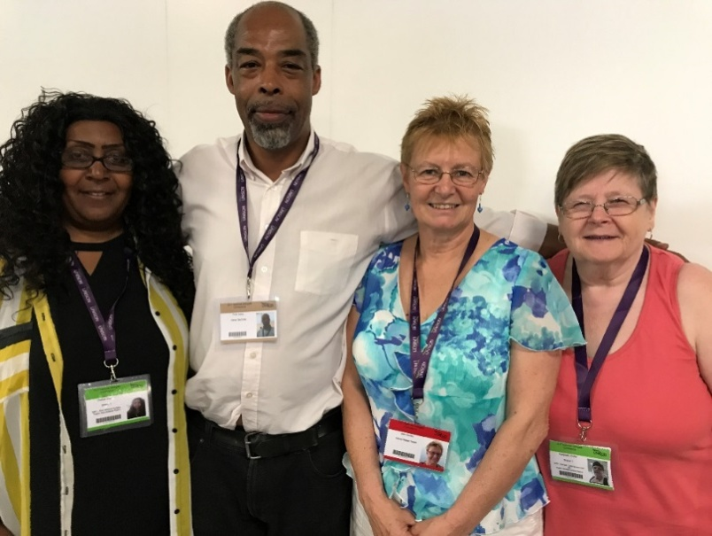

Chelsea Skervin, Peter Daley, Jean Sowley and Maggie Griffin

Sadly this year the committee lost a member, Margaret McAlees, who passed away after a short illness. Margaret was very active within the union as a branch equality rep and with her regional disabled members group. We also lost Julie Robinson, a former NDMC and NEC member who was very active within disabled members for a long time. Their loss is felt by us all and our thoughts are with their friends and family.

Finally, on behalf of all Disabled Members we want to pay a very special tribute to Gloria Foran. Gloria was National Officer for Disabled Members for a long time and retired this year. We want to say a huge thank you to Gloria for everything she did for us and wish her well for the future.

Also a big thank you to Lucille Thirlby, Haifa Rashed and all the support services that have enabled us to operate as a committee throughout the year, including QED, the speech to text operators, notetakers, British Sign Language interpreters and the UNISON Conference office. Thank you all.

Wishing you all a great conference.

**Jean Sowley and Peter Daley (Co-Chairs)**

**Chelsea Skervin and Maggie Griffin (Deputy Co-Chairs)**

# 

# Fighting for the rights of Disabled People

Despite the government’s assertion that it is a ‘world leader’ in disability rights, it recently had its record on disability rights examined by the UN committee on the rights of disabled people. The conclusion? That the government’s treatment of disabled people is a ‘human catastrophe’.

Since last year’s disabled members’ conference, government policies have remained hostile towards disabled people. There has been continuing uncertainty and fear from scare mongering EU referendum campaigns as well as the calling of a snap general election. This has all created a difficult ongoing political backdrop for the National Disabled Members Committee (NDMC) to work within.

Up until this year, the NDMC has had three National Executive Council (NEC) nominated representatives, who all identify as disabled, on the committee. Following an agreed change to UNISON’s Rule book at 2016 National Delegate Conference, for the first time in the union’s history, this year the election of two reserved seats for disabled members to the NEC was held as part of the wider NEC election process. We welcome the successful candidates Angela Hamilton and Pam Howard, who will represent Disabled Members on the NEC and as such disability issues must be their top priority in all NEC meetings. They will need to make sure that Disabled Members’ issues are considered in all UNISON decisions and campaigns and raise the profile of Disabled Members throughout the union.

On 31 October 2016, the government published a green paper ‘Work, health and disability: improving lives’ The green paper set out the government’s proposals on ways to halve the disability employment gap for disabled people and people with long-term health conditions. It follows on from the Conservative party’s manifesto commitment to halve the disability employment gap by 2020, although the green paper focuses on a ten year timeframe. UNISON disabled members submitted a full response to the consultation, including raising questions around how the green paper referred to mental health support and support from NHS workers at a time when the NHS is in crisis due to underfunding. We also highlighted that not all work is beneficial, the type of work is crucial. Low paid, insecure jobs with limited autonomy and support can be detrimental to the health of disabled employees.

As well as responding to the government’s consultation, UNISON disabled members have also been engaging with the Labour party to feed into their manifesto policies relating to disabled people.

# National Disabled Members Committee Work Programme

The agreed motions from the 2016 Disabled members’ conference set out some key areas of work for the committee.

The first NDMC meeting each year is a policy meeting where we agree the work programme based on conference decisions, any ongoing pieces of work plus any societal and citizenship issues. As the NDMC only meets four times, including the policy meeting, much of our work is carried out between meetings and we rely on a great deal of support from our National and Assistant National Officers.

NDMC’s priorities are set in line with UNISON’s agreed objectives. At our policy meeting we agreed to group the 31 motions from conference under the 2 themes of;

* Disability Policy and Campaigns (including welfare reform and working with external groups); and
* Tackling Ignorance, Prejudice and Disability Discrimination (including guidance to branches, internal UNISON issues)

A member of the chairs group facilitated each group with support from a National Officer or Assistant National Officer. Each group prioritised their work programme and individual committee members took responsibility for leading particular pieces of work on individual actions.

## Disability Policy and Campaigns

Motions 4, 13, Composite A, 16, 17, 20, 22, 23, 24, 28, 29, *EM2 (not reached) EM3 (not reached)*

**Equality Act and Disabled people**

The motion asked the union to follow up on the findings of the report issued by the House of Lords Equality Act 2010 and Disability Committee which found that disabled people are often an afterthought for government and public authorities was a key priority for the Committee. A motion was submitted and passed at Labour Link Forum to campaign for additional legislation to be introduced to protect and improve disabled people’s rights. We have built relationships with the Equality and Human Rights Commission over the year and have worked with Disability Rights UK where possible to champion the rights of disabled people. The request was made that the Minister for Disabled people be moved from the Department of Work and Pensions to either the Cabinet Office or the Department for Communities and Local Government. Representations have been made to the Labour shadow minister and the leader of the opposition about the rights of disabled people and the Labour manifesto in May reflected UNISONs priorities.

**Taking our Rights Forward**

Disabled Members are concerned that we will not only lose workers' rights that are underpinned by European Union (EU) legislation but that the anti-discrimination legislation we rely on will be repealed. Furthermore, disabled members are concerned that the UK improves its legislation, and that the current legal protections do not remain static, rather that they evolve and improve as time goes on. Ideally the UK would consider mirroring any future developments in EU legislation that relate to disabled people, such as the Accessibility Act, which is a law that would make many products and services more accessible for people in the EU.

Many aspects of being a member of the EU have been a benefit for disabled people – the reciprocal healthcare agreements for example. At present it is unclear what arrangements, if any, will remain.

Whilst the Human Rights Act is seemingly no longer under immediate threat, the future of equality and human rights legislation in the UK is still at risk. The national committee has been liaising via a union wide group on Exiting the EU to feed in disabled members’ concerns around the threat of loss of rights. UNISON disabled members also submitted a motion to Labour Link forum this year highlighting these issues and the importance of maintaining legal protections for disabled people in the upcoming negotiations. Some national committee members spoke with Keir Starmer MP who agreed to a future meeting whereby UNISON disabled members can input their concerns regarding the Brexit negotiations.

Since the EU referendum, there has been an increase in hate crimes across the different equality strands, including disability hate crimes and hate incidents, which are often significantly underreported. National disabled members committee members have been inputting into the forthcoming guidance on hate crime that the bargaining support unit is currently drafting, which is due to be launched in October 2017. This guidance will include a model hate crime policy for negotiation with employers. These members have also been inputting into UNISON’s forthcoming learning and organising short course on ‘Hate Crime Awareness’ for activists.

**Driver Operated Trains and Accessible public transport**

Many stations are still disabled unfriendly, having no lifts or staff to assist passengers. Conductors on the trains are needed to assist those with mobility issues and ensure the safety of passengers. A staffed ticket office is needed so that those with a visual impairment and those with other disabilities who are not able to manage to use a ticket machine will not be excluded from public travel.

The motion called on the National Disabled Members Committee to work with the TUC disabled workers committee, Scottish Trades Union Congress (STUC) Women’s Committee, STUC Disabled Workers Committee and National Women’s Committee and other relevant bodies to raise these issues and campaign to secure accessible and safe train and tube transport.

A motion has been submitted to the STUC Disabled Workers Conference on these issues and to campaign to secure accessible and safe train and tube transport. The National Women’s Committee surveyed members on women and safe travel and the results will be discussed at its next meeting. We have circulated information on the RMT/TSSA campaigns for safe travel which include the issues raised in the motion. The Transport Service group focus on passenger safety and access is on buses and trams, which is where our membership is based. The committee wrote an article for members on the Supreme Court case regarding priority for wheelchair users on buses.

**Access to Housing for young Disabled LGBT people**

Many Disabled LGBT (Lesbian, Gay, Bisexual & Transgender) people are unaware of their rights with regards to accessing suitable housing. The current government’s attack on Housing Benefit for young people disproportionately affects young disabled LGBT people, forcing them into unsuitable accommodation.

The committee submitted an amendment to the Labour Link motion ‘Why we need to build a new housing consensus for affordable and decent homes for all’, which was debated and carried at the Labour Link forum. The amendment outlined the specific issues faced by disabled people with regards to finding safe and suitable accommodation.

Additionally, a fringe meeting was also held at LGBT Labour on access to housing. Liaison with the national LGBT committee has also taken place especially surrounding the findings of the NATCEN report of the impact of cuts on services to LGBT people.

**Witnesses to the Holocaust**

The motion highlighted the fact that disabled people were targeted during the Nazi Holocaust, including through a state-run euthanasia programme. Articles have been written for the Disabled members’ e bulletin (once it is operational), which will be profiled at the next Holocaust Memorial day in January 2018. In it the committee intends to profile the Sefton Holocaust study trip, with the acknowledgement that given the nature of the location, the study trip isn’t fully accessible.

**Disability Benefits and Chronic conditions**

The motion recognised the Government decision to stop repeated fitness to work tests for a disabled person with chronic conditions is a step in the right direction. However these changes only apply to Employment Support Allowance (ESA). Disabled Members with chronic conditions who are in receipt of Disability Living Allowance (DLA) or Personal Independence Payments (PIP) continue to be subjected to assessments on a regular basis. The union has ensured it is now Labour Party policy to apply this DLA and PIP if they come to power. There should be no reassessment for PIP but the NDMC have found this is patchy so a letter has been submitted to the current Government requesting action on this matter.

**Trade Union Act and Disabled Women Activists**

The motion highlighted the importance of disabled women having sufficient facility time in order to be fully involved in trade union activism.

The NDMC has inputted into the union wide working group on facility time. This has focused on the Trade Union Act regulations on facility time. Initial guidance on the regulations was issued earlier this year. The government is due to put out more comprehensive guidance to employers, after which the union will issue its own guidance in response and in more detail than the initial guidance. The next stage will be to survey branches, towards the end of this year about what their experience of the implementation of the regulations has been and the NDMC will input into that survey.

In the Local Government service group there are two current strands of work: working with political bodies in the sector to get their support:

1. The Local Government Association’s Labour Group have pledged their support and it will be used to get messages out to Labour councils and councillors about the value and benefit of facility time. It is hoped that similar work will happen in Wales, Scotland and Northern Ireland.
2. There is a ‘principles for local government’ document agreed by the Local Government unions and the Labour Party, and this contains good material about facility time. It will be promoted. Similar or equivalent work is going on in each service group.

A third area of work is to ensure that branches which have lost a lot of facility time are resourced sufficiently to continue their work. The NEC has made significant strides in this respect, with new funding streams available, and this is continuing to be extended. The NDMC have ensured that disabled members perspective is fully represented at all the union service group conferences and our delegates maintained a high profile of disabled activists at national delegate conference.

**Cuts to disability colleges, disabled students funding, inclusive education and forced Academisation**

Three motions were passed relating to education. The NDMC has worked closely with the Higher Education service group and education workforce unit to ensure the issues raised within the motions are tackled. The education workforce officers have met with both the Minister for Further Education, Anne Milton MP and the Chair of the Education Select committee, Robert Halfon MP, to ask that the government allocates more resources into colleges to cater for disabled people as well as fully funds training to help achieve full employment for disabled people, as well as to ask for selective education to be reconsidered.

**Access to Work**

Following the general election the policy issues surrounding Access to Work has been quieter but the NDMC have maintained its links with the Department of Work and Pensions via Graeme Ellis and raised issues throughout the year on the ongoing implementation. Additionally we have continued a dialogue on Access to Work and Universal Credit with the Shadow Minister for Disabled people.

**End the extra burden placed on visually impaired person**

The committee have investigated this issue raised at Disabled members conference in 2016 and has sent a letter to the Minister for Disabled People raising the concerns with them.

**Tackling ignorance, prejudice and disability discrimination**

Motions 2, 3, 5, 6, 7, 8, 9, 10, 11, 12, 18, 19, 21, 25, 30, 31(not reached) *EM1 (not reached)*

**Supporting Black Members with Dyslexia and Dyspraxia**

This motion highlighted the fact that Black people are disproportionately affected by dyslexia and dyspraxia and that the issues they face are often misdiagnosed as performance related.

The committee have worked with LAOS to develop UNISON’s new e-note, *Dyslexia Awareness*, which aims to help UNISON members and activists better understand dyslexia and see how they can help and support any colleagues who have, or suspect that they might have, dyslexia. Through a series of activities and video interviews with UNISON members, the interactive module explores what it’s like to have dyslexia and the legal obligations and protections for people with dyslexia, and has tips on how to make branch communications dyslexia-friendly. UNISON members can find [*Dyslexia Awareness*](https://learning.unison.org.uk/course/view.php?id=18)and all their e-notes at [learning.UNISON.org.uk](https://learning.unison.org.uk/). This was promoted across all SOG groups and the union more generally; we have also distributed links to the TUC document on dyslexia awareness.

**Reasonable Adjustments, sickness absence, capability procedures, phased return to work and homeworking**

A number of motions were submitted which related to reasonable adjustments, the link to sickness absence, capability procedures and return to work.

The Committee have dealt with these motions as a priority area of work. We have been working with LAOS to ensure the guidance, which accompanies a UNISON training course, Disability Discrimination and Reasonable Adjustments is updated to cover the issues related to reasonable adjustment on sickness absence, capability and phased return to work. This piece of work is externally commissioned and the document is due to available in November. The committee will then make sure the advice is cascaded to branches and regions. We have raised the experience of our members in the workplace with Service Groups to ensure reasonable adjustments and disability leave is highlighted with negotiators and representatives

An easy to use branch guide to reasonable adjustment is being produced and will be available at Conference.

UNISON has produced advice on homeworking for branches to use in negotiations with employers, it is reviewed regularly and we have in putted the views of disabled members to the bargaining support group for the next review, in particular that if a disabled person who has a reasonable adjustment to work from their office base rather than to work from home plus to consider the definition of home to work and working at home, the current guidance already provides information on the protection for workers who do not wish to work from home/remotely.

**Supporting Black Members with Sickle Cell, Thalassemia and Lupus**

NDMC has worked with the national Black members committee to profile the impact

of Sickle Cell, Thalassemia and Lupus within the Black community and produced and published an article in Black Action. These conditions will also be covered in the revised Disability discrimination and reasonable adjustments guide.

**One size doesn’t fit all**

The motion highlighted the fact that sick leave due to disability being inappropriately classified as sickness absence can lead to disabled women facing disciplinary or capability action and that many disabled women are not aware if a disability leave policy exists in their workplace or how to make use of it if one should exist.

The Committee were asked to work with service groups and sector committees to promote consistency across employers plus encourage the adoption of disability leave policies and investigate the benefits of employers adopting a more person-centred approach to sickness absence. This has been actioned and the model disability leave policy has been cascaded across service groups and sectors. Additionally the committee is in the process of reviewing the current model policy which was developed in 2012 with a view to refresh it with new examples. We are planning this to be ready for disabled members conference.

**Combating bullying and harassment**

The motion highlighted the high numbers of disabled workers experiencing bullying and harassment in the workplace and asked the committee to produce information, in accessible formats, for disabled members on bullying and harassment within the workplace, on what they can do and what support is available to them and develop a campaign to highlight mental health impacts of bullying and harassment on disabled workers and how they are more vulnerable to its effects.

The committee have worked with the health and safety unit within UNISON and promoted their guidance on bullying and harassment. The committee also profiled the impact of bullying and harassment on disabled workers. An article on bullying and harassment of disabled workers has been written and will be cascaded.

**Young workers and mental health, mental health champions**

The committee have worked with the young member’s forum to assist with profiling the need for support for young workers. We cascaded the TUC toolkit to regional disabled members committees and branches and encouraged regions and branches to use the toolkit and run an activity during young workers month in November

The committee submitted a motion to TUC Disabled Workers Conference on young workers and mental health which was debated and passed. Two motions were submitted, one by the NDMC, to National Delegate Conference in June on both mental health champions and mental health first aiders and there has now been a cross union group set up to develop the guidance across the union.

**Invisible/non apparent disabilities**

The committee cascaded the detailed guidance which the TUC had produced on invisible/ non apparent disabilities.

**Impact of Menopause on disabled women**

The committee has liaised with the national women’s committee to ensure their guidance reflects the impact of the menopause on disabled women. The guidance has been cascaded through disabled members’ networks.

**NDMC Constitution and Disabled Members Conference Standing Orders**

A motion was submitted to the 2016 National Disabled Members’ Conference to revise National Disabled Members Committee Constitution and Standing Orders of the National Disabled Members’ Conference**.** This motion was debated and lost. Since then the committee have reviewed the NDMC constitution and standing orders documents with the following principles;

* To bring the standing orders into line with national rule book, subject to specific content for Disabled Members (Conference)
* To address access issues
* To take on board the issues raised during debate at 2016 Conference
* To rectify any conflicts between the Constitution and the Standing Orders (SO)

Once this work was completed the NDMC consulted regional disabled members’ groups in May 2017 on a revised consultation. A number of regions responded and their comments were inputted into the final version which has been submitted along with an explanatory note to the preliminary agenda for national disabled members conference 2017.

**Promote Self Organised Groups (SOGs), young members and retired members**

The motion called on the NDMC to ensure that members are aware of the SOGs**,** young members and retired members groups, where these exist, and to consider what they can do to support and encourage the creation of such groups, promote regional events and encourage them to work and campaign together on overlapping issues.

Over that last year NDMC has established and been using the disabled members Facebook page [facebook.com/UNISONdisabledmembers](http://www.facebook.com/UNISONdisabledmembers) and Twitter account @UNISONdm, We have developed better links with regional contacts and helped cascade more information on self organisation across the union. The equality survey developed and cascaded by the membership participation unit led to over 11,000 replies and will help the union to profile the issues members are facing

Within the SOGs and the young members forum there is currently joint work being undertaken on mental health and hate crime.

**Conference reports**

**National Delegate Conference**

National Delegate Conference was held in Brighton from 20 to 23 June. Angela Hamilton and Kathleen Kennedy were elected at National Disabled Members Conference and attended on our behalf.

Disabled Members motions had two motions on the agenda: Motion 13 “Mental Health Champions” was the first motion scheduled on Friday morning; Motion 16 “Invisible or Non-Apparent Disabilities” was on the remaining order of business but as it was quite a way down we knew we had work to do if it was to be heard.

Kathleen and Angela spoke on a number of motions including Tackling Stress (Kathleen) and Housing (Angela). Young Members had submitted a rule change to increase their representation on the NEC from one to two and following our successful rule change last year Angela also spoke in support of this.

The first Disabled Members Caucus meeting was held on Tuesday lunchtime and was very well attended, especially as it clashed with Women’s caucus and a fringe on Brexit led by the Shadow Minister for Exiting the EU Keir Starmer. We followed a fairly relaxed format so that people felt comfortable speaking and able to get involved.

There were a number of issues discussed including people shouting into microphones, people sitting in chairs that were designated for someone else, members’ behaviour towards each other including people booing those who they did not agree with and meetings being promoted as fringe meetings when they weren’t UNISON fringe meetings. We also asked those in attendance to campaign for motion 16 to be reprioritised.

Following the caucus meeting Angela and Jean Sowley, who was our Newsheet team, sprinted (as well as we could) across the conference centre to try to speak to Keir Starmer MP. Our efforts were repaid when Keir gave us an exclusive interview (the only one he gave at conference) and offered to meet with us to discuss the impact of Brexit on disabled people and how we can be influence the negotiations – and of course we intend to take him up on this offer when it can be arranged.

On Wednesday evening we met with the other SOG representatives to discuss reprioritised motions and re-doubled our efforts with Branches and Regions to get our motion prioritised as we know this is a really important issue to Disabled Members.

Jean Sowley was invited to participate in the Equality Fringe ‘Equality in our Time’ on Thursday lunchtime on behalf of Disabled Members.

On Thursday afternoon we received the list of re-prioritised motions and Motion 16 was now third on the list. Although we were pleased with this result it also raised the question about why we can get motions re-prioritised when they haven’t been made a high priority in the original prioritisation process. National Disabled Members Committee need to consider this and look at what we can do in future years if we want our motions on the agenda or high up the remaining order of business.

Our second caucus meeting was held after conference on Thursday. There had been an announcement about increased security on Friday morning as Jeremy Corbyn MP would be speaking which led to quite a heated debate about the need for bags to be searched. Other issues discussed included reasonable adjustments, bullying of a disabled member at a meeting which had been promoted as a fringe meeting and people talking on the conference floor.

Friday morning started with the debate on Mental Health Champions with Kathleen moving our Motion 13. The debate was quite emotional with people talking about their own personal stories. The guest speaker was Jeremy Corbyn who not only delivered an impassioned speech but answered a number of pre-selected questions from the conference floor. On Friday afternoon Angela moved Motion 16 and although there were lots of speakers wanting to speak in support only two were able to before a point of order was put. Both motions were passed with unanimous support.

The closing session of conference was very emotional as the Senior Vice-President, Carol Sewell, paid tribute to President Eric Roberts who had passed away suddenly during his term of office. The tribute included a slideshow of photos of Eric to the sounds of the song ‘You’ll Never Walk Alone’. Carol did a fantastic job throughout conference and will be a big miss on the NEC.

**Angela Hamilton and Kathleen Kennedy**

**National Delegate Conference Newssheet**

This year’s National Delegate Conference came only weeks after the general election. As always there was a great combination of guest speakers from various parts of the world that I managed to interview for the news sheet. I asked them to tell me about what was available to support disabled workers into and in employment in their country.

Erez Wagner has worked for the Independent trade union WAC-MAAN, the Workers Advice Centre, since 2008. Erez has worked to defend the rights of the unemployed Palestinian workers in Jerusalem and the settlements. He spoke about how hard it is to find work. Accessibility is difficult not only with buildings but language barriers. The workers’ first language is Arabic but their workplaces are a Hebrew speaking environment. Workers think that they are disposable commodities and workers often risk their lives every day in workplaces. It is expected that at the age of 40 you won’t be able to work anymore as you will be disabled due to accidents at work.

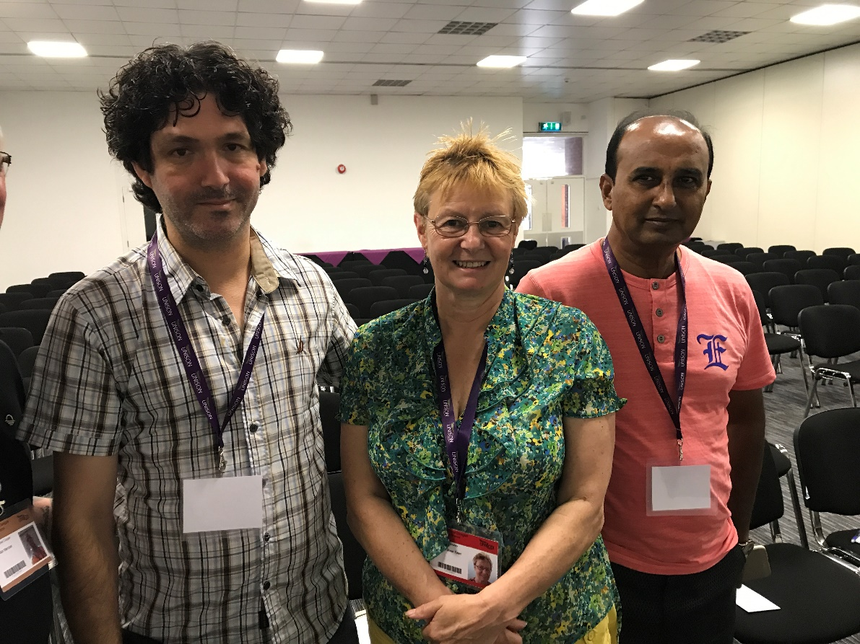

Erez Wagner, Jean Sowley and Shapon Salauddin

Shapon Salauddin is President of Bangladesh Revolutionary Garment Workers Federation, which organises garment workers in and around Bangladesh’s capital Dhaka. He is one of the original founders of the federation which started in 1994. Shapon spoke about the amount of injuries caused at work. When someone becomes disabled in the family, another member of the family has to find work as there is no benefit or money coming into the house. Those becoming disabled and injured at work get no compensation.

The UK minimum wage is £7.50 an hour, whilst Erez’s workers get £5 an hour equivalent and Shapon’s workers get 22 pence an hour, only enough to buy ½ litre of water!

Disabled members got an exclusive interview with Keir Starmer MP, Labour Shadow Secretary of State for Exiting the EU. Jean Sowley and Angela Hamilton asked the question ‘what would Brexit mean to disabled people?’ His response was that if there was to be a hard Brexit there would be no protection and it would be very hard for disabled workers. The Labour party are looking to increase the rights and protections that already are in European Law. They wish to be at the cutting edge and be much more proactive with rights for disabled workers. When asked if he would consult with disabled people on issues he invited UNISON disabled members to have a

meeting to be consulted and to be listened to.

Jeremy Corbyn joined conference on Friday morning, and was hugely popular.

The caucus meetings were reported in the daily newssheet as there was much support and discussion around the disabled members issues, including Access to work, technology and UNISON emails.

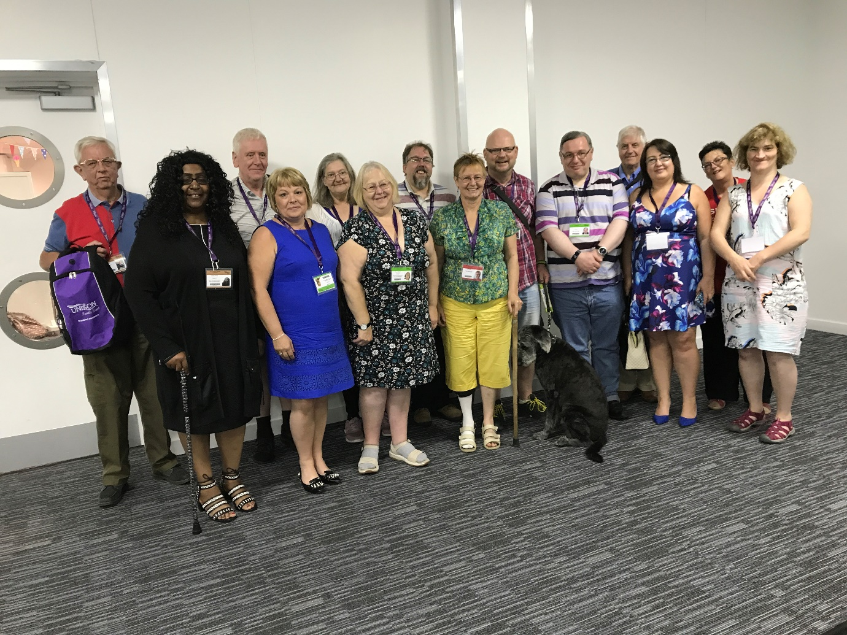

Disabled members at conference

There were many things covered by the newssheet, which included caucus meetings, fringe meetings, general disability issues and information, encouraging branch self-organisation and conference.  
  
As always I enjoyed the work of the newssheet, it’s a busy time on and off the conference floor but the buzz and overall experience of conference was great to be a part of.

Many thanks to all those who agreed to speak to me, or be interviewed, giving me their opinions on disability issues that I could report on, as well as the officers who supported my work. It all contributed to an interesting and informative disabled members newssheet.

**Jean Sowley**

**TUC Disabled Workers Conference**

This year’s UNISON delegation was comprised of:

Carol Sewell (delegation leader), Sian Stockham (UNISON’s representative on the TUC Disabled workers committee), Lisa Dempster, Maggie Griffin, Jacqueline Jones, Bev Miller, Carl Phillips, Iain Scott-Burdon, Jean Sowley and officers Haifa Rashed and Lucille Thirlby.

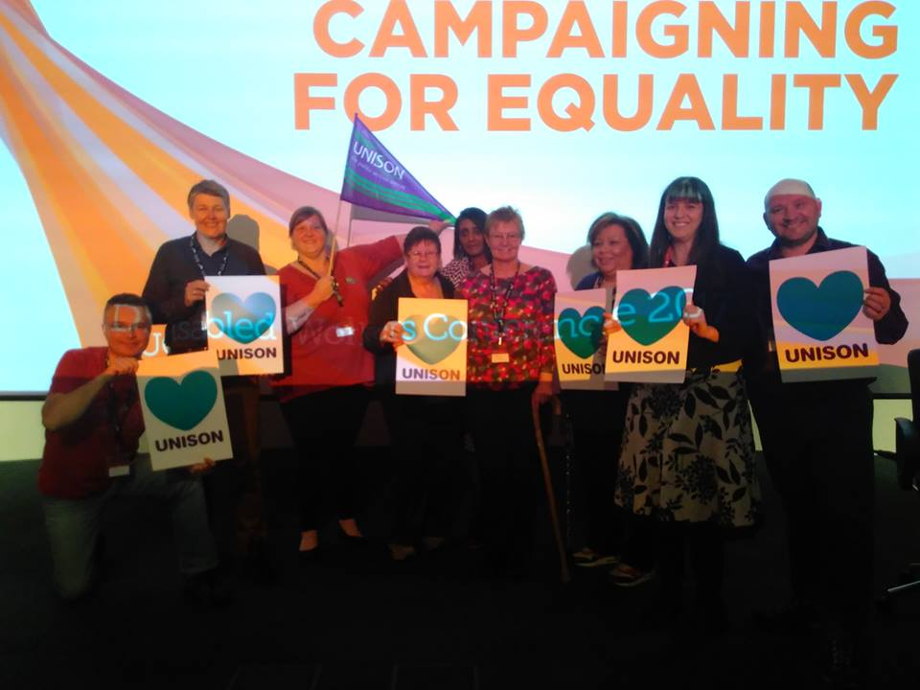

The UNISON delegation

There were 22 unions represented at the conference with nineteen motions and two emergency motions. This came only weeks before the general election.

During the conference there were several guest speakers, including:

Mary Bousted, the President of the TUC,

Tara Flood, Director of Alliance for Inclusive Education

Paul Novak, Deputy General Secretary TUC

Aisling Gallagher, Unite young workers activist

The chair’s address was given by Sean McGovern, who talked about mental health

in the workplace, the dignity of disabled workers in the workplace, and how removing barriers is critical to allowing disabled workers to continue to work. He also spoke about the NUT wellbeing at work charter, which can be accessed at http://www.teachers.org.uk/help-and-advice-/health-and-safety/mental-health-

Tara Flood talked about young people in schools and accessible apprenticeships.

She spoke about barriers being put in the way to disabled young people because they have to achieve academic standards that they may not be able to achieve because of lack of support or accessibility in the ways they learn.

The upcoming general election was also discussed. The barriers for disabled workers need to be taken down! Brexit needs to deliver a better society for disabled people. There will be huge challenges in the next few years and the unions will have an important role in these challenging times. We will all help to shape the future.

Aisling Gallagher, a Unite young worker activist was very open about her mental health and the work that union reps do to support others with mental health in work. Many look after everyone else around them and take less care of themselves. The systems punish rather than supports people with mental health, with cuts to all services, housing, NHS services, education and benefits to disabled people.

On Friday there was also an informal session on supporting workers experiencing mental ill health with the PFA and NUT. The speakers were Michael Bennett from PFA (professional football association) Jason Brown PFA and Catherine Scarlett from NUT.

UNISON spoke to the following motions:-

Motion 5 ‘Separating disability related absence from sickness absence’

Motion 8 ‘Improving support for disabled workers’

Motion 10 ‘Disabled performers’

Motion 12 ‘Building a mentally healthy workplace

Motion 17 ‘hidden disability rights’

Motion 18 ‘driver only operated train services’

There were 6 motions covering the subject of mental health which were all heard together on Friday morning. This included UNISON’s motion ‘young workers and mental health’. The content of the other motions included healthy workplaces, wellbeing of staff, sickness absence, a young workers guide, access to mental health services and reasonable adjustments for those who do not look disabled.

Emergency motion 1 was brought to the conference by the TUC disabled workers committee. The motion covers the issues raised from delegates over the years from disabled workers conferences highlighting the inaccessibility of TUC Congress house. It called on the conference to instruct the general council to organise the improvement of congress house or hold this conference at another accessible venue.

Emergency motion 2 raised the concern that on 9th March the Home Office issued the refugee leave document, which could disrupt the healthcare and support needed by disabled child refugees.

All motions were carried at the conference.

**Fringe meetings**

On Friday lunch time UNISON sponsored the fringe meeting ‘union representatives and frontline support for disabled workers’ This was chaired by Jean Sowley disabled members co-chair NDMC, Professor Kim Hoque from university of Warwick and Philip Connelly from Disability Rights UK.

This fringe meeting was organised to seek delegates’ views in a research project that seeks to improve this issue. It is proposed to develop a comprehensive and searchable database of reasonable adjustments that will be made available to union representatives and disabled people. The intention is to increase awareness of examples of reasonable adjustments on which disabled workers and their union representatives can draw when negotiating reasonable adjustments with employers.

On Thursday evening immediately after the close of conference there was a free screening of 'I Daniel Blake' followed by an audience discussion. UNISON was one of the sponsors for this event and participated in the discussions afterwards.

Sian Stockham from UNISON’s national executive council was elected to be part of the TUC disabled workers committee.

**Jean Sowley**

# National Labour Link Forum

This year’s National Labour Link Forum was held in Liverpool from the 6th-7th July, your representatives were Neelo Farr and Craig Martin.

The Forum was interesting but unfortunately not very well attended; there was a full agenda though some motions were withdrawn due to the General election being called and subsequent excellent performance by the Labour Party.

The motions were very interesting and illustrated so many delegates’ experiences of public sector cuts, from social care, to the NHS, to policing and the WASPI campaign. The summary of UNISON’s general election activities and the determination to end the pay cap for all public sector workers by pressuring to Tory MPs in marginal seats and with industrial action if necessary was quite rousing, it showed the power that working people can wield when united.

The agenda started on Thursday morning with a welcome speech by Joe Anderson, Mayor of Liverpool, followed by motions and composites.

Neelo Farr moved our amendment on Motion 11 “Why we need to build a new housing consensus for affordable and decent homes for all” outlining the specific issues faced by Disabled People with regards to finding safe and suitable accommodation.

Craig Martin moved our motion 15 “Protecting Disabled people’s rights” with regards to Brexit and EU law and the UKs position on withdrawing from the European Convention on Human Rights, both were carried unanimously.

There were speeches from our General Secretary Dave Prentis and a question and answer session from MPs.

Angela Rayner Shadow secretary of state for Education and Former UNISON Regional Convenor for the North West gave an excellent and empowering speech and question and answer session drawing from her personal as well as professional experiences.

Workshops were also held on the first day which looked at following issues:

* The fine tuning of Labour Link
* Moving to a system whereby new members of the union pay the political fund contribution on top of the integrated sub/political fund contribution rates that current member pay?
* Pros and cons of a two stage process, with people joining the union and a follow up approach about an additional contribution to the Labour Link/political fund?
* Would a more explicit relationship with Labour, including a greater sense of joint membership and involvement in party activity, be appealing to new members?

The majority of the motions were supported by the delegates on both days except the motion on Industrial Democracy, which wanted to expand workers’ control and ownership of the economy and agency in the workplace. The mover believed that it’s essential to any serious progressive restructuring of the economy and is precisely the kind of thinking that is demanded from the labour movement in a period of de-unionisation and potential automation. This was the only motion that raised a heated debate from the floor with speakers opposing the notion of employees being accountable to put forward proposals to increase productivity from staff. We needed to count twice for this motion, which was ultimately carried.

One emergency motion was accepted on the agenda by the standing order committee on EU Rights Post Brexit. The mover delivered a very moving and emotional speech by an EU Citizen who has lived and worked in the UK for the past 42 years who now did not know where she belonged. There were several speakers on the motion and it was carried.

**Neelo Farr and Craig Martin**

**Report from Disabled Members elected to the NEC**

**Names of NEC reps:** Angela Hamilton, Pam Howard

**Summary of activities**

The new NEC took office at the close of National Delegate Conference with two reserved seats for Disabled Members being added for the first time. These seats are held by Angela Hamilton (General Seat) and Pam Howard (Female Seat).

The only item on the agenda for the meeting was the election of the new Presidential team. The outcome of the election was President – Margaret McKee (Northern Ireland), Senior Vice-President – Gordon McKay (Scotland but occupying a Health Seat) and Junior Vice—President – Josie Bird (Northern).

On 3 July Angela and Pam attended an induction meeting for new NEC members. This included talks from the General Secretary and Assistant General Secretaries as well as information on how the NEC works, training opportunities and an overview of current priorities.

The next NEC meeting was held on 4 July. The primary focus of this meeting was the allocation of NEC members to Committees and the election of Chairs and Vice Chairs of each committee. As members of the NEC represented to elect Disabled Members Angela and Pam were automatically allocated two of the seats on NDMC. Sian Stockham was given the third seat as she represents UNISON on the TUC’s Disabled Workers Committee. Other Committees allocated were:

Angela Hamilton – Policy, Development and Campaigns Committee

Pam Howard – Services to Members Committee

Sian Stockham – Services to Members Committee, Industrial Action Committee, Welfare Committee and General Political Fund Committee

**Keeping in touch**

Meetings are scheduled to take place throughout the year and we will provide reports of the meetings we attend to National Disabled Members Committee throughout the year.

We know it is important for all Disabled Members to know about the work we are doing on the NEC and have their say on things. To help with this we have set up a Facebook Page which can be found at [www.facebook.com/NEC-Disability](http://www.facebook.com/NEC-Disability) so all Disabled Members can tell us what they think, raise issues or just keep in touch.

Disabled Members who want to raise issues confidentially can contact Angela or Pam directly by email or telephone.

Angela Hamilton (General Seat) [a.hamilton@unison.co.uk](mailto:a.hamilton@unison.co.uk) 07890 527281

Pam Howard (Female Seat) [p.howard@unison.co.uk](mailto:p.howard@unison.co.uk) 07814 777358

**Self Organised Group Conferences**

**LGBT Conference**

The conference venue at Llandudno was very good, with good disabled access and facilities; and there were also non gender specific toilets which worked very well.

The disabled members caucus meeting went well and was well attended. Unfortunately one of the delegates experienced an incident of discrimination at their hotel, and several delegates reported difficulty booking tables in restaurants for larger groups, and one instance of not comfortably having enough space for a wheelchair, and them having to sit near an exit door constantly being opened when the weather was ‘a little cold’.

Many motions this year related to discrimination, hate crimes and lack of services.

Below are the motions of particular interest to disabled members that were passed this year:

1. Transitioning to Best Practise

4. End of Life Care for LGBT People

6. LGBT Scrutiny in the Commissioning Process

Comp C. We stand together to say no place for hate crime

Comp E. Pre- Exposure Prophylaxis (PrEP) for the future – United Kingdom (UK)

awareness and access

Comp G – Dementia care for the Lesbian, Gay, Bisexual and Transgender

Community

34. Time for inclusive education

Comp F. Protecting the human rights of sex workers – decriminalisation for safety

45. Equality since the 2010 Equality Act – regression instead of progression

**Sam Sharp and Carl Phillips**

**Women’s Conference**

The conference was well attended. The main themes this year continued to be: the wage gap, the WASPI campaign, the impact of the increase in the retirement age, how cuts to services were impacting disproportionately on women, discrimination, and violence against women.

The disabled members’ motions on the agenda were:

* 22 ‘The Trade Union Act and the government’s austerity cuts and their impact on disabled women’
* 30 ‘Driver only trains deny accessible support for disabled women’

Both of our motions were passed, and there were good supporting speeches from delegates. It was also interesting to note that the National Women’s Committee submitted a motion on dementia.

Issues raised at the disabled members caucus meeting related to the disabled toilets being locked and requiring a key, and why when delegates submit access requirement for one conference can this not automatically be stored for the next conference.

A link to the record of decisions at conference:

<https://www.unison.org.uk/events/2017-womens-conference/>

**Sam Sharp and Jacqueline Jones**

**Service Group Conferences**

**Community Conference**

The Conference started at lunch time on the Friday with sector meetings for:

* Community and Voluntary Sector
* Housing Association Sector
* Major Charities Sector

We attended the Housing Association sector meeting which discussed terms and conditions for workers in the sector, pay negotiations, and the mergers of several housing associations. The delegates represented many different areas and sizes of housing associations across the UK.

We asked about terms and conditions, from the amount of days leave to sick pay, and what the sector had negotiated for the pay awards in 2017. Some in the sector were having no pay increase this year and some had a freeze on increments. Those who were to receive a pay increase were on the whole up to 2%.

Steve Reed OBE, MP for Croydon North was Friday’s guest speaker.

The first of the seminars followed for the rest of the afternoon. The choices were:-

* How to Lobby Your Councillors and MPs
* Dealing with Mental Health in a workplace
* Organising disparate workplaces
* Democratising Housing Associations

These seminars were repeated on Saturday morning so that there was an opportunity to attend two different sessions over the conference. These were very useful and informative sessions with full participation from all the delegates in each session.

The last session on Saturday morning was a panel session for question and answers on “Regional structures for the community service group”, with speakers James Hawker and Sittu Ahmed from West Midlands and Michelle Bradley from Essex branch.Two examples of how the community branches are working were explained and discussed. The communities sector is not as structured with branches and support as is the other sectors in UNISON.

The conference business commenced on the Saturday afternoon

There were 2 motions on the agenda from the National Disabled Members:

Motion 17 ‘Combating Bullying and Harassment of Disabled Workers in the Community Sector and Motion 18 ‘Contracts and Retenders’. These motions were carried.

We also spoke to motions 6 ‘community in the race to the bottom’ and 9 ‘bullying and harassment’, putting a disabled members perspective to them.

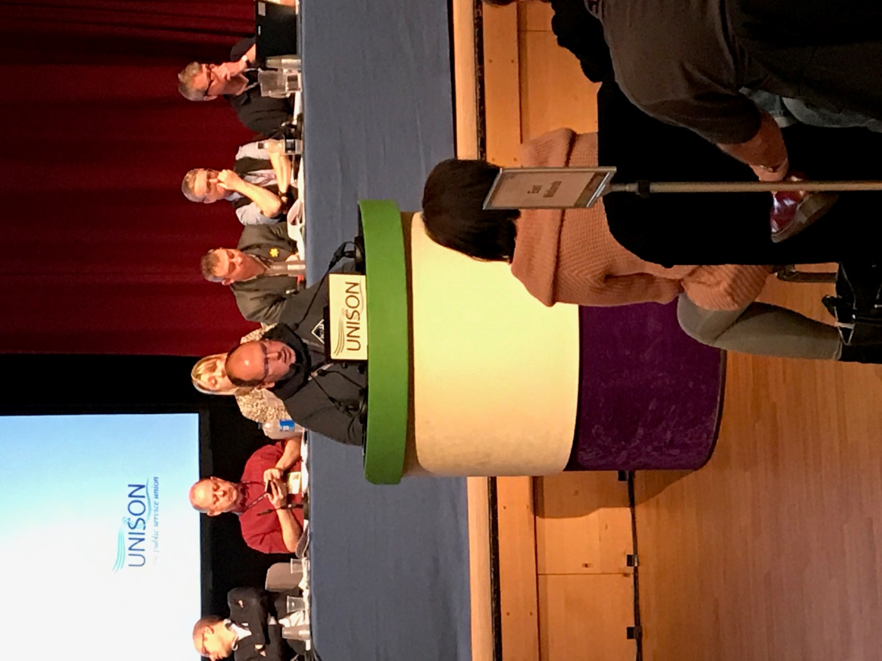

David Mills speaking at conference

**Disabled members caucus meeting.**

The disabled members held a caucus meeting in the lunch break. They discussed the accessibility of the venue and fed that back.The caucus meeting time was an issue. Some delegates may not have had any time to have any lunch and certainly not to go out and buy any as the caucus meetings were back to back in the lunch time.  Disabled members caucus was the middle half hour and that meant that you didn't have the opportunity to get something to eat from outside and be back in time for the start of conference. Disabled members may have needed more time to eat and so it would have been better to put their meeting at the beginning of lunch times. We also discussed the disabled members motions at conference.

Disabled members’ forthcoming network days were discussed and the dates shared.

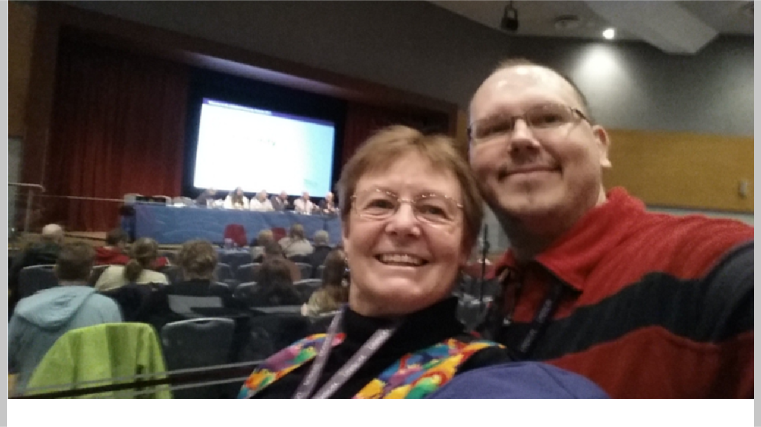

**Jean Sowley and David Mills**

**Energy Conference**

Conference went really well, Dave Prentis spoke and has said how the recruitment within the service group has increased greatly especially in British Gas. He also spoke about the uncertainty in the energy sector regarding the government and their manifesto promise that they would cap the energy market.

We held a minute’s silence for all those we had lost in the last 12 months and for those of the Manchester and London attacks

Margaret McKee chaired the conference and certainly kept us in line. There only a few motions and all went through with no issues, one of the motions is to put the Energy seminar and the conference together which we hope will increase the numbers to the Energy Conference.

**Irene Humphreys**

**Health Conference**

The general themes of the conference were the impact of cuts and underfunding to the NHS, the privatization of services and the impact of Brexit and potential loss of European NHS staff and the loss of the NHS training bursary. Conference was very pleased to hear from Jonathan Ashworth MP, Labour Shadow Secretary of State for Health, about Labour’s commitment to address these issues and he received a standing ovation.

One concern was a delegate telling conference that their employer was looking to bring back the Bradford factor scoring.

Nigel moved the disabled members motion ‘Dementia friendly employers’***.*** There were no speakers against the motion, but some good supporting speeches. Both the motion and the amendment were carried. Below is some useful information that was given during one of the speeches regarding language and dementia:

<http://dementiavoices.org.uk/2014/10/dementia-words-matter/>

The disabled members caucus meeting was poorly attended, only eight people attended. By the time of the meeting many of the motions which had a specific impact on disabled members had already been debated and they had been carried. We asked those attending to support our motion and discussed this. There were no concerns about access at the conference venue and other issues related to hotels were being addressed.

We explained and gave the dates of the network days, and then much of the discussion was taken up with concerns regarding disability benefits, cuts to benefits, and the assessment for benefits with some very concerning personal stories.

One member also discussed concerns about not knowing who to contact nationally regarding disability, and another member discussed concerns around social prescriptions, which may lead to a delay in patients receiving other NHS services, or whereby non-attendance is linked to healthcare or benefit sanctions.

**Nigel Peirce and Sam Sharp**

**Higher Education Conference**

I attended the Higher Education conference on 02 March 2017 at Bournemouth on behalf of the National Disabled Members Committee. The disabled members’ motion ‘Removing barriers for disabled workers’ was well received and was passed with no objections. It was an interesting conference which I would have no problem attending again if needed on behalf of disabled members. In total, there were 18 motions at the conference of which 15 were passed one was lost and two were withdrawn.

**Eric Atkinson**

**Local government conference**

This year’s Local government Conference was held in Brighton on the 18 and 19 June, your delegates were Angela Hamilton and Kathleen Kennedy.

Sundays morning’s session began with a welcome from Unison Senior Vice President, Carole Sewell, who also paid tribute to late President Eric Roberts. A minute’s silence was held for those affected by the fire at Grenfell Tower and it was agreed to hold a bucket collection in support.

This was followed by a report from the Standing Orders Committee (SOC), the Local Government Service Group Executive (LG SGE) Annual Report and a report on Recruitment and Organising. The debate focused on funding cuts, homecare and social care including health and social care integration.

On Sunday afternoon we received the Annual Reports on Recruitment and Organisation and Education and Children’s Services. The focus of the debate was apprenticeships and education. We also heard from speakers involved in the Durham and Derbyshire Teaching Assistants disputes.

Monday morning began with further reports from SOC and the LG SGE Sector Committee reports. Kathleen gave an excellent speech in support of motion 16 “Bullying and Harassment of local government workers must stop” while Angela spoke in support of amendment 18.1 on “Bullying of Black workers in the workplace.” Our motion 4, Disabled Members and local government pay and conditions was scheduled to be on the agenda but unfortunately we did not reach it so it was not moved.

On Monday afternoon the debate moved onto pensions before we received the LG SGE report on Anti-privatisation and service delivery. The first motion after the report was out motion 26 “Defending our libraries” which Angela moved. There were two amendments to the motion which we accepted, one with qualifications. The motion was passed unanimously but we need to be careful in future that the action points in our motions are disability specific as they weren’t in this motion.

As scheduled business was completed on Monday afternoon we returned to unfinished business from Sunday morning. As part of this Angela spoke on motion 39 ‘Social Care is now beyond crisis’ raising the issue of enforced institutionalisation.

Disabled Members Caucus was held after conference on Sunday. It was well attended and conducted in an informal and open way, allowing people to feel comfortable talking and providing assistance for new delegates. Issues discussed included the mental health, privacy issues relating to requests for reasonable adjustments and the lack of refreshments at Disabled Members Caucus which prevents some people from attending.

**Angela Hamilton and Kathleen Kennedy**

**Police and Justice Conference 2016**

The conference was well attended, however there was a noticeable shortage of Probation members. The conference was chaired by President Eric Roberts. The standing orders received one emergency motion about the double waking night cover. This is a second year that workshops were split. Both Police and Probation had their own workshops, offering both services the opportunity to discuss issues that were specifically pertaining to their organisation on day two.

The movement of motions was one of the highlights of this year’s conference, in particular motion four. The motion was moved by Neil Brooks he spoke passionately about not wanting to see the breakup of the NNC and to just accept this would be giving away our existing national collective bargaining arrangements. It was exciting to see the passion that was displayed both for and against the motion. I was at the edge of my seat, how proud I felt to be a part of such a union, which had so much passion and commitment. Surely, I thought to myself, the robust debates in the House of Parliament, had nothing on this one!

Result: Motion fell.

**Probation Workshop**

During the meeting UNISON members spoke about their experience in relation to health and safety issues of having to do more home visits and discussing issues with victims and perpetrators in the same ear shot especially in relation to domestic violence. Members were then given an overview and the benefits of joining the Probation Institute. Jim Barton spoke on the National Probation Service’s ‘E3’ programme.‘E3’ (effectiveness, efficiency and excellence) was launched because of what was inherited from former Probation Trusts. It was found that there were significant differences in practice. Jim Barton stated that they needed to undertake E3 to get a clear model of how services were to be delivered within the National Probation Service and how we would best deliver those services to improve outcomes, and not run away from it costs need to be reduced.

**Police Workshop:**

Key factors:

* 30,325 membership in England & Wales
* In 2015 England and Wales density of 47%
* How could we arrest the decline in total membership and density?
* Things to think about:
* how we communicate with members/potential members
* what do people want from UNISON

There were not as many stalls as before which was a slight down point but all in all it was a very enjoyable conference. The 2016 Police and Justice Conference was a huge success, there was opportunity to network and see colleagues that we had not seen for a long time.

**Chelsea Skervin & Jo Spear**

**WET Conference**

UNISON vice president Margaret McKee opened business with a minute’s silence for those who lost their lives recently, notable amongst those was, of course, President Eric Roberts, who died last autumn.

“We are strong and stable – even if the government isn’t.” That was the message from UNISON’s WET Service Group Executive chair Ruth Davis as she spoke at the Water Environment & Transport conference in Brighton.

“We live in difficult times, but we must carry on and not allow people to make us change our lives,” she spoke in the aftermath of the recent terrorist attacks in London and Manchester, together with the Grenfell Tower fire. She also thanked public service workers who have tackled these events. As did many other speakers at the conference.

A busy morning saw a range of debates arranged around organising and recruitment, negotiating and bargaining, and campaigning.

John Wilkinson of the United Utilities branch told us how traditional, printed magazines help to “increase UNISON’s visibility in the workplace” a point made in support was that one of the values of printed media is that it’s more visible to non-members. Especially, when left for the casual reader to pick it up.

* Other motions in the morning session dealt with a wide variety of concerns:-
* Getting members onto the Trustees of Pensions.
* TUPE transfers, where workers’ jobs are outsourced to another company,
* The difficulties faced by members working with the Environment Agency whose jobs are being transferred to Defra, which currently does not recognise UNISON.
* The crisis in the bus sector and the problems for members working in it highlighting the vital importance of bus services to many people – whether to get to work, to the shops or to leisure activities, especially in rural areas.
* The lack of support for smaller transport depots, being swallowed up into non transport branches
* The need to protect national collective bargaining through the Passenger Transport Forum, after a number of employers made it clear that they intend to withdraw.
* Malcolm West of the Yorkshire Water Brach urged everyone, including the executive to help branches share best practice on the National Equality Standard, while the national
* Black members’ raised the issue of the glass ceiling faced by Black WET employees.
* As always Health and Safety and protecting the environment were discussed – however Motion 13 was dropped by Yorkshire Water never found out why.
* It was pointed out that that DEFRA was the biggest government department affected by the UK Exiting the EU, with 600 of 1,000 pieces of EU legislation affecting DEFRA.
* Increased competition in the water industry
* Wheelchair access on buses.

Probably the high point was hearing from Roger McKenzie, our Assistant General Secretary. Speaking out against the self-serving politicians who used the tragedies to bolster their own support with all the “Aren’t public service workers, great?” and then they put the boot in by re-enforcing the pay cap.

The Motions, as usual, were hardly contentious, there was not an against voice on any of the motions.

One downside was the obvious use of generic motions where the speech wasn’t changed for the WET conference – it was still worded for A N Other Service Group.

**Chris Haywood**

**Caucus reports**

**Black caucus**

Sharon Dixon was elected as the Black caucus representative at National Disabled Members Conference in October 2016. Sharon led the Black members network day in June, assisted by Peter Daley from the national disabled members committee. The caucus submitted two motions onto the National Disabled Members Conference motions agenda: ‘Perception of Black people and Mental Health’ and ‘United Nations Conventions.’

**Deaf (native British sign language users) caucus**

Iain Scott Burdon was elected as the Deaf caucus representative at Disabled Members Conference in October 2016. The caucus wishes to extend its thanks to Denise Lightbody, who was for a long time a deaf representative on the national committee and who retired after last year’s disabled members conference. The caucus is hoping to elect a deaf woman as caucus rep this year, as this seat remained vacant this year.

The caucus met twice this year. As well as submitting motions and amendments to this year's conference, the meetings have attracted some more deaf members to attend and get involved.

We have discussed with the National Disabled Members Committee about our concerns with the Clinical Commissioning Groups (CCG) Commissioning and interpreting services. It would seem that many CCGs have awarded contracts to the agencies that cover foreign spoken languages which also includes BSL (British Sign Language) interpreters. However, the agencies seem not to follow the strict guidelines on how to use the BSL Interpreters - it is a mandatory that all interpreters must be registered and have the right level of skills (Level 6). At the moment many agencies don’t follow the guidelines, which puts a risk on deaf people getting lack of information due to mis-interpreting! The caucus is trying to work with the NHS to make improvements in this area.

We continue working with UNISON to update all information into BSL clips on their website which is working well.

**Iain Scott- Burdon**

**Lesbian Gay Bisexual and Transgender Caucus**

The caucus meeting at 2016 disabled members’ conference saw our biggest attendance for a long while. Sam Sharp and Carl Phillips were elected for the 2017 committee cycle, also Pauline Cole and Phillip O’Shea were elected to represent LGBT disabled members on standing orders for this year’s conference.

The year the caucus grew due to new members joining the national committee and supporting the work of the group. The LGBT caucus has been heavily involved with the work of the National Committee work plan. We have participated in both the working groups of the committee.

Carl was elected to attend the TUC Disabled Workers Conference and moved UNISON’s motion on behalf of the delegation. This was great opportunity to

promote to other unions how UNISON works with self-organisation.

A number of the caucus members from the committee attend National delegate conference in Brighton, we were able to network with other delegates, encouraging them to get more involved with Disabled LGBT self-organisation.

We held a network day in June at UNISON Centre, this year the caucus were able to trial a full day, starting at 11am and running through till 4pm. Sam, Louise Ashworth and Carl gave an update on the national committee work plan and our involvement in it. The morning session was as a training session, were we looked at the LGBT timeline and how discrimination has affected LGBT people over the years, looking at the positives and negatives and how long the fight for full equally still has to go. We then had a discussion around hate crime and how we can keep ourselves safe. In the afternoon session we discussed topics for motions to national disabled members conference. We focused on the rise in hate crimes against Disabled & LGBT People since the Brexit decision, and we have put a motion to conference on this matter.

We also talked in depth around working for intersex equality; there was a varying level of knowledge around the issues faced by Intersex members within the group. We then proposed our 2nd motion on this matter to start a wider conversation within UNISON and our partners. This discussion also raised issues around how we gender specific language to identify people. Instead of using “She/He, Him/Her” at meetings we could refer to “the member in the red top” or “next speaker” etc.

We have attended as many Pride and LGBT events as we were able to. For the second Carl was able to attend and host the Knowsley launch of the ‘Come Out of the Shadows Project 2017’, which is a three-year initiative promoting a positive LGBT image spanning the Liverpool City Region. It is funded by the Police and Crime Commissioner and will run for the duration of the Liverpool Pride festival between 23 and 31 July.

**Sam Sharp & Carl Phillips**

**Women’s Caucus**

The disabled women's caucus meetings have been well attended with a diverse membership and discussing a wide range of issues pertaining to disabled women within UNISON’s structures and communities. The main focus for the caucus is around how we continue to raise the profile of disabled women throughout the union. It was good to see more disabled women from branches attending our network day in London this year but we still have a piece of work to do on getting the information out to members and highlighting this vital meeting where we discuss and pull together the women's caucus motions to National Disabled Members Conference. This year we came up with five topics for motions and the group selected three to go forward and rather than lose other two they were picked up by two regions.

Our topics are on:

*Reasonable Adjustments

*Disabled Women in Politics

*Hate Crimes -Hate Incidents

The caucus agreed to support the Women Against State Pension Inequality (WASPI) campaign on behalf of disabled women and we are working with the national women's committee and the disabled members committee to ensure that our disabled WASPI women have the equal opportunity of support and assistance to information and adjustments to fully partake in the campaign.

The caucus has identified child marriage and child slavery as a potential motion topic for 2018 National Women's Conference to raise awareness around the fact that girls and young women with learning difficulties, autism and physical disabilities are married off or put into servitude by their families giving them no voice or choice.

It is a priority for our women's caucus to ensure that we work with our fellow delegates on the national committee to get the word to branches about how they can better engage with disabled women regarding their issues at work, home and in their communities. It is particularly important in these times when austerity and the government are putting increasing pressures on already stretched public services that our disabled women members work in and depend on.

**Pat Heron**

# National Disabled Members Committee 2017

**Eastern**

Kathy Bole

Suzanne Williams

**East Midlands**

Chelsea Skervin (NDMC Deputy Co-Chair)

David Smith

**Greater London Region**

Maggie Griffin (NDMC Deputy Co-Chair)

Peter Daley (NDMC Co-Chair)

**Northern**

Angela Hamilton (until June 2017)

Cath McGuinness (from June 2017)

**North West**

Graeme Ellis

Lisa Dempster

**Northern Ireland**

Gillian Foley  
Ricky Kennedy

**Scotland**

Margaret McAlees (until Aug 2017)

John Nesbit

Viv Thomson (from Aug 2017)

**South East**

Sarah Barwick

Abdul Rahman

**South West**

Craig Martin

Karen Rice (until June 2017)

**Cymru/Wales**

Irene Humphreys

Peter Williams

**West Midlands**

Jacqueline Jones

Hilary Mellor

**Yorkshire and Humberside**

David Mills

Jean Sowley (NDMC Co-Chair)

**Black Members Caucus**

Sharon Dixon

**Deaf Caucus**

Iain Scott Burdon

**Lesbian, Gay, Bisexual and Transgender Caucus**

Carl Phillips

Sam Sharp

**National Black Members Committee**

Kuldeep Bajwa

Kitty Smith

**National LGBT Committee**

Louise Ashworth

Bev Miller

**National Women’s Committee**

Gail Andrews

Pat Heron

**NEC**

Angela Hamilton (from June 2017)

Pam Howard (from June 2017)

Irene Stacey (until June 2017)

Sian Stockham

Polly Smith (until June 2017)