August 2016

Learning and Organising:
Short Workshops for delivery in Branches

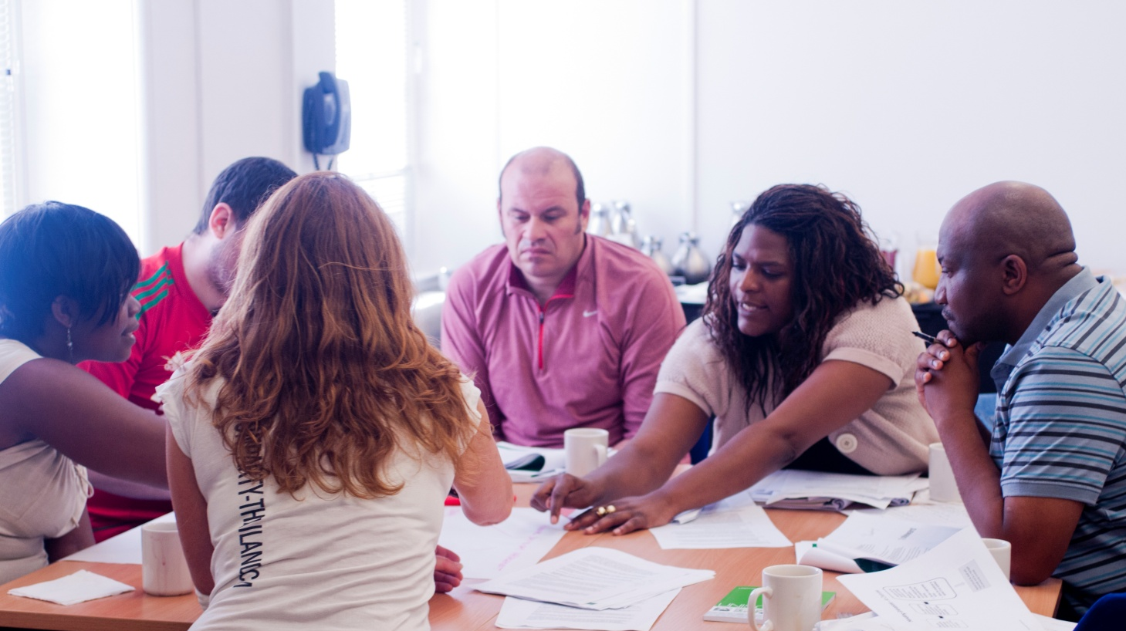
http://www.unison.org.uk/for-activists/training/u-train/learning-and-organising-courses/

Learning and Organising
Short Workshops for delivery in Branches

This range of short workshops has been developed for delivery in branches. They vary in length from half an hour to half a day and cover a wide range of topics. They are organised under the following categories and a summary of each workshop is included overleaf :

General Skills Development 2
Member Education 2
Organising Recruitment and Campaigning 3
Recruiting 3
Developing and Supporting Activists 3
Political Education 5
Legal, Privatisation and Transfers 6
Service Groups 6
Women’s’ History and Campaigning 7
A Guide to using Short Workshops – Learn and Do 8

If you would like to run any of these workshops in your branch, speak to your branch education officer, branch secretary, or regional education officer or organiser. If you have any queries about the workshop materials, contact LearningAndOrganising@unison.co.uk.
Discussion Leaders training and Lay Tutor training is available to help you develop confidence in delivering these short workshops – contact your Branch Education Co-Ordinator or Regional Education Organiser for more information.
General Skills Development
- LAOS W1- TEAM WORKING – A series of short standalone sessions: - Identifying when it is appropriate to work in teams; successful team working; establishing the role of team working within partnership agreements; reviewing practices; developing skills to improve the effectiveness of a team; getting some practical experience of effective team working; considering the role of leadership in developing effective team working.

- LAOS W44 – CONFLICT MANAGEMENT FOR PAs – This is a specialised exercise for Personal Assistants, which gets delegates to examine reasons behind reactions to conflict and to develop skills in setting mutual guidelines to reduce and prevent conflict with their employer.

Member Education
- LAOS W2 - MONEY TALKS, SUPPORTING MEMBERS – universal credit, debt and budgeting - half day - looks at issues where members are affected by debt; looks at basic budgeting; considers ways in which to approach members who may be going through debt problems

- LAOS W3 – STAYING STRONG, STRESS MANAGEMENT – short session - to consider the effects and sources of stress; explore how to begin to manage stress and handle pressure

- LAOS W19 – CVs and INTERVIEWS – Short session to identify transferrable skills and where they can come from; To explore what information to include in a CV; To explore what to prepare for an interview and how to beat nerves

- LAOS W47 – DEALING WITH PAPERWORK – 3 session course – to provide practical techniques to reading and interpreting information so it is easier to manage and prioritise information.

Organising Recruitment and Campaigning
See also the ‘Learn and Do’ guide to using short workshops for organising and recruitment activity, at the end of this document
- Recruitment Workshops
- LAOS W13 - MAPPING WORKSHOP – short session -to understand what a workplace map is, and why we make maps; how to map your workplace, and see how maps can be used across the branch, employer, or community

- LAOS W14 - PLANNING A ONE TO ONE RECRUITMENT AND ORGANISING WORKSHOP – short session - to discuss the purpose of the organising campaign and who will be involved, and how to involve people

- LAOS W17 - QUICK CONVERSATIONS – short session -to prepare stewards and activists to have initial conversations in the workplace, to consider how they will gain access to their colleagues to talk to them about the union, and how to build confidence in talking to members and potential members they don’t know and to establish a rapport.

- LAOS W18 - RECRUITMENT AND ORGANISING ACTIVIST – short session-to develop a plan for a workplace union recruitment campaign around a specific theme

- LAOS W8 - FOLLOW UP RECRUITMENT ACTIVITY – short session -follow up actions to recruitment drive

- Developing & Supporting Activists Workshops
- LAOS W20 - TALENT SPOTTING AND DEVELOPING ACTIVISM – short session -to discuss best practice on identifying activists and leaders, to recognise the different levels of activism, and to consider ways of mentoring and supporting activists, including UNISON’s trained & active approach

- LAOS W43 – TASKS TO GET MEMBERS ACTIVE – A short activity to help you work with members to identify tasks they can carry out to get more active in the workplace.

- LAOS W5 - DEVELOPING AND SUPPORTING ACTIVISTS STORYBOARD ACTIVITY – short session - to discuss the kind of activities to get members involved which help to build the union, and consider how we can support those members and develop them to get more involved

- LAOS W42 – GETTING A MENTORING SCHEME OFF THE GROUND – USING THE TAP FORM AS A STARTER – a PowerPoint from North West Region to use with branches on how to set up a mentoring scheme using rained and active resources. You need to add branch specific information to the relevant slide

- LAOS W38 – BUDDYING WORKSHOP – half day - The aim of this workshop is to assist branches build up their capacity to provide a systematic and consistent approach to supporting new reps by utilising the skills and knowledge of experienced reps.

- LAOS W4 - COMMUNITY ORGANISING TRAINING MODULE – short session - think and discuss around building strategic alliances, and long term relationships with other organisations with which we share some common goals and the natural links we have as individuals and an organisation with other groups in our communities.

- LAOS W7 - FACILITIES TIME OFF - half day - to produce Branch/workplace map on facility time and how it’s used; ability to target debate and arguments on the merits of facility time; prepare to defend/improve facility time through organisation and negotiation; produce Branch action plan

- LAOS W46 – INTRODUCTION TO NEGOTIATING SKILLS – One hour workshop
- LAOS W12 - MAKING MOST OF NEW CASE FORM – short session - to introduce the changes to the employment tribunal procedures and the UNISON protocol and new CASE form

- LAOS W9 - HANDLING REDUNDANCIES – short session - Analyse impact of redundancies in workplace; understand basic legal entitlement and employers policy on redundancies; build knowledge, and skills to enable us to negotiate and improve on redundancy agreement; understand organising around redundancy situations.

- LAOS W16 - PREPARING FOR STREET CAMPAIGNING – a short ‘learn and do’ to enable members to engage with the public on UNISON campaigns; how to plan a campaign; and how to follow up.

- LAOS W10 – PREPARING FOR INDUSTRIAL ACTION – half day -A detailed plan of action in the run up to industrial action; a clear understanding of UNISON’s Industrial action guide and how to respond to issues which might arise; a plan for recruiting and organising around the industrial action.

- LAOS W50: DEVELOPING LINKS WITH POLISH MEMBERS – a short workshop to improve communication and understanding between branches and Polish members and increase awareness of issues these members face during disciplinaries, capability and performance management meetings.

Political Education
- LAOS W21 - BOOM/BUST FIGHTBACK WORKSHOPS – Four X 2-3 hour sessions, and can be run as a weekend. The Workshops are:
    - W21.1 - the origins of the welfare state – Worth Defending
    - W21. 2 - understanding the threat to the welfare state
    - W21. 3 - looks at the economic crises and the causes and responses
    - W21. 4 - is around getting active in the union.

- LAOS W22 - DEFENDING PUBLIC SERVICES - short activity - to encourage UNISON members and activists to see themselves as public service workers and recognise that there is an alternative to public service cuts.

- LAOS W23 - LOBBYING GAME – short session - to introduce the idea of lobbying and to give members and activists the confidence to talk to elected politicians about issues which are important to them; look at ways members might win support for a UNISON campaign amongst politicians and get involved in the union’s political work themselves.

- LAOS W24 - MARCHING IN OUR TRADE UNION FOOTSTEPS - short session - to encourage members to: Think about the history and importance of marches and rallies for the trade union movement; feel confident about taking small actions for the march; plan straightforward actions for A Future that Works march on 20 October 2012

- LAOS W25 - MOBILISING AROUND THE CUTS - short session - to understand the importance of one to one conversations in organising around the cuts; to offer the ‘anger hope action’ method as an effective way of carrying out these conversation; to practice a one to one conversation with a member, potential member or member of the public

- LAOS W26 - YOU CAN MAKE A DIFFERENCE - short session - Get a feeling for what the impact of local public sector cuts will be; feel confident about taking small actions; plan straightforward actions they can take.

Legal, Privatisation and Transfers
- LAOS W27 - PRIVATISATION AND PROCUREMENT – half day - to map the branch for outsource and privatisation threats; how to influence the stages of outsourcing; how to understand and negotiate procurement agreements.
- LAOS W28 - TUPE BRANCH - half to one day - for members to gain a basic understanding of TUPE; TUPE in the context of the privatisation process; ability to organise around TUPE issues

Service Groups
- LAOS W37 – FOUR SEASONS – INTRODUCTION TO UNISON – short session -to enable contacts and stewards to confidently talk to members and potential members in the workplace around the role of UNISON in Four Seasons; to discuss the process of union recognition within four seasons and how negotiations will take place with the company with and on behalf of members; to understand the wider benefits of union membership; and to explore how the process can help to recruit and activate more members.

- LAOS W45 – CAMPAIGNING AND RECRUITING AROUND SICKNESS ABSENCE IN FURTHER EDUCATION COLLEGES – This half day workshop is aimed at UNISON activists in Further Education Colleges. It includes activities on campaigning in response to unfair sickness absence policies being implemented in some FE colleges. Activities, including comparing policies, strategic campaign planning and recruitment.

- LAOS W29 - DEFENDING AGENDA FOR CHANGE – half day – to familiarise members with the Defending Agenda for Change Toolkit; identify the key negotiable elements of Agenda for Change at a local level; set priorities for defending Agenda for Change; plan how to take the issue up with management

- LAOS W48 – INDUSTRIAL ACTION WORKSHOP – HEALTH 2014 – how to plan action, and UNISON policy.

Women’s’ History and Campaigning
- LAOS W30 - FORWARD STILL AND FURTHER TO GO – GLASGOW RENT STRIKE - short session - Look at the role of women campaigning and organising around a community issue; discuss the Glasgow Rent Strike of 1915; think about the legacy of the campaign to women in the trade union movement

- LAOS W31 - FORWARD STILL AND FURTHER TO GO – MATCH WORKER STRIKE short session - an example of campaigning and organising

- LAOS W32- FORWARD STILL AND FURTHER TO GO – TRADE UNION WOMEN AND THE CAMPAIGN FOR GAINING THE VOTE - short session - to discuss the campaign for votes for women; to look at the contribution made by trade union women to the suffrage movement; to look at campaigning and organising

- LAOS W33- FORWARD STILL AND FURTHER TO GO – WOMEN AND SPENDING CUTS - short session – to think about the impact that public sector spending cuts will have on women; discuss the role of women in unions and society; feel confident to discuss these issues

- LAOS W34 - FORWARD STILL AND FURTHER TO GO – WOMEN AND THE 1934 HUNGER MARCH- short session - to discuss the Hunger March of 1934; consider the role of women in the campaign; think about the importance of recent union rallies and marches

- LAOS W35- FORWARD STILL AND FURTHER TO GO – WOMEN AND THE WELFARE STATE - short session - Think about the impact that public sector spending cuts will have on women; discuss the role of women in unions and society; feel confident to discuss these issues

- LAOS W36 - FORWARD STILL AND FURTHER TO GO – WOMEN IN UNIONS AND SOCIETY TODAY -short session - This short activity can be used informally with members or potential members to encourage them to think about the contribution of women to the trade union movement
A guide to using short workshops - Learn and Do
Learn and do means running a short organising workshop which is immediately followed by an opportunity to try out the new skills learnt. These usually are some kind of one to one organising or recruitment activity. A learn and do activity concludes with a de-brief to review how it went and to plan next steps.

Principles
- Always delivered when and where it is needed.
- Organising and campaigning skills need to be embedded into everyday practice at workplace level.
- We have to create the right conditions for activists to try out one to one skills in a safe environment and to build confidence.
- Careful planning can deliver very tangible organising outcomes.
- ‘Learn and do’ does not replace more formal learning.
Before the session
Decide what the organising challenge is.
Consider what organising technique will best help this situation. For example, what kind of one to one conversation will you be practising in the workplace?
Analyse your group and decide how you will get them along to a learn and do session. For example, tacking onto a stewards meeting.
Plan the training element.
Be clear with activists about the ‘doing’ element so that it doesn’t take them by surprise.
What RMS information will be useful?
What will the ‘doing’ part of the session look like?
What organising materials will you need? Do you need to gain permission from management? When will workers be available to talk to activists?
Gather together relevant workshop resources, i.e. handouts, flip charts, pens etc.

During the Session
Pair up experienced and less experienced people, particularly if you are going into a workplace to do one to ones or on a street campaigning exercise.
Give activists the option to play an observers role if they are very nervous.
Build confidence. Give it a go!
Be clear about the logistics.

After the Session
An immediate debrief is most effective.
Ensure you add up how many people have been spoken to, contacts made, new members recruited. This can give participants a real feeling of achievement.
Plan a debrief to include:-
- What went well?
- What didn’t go so well?
- Feedback from the observers.
- What was the reaction?
- Any highlights?

Plan further follow up actions.

