Our vision for LGBT equality
As social attitudes are changing, some people think the fight for lesbian, gay, bisexual and transgender (LGBT) equality is over.
The evidence says otherwise. There are many examples. To pick some, LGBT people still:
- face bullying at school and harassment and discrimination at work
- fear being open with employers and service providers, such as GPs
- face everything from name-calling to violence when out in public
- have higher levels of homelessness and other housing problems, particularly young LGBT people
- find health services fail to meet their needs, particularly for trans people
- are disproportionately affected by mental health issues
- are under-represented in public life, particularly LGB women and trans people
- are subjected to degrading treatment when seeking asylum in the UK.
As Tory public funding cuts bite ever deeper, specialist LGBT services are disappearing, along with the jobs for those providing them. Our members report that equality is often viewed as a luxury for the good time.
In UNISON, we are working for:
LGBT equality in education
- Education free from homophobia, biphobia and transphobia
- Education fully inclusive of LGBT people and issues
- Compulsory sex and relationship education in schools, inclusive of LGBT issues.

Equality for young LGBT people
- All services for young people to acknowledge and meet LGBT needs
- Adequate funding of specialist LGBT youth services, child and adolescent mental health services, LGBT housing services, noting that young LGBT people are particularly vulnerable to mental health and housing issues.

LGBT equality at work
- Visibility and dignity at work for all under the LGBT umbrella
- Increased awareness of LGBT workers rights
- Sexual orientation equality to explicitly include bisexual equality in policy and practice
- Broader Equality Act protection for trans workers
- Full pensions equality for surviving same sex partners and for trans women
- LGBT equality written into equality objectives and equality action plans.
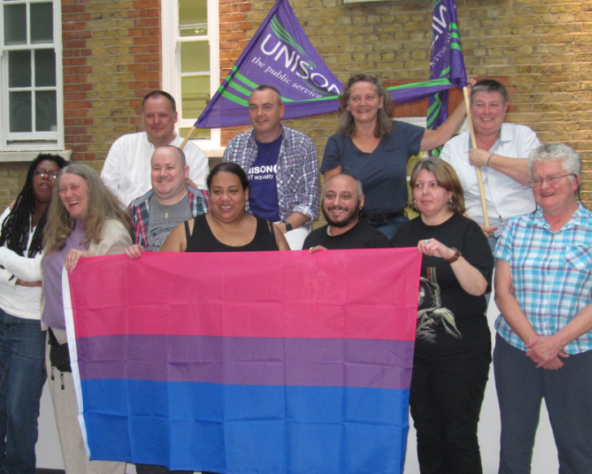

LGBT health equality
- An end to the LGBT health penalty which sees LGBT people at higher risk of physical and mental health issues
- Effective action to reverse the increase in sexually transmitted infection (STI) and HIV rates among men who have sex with men
- Proper investment in public health initiatives targeted at LGBT people
- Early implementation of the Parliamentary Trans Equality Inquiry recommendation of ‘a root and branch review’ of NHS services for trans people, both gender identity services and general services
- A review of treatment protocols for gender identity services; funding and other essential steps taken to reduce waiting times.

LGBT equality across all public services
- All public services to meet the needs of the diversity of LGBT people
- Adequate funding for specialist LGBT public services, across the UK
- Safe, secure, decent and affordable housing for LGBT people and improved LGBT housing support services
- Effective programmes to encourage hate crime reporting and tackle LGBT hate crime
- Specialist and mainstream domestic abuse services for LGBT people.

LGBT equality under the law
- A review of all UK legislation relating to trans people, including the Gender Recognition Act 2004 and the Equality Act 2010
- An end to a medicalised approach to gender recognition in the law, replaced with the principle of gender self-declaration
- An end to ‘spousal veto’ on gender recognition
- The protected characteristic for trans people in the Equality Act to be changed from ‘gender reassignment’ to ‘gender identity’
- People with a gender recognition certificate should not be subject to Equality Act exemptions from protection or application of genuine occupational requirement/single sex services provisions
- Legal recognition of those with a gender identity outside the binary of exclusively female or male
- Marriage equality in Northern Ireland
- Strengthened legislation on homophobic, biphobic and transphobic hate crime, equalising protection
- Equality, dignity and justice for LGBT people fleeing persecution and seeking asylum in the UK.
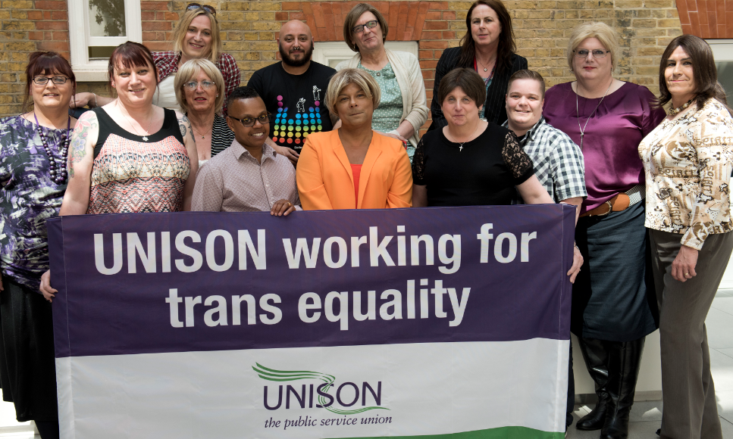

LGBT equality in public life
- Openly LGBT people elected as representatives in Westminster, devolved parliaments/assemblies and regional and local authorities
- LGBT politicians reflecting the diversity of LGBT people
- LGBT role models across public services
- Diverse, representative, realistic and positive portrayals of LGBT people, particularly trans people.

Equality for all within the diverse LGBT community
- An end to discrimination within the LGBT community, including biphobia, transphobia, sexism, racism and disablism
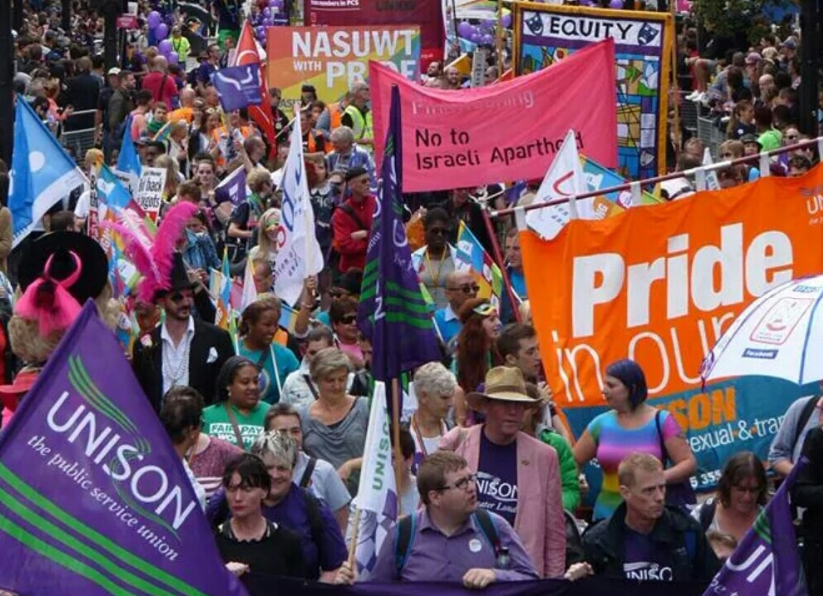
- A vibrant LGBT community – including pride events – accessible to all.

Equality for older LGBT people
- Home-care and residential care for older LGBT people that acknowledges their identities and meets their needs – nobody should be forced back into the closet in their later years.
These points are not all that we strive for but they summarise our vision. It is a living document that changes as we achieve objectives and identify new issues. UNISON LGBT members work with every part of our union for a society that is fully equal for all LGBT people.
Find out more about our work at unison.org.uk/out or by emailing out@unison.co.uk.

June 2016

